Zhong Yiyang
Law Firm Partner
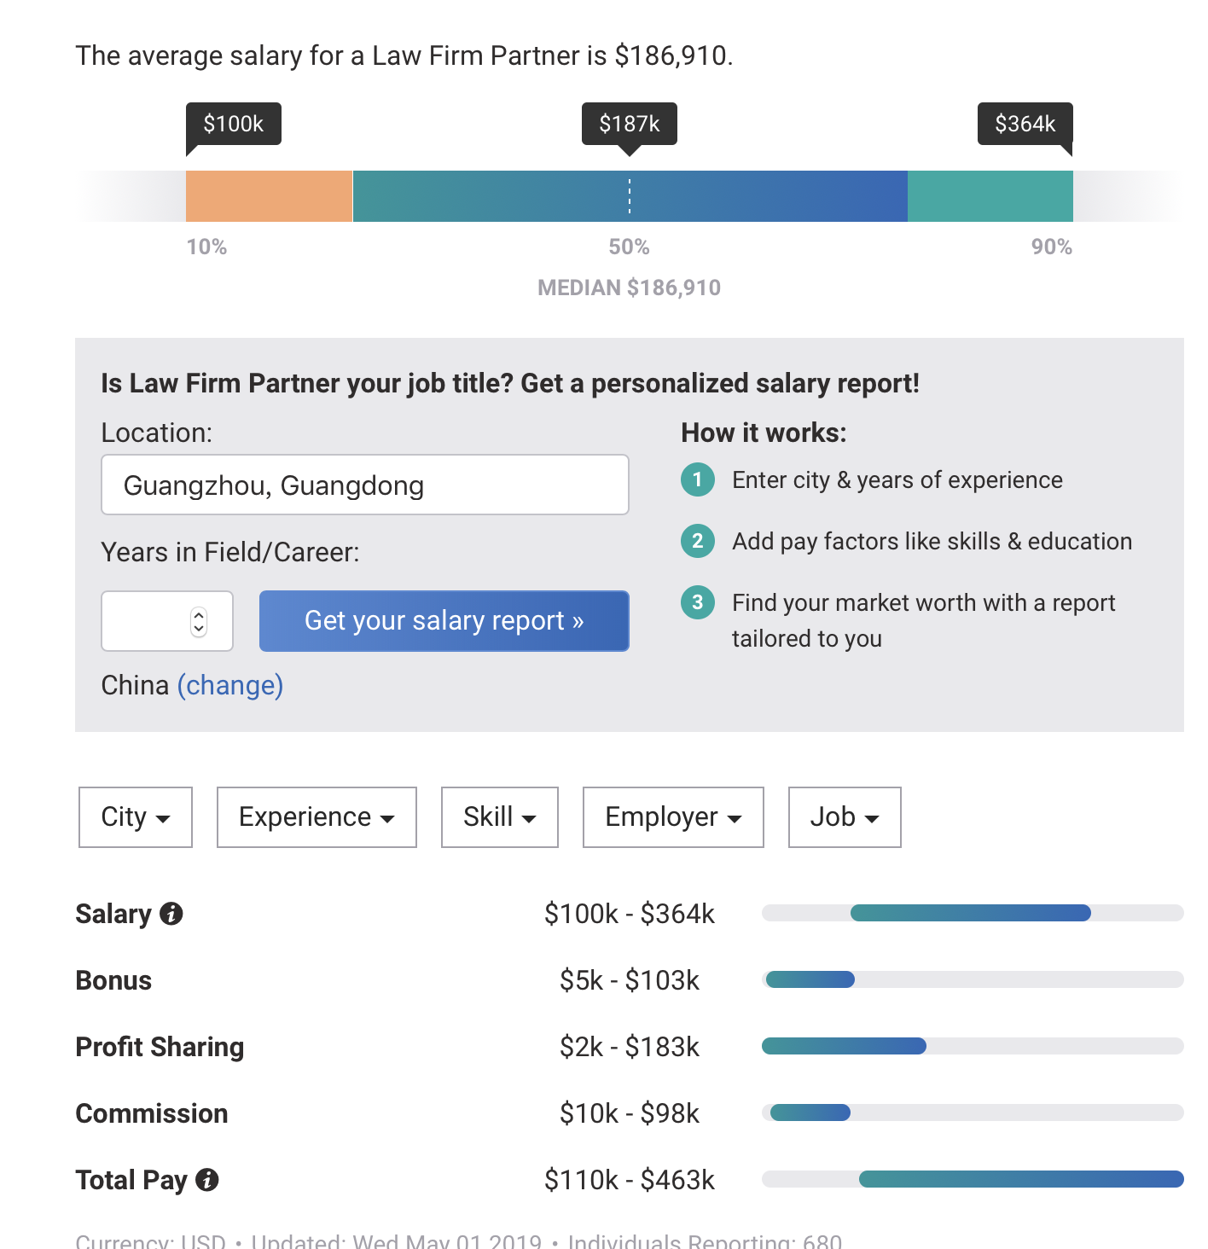

According to the information from Payscale, Law Firm Partner requires people to have a degree from an accredited law school and to have passed the bar for the state in which they practice and fully understand different state’s law to finish their job. Law Firm Partner’s tasks include 1. supervise the firm’s legal and technical support teams,
Source:https://timgsa.baidu.com/timg?image&quality=80&size=b9999_10000&sec=1561231676508&di=7c95898638ac8054d98ed12ff9a33283&imgtype=0&src=http%3A%2F%2F5b0988e595225.cdn.sohucs.com%2Fimages%2F20170711%2F4bc07828daa3404e9dd5a24cb2222185.png
2. coordinate logistics for new cases, 3. handling numerous cases simultaneously, 4. interacting with lawyers within the firm to provide advice and guidance, 5. managing payroll, 6. hiring clerks, and 7. manage budgets and vendor relationships. This is a well-paid occupation, the salary of Law Firm Partner is one of the highest one in America, which is really attract me. However, it is not fit with what I am studying, so it is not a good choice for me. Compare with intended major, financial math, they both require an excellent logic thinking, but Law Firm Partner requires other indispensable skills which is not that necessary in math. The Law Firm Partner is based on the experience. The experience sometimes is more important that professional knowledge because it involves interpersonal relationship. To make sure we can finish the job perfectly, most of time we are working in an unsatisfied environment because this job is dealing with interpersonal relationship and complex litigation case. Nevertheless, accompanying is high salary. From the data collected by Payscale, 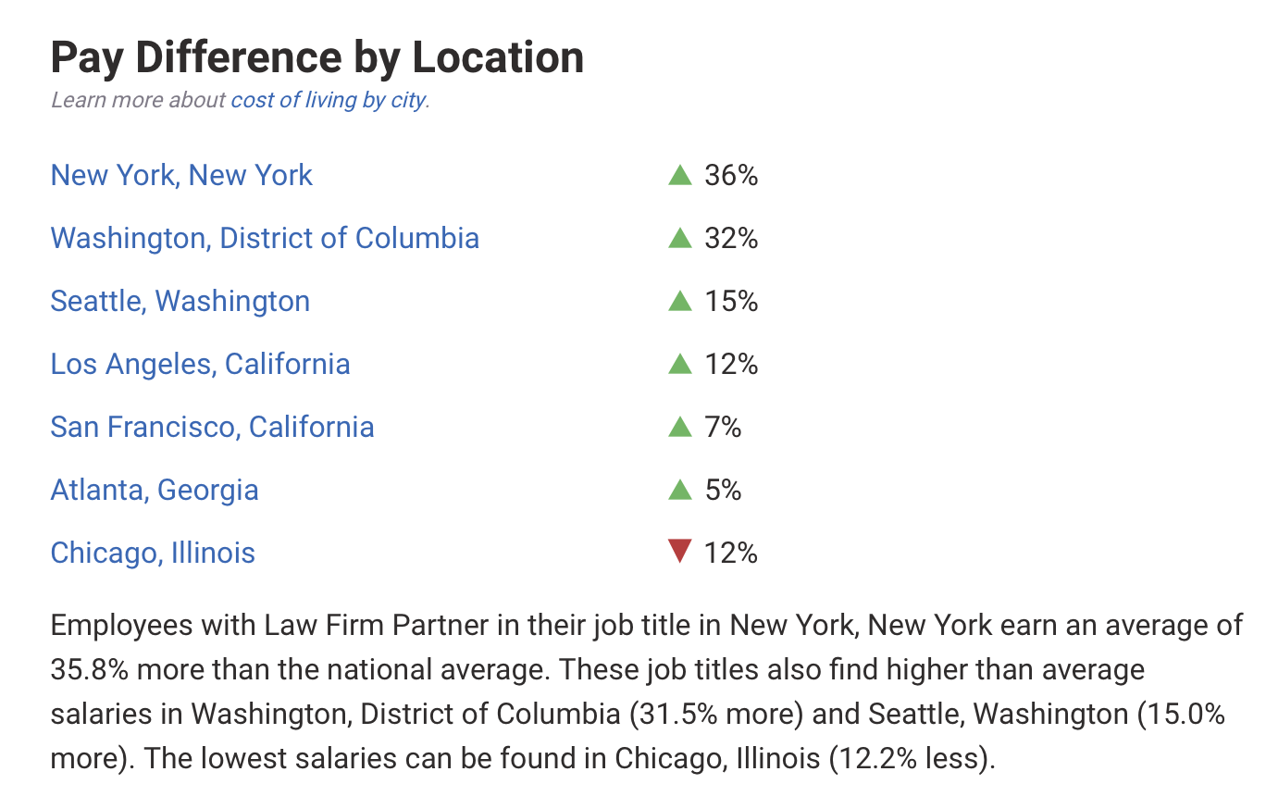 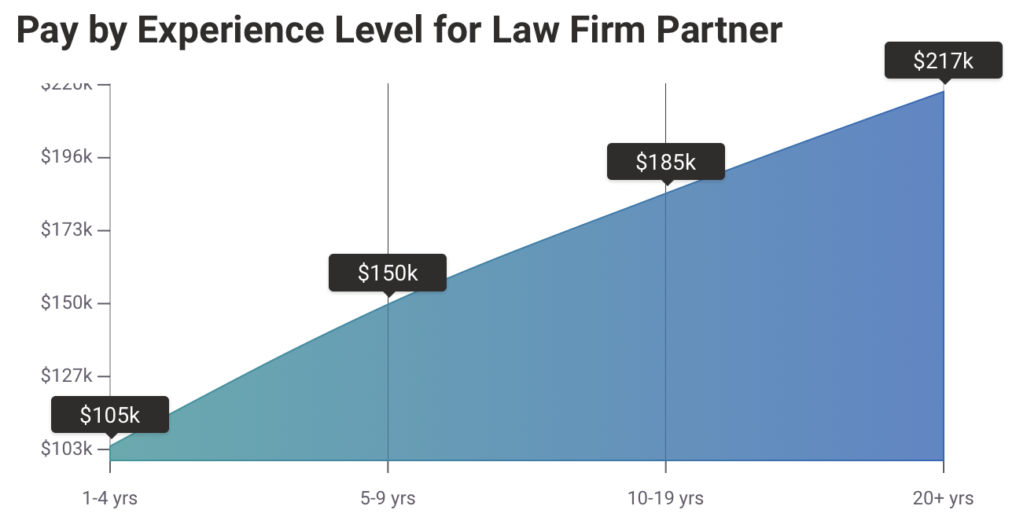
We can see that the Law Firm Partner average salary is higher than American average salary in lots of location of America and the salary will grow up while people’s working experience increase.

Senior Vice President (SVP), Marketing Salary
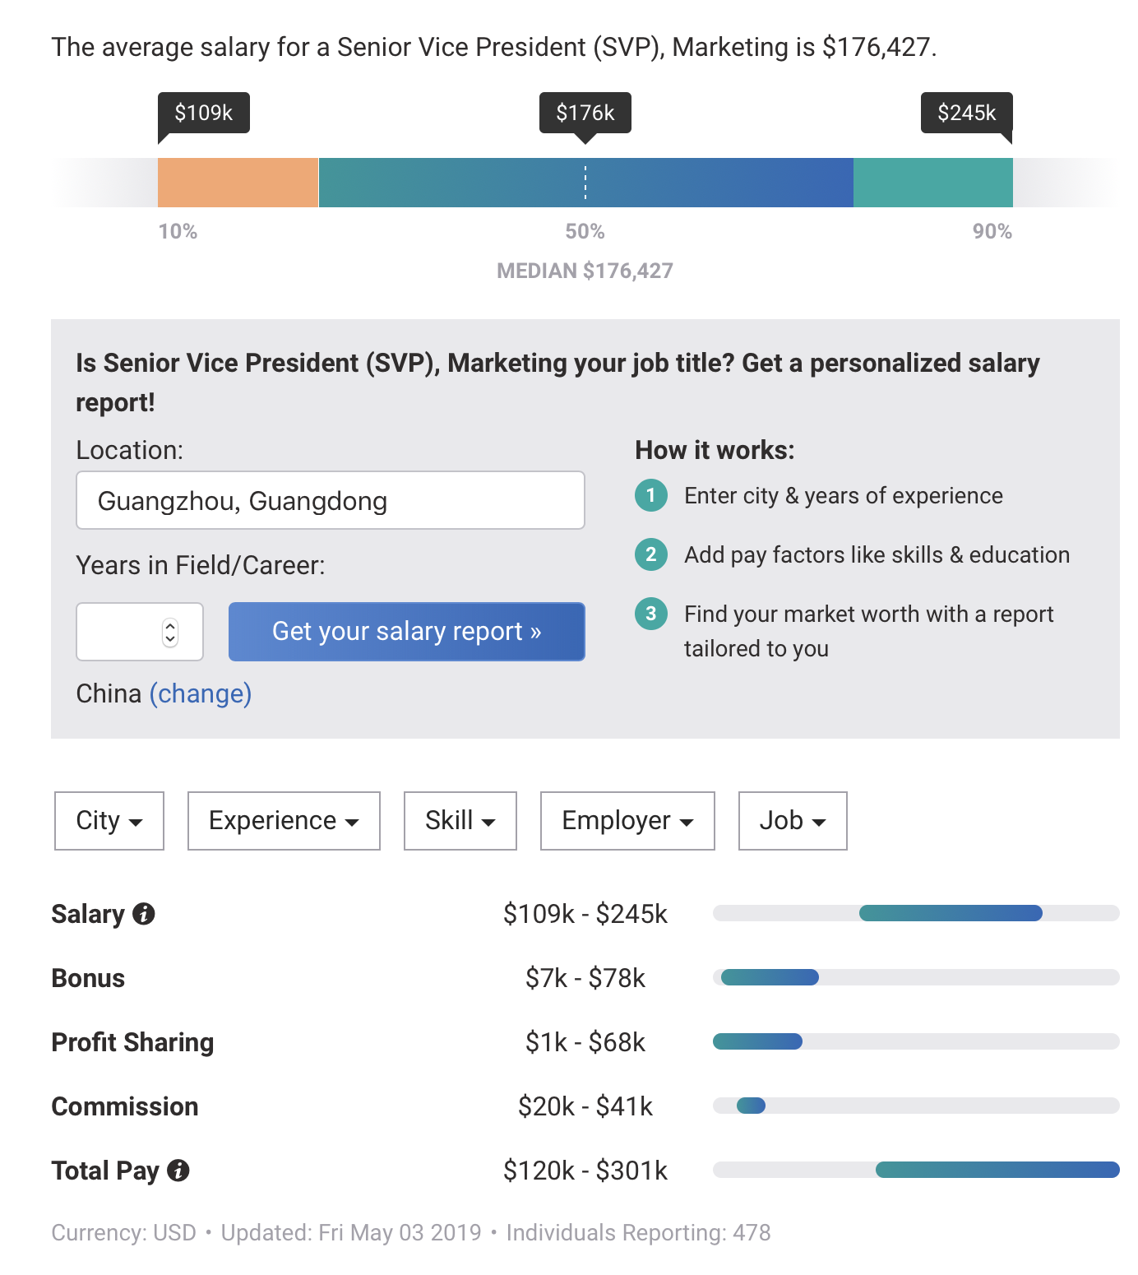
We can see the data showed from Payscale that. Senior Vice President, Marketing (SVP, Marketing) has a higher minimum salary but a lower maximum salary than Law Firm Partner. The requires of SVP, Marketing includes people have at least a bachelor’s degree in business, with a Master of Business Administration (MBA) preferred. I am now studying Financial Math now and I can transfer into Business in the future. Therefore, this job might be a good choice for me. Furthermore, the SVP Marketing Salary’s average salary is related to the person working experience. ￼
Source: payscale.com
According to the data from pictures, although the salary decreases sharply at 5-9 years, from the first year to over the twentieth years, the amount of salary has an increasing trend in general. On the other hand, SVP provides great satisfaction with jobs. According to the Payscale, the tasks of SVP include developing and executing a defined marketing and communications strategy that supports business growth and enhances brand awareness.
Source:https://timgsa.baidu.com/timg?image&quality=80&size=b9999_10000&sec=1561231383100&di=ca59a44f1ceb22215f1a5b41a28c5ac6&imgtype=0&src=http%3A%2F%2Fimg1.mydrivers.com%2Fimg%2F20181228%2F728dee55-efec-43dc-ba4c-92ab1636afb7.jpg
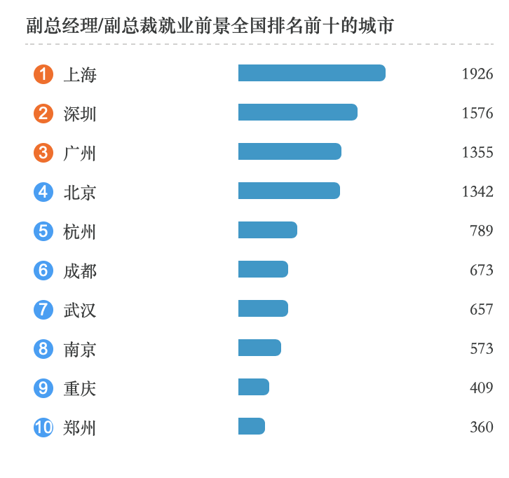 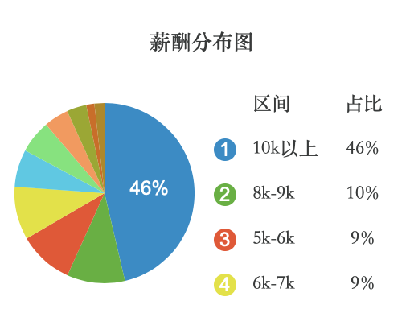source: https://www.job592.com/direction/job100521/
Compare to the China National average salary, SVP Marketing Salary tend to be paid more in well-developed cities and be paid less in secondary cities. Therefore, a great location company is an important factor for me when I choosing the job, especially in the 5-9 years when the average salary level drops sharply.

