Zhong Yiyang
I am now living in Huizhou with my family with my family when summer break started. Huizhou is a wonderful city but fewer people know it. (just like the OSU in China, although it is one of the best universities in the world, there are few Chinese know it.) Huizhou is more like a leisure city, so we can find lots of entertainment facilities. There is a basketball court in front of my apartment and I usually play basketball with my friends. That court is also the place for NBA’s fans to solve some personal problems such as Rocket fans and Laker fans will play basketball together and prove which one is better. It is so funny to see them compete because we all know whatever which one wins it will change nothing about warriors becoming champion. :P
Photo source: https://baike.baidu.com/item/惠州/1396484?fr=aladdin

In the past, I spent 6 years in one school (junior school+ high school). The funniest thing for me was waiting for the class over to be at 11. Our restaurant is not big enough to hold all school students. Therefore, we must go to the restaurant in batches. Even that, some time we had to wait for 30 minutes to get our food. Therefore, the first one who reach the restaurant could take the first meal and we thought that was a glory to get the first meal. You can see full of students run to the restaurant when the bells are ringing like zombies in Resident Evil.
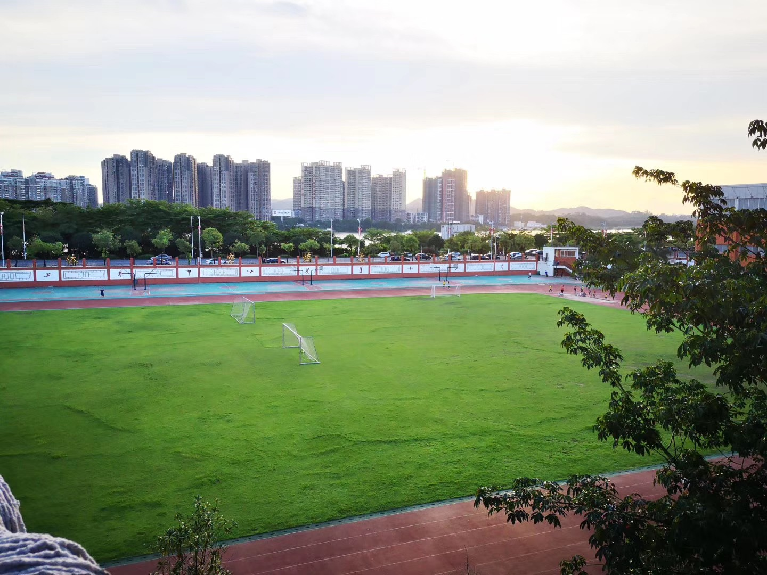 (My classroom was the furthest one and we have to run across that sports ground to reach the restaurant. Most of time we need to wait for 20-30 min to have lunch)

The reason that I choose OSU is because some China media says that OSU is one of the friendliest universities to Chinese. Most people in this university are very nice. For some political reason, Chinese international students are in an embracive situation. Wherever we go, we will meet some racists even though we want to be friend at first. That is why I chose to study in OSU and that is the only and the most important reason.
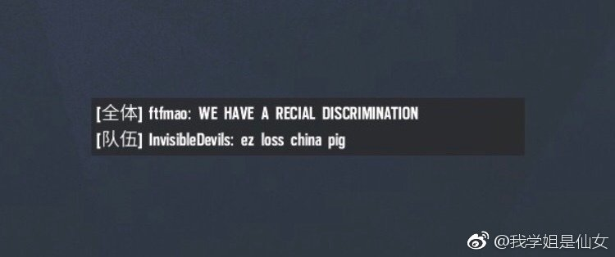 photo source: 新浪微博: @six7373

