The photo reflection
The first job is product owner. As far as I am concerned, it is a good choice for me, because I like to manage daily project goals and product schedules, adjusting expectations and setting priorities. Actually, I always help my classmates do some schedules of study and something else. I also like work with customers, stakeholders and internal teams to create and customize products. I like some other tasks, and a product owner should write and capture user stories and user needs to communicate product objectives and requirements. A product owner should schedule and lead meetings to surface issues, identify fixes and advance projects. Additionally, there is a question that how do these jobs compare to your intended major? I want to say this is my dream job. Let’s talk about the salary of this job. The average product owner in the United States earns approximately $81K per year. In my opinion, the salary of this job is not in a low level, so I can accept it. Additionally, there is a chance of making a better salary with more experience or education. The highest salary is $120,097 per year. I am satisfied with this job, because I love all of tasks of this job, and the salary is accepted. I think the level of satisfaction is more important than the salary, because if you love this job, you might not care about the salary. 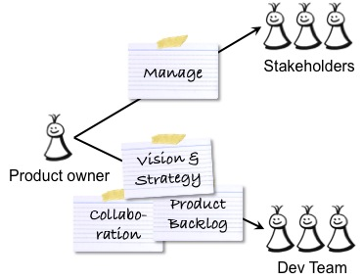
The image is the role of product owner and the image is from BAIDU Website.

The second job is senior accounting manager. Actually, I am not very satisfied with this job, because my math grade is not very good and I don’t like math very much. Although my major is economics, I still do not like this job. It requires people to count many different data. I might use much time to finish a small amount of my task. Luckily, the salary of this job is higher than many job’s salary. The average senior accounting manager in the United States earns approximately $92 per year, and people who have more experience of accounting will get higher level of salary, except somebody work in late-career. My satisfaction of this job is not vey high, because I do not love some tasks of it, such as develop, prepare and review financial statement and reports. I am interested in preparing some schedules and help somebody solve some problems. I really don’t care the salary of my job, because if you do not like a job, you will always have stress when you work. What’s more, I think that people should choose their dream. Although many people could not choose their dream job, they still should choose a job which close to it.
The image is Accounting knowledge and the image is from BAIDU Website
From what has been discussed above, we could safely draw the conclusion that I prefer to be a product owner rather than to be a senior accounting manager.

