About me
My name is Zhang Songcheng and I am from China. I was born in Wuhan, a beautiful city, but I studied in Beijing when I was a child. My father is an engineer and my mother is an accountant. Influenced by them, I am very interested in numbers and mathematics is my favorite subject. In life, soccer is my favorite sports, because not only can I make many friends with other players, but also have a strong body. My favorite food is dumplings. The meaning of dumplings in China is reunion, so eating dumplings means that I can reunite with my family.
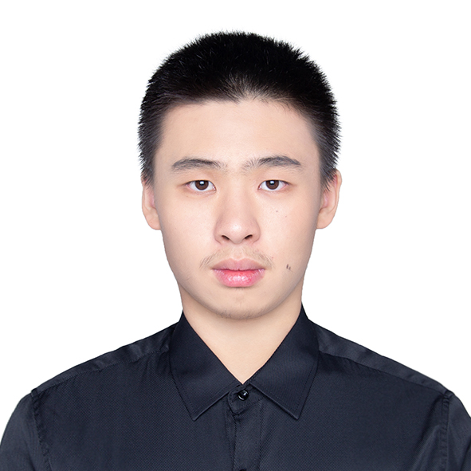

About my past
I lived in Beijing before I went to college. Beijing is a prosperous city, but it is also very crowded. (I think American people can’t imagine how crowded in Beijing). There is one thing I want to say: taking subways and buses is absolutely a very bad experience. Normally subways can’t hold so many people and everyone tries his best to get in to the subway. As a result, almost every time there's no more than one person’s space and all the people press each other in the subway. I remember that I went to The Great Wall and I can’t see anything except people.
Photo Source：https://image.baidu.com/

Why did I choose the OSU?
I had a dream to study abroad since I was a child. I want to see the world. The United States is the best choice for me, because The United States has excellent academic level, and a strong cultural inclusiveness. I think studying in the United States can help me experience different cultures and meet friends from different countries. In Ohio, I think OSU is the best for me. OSU is not only academic, but also rich in facilities. The proudest thing is that no matter where you shout O-H, someone will answer I-O.

