The first job that fits the question I answered is proofreader. These people generally help others to check the correctness and accuracy of some copywriting. In daily life, we will inevitably make grammatical errors. This is the simplest part of their work, but it is more about content modification.
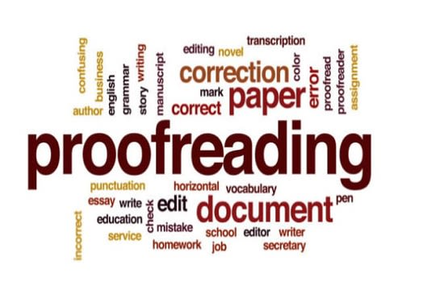
This image is from https://www.fiverr.com/desiree_hoobs/do-proofreading-and-editing-proofreading

Some of the work in my mind does not meet, or should be said to be completely out of touch. I am an engineering student personally, and I am going to study materials engineering in the future, and I am not good at grammar and the like. This kind of liberal arts is very difficult for me. I think the professional model I hope is completely different from proofreaders. I dream of being a material engineer. To develop better-performing materials requires a spirit of innovation, but proofreaders focus on details, and they also work hard on details. Things that should be paid attention to.

The average salary of proofreaders is US$42,300 a year, which is still far from what I hope to get, but overall it is still acceptable. If I get such a salary, I would be quite satisfied. I think the difference in salary for this job is relatively small, because it is a fixed mode of work and it is difficult to innovate, so the upper limit is not particularly high. I think this kind of work should also attach great importance to popularity. When a person gains prestige and reputation, everyone will rush to hire him.

The job satisfaction is 3.7/5. When converted into a percentage, it is 74%. It shows that overall it is quite satisfactory. My personal opinion on satisfaction or salary is more important: I am more inclined to choose a job with higher satisfaction when I make sure that the salary does not vary much in a grade. I think most people have such a tendency. So the priority in my mind is still a grade of salary, of course, some relatively small differences can still be ignored.

The second job I was recommended was a writer. Of course, everyone is very familiar with the profession of writers. As long as we read books or other reading materials, there will be writers. The writer is the one who creates these readings. Although writers will be urged, they have plenty of time. Generally, powerful writers have their own style and style of life.
This image is from https://searchengineland.com/how-to-create-a-style-guide-for-your-seo-content-writers-305893

The profession of a writer is still not relevant to me, because I am good at science and engineering, and I have neither such literary quality nor good writing style. In elementary, middle school and even high school, my essays were called "Liushuizhang" in Chinese by the teacher. This phrase represents a mediocre writing style, and there is no outstanding substance.
But the essence of such a job and the job I want to do is still the same, that is, creation. We must find ways to make some new things, which is also a very important part for the whole world and all mankind. So why we need to cultivate creativity can also be seen. The annual salary of such a writer is about US$50,148, which is quite satisfactory to me. I also mentioned before that I have priority over salary over satisfaction. The professional satisfaction of a writer is also a relatively high 4.1/5, which is 82% when converted into a percentage. So compared to proofreader, I hope to be a writer even though I may not develop in this direction in the end. None of us can predict what will happen in the future, and may be treated as a secondary profession, such as amateur Internet novel writers.

