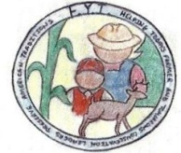Application for Participation in FYI Program
For us to help you have a positive experience in the Farmer Youth Initiative, please fill out the form below. Answering yes or no does not make you more or less eligible to participate, it just lets us know where we can help. Also, please fill out the enclosed assumption of risk form, both front and back, and return both forms.

Name: _______________________________________________________________________________
Address: _____________________________________________________________________________
Phone: ______________________________________
Date of birth: _______________________________
Guardian/Parent: ______________________________________________________
Circle one
Do you need a place to hunt? Yes No
Is there an adult family member/friend able to guide you? Yes No
Do you need to borrow a gun? Yes No
If no, what gauge firearm will you be using? _____________________________
Do you have a pair of hiking boots? Yes No
Do you have warm, winter type clothing? Yes No
What size shirt do you wear? ___________________
Is there anything else you may need?
____________________________________________________________________________________________________________________________________________________________________________________________________________________________________________________________________________________________________________________________________________________

