Rabbit & Cavy Youth Fun Show

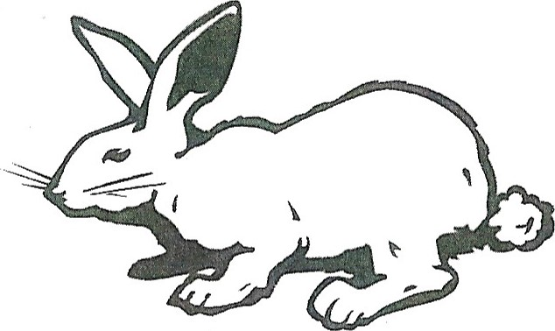
Saturday, May 11, 2019
Champaign County Fairgrounds
384 Park Ave, Urbana, Ohio 43078 Woodruff Show Arena
Sponsored by:
Champaign County Rabbit & Cavy 4-H Advisors
Registration the day of the show only
$1.50 per animal
Registration begins at 8:00 AM
Show begins at 9:00 AM
Awards for Rabbits & Cavies
Awards to be given for
Best In Show & Reserve Best In Show
Rosettes for BOB & BOSB
Plaques for Best & Reserve 4 Class & 6 Class Rabbits
Educational Show Raffle Food
All youth welcome. Do not have to be a 4-H member to participate.
Please contact the following regarding questions:
Rabbits : Carol Hunter (937) 408-6839
Cavies: Lisa Blake (937) 726-2379

