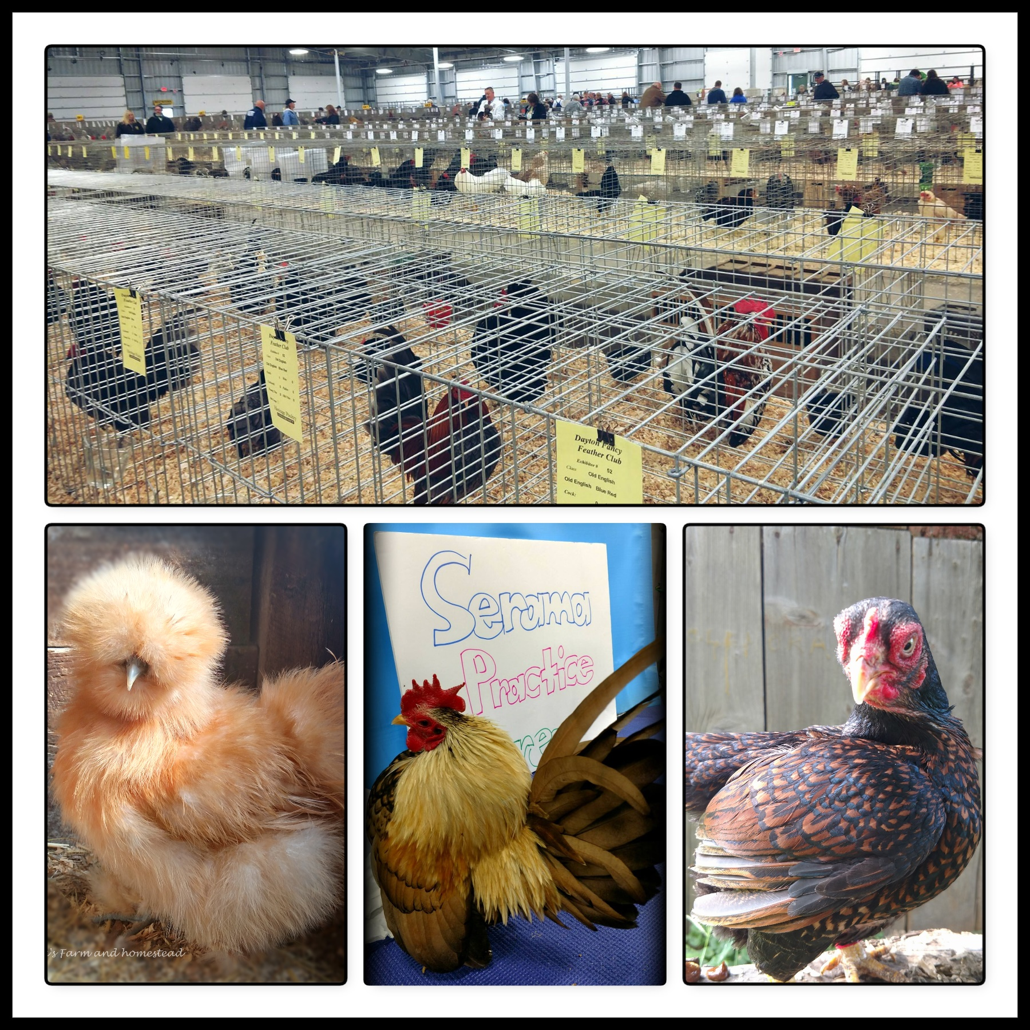  - March 30th 2019  SEOPA Spring Show  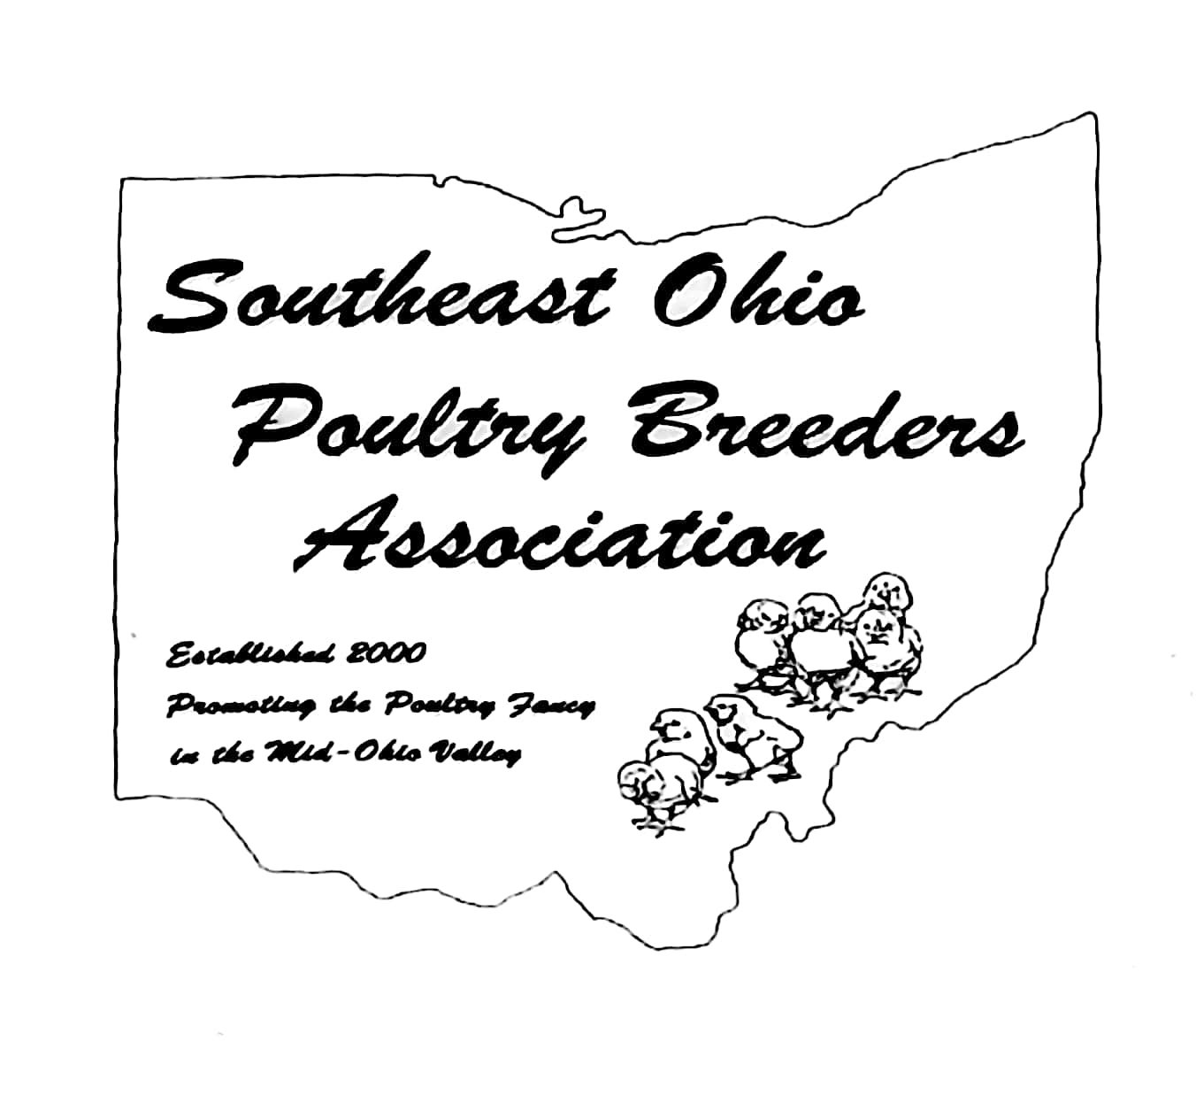  Stop down and discover the world of fancy poultry! We will be holding our annual poultry show March 30th at the Washington County fairgrounds. In addition to our APA show, there will be a Serama tabletop competition, a game bird show, and youth showmanship. **If you would like to exhibit, entries are due by March 20th . Please see our Facebook page or for a catalog contact Amber Peck 740-434-8058  *Game bird show is a drop in show, exhibitors will be responsiable for exhibition cages.  *Entries Fees are $3.50 and due March 20th 2019  *Coop in deadline March 30th at 9:00am | American Poultry Association Sanctioned Show  ____  SCNA Serama Tabletop Competition  ____  Gamebird Show  ____  Youth Showmanship Competition  ____  Sale Area, and poultry supply Vendor  Washington county fairgrounds  922 Front Street  Marietta Ohio  Telephone  FB @SEOPA  March 30th show starts at 9:00 am

