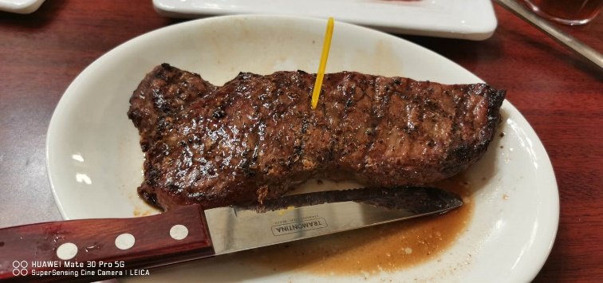
To be honest, my life has been very bad recently due to the epidemic and the relevant policies of the US and Chinese government. The announcement of the school to continue offline classes next semester. If schools plan to implement face-to-face classes offline, that's bad for international students who have already returned to their home countries but can't return to campus because of various policies, which means they have to get up at 2 or 3 a.m. to join their online in-person class. That is too bad. So many factors came together that I did not plan to return home. I miss my parents very much. When I arrived in the United States on the first day of August 3 last year, I missed my relatives very much for nearly a year. The feeling of missing someone is so hard. I now live in a rented apartment far from the school, and I do not venture out much because of COVID-19. Only occasionally leave the house at 6 a.m. to run a few laps around the apartment. I really hope this outbreak ends soon, since moved to this apartment at the end of March this year. I really miss all the food in Kennedy Traditions.

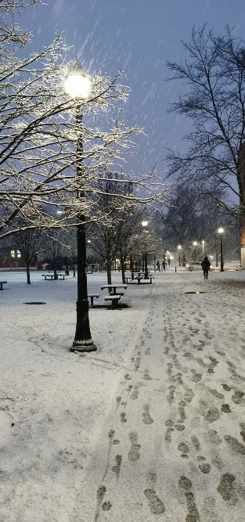
I come from China and live in Zhengzhou, the capital of Henan Province. My primary school, junior high school and senior high school were all completed in Zhengzhou. Although it is a city in temperate zone, the temperature in Zhengzhou rarely drops below 0° in winter due to the city thermosyphon effect. (The simple explanation is that the temperature in the city is relatively high and difficult to cool down, and the cold air around the city will take advantage of the density difference between the cold air and the hot air, so that all the hot air will gather in the city) Zhengzhou has an average temperature of 104℉ in summer. When I arrived in Ohio, I immediately fell in love with its cool summer air. But the following winter I really did not like it. Maybe it was because it was the first time I lived alone and could not take good care of myself. I had a cold all last winter. This seriously affected my studies, and I was taking the course in 1901. Unfortunately, I did not get a good result due to my body problem. Therefore, I plan to take this summer school time to retake this course.

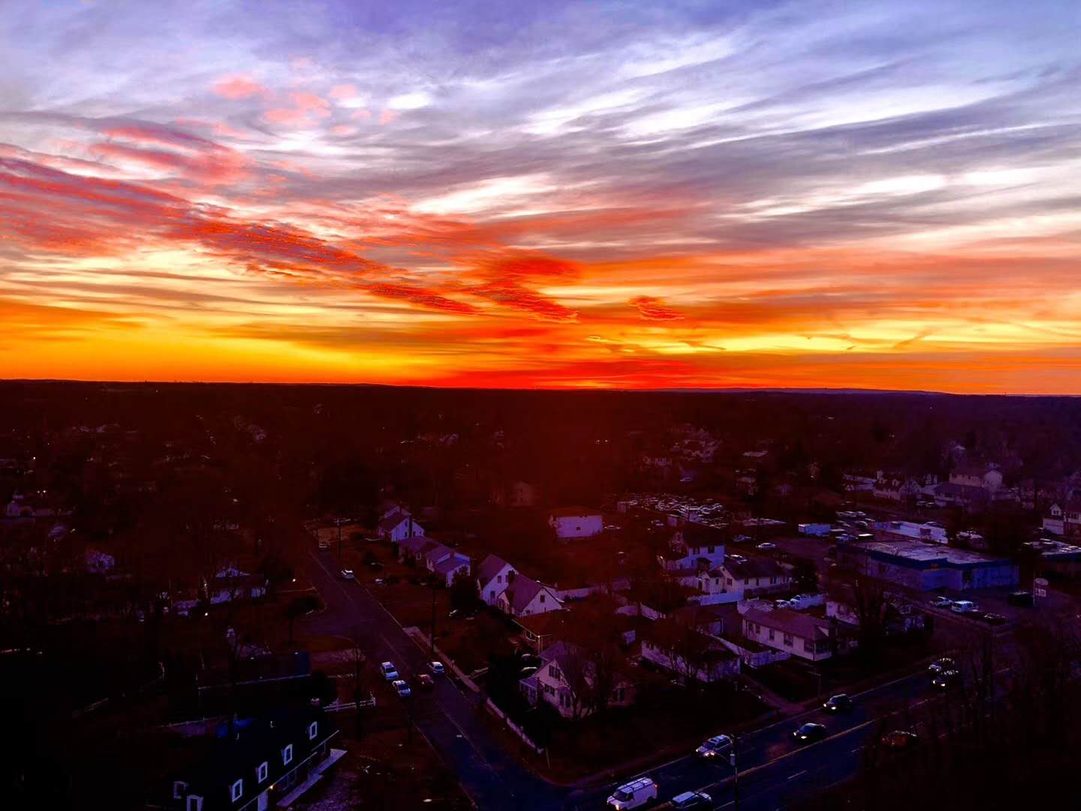
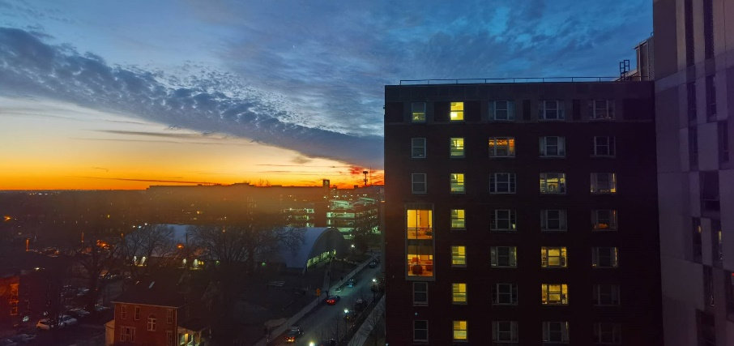
I chose Ohio State university for the simple reason that it accepted me and I also like the super big campus. I like to wander around the campus aimlessly when I am free. In addition, two of my best friends from high school also chose this university. So we came to this school together. At the same time, I also believe in the international academic reputation of this school. Now I have been living here for almost a year. I think I am very happy here, and I have made some interesting American friends, which makes me feel like I'm getting used to living in America. I like it here. It proves that I made the right choice.

