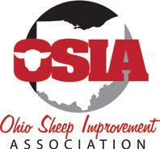
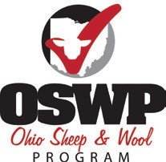
Buckeye Shepherd’s Symposium
Friday, Dec. 4, 2020
2:00-5:00 p.m. Zoom Webinar
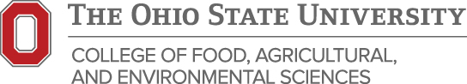
Event Schedule

2:00 p.m. Webinar Welcome

2:05 p.m. Feed Processing, Digestive Upset, and Observations During Feeding
Dr. Francis Fluharty- Animal Science Professor and Department Head, University of Georgia

2:45 p.m. Ohio State Fair Inside Look at Lamb Carcass Evaluation
Tim Barnes- OSU Extension, Ohio Ag Net, Ohio Country Journal, & Studio 149

2:50 p.m. Break

3:00 p.m. Feeding Wet Forages- Considerations for Sheep
Garth Ruff- OSU Extension Beef Cattle Field Specialist

3:40 p.m. Ohio State University Sheep Research Video Update
Brady Campbell- Ph.D. Student | Program Coordinator & Christine Gelley- OSU Extension

3:55 p.m. Break

4:00 p.m. Minerals and Vitamins for the Ewe Flock
Dr. Francis Fluharty- Animal Science Professor and Department Head, University of Georgia

4:55 p.m. Closing Statements

5:00 p.m. Webinar Concludes

Register online for no cost to receive the webinar connection information through email.

Visit https://go.osu.edu/ohiosheep to register!

Additional Events Following

5:00-5:30 p.m. OSIA Annual Meeting and Election

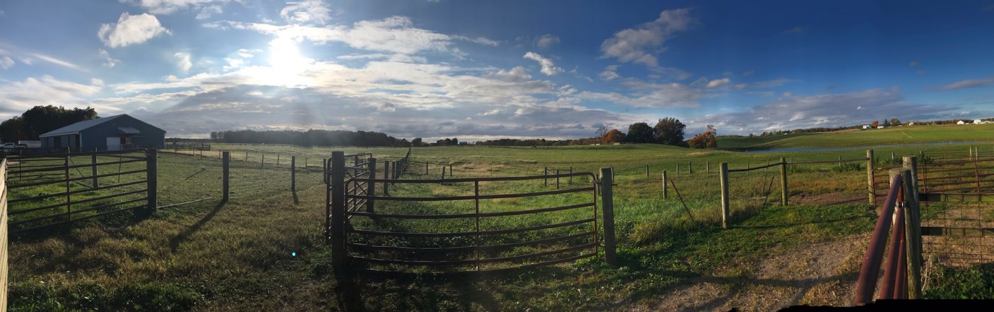
7:30 p.m. Virtual Shepherds’ Social Hour

