McKenzie Scott
Professor Nancy Johnson
English 2367.01H
28. April 2017
Not-So-Sweet Dreams:
Why Sleep Deprivation is a Major Problem for High School and College Students

With a gratifying last few strokes on my keyboard, I had finally finished my ten-page research paper for my Environmental History class. I’d been working on it for a while, but I finally had time to finish it tonight. Good thing, too, because the following day was packed—first my German class at eight o’clock sharp, a doctor’s appointment to refill a prescription, then Art and English classes, a meeting with my advisor, a study session for Statistics, band rehearsal in the evening, and a scholarship application I needed to finish after I made it back to my dorm.
I closed out my Word Document as I looked at the time at the top of my laptop: 1:47 am.
My bleary eyes blinked wide open for a moment as I realized how late it was. I’m usually pretty good about going to bed by midnight on the nights before my early classes, but I had been so focused on finishing my paper that I hadn’t looked at the time in a while. I knew I had to go to bed, but I had planned on looking over my Statistics notes ahead of the next day’s study session.
Maybe I’ll go to bed after studying a few chapters of my notes, I thought as I sighed and opened a new tab on my laptop to type in statistical formulas and concepts.
I’m sure many—if not most—college students can relate to this recent Wednesday night. I’ve only had a few nights that were this hectic, but for many students this is a much more frequent occurrence. Busy days full of classes, meetings, and activities can leave little time for doing homework, so many students sacrifice precious hours of sleep in order to finish up any assignments or to catch up on social media. As a result of academic and social pressures and other sources of stress, researchers say that sleep deprivation is on the rise among high school and college students, and it can result in difficulties with focus, memory, and learning, in addition to serious health and emotional problems in the future. Because of the physiological risks, mental health problems, and other concerns that arise from an insufficient amount of sleep, I think high school and college students would benefit from later class start times. In addition, there are individual changes we can make in our routines to sleep better, such as putting our phones away before bed or trying not to rely too much on coffee to wake us up.
Overwhelming feelings of stress and exhaustion can occur as a result of sleep deprivation. (Source: https://www.pinterest.com/cgtwang/phd-supervision/)

So why is sleep deprivation is so prevalent among teens and young adults in the first place? It turns out that there are inherent biological differences in the way adolescents experience sleep as compared to older adults, as a result of developmental changes that are still occurring in their brains until they reach their mid-twenties (Hershner and Chervin). These changes take place in our brain’s sleep-regulating mechanisms that control when and for how long we sleep—known as sleep/wake homeostasis and our internal circadian rhythm (National Sleep Foundation). Sleep/wake homeostasis is a restorative cycle that allows us to balance the amount of time we are awake with the amount of time we need to sleep, while our circadian rhythm is a biological clock that cycles roughly every twenty-four hours, regulating the times of day at which we feel tired and awake (National Sleep Foundation).
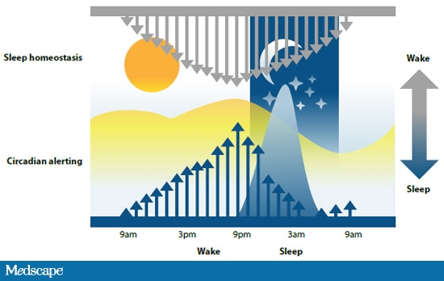
A visual depiction of the sleep/wake homeostasis and circadian cycles. (Source: http://bedroom.solutions/science-sleep-know-defines-sleep/)

According to research, it appears that teens’ circadian rhythms and homeostatic sleep drives change significantly after puberty as a result of developmental and hormonal changes, causing sleep cycles to shift due to the delayed release of the sleep-inducing hormone melatonin (Richter). For example, the circadian rhythm of older adults lasts around 24.1 hours (Hershner and Chervin), which generates feelings of tiredness earlier in the evening. In addition, their higher homeostatic sleep drives means their brains signal a need for sleep by releasing melatonin earlier, resulting in earlier bed times and wake-up times among adults (National Sleep Foundation). However, in younger adults, a longer circadian rhythm lasting 24.27 hours on average (Hershner and Chervin) means that their brains initiate feelings of tiredness around two to three hours later in the evening than in adults, causing a shift to later bed times (National Sleep Foundation). On top of this, their homeostatic sleep drives, while lower in the evening, are much higher in the morning than those of older adults, resulting in feeling an intense need to sleep well past 7:00 or 8:00 (National Sleep Foundation). As a result of developmental shifts in their sleep cycles, it appears that teens and college students are predisposed to stay up later and sleep in later, making it harder to operate on a schedule geared towards the early mornings reflective of the sleep cycles of older adults.
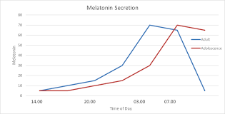
Differences in melatonin release times between teenagers and adults. (Source: http://publish.ucc.ie/boolean/2015/00/ONeil/34/en)

While it seems that young adults feel the need to sleep later at night than older adults, many aren’t getting enough sleep in the first place. According to experts, full-grown adults need six to ten hours of sleep every night, but teens and college-aged adults should aim for eight to nine hours (University of Georgia). On average, college students get from 6 to 6.9 hours of sleep on weeknights (University of Georgia), but a recent study shows that here at Ohio State, students sleep for 6.96 hours on weekdays and around 7.29 hours on weekends (Wilt). It looks like Ohio State students sleep for a little longer than average, but we’re still not getting enough sleep.
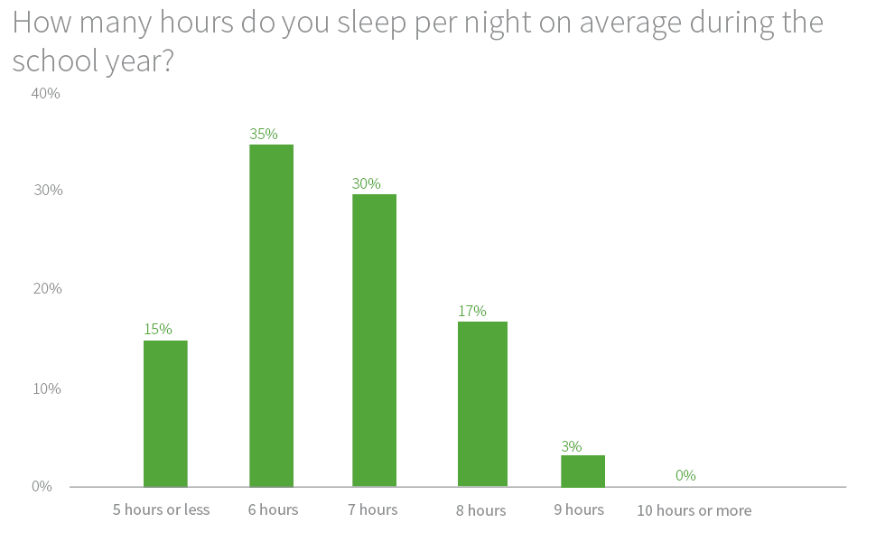
Average hours of sleep among college students, as reported in one poll. (Source: https://ink.niche.com/sleeping-habits-american-college-student/)
Putting aside the biological differences in the sleep patterns of adolescents, there are several other factors that could help explain why so few of us are getting enough sleep. A significant reason is an intense social pressure to succeed academically while also pursuing well-rounded interests and extracurricular activities, an experience that a majority of high school and college students report feeling (Richter). A common mindset among college students is that “Overwork is good work” (Hong), explaining why many of us seem to feel that the less sleep we get, the more homework we can get done. In addition, high schools and universities make it a priority to encourage students to get involved and to be a part of multiple student organizations, and students often report that sleep is the first thing they will sacrifice when they’re overwhelmed with too much going on (Richter).
Too much caffeine intake and late-night technology use are other causes of sleep deprivation. As a natural stimulant, caffeine can increase alertness and make it difficult to fall asleep, evident in a study that found students who reported drinking coffee in the afternoons and evenings experienced poorer sleep quality than those who only drank coffee earlier in the day (Hong). Many students fall victim to drinking caffeinated beverages at night to provide a boost of energy while trying to stay awake and study, but this late-night coffee consumption turns out to cause more sleep deprivation. It is also common among teens and college students to spend time scrolling through social media right before bed, which is another factor that tends to cause poorer sleep. The blue light coming from the screen of a phone or another device can suppress the release of melatonin in our brains, causing us to feel more awake and results in difficulty falling asleep or waking up multiple times throughout the night (Hershner and Chervin).
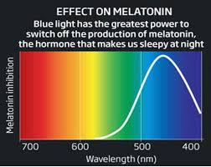
How blue light inhibits melatonin production. (Source: https://medium.com/@jubishop/how-to-get-better-sleep-fcb74f4df0b5)

So what are some of the effects of sleep deprivation? There are several consequences of not getting enough sleep, and while some appear to be minor problems, some effects can result in severe complications and disorders. Short-term effects of sleep deprivation can include headaches, irritability, forgetfulness, confusion, distractedness, and worsened performance in tasks that require concentration (Hocking). During sleep, our brains replenish neural pathways and build proteins to help repair damaged cells (Pietrangelo), so if we don’t get enough sleep, neural signals can’t travel as efficiently because the pathways have not been sufficiently restored, causing a loss of focus and distractedness. Such confusion and lack of focus could lead to car crashes or other accidents and injuries that could result in death. Another major consequence of not getting enough sleep is weaker immune responses to pathogens—because as we sleep, our immune systems develop disease-fighting antibodies (Pietrangelo). Less sleep means less time for our immune system to build up defenses against diseases and pathogenic invaders, resulting in increased difficulty of fighting off even a simple cold. Sleep deprivation can also contribute to obesity, due to the fact that lack of sleep increases insulin production, which in turn promotes fat storage and can increase one’s risk for developing high cholesterol, high blood pressure, Type II diabetes, cardiovascular disease, and stroke (Pietrangelo). Aside from the physical effects of sleep deprivation, a lack of sleep can also promote the onset of mental health problems such as chronic stress, anxiety, depression, hallucinations, paranoia, and other conditions (Pietrangelo).
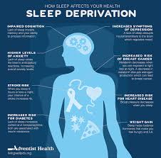
Some of the various health problems that sleep deprivation can cause. (Source: http://livingwellpdx.adventisthealth.org/sleep-deprivation-how-sleep-affects-your-health/)

It appears that a lack of good quality sleep can quickly cause a myriad of serious health problems, but it’s not as hard as many think to get better sleep. While many college students have poor sleep hygiene, there’s many ways that we can implement routines that allow us to make the most of our sleep. For example, most experts recommend that we put away our screens at least one hour before bed so that we don’t expose our brains’ visual receptors to artificial light, in addition to abstaining from caffeine or other stimulants (such as nicotine) within four hours of bedtime (Breus). Specialists also encourage keeping distractions away from the bedroom—no watching television or eating in our beds—because such distractions could cause our brains to associate our bed with other activities instead of sleeping, which may make it more difficult to fall asleep (Breus). Napping extensively during the day is another example of poor sleep hygiene, because it makes it harder for us to feel tired when we actually need to sleep (Breus).
While these tips are all great ways to promote better sleep, there are some solutions to sleep deprivation that could be applied beyond an individual basis. Recently, several school districts throughout the country have experimented with later start times in high schools to encourage increased focus and alertness among students. While starting school an hour later doesn’t seem like it would make much of a difference, students in schools outside of Minneapolis reported feeling less drowsy and more focused in classes throughout the day after the district shifted start times from 7:20 to 8:30 (Richter). In addition, a 2014 study in Virginia found that students at high schools with later start times were less likely to be involved in car crashes on the way to school than students who started class at earlier times (Richter). In my central Maryland school district, our Board of Education has talked about moving the start times of high schools to 8:00, but unfortunately that hasn’t happened yet. However, one day I hope high schools and colleges around the nation can agree to start classes no earlier than 8:00 or 8:30.
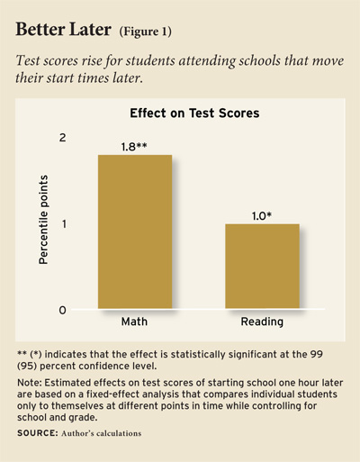
How test scores can be positively impacted by later start times in schools. (Source: http://educationnext.org/do-schools-begin-too-early/)

It’s clear that there are many causes and consequences of sleep deprivation among students, and in most cases, it’s impossible to place all of the blame on just a single factor. Personally, pressure to succeed and to complete all my assignments is one of the biggest reasons why I sometimes stay up later than I should—this paper itself took me until eleven o’clock at night to finish. But while there are many different reasons that cause us not to get enough sleep, there are also many ways that we can develop better sleep habits. And if students experience difficulty in trying to get better sleep, there are plenty of resources and services that can connect students to specialists who may be able to provide medicines or psychological advice. Ohio State’s Counseling and Consultation Services can be reached at (614) 292-5766, and they are well-trained to deal with students’ difficulties with sleeping problems and other concerns. In my experience, I’ve been prescribed a small melatonin supplement I take an hour before bed, which helps me relax after a busy day. So I’d encourage anyone to talk to someone or to think about individual habits they could change, because everyone deserves better sleep and sweeter dreams.

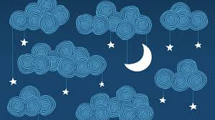
There are several solutions to help us get better sleep and sweeter dreams. (Source: http://english.alarabiya.net/en/variety/2016/06/29/Life-coaching-Nine-habits-for-deeper-sleep-if-you-suffer-from-insomnia.html)

Works Cited:
Breus, Michael J. "How to Sleep Better." WebMD. Sound Sleep , 2004. Web. 09 Apr. 2017. <http://www.webmd.com/sleep-disorders/features/sleep-hygiene#1>.
Ann, Pietrangelo. "Effects of Sleep Deprivation on the Body." Healthline. Healthline, 19 Aug. 2014. Web. 09 Apr. 2017. <http://www.healthline.com/health/sleep-deprivation/effects- on-body>.
Hershner, Shelley D., and Ronald D. Chervin. "Causes and Consequences of Sleepiness Among College Students." Nature and Science of Sleep. Dove Medical Press, 2014. Web. 09 Apr. 2017. <https://www.ncbi.nlm.nih.gov/pmc/articles/PMC4075951/>.
Hocking, Chris . "The Immediate, Short-Term Health Effects of Sleep Deprivation." Optalert. Optalert, 09 Nov. 2016. Web. 09 Apr. 2017. <http://www.optalert.com/news/short-term- health-effects-sleep-deprivation>.
Hong, Justin . "Caffeine and College, Do They Go Hand in Hand." Student Health and Counseling Services. University of California Davis, 26 July 2016. Web. 09 Apr. 2017. <https://shcs.ucdavis.edu/blog/healthy-habits/caffeine-and-college-do-they-go-hand- hand>.
Richter, Ruthann. "Among Teens, Sleep Deprivation an Epidemic." Stanford Medicine News Center. Stanford University , 08 Oct. 2015. Web. 09 Apr. 2017. <https://med.stanford.edu/news/all-news/2015/10/among-teens-sleep-deprivation-an-e pidemic.html>.
"Sleep Drive and Your Body Clock." National Sleep Foundation. National Sleep Foundation , n.d. Web. 09 Apr. 2017. <https://sleepfoundation.org/sleep-topics/sleep-drive-and-your- body-clock/page/0/1>.
"Sleep Rocks! ...Get More Of It!" University Health Center. The University of Georgia, n.d. Web. 09 Apr. 2017. <https://www.uhs.uga.edu/sleep>.
Wilt, Brian. "How University Students Sleep." The Jawbone Blog. Jawbone, 02 June 2016. Web. 10 Apr. 2017. <https://jawbone.com/blog/university-students-sleep/>.

