Wait on crosswalks
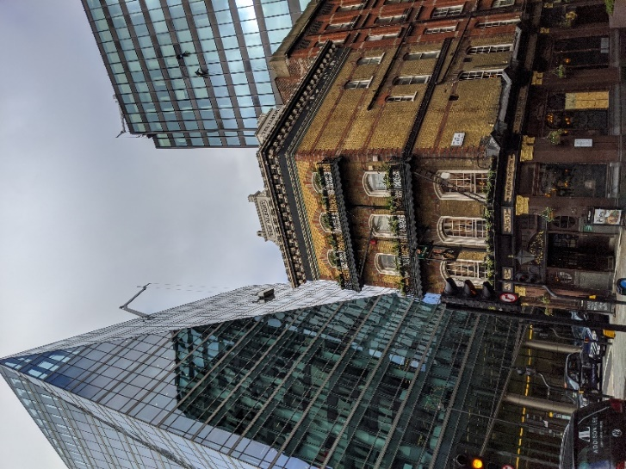
No, this is no reproach to Dr. Cogan, but what I would like to say is: it is okay to slow down for a while because it is not necessarily pausing, it is rather discovering new things that may have been missed. It is worthwhile to take a very deep look at the pictures you took!

Nullius in verba

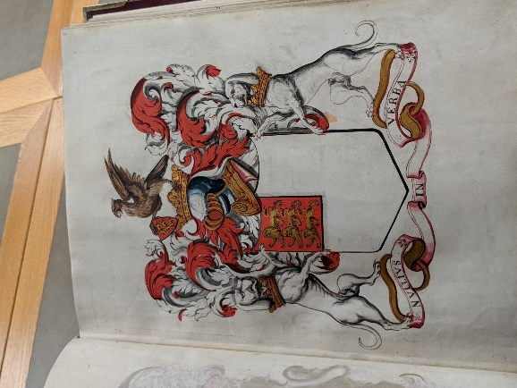

The year 1660: After the middle ages and before social media.
What a brilliant idea: the white space represents scientific knowledge to be discovered. It reminded me of the commencement speech by Dr. Anthony Fauci in 2016 at OSU: he used the term of the “mosaic of knowledge” – so much to be discovered, but read for yourself: https://kb.osu.edu/bitstream/handle/1811/77359/1/ARV_Commencement_2016_Spring_Fauci.pdf

Carnivores, pollination, phototropism

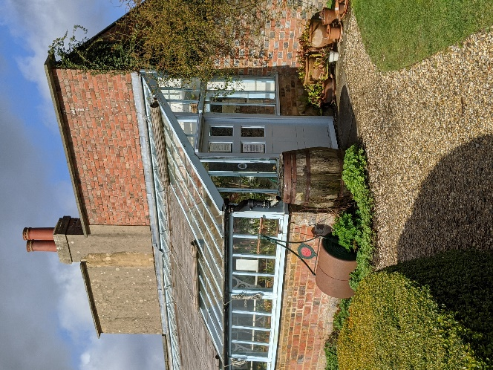

There are three sections in Darwin’s green house, each with different temperatures and humidity. In the first section he studied plants that trap and digest insects, to use as a source of nitrogen. He used the local tiny sundew plant (Drosera rotundifolia) as a carnivorous plant. To study pollination he used orchids. In the third section of the greenhouse, he and his son Francis, investigated the movement of plants towards light. They published their work (The power of movement in plants) and Dr. Hamel told me that they suspected a chemical that was responsible – now we know that this chemical is the plant hormone auxin.

