Patricia Perez Eustaquio
Patricia Perez Eustaquio is a Filipino multimedia artist who uses a wide range of materials and techniques to explore fields of art, design, craft, and fashion. As an emerging artist, she made a name for herself by creating sculptural art that could be worn as clothing, and since then has created sculptures made of cardboard, draped fabric, metal, even plastic plants and PVC pipes. All her work, like these sculptures, have unexpected details: paintings on uniquely shaped canvases and metal sheets, graphite drawings with gold leaf accents, or mirror pieces stuck on fabric, to name a few. She also uses wrought objects, such as furniture, textiles, glasswork, and tapestry in her installations alongside these paintings and drawings, demonstrating that she is talented in every field she applies herself to; that she does not have a particular niche she settles into, but constantly is trying out new ideas with new materials, exploring the art world boldly, and in turn, creating a beautiful array of artwork.
I was drawn to Patricia's work because of the similarities I saw between her art style and my work. In my work, and especially in the collage project - I use a mostly black and white color scheme, with abstract shapes and close-up details. I enjoyed taking representational art and transforming it into abstract shapes. I was extremely impressed with Patricia’s work because of the unique shapes of her canvases: sometimes sharp and angular, other times wavy or floral. I was intrigued by how she used shading and abstract shapes to create form and movement, and how the limited color palettes she works with somehow made them pop even more. Finally, I was really inspired by the materials used, as I would never think to put oil on aluminum sheets or to incorporate gold leaf. I was immediately drawn to her work - and am excited to study her work more.

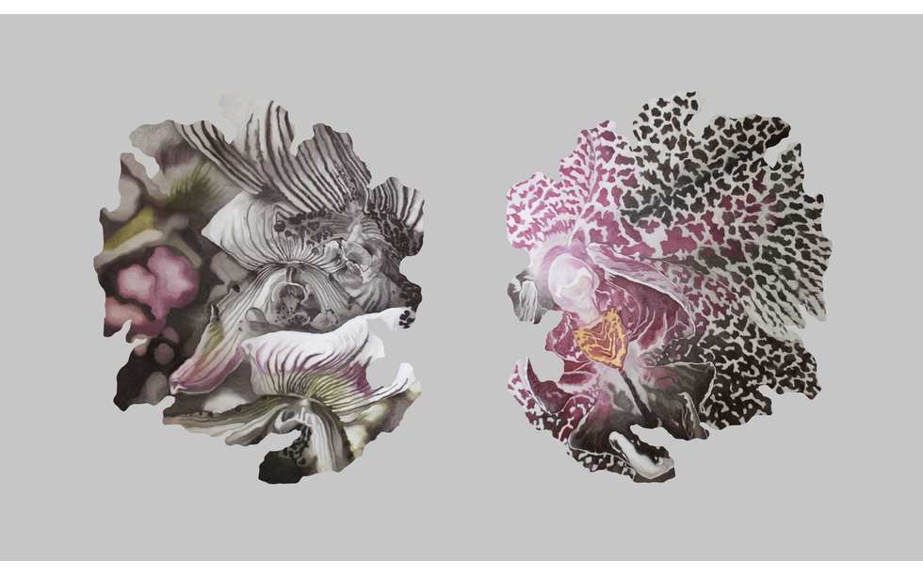

“The Hunters Enter the Woods” by Patricia Perez Eustaquio
https://www.artsy.net/artist/patricia-perez-eustaquio

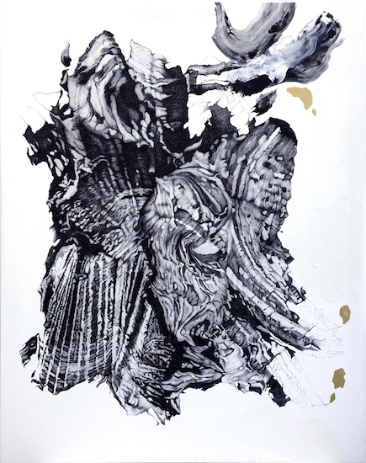

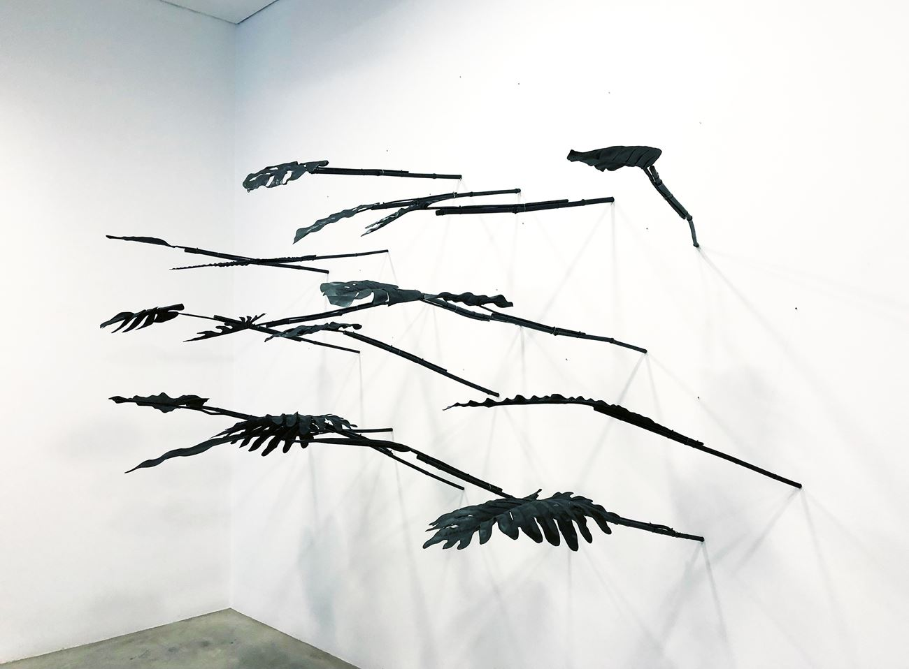

“Land!” by Patricia Perez Eustaquio (Left)
https://ocula.com/artists/patricia-perez-eustaquio/

“Archipelago 6” by Patricia Perez Eustaquio (Right)
https://ocula.com/artists/patricia-perez-eustaquio/

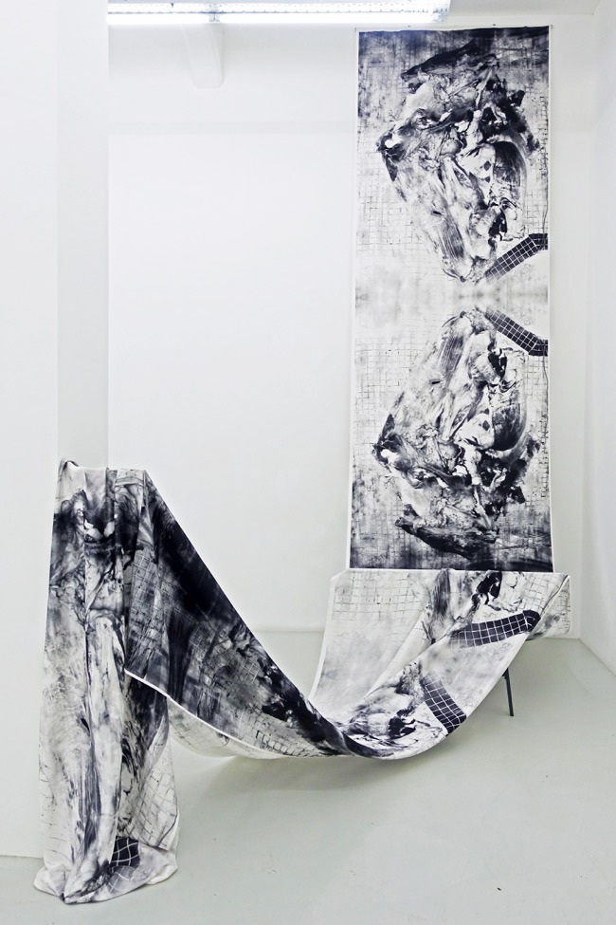
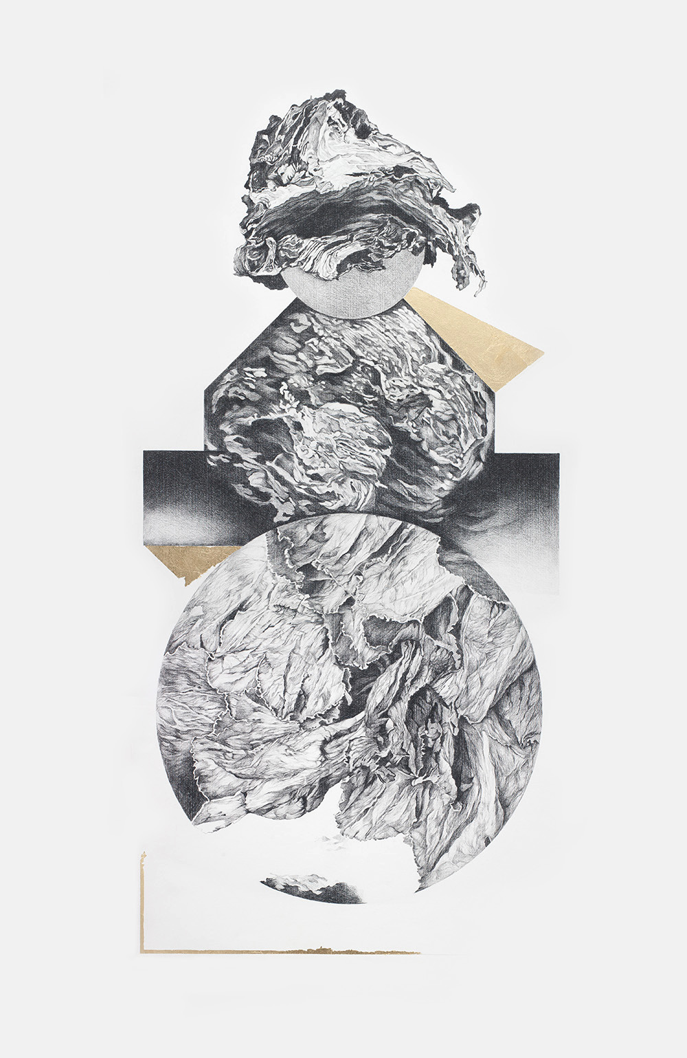

“Figure Babel 10” by Patricia Perez Eustaquio (Left)
https://www.silverlensgalleries.com/artists/patricia-perez-eustaquio

“Untitled (Carcass)” by Patricia Perez Eustaquio (Right)
https://www.silverlensgalleries.com/artists/patricia-perez-eustaquio

Works Cited
“Patricia Perez Eustaquio”, Yavuz Gallery,
https://www.yavuzgallery.com/artists/patricia-perez-eustaquio/
“Patricia Perez Eustaquio”. Ocula, https://ocula.com/artists/patricia-perez-eustaquio/
“Patricia Perez Eustaquio”. Tyler Rollins Fine Art, http://www.trfineart.com/artist/patricia-perez-
eustaquio/#artist-works

