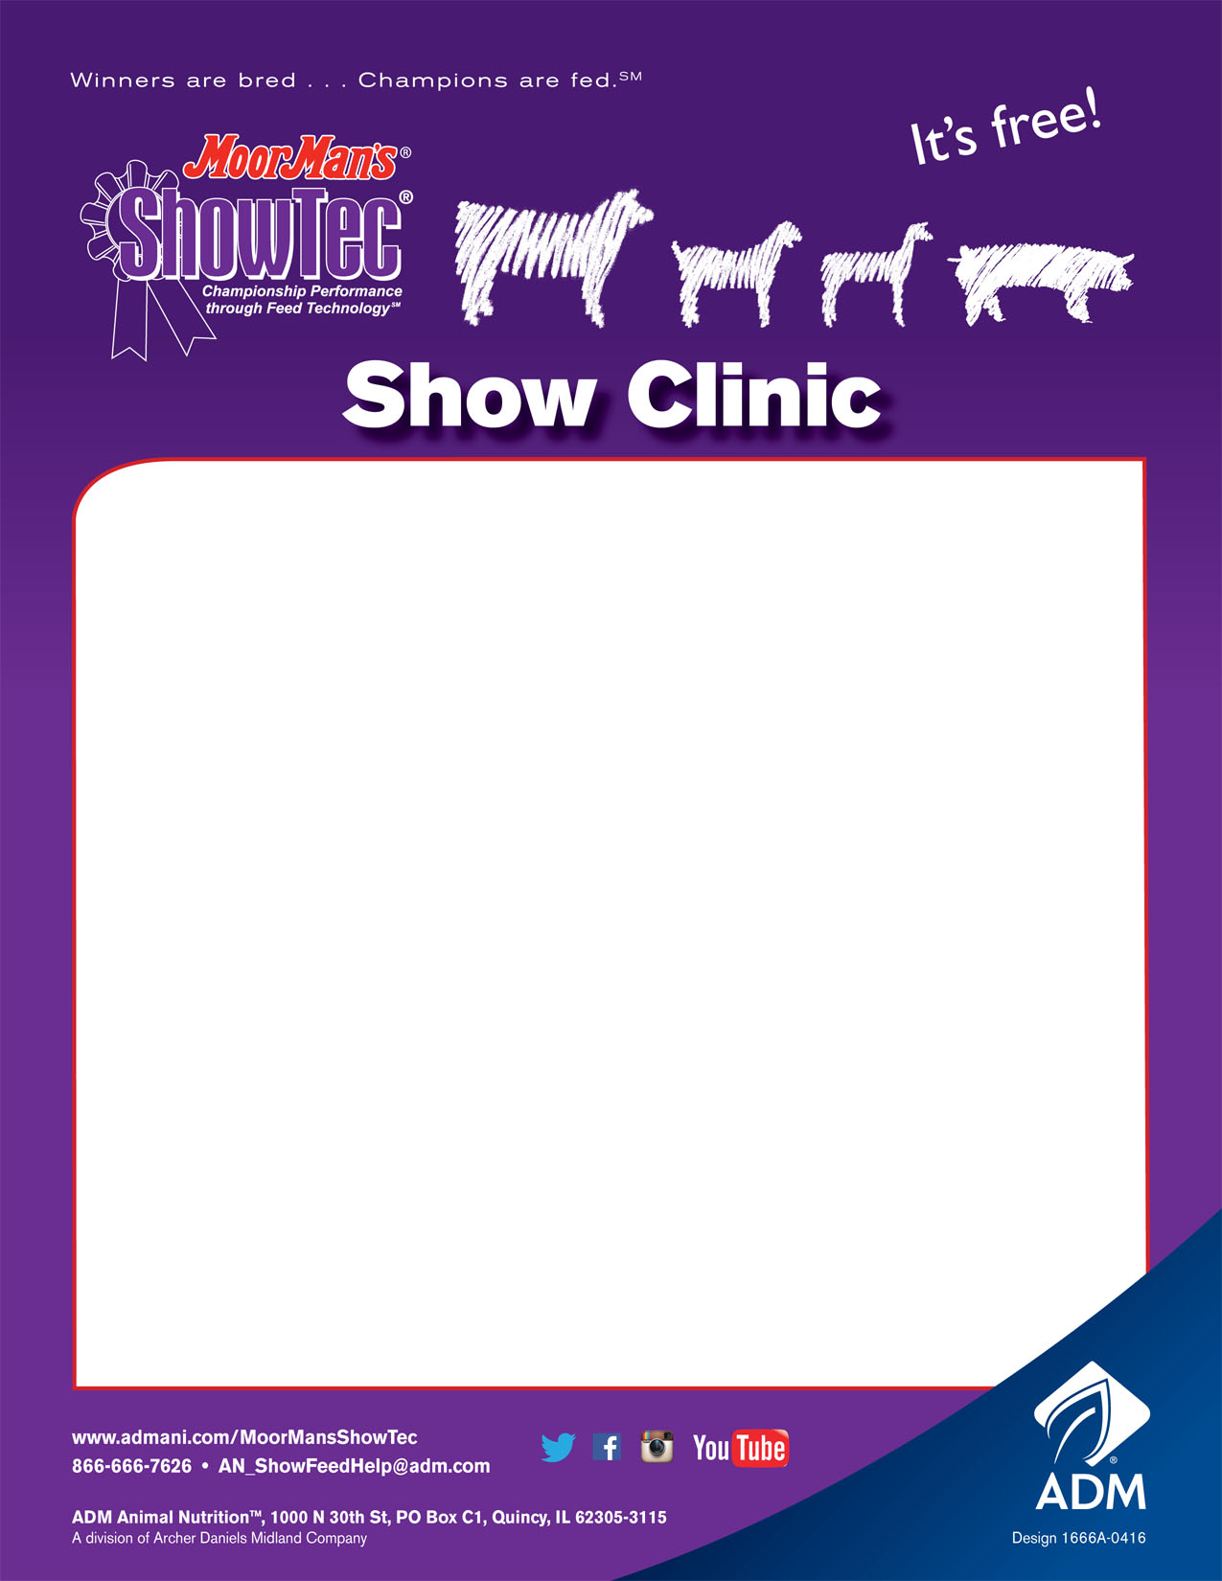

When: Monday, March 20, 2017

Where: Suffield Town Hall

1262 Waterloo Rd.

Suffield (Mogadore), OH

Time: 7:00 pm

Topics: Nutrition and management of show

Pigs, lambs and goats

Speaker: David Brainard - ADM Animal Nutrition

**We will also be answering questions about the Veterinary Feed Directive and talking about management and nutritional tools to help with herd health.**

RSVP if possible to: linda@dusselfarm.com or 330-673-5957

*Hosted by Dussel Farm Feed Store*

*1109 Old Forge Rd. Kent, OH 44240*

*330-673-5957*