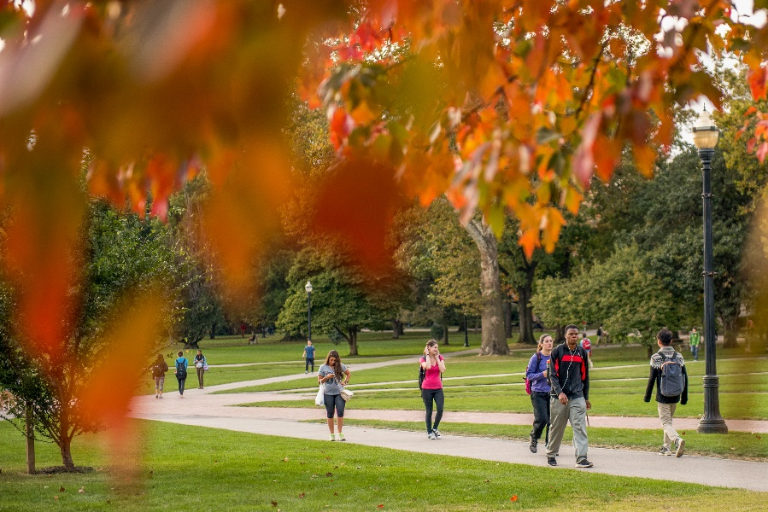
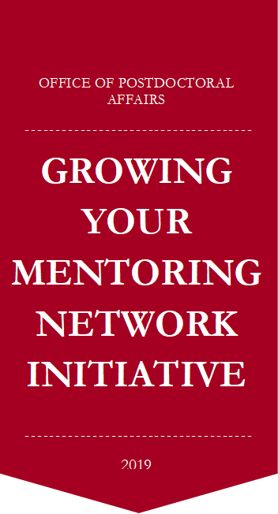
How did you meet | When did you meet | Name of the new network member | Title of the new network member
Conference (Non-OSU)
Linked-In
At an Ohio State event
Through a collaboration
Through another professional network
Through your advisor
OPA’s Lunch with a Professor program
At another OPA or PDA event

