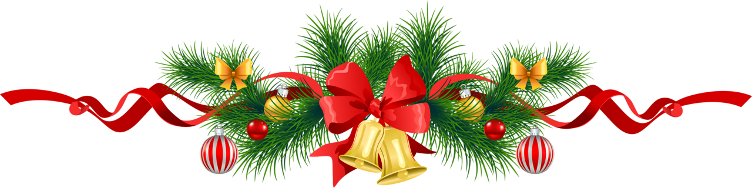
Happy Holidays!

November 1, 2019

Dear residents of New Vienna,

It is time to take part in helping us plan the Second Annual 2019, “New Vienna Christmas Parade!” The New Vienna Community Center is excited to continue this new event within our town, Clinton County and surrounding areas. The parade will be held on Saturday, December 7th at 530 pm. We encourage your support and participation!

Following the parade, we invite everyone to the New Vienna Community Center to warm up! Santa and Mrs. Claus will be in attendance! Children will be able to visit and have pictures taken with Santa. Cookies, hot chocolate and refreshments will be provided. We are also going to be offering cups of soup as part of our “free will food donation”.

Criteria of the parade entries will be judged upon Christmas spirit, pride, the use of colors, artistic beauty, costuming and the use of lights. Originality, creativity rider personnel, and the overall visual appeal, are what give a night parade its festive beauty. You may determine the content of your entry, but you must follow our “Christmas” holiday theme.

We hope that you will join us by participating in this festive night of celebration!

Sincerely,

The New Vienna Community Center
Planning Committee

