Reporting in OnCourse
There are several reports that you can run in OnCourse. They can be found by selecting the “Reporting” page from the red navigation bar. Some reports require additional permissions to access, please email oncourse@osu.edu for more information. The reports use the same structure as Advanced Search but they also pull additional details than what you will find in Advanced Search.
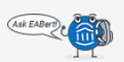
Each report has a “Report Information” section at the top of the page that will explain the function of the report as well as what data will be pulled. Within the “Report Information” you will also see EABert (pictured below).
Hovering over EABert with your mouse will bring up a list of questions that the report might help you answer.

Report Spotlight
Appointments
This report will show any appointment created by a user within the platform.
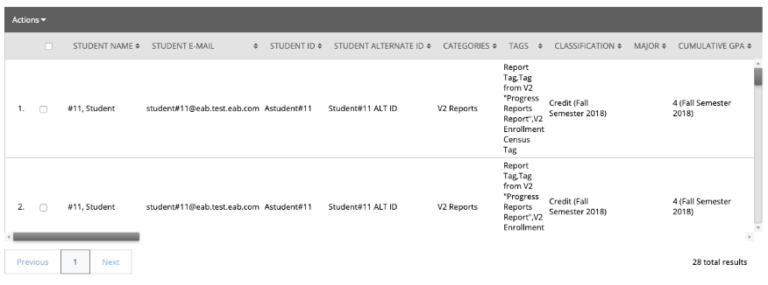
Appointment Summaries
This report will show any appointment summary created by a user within the platform. Note that an appointment can be either a scheduled or drop-in interaction with a student.
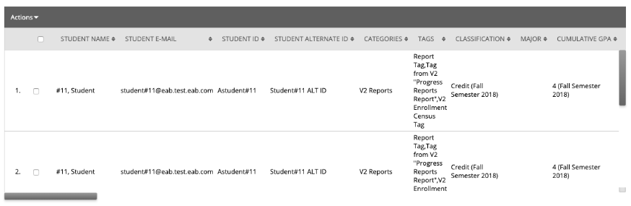

Notes
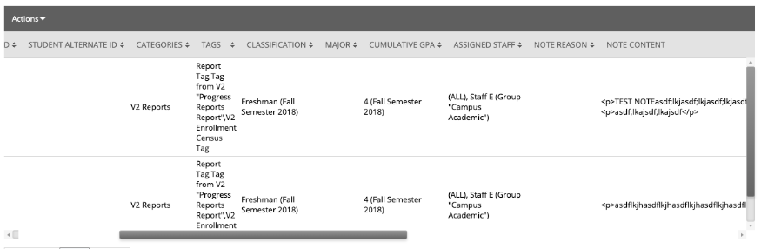
This report will show any note created by a user within the platform.

Progress Reports
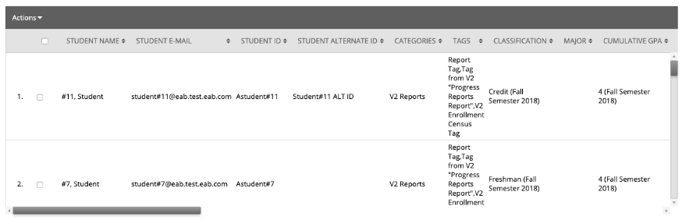
This report will show any Progress Reports and Progress Report responses created by a user within the platform.

Student Info
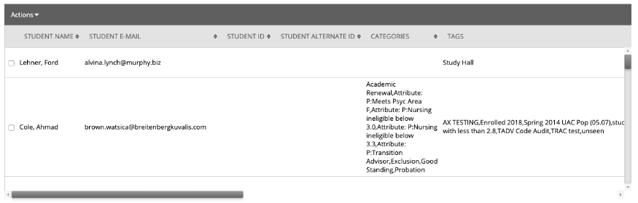
This report will show general information for students in the platform. It will also show if the student can receive SMS communications from the Navigate short-code or a telephone number from the pool.

