Analytics
The analytics section of OnCourse houses multiple dashboards that summarizes various data sets that can be filtered. The following three dashboards will most likely be the most beneficial to you in your ambassador role. To access analytics, additional permissions are needed. Please email oncourse@osu.edu for more information.

Population Health Dashboard
The Population Health Dashboard (PHD) helps you to manage student success by identifying student populations in need of interventions and to determine sub-populations within that group who may need specific types of interventions to succeed at your institution. From PHD, you can download lists of students in need of intervention to use in campaigns, to create caseloads for your student success staff, and to provide snapshots of performance against goals and key performance indicators for your institution.
The PHD has three tab options at the top of the page: Overview, Academic Performance, and Academic Progress

Overview
This section shows broad totals for the population selected. To filter the population, use the options on the left of the page.

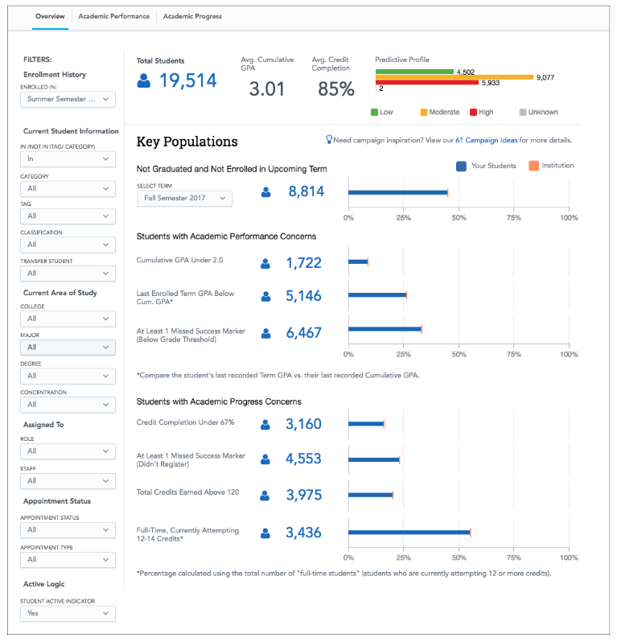

Academic Performance
This section shows academic specific breakdowns for the population, such as GPA, changes in GPA, and course performance.
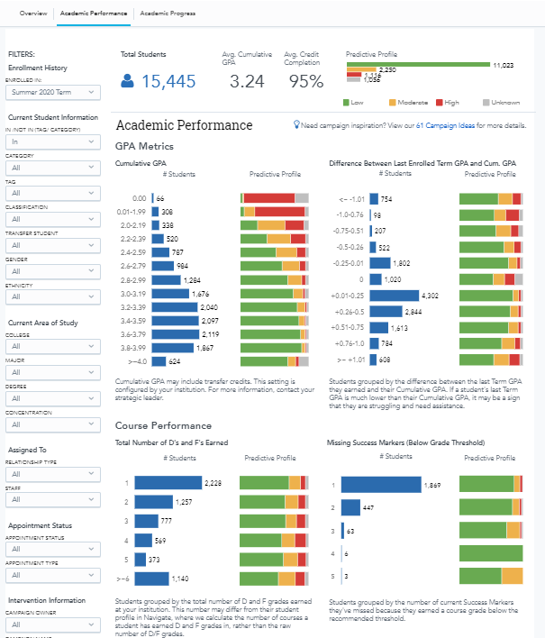

Academic Progress
This section shows how the population is progressing through their coursework. You will see credit completion percentages, total number of earned credits, total attempted credits, number of withdrawals, number of repeats, and number of major switches for the population.
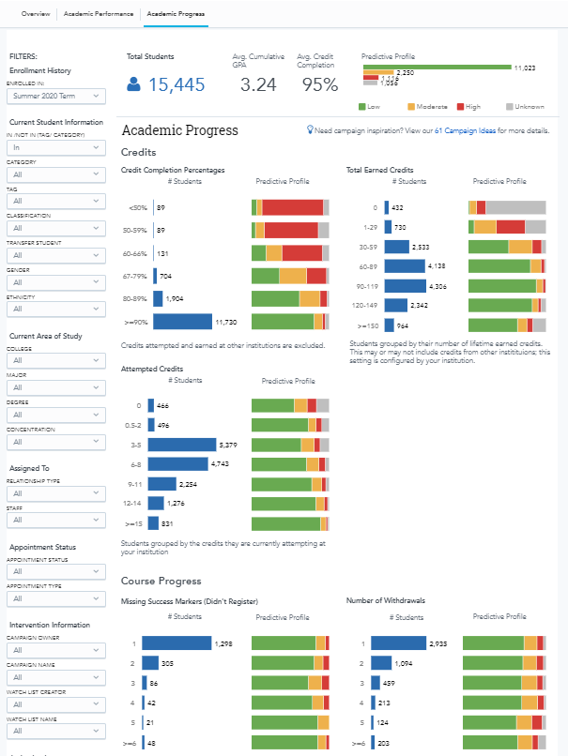
Activity Analytics
Activity Analytics track student and staff activity for accountability and resource planning. The tool offers visualizations of how and when staff time is being spent. There are two reports in Activity Analytics, Activity Dashboard and Activity Reports.
Activity Dashboard
This dashboard summarizes appointment statistics and can be filtered to show a single office or unit. Dashboard includes total number of appointments, number of distinct students, attendance by week/day/hour, heat maps of most common appointment times, along with cancelled and no-show appointments.
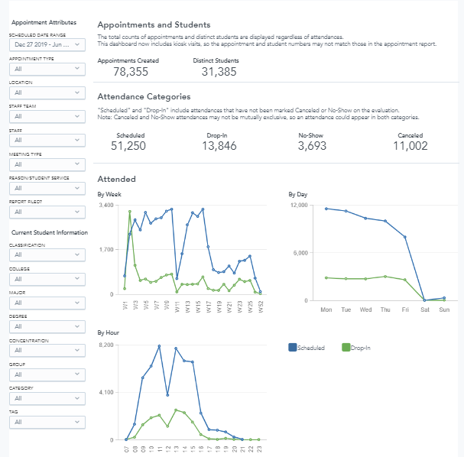

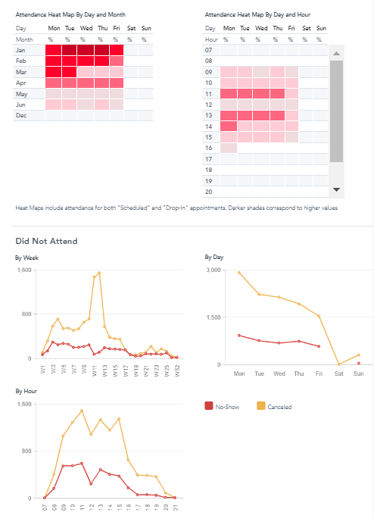

Activity Reports
Activity Reports dive deep into the metrics shown in the Activity Dashboard. It breaks down activity over sub-reports, as defined below.

Appointment Details
The Appointment Details report provides counts for appointments that are Scheduled, Walk-In, No-Show, and Cancelled, including information about the total scheduled duration as well as the appointment attendees by staff member.
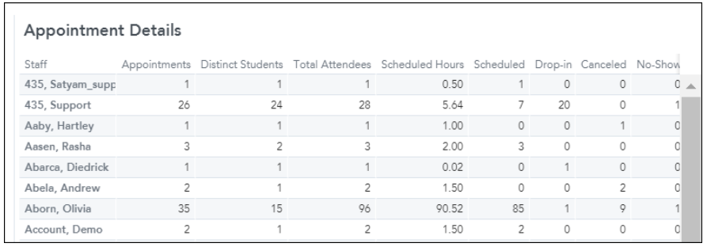

Attendances
There are several tabs to choose from for attendances for an evaluated time period. Options include attendances by Day of Week and Hour, Month, Reason, Location, and Appointment Organizer.
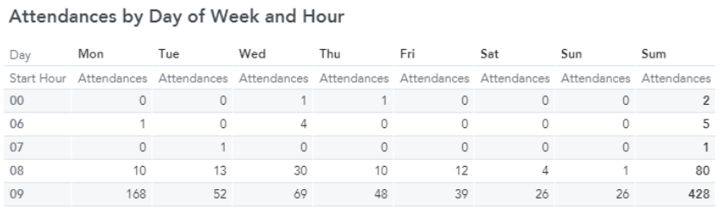

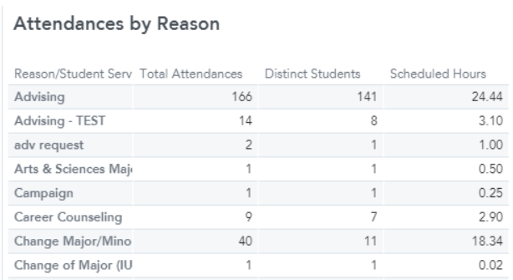
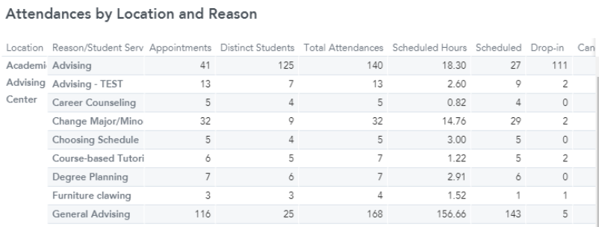

Intervention Effectiveness
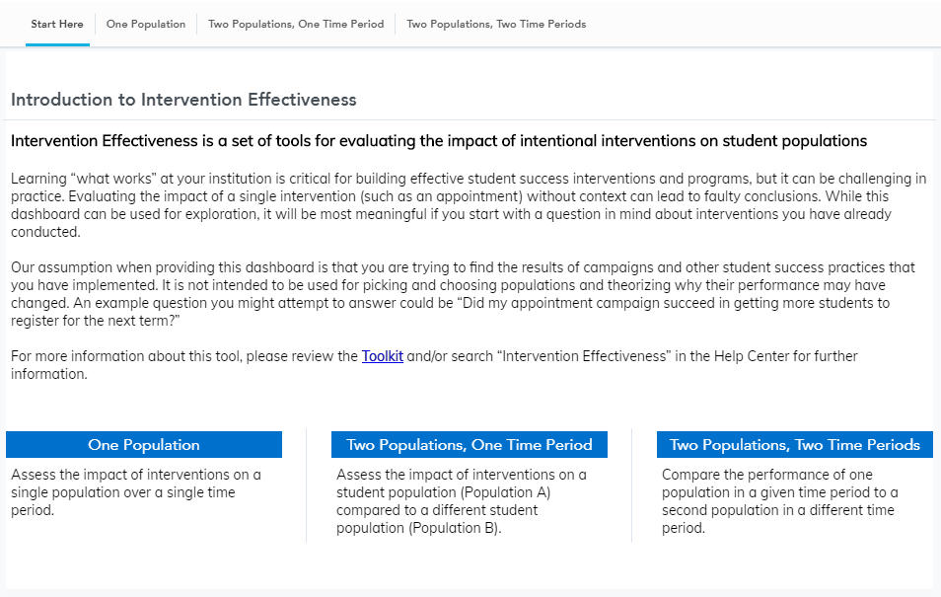
Intervention Effectiveness is a backwards-looking tool to help student success leaders and administrators evaluate the impact of interventions they have already performed at their institution. The tool can also be used to look at general retention or credit accumulation trends at the institution or among special populations.

Each option above produces a set of data and graphics based on the population(s) selected. These include enrollment, performance, and progress summaries, GPA outcomes, and GPA and credits over time.

