guide to pre-recorded closed caption files

Our accessibility standards require captions that are accurate. For pre-recorded media these captions should be close to perfect because, unlike live captioning, there are effectively no time constraints.
All captions must be reviewed for accuracy. Any errors in the captions must be corrected prior to use or publication.

Workflow for recordings in carmenzoom
- Download video and closed caption files from CarmenZoom
- edit the closed captioned file
  - Open the closed caption file using the Notepad application
  - Add “WEBVTT” to the first line of the file
  - If present, remove the lines labeled “Kind” or “Language”

Original:
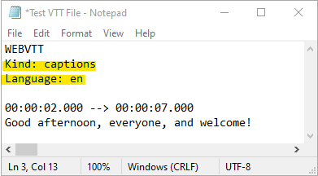

Edited:
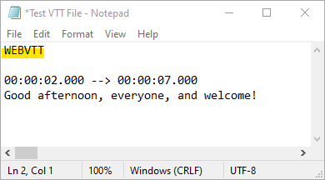

  - Play the video and correct mistakes in the closed caption file
- Upload video and edited .vtt closed caption file to a location of your choice to create a usable link for sharing your content

