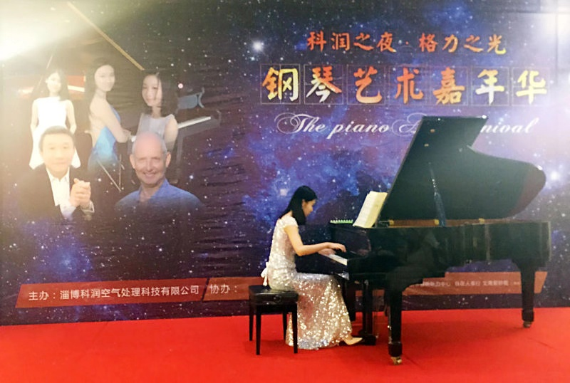
My name is Xiangqi Meng, and I come from China. I also go by Amanda, which is much easier to pronounce. I like to listen to music in my free time, such as pop music and musical theater pieces. I started to learn to play the piano and singing since I was 6 years old. Through music, I can express my emotions and feel peaceful in my heart. In my free time, I also like cooking and baking. Using different seasoning to cook the same ingredient, it will turn out totally different dishes. For me, it is the most interesting thing in the world.
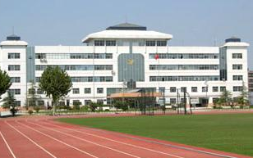
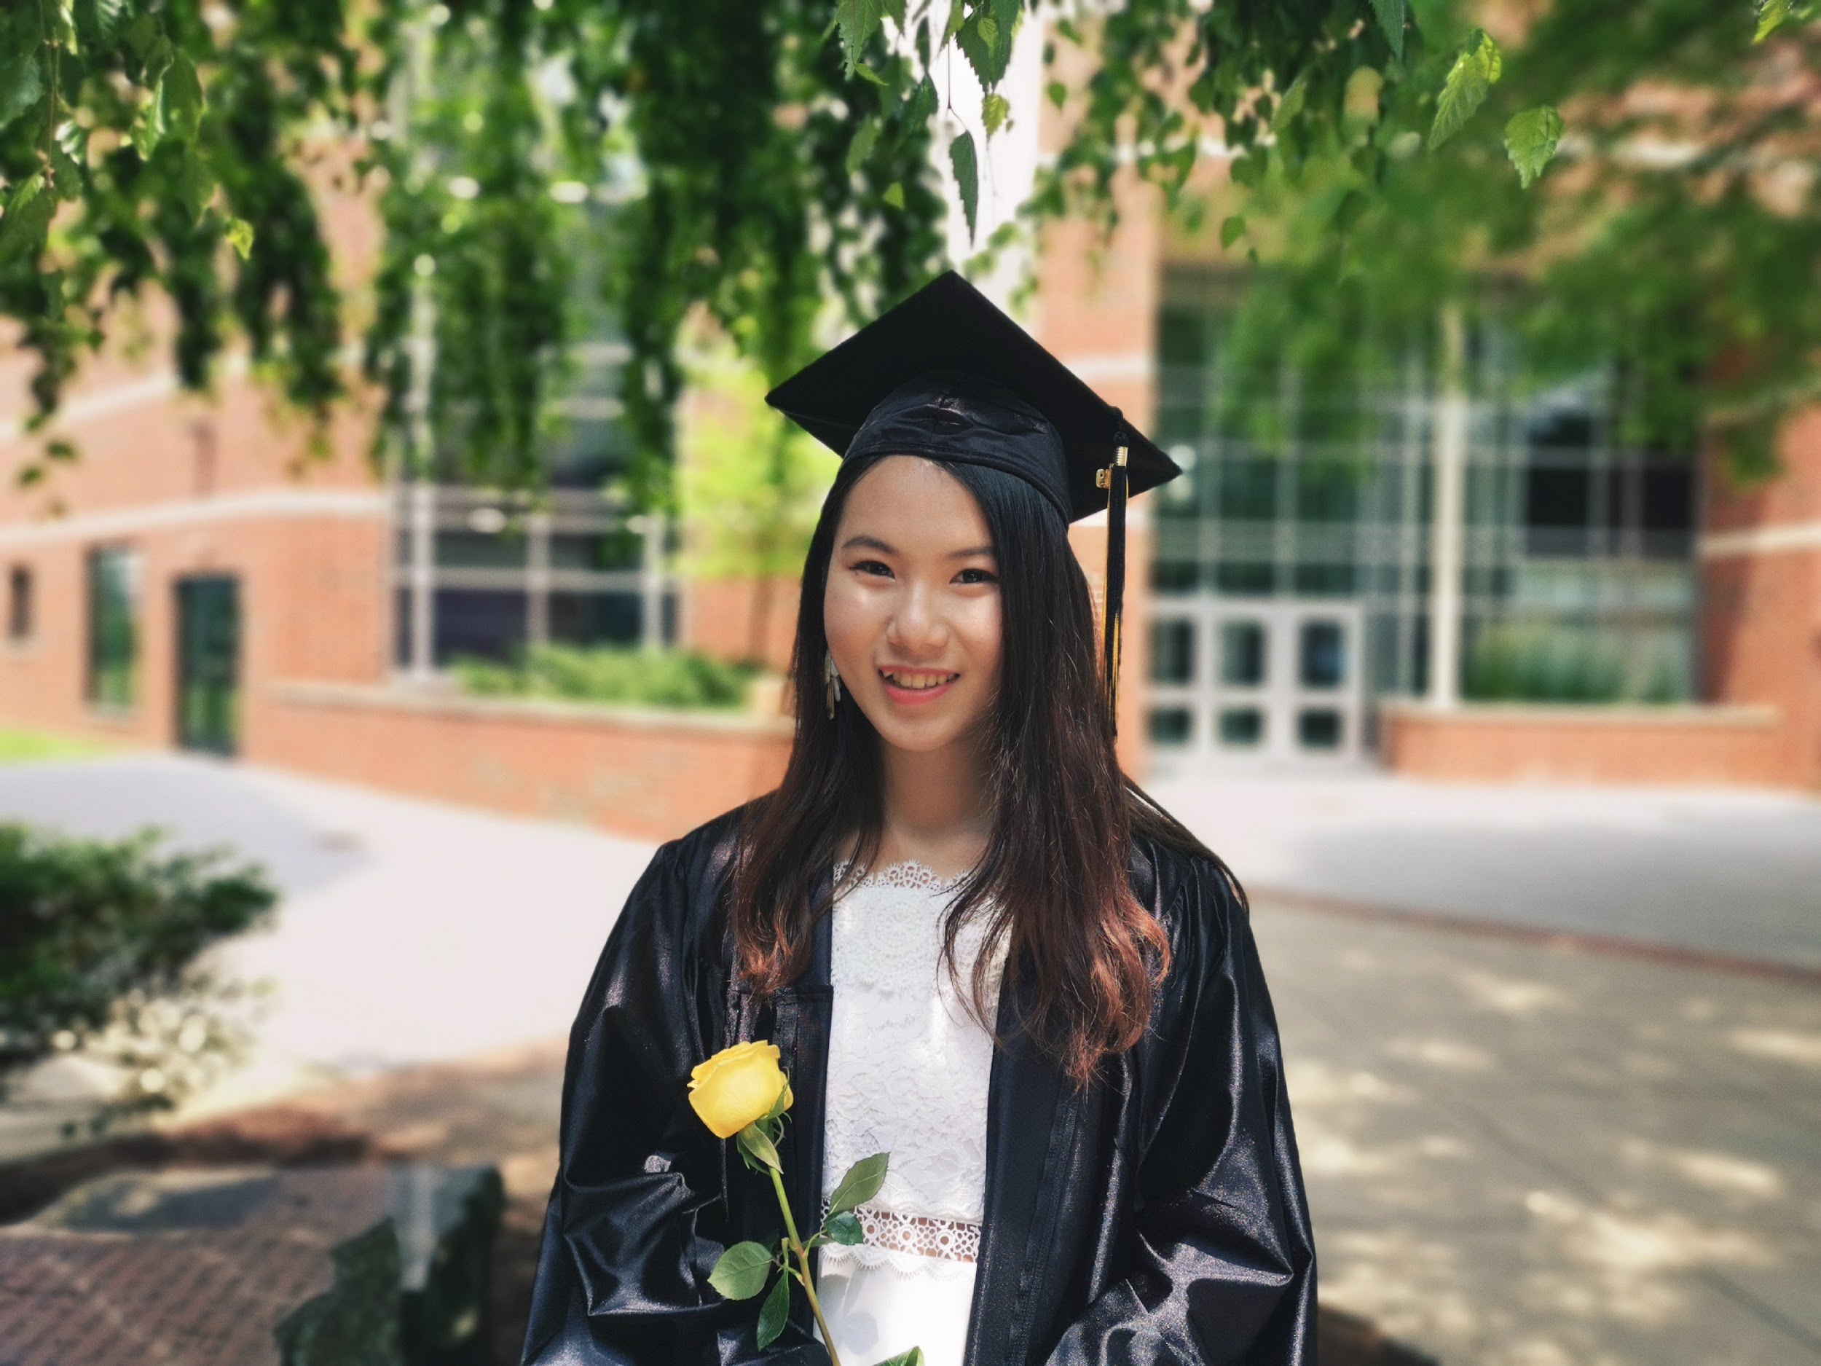
Both of my elementary school and middle school were in China. I made some very good friends back then. Even now, when I go back to Chian, we will still gang out. We love to share our recent life and laugh together. I am really proud of those friendships I have with them. I came to the US when I was a sophomore in high school, and I went to Lancaster Mennonite School in Lancaster, Pennsylvania. I am glad I made that decision. People from there were all very peaceful and friendly, and I felt I belong there. I learned a lot about US pop culture, and also made some life-long friends which I never expected.
photo resource: http://book.zdsy.net/xwindex/
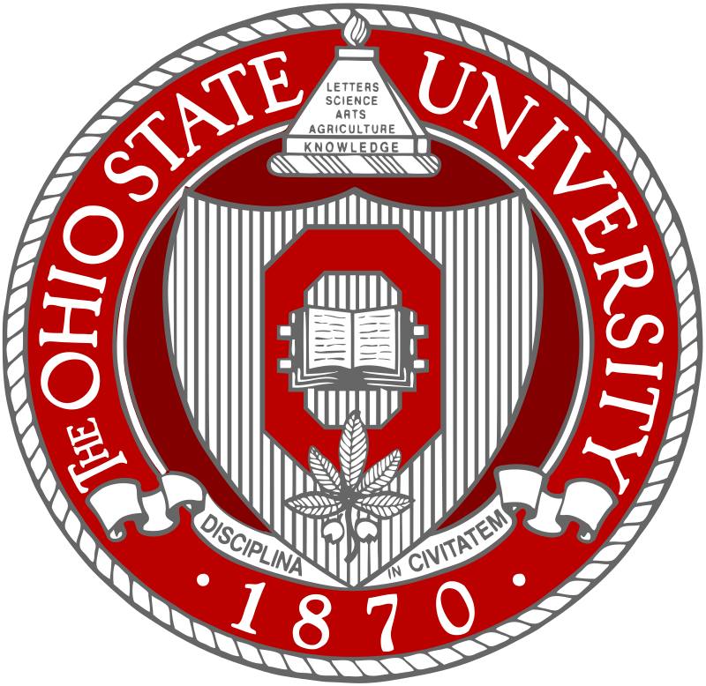
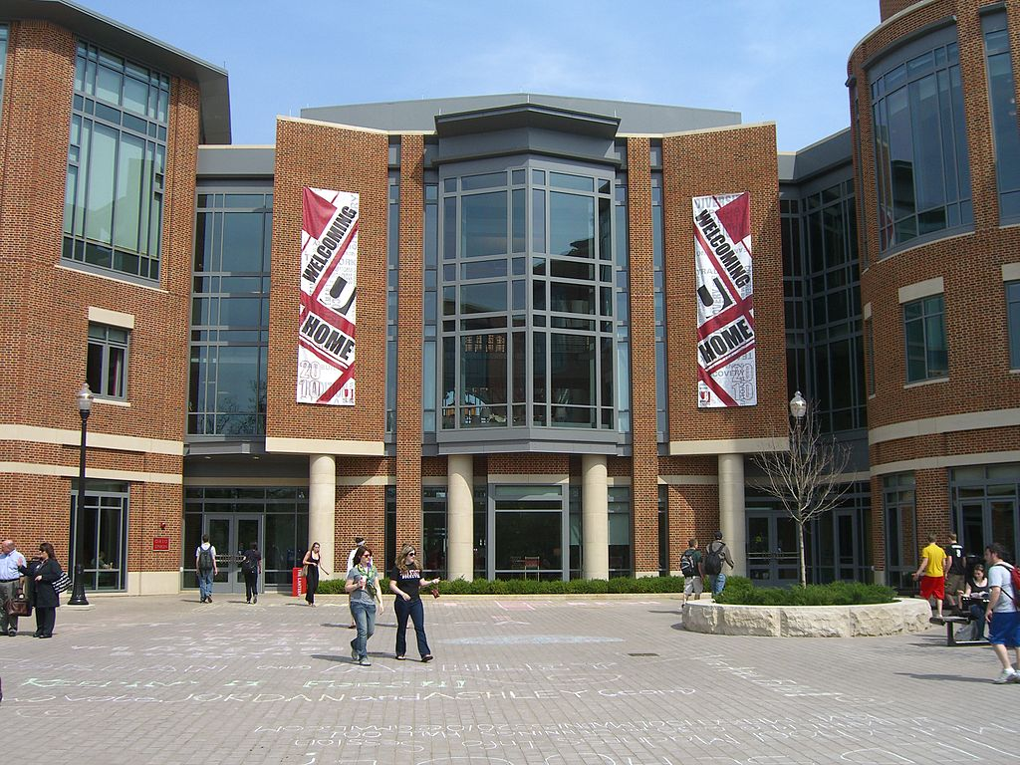
I applied to seven colleges last year and the Ohio State University was one of the three schools that admitted me. I choose to come to the Ohio State University because I thought here will fit my the best. I always wanted to be on a big campus, therefore I can experience more diversity and different culture. Now I am a BA degree student, however, I might change it to a music education major. I like to work with little children. I also want to learn some music media skills. In the future, I really want to have my own music school so I can apply all my knowledge that gain from the OSU to my daily life.
photo resources:https://en.wikipedia.org/wiki/Ohio_State_University

