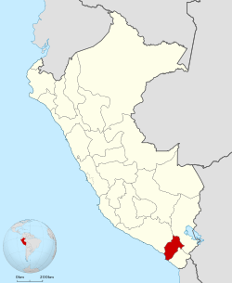
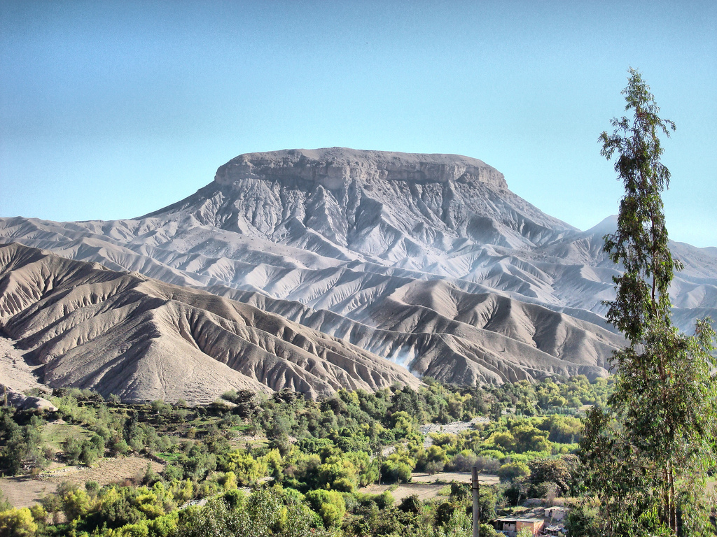
MOQUEGUA ARCHAEOLOGICAL EXPEDITION
Second Year Project 2018
Bonnie Legg, legg.73@osu.edu. Anthropology and Romance Studies majors.

Description
Over the summer of 2018 I will be joining a team from the University of North Carolina Greensboro in an archaeological lab school to take place in Moquegua, Peru. This project will cover Wari and Inka artifacts as well as human remains from June 9th to July 22nd. Two classes will be covered; Human Osteology and Analysis of Archaeological Data.
Process
I have been hoping to attend an anthropological field school since I determined my major. Throughout the year it has been a long process to realize this goal. This past fall I used several search engines that are useful for finding field schools for which to apply, mainly the Archaeological Institute of America (https://www.archaeological.org/fieldwork/afob). I determined that my area of interest was primarily in South America as I am planning a second study abroad for the summer of 2019 in Europe. Once I found several projects I wanted to apply for I started applications. The first school I heard back from was the Contisuyo Archaeological Lab School in which I am participating and it seemed like a good fit so I accepted. Since that acceptance there have been several forms I had to fill out, passport updates and photocopies, vaccination updates, airline ticket purchases, and deposits (a $3200 program fee) to the university. I also recently remotely attended an orientation to prepare for packing and navigating the Lima airport.
Results
I expect that this project will give me experience in my field so that I can figure out what I want to go after graduation. It will also fulfill two elective requirements for my anthropology major assuming I can get Ohio State to approve the transfer credit.
Reflection
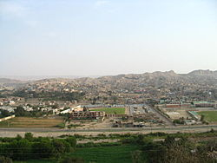
I believe that I am the type of adventurous person well suited for world travel. Sadly, I have not been able to travel very far abroad until now. I am excited to experience this other culture in Moquegua and to be able to use my Spanish language skills that I have been practicing for six years. This is a good place for me to start because many citizens of Moquegua also speak Spanish as a second language to an indigenous language so they speak relatively slow. This project has helped me find my place as a humanities scholar and I believe in that respect I have come a long way from starting college. Planning this trip has helped me realize that there is not one given mold for every college student, everyone can choose their own path and no one is going to judge you based on what you do in college. My craving for adventure and knowledge is something that I can identify that most makes me a humanities scholar. I anticipate that because I attend this program, I will be a better candidate for applications to graduate schools in the anthropology field if I so choose to apply. I chose to attend this archaeological study abroad because it will benefit me academically, culturally, and personally.

