caption.https://www.mediabistro.com/be-inspired/advice-from-the-pros/what-does-a-content-strategist-do/ My first suitable job is content strategist. Content strategists are people who provide text services for advertising texts, planning schemes, website bidding texts, product descriptions, involved in copy writing planning.The career of content strategist is a comprehensive career that integrates various industries such as planning, marketing, news media, advertising, and psychology. To do this job, you need to master many skills. First of all, you need to have language skills and aesthetic skills. You must also have deep writing skills, active thinking, strong insight, and creativity. You must also master marketing, planning, psychology, and management. Only after having many skills, can you become a qualified content strategist. I think this job attracts me because i can create my own content. This job is challenging and creative for me.The salary is also suitable for me，but if i want to take this job，I need to improve my English writing skills.The era of the network economy has arrived. More and more companies, advertising companies, and clients are individually recruiting copywriter planners to complete all the writing tasks they face in their work. They require independent thinking and analysis skills, strong logic, and strong sense of responsibility, work carefully and meticulously, orderly, work initiative and feedback consciousness.This means that the future, China will need a large number of copy planners, but there are few professional planners, and the gap in talent demand is very large. I can earn about 67000 dollars each year. It is quite enough for me.Because if i work in china, I will only earn half of this amount. This means i have more money to spent on things i like like cars. 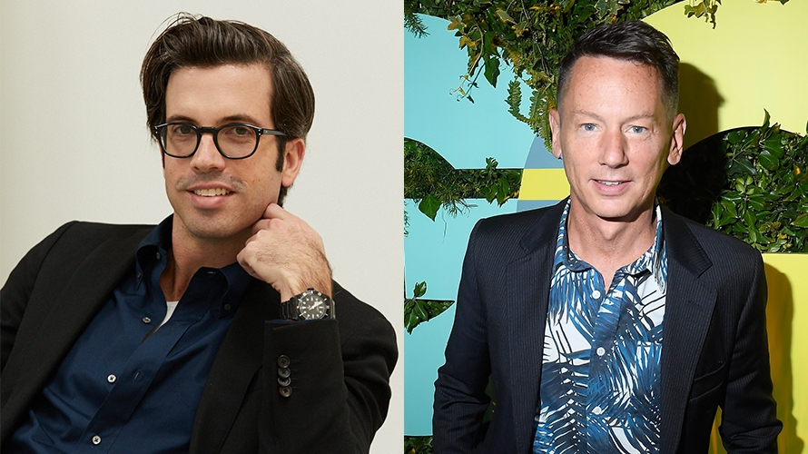 https://www.adweek.com/digital/gq-names-new-editor-in-chief/ My second job is editor in chief. Editor in chief is the people that the leadership of the editorial board or editor-in-chief, the specific business of a certain aspect shall be implemented in accordance with the editorial policy. His work is to research, formulate a certain aspect of the work plan, organize and lead daily editorial affairs, such as reviewing manuscripts, reviewing samples, writing important speeches, etc. The editor-in-chief generally needs to have a high degree of judgment and organizational skills so that each editor can give full play to his role. He must be good at mastering the progress of the work and make necessary adjustments at any time according to the requirements of the objective situation. In addition to mastering the entire publishing policy, the editor-in-chief of newspapers and periodicals is often also responsible for writing important editorials and commentary articles that represent the newspaper’s position. The editor-in-chief of an academic journal should be an expert in the subject, standing at the forefront of the subject and keeping abreast of academic development trends to ensure the quality of the journal. The editor-in-chief and the editor-in-chief of the publishing house are different. The editor-in-chief is only responsible for a specific publication, and the editor-in-chief is responsible for the editorial affairs of the publishing house, including certain administrative matters. This job is quite similar to my first job.But compare to the first job，this job is much more boring.Some times i need to spend a lot of time if i need to edit dictionary. Content strategist can work more creatively. Editor in chief is more like a boss. I need to organize each editor to finish the work. I mean it is always more difficult to lead people than finishing the whole work by your own. I need to be more stricter to my teammate and my self and use each persons benefits. This job has a lot of skills in common with my majors. I need to learn how to work and communicate with my teammate or business partner.

