Ryan Jeon
Biological Engineering
Why Livestock Should be fed Genetically Modified Crops

Cow: Been there done that

One of the topics we learned in this class was the incredibly large issue of genetically modified organisms. Ranging from areas such as international policy, world hunger, businesses, to veterinary medicine, this technological innovation encapsulates a diverse range of global topics. One of which, is a growing area of concern: should we feed our livestock genetically modified crops?

More and more farm land is being urbanized and converted into land unsuitable for agriculture. Water resources have begun to dwindle, and recent legislation has caused food prices to shoot up. With all these problems, how can we create agricultural practices that allow us to grow sustainable food with dwindling land and water?
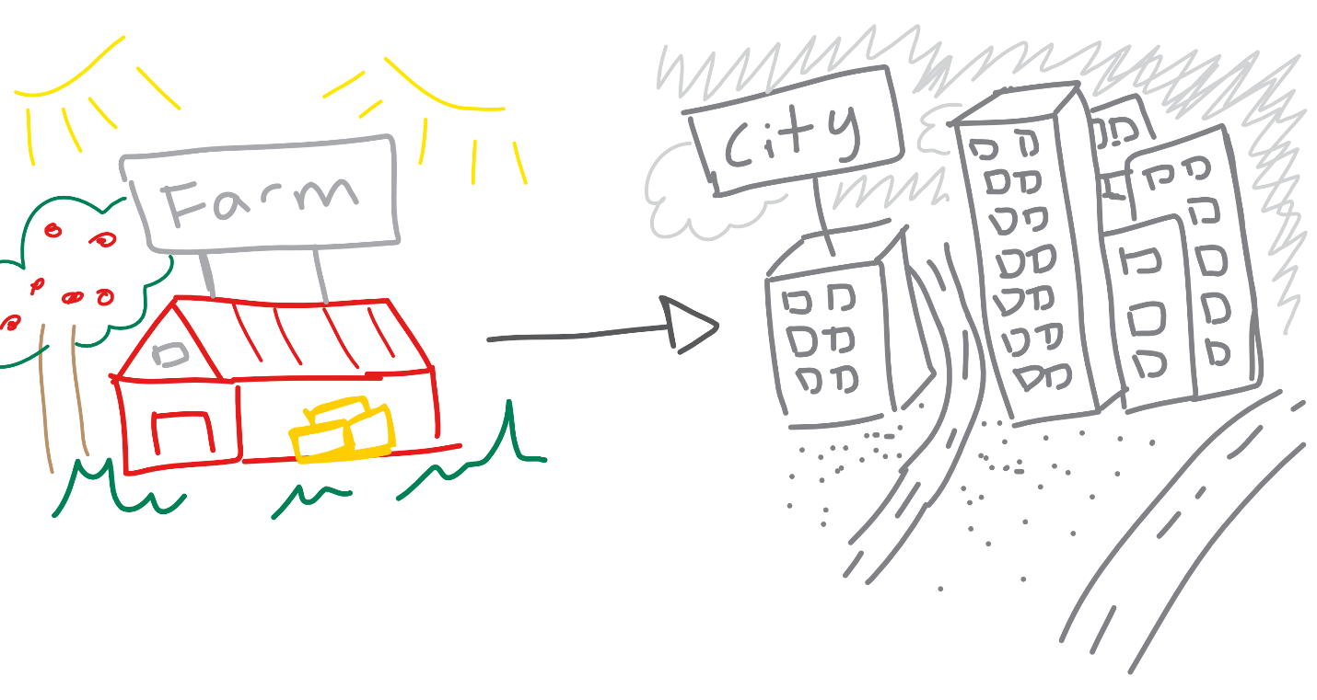
Well genetically modified crops are plants that humans have purposefully changed to provide us with a trait that we want. Humans have been doing this for a long time, but now we’ve come to a technological innovation that allows us to combine fragments of DNA from bacteria and other organisms, with plants. This gives the plants unique benefits, such as larger yield, disease resistance, drought tolerant, or even something subtle, like requiring less land or water.

“Oppressive Weather”

With the global population exponentially rising, these are important traits that are necessary to feed our growing population. Likewise, we need food that can feed our livestock, such as cattle and eggs. Genetically modified crops, like corn and wheat, can provide livestock with food that requires significantly less water and land. With our water resource draining away every day from livestock, in addition to more farmland being converted to suburbs or cities, we need crops and livestock that don’t require as much land. In addition, these plants can grow larger, faster, and more fruitful, allowing prices for crops to be cheaper.

However, from the public’s perspective, they’re going to want to know how this might affect them, their food, their family, or the environment.
Ideally the public may ask, with a curious mind,

“I’d like to know, will there be toxins from the eggs from chickens that are fed GMO corn?”

If they are worried, I’d tell them that it is important to understand that the FDA carefully regulates all food that enters the market. A research study done by UC Davis has concluded that there are no nutritional differences between beef that are fed GMO products and those that haven’t. In addition, the study shows that extensive research has been done to make sure that there is no residues from the GM crops that make it into the milk. There are no deadly prions, no DNA fragments, no nothing. It makes sense too-if it wasn’t safe to eat, then the FDA wouldn’t allow it without a warning sign. So enjoy your slightly-cheaper-steak without the worry that the cow it came from ate GM crops.

Ideally, they might say thank you for your time, and proceed to share their newly earned knowledge with other people

But sometimes you might meet someone more like this
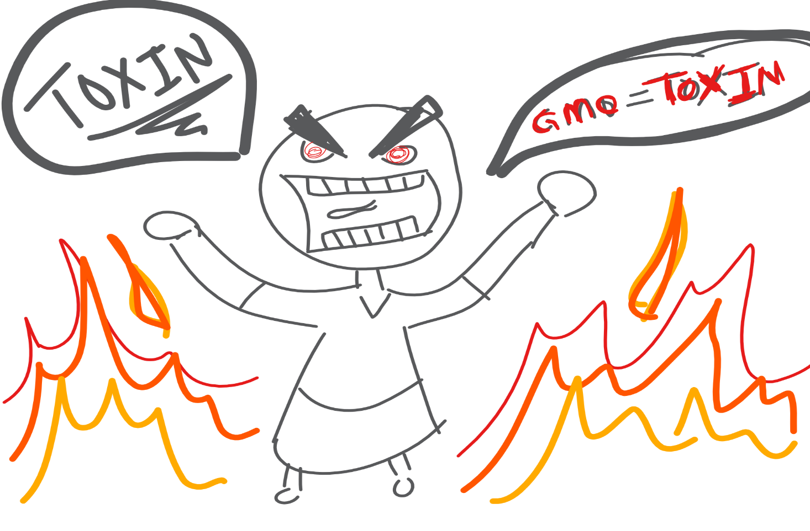

If that’s the case, there is an alternative option: organic beef.
“Organically Grown Cow”
Sources:
https://factsaboutbeef.com/2013/09/03/safety-first-the-role-of-gmos-in-cattle-feed/

Biography:
My name is Ryan and I am a 6th year bio-engineering student. I am minoring in both Animal Sciences and Pre-Veterinary Medicine, and I aspire to put my engineering skills to use in the veterinary world.

