NASA Recycling Spot Report

Prepared for:
Dr. Jane Fife
Jesse Blanton

The Ohio State University
590 Woody Hayes Drive
Columbus, OH 43210

Prepared By:
John Capuano
Jamie Heidel
Ryan Jeon
Tayo Pedro

The Ohio State University
590 Woody Hayes Drive
Columbus, OH 43210

March 24, 2017

Contents
Introduction 3
Project Update 4
Future Plans 10
Issues or Concerns 11

Introduction

The NASA space crew needs to recycle inedible plant biomass to create products that will help sustain food production, reduce excess weight, and minimize crew time to maintain a functioning life support system. If this is accomplished, it will enable longer space missions, create a healthier environment for astronauts, and play a role in Mars research and exploration. The purpose of this project is to provide a solution for recycling inedible plant biomass with the design of an aerobic composter suitable for extraterrestrial applications.
This spot report will provide the reader with updates on the status of the aerobic composter, as well as progress and improvements made since December 2016. This spot report will include the following:
- Project update - an overview of the work completed, with respect to project milestones and schedule.
- Future Plans - summary of next immediate steps
- Issues and/or concerns - summary of issues/concerns that could affect completion of work and staying on track to meet project deliverables

Project Update

To date, all structural components of the bioreactor are assembled and data acquisition tools are connected for data collection and monitoring. Construction of the bioreactor was completed on March 3, along with setup of a scale for measuring the mass throughout the decomposition process and thermistor attached at one end of the bioreactor to monitor internal temperature. The team has moved forward with the design of the bioreactor using a batch process, with the first batch of inedible biomass being fed into the bioreactor on March 6. Inedible biomass was acquired from food scraps collected by team members at home as well as in the staff kitchen in the Agricultural Engineering building on Ohio State’s campus and include, dry roots and leaves, banana peels, orange peels, soil, pears, strawberry stems and leaves, potatoes, and basil leaves. A representative sample of inedible biomass was obtained and brought to Ohio State’s Service Testing and Research (STAR) Lab for evaluation of carbon and nitrogen levels. Results for the sample are expected to be returned the week of March 27.
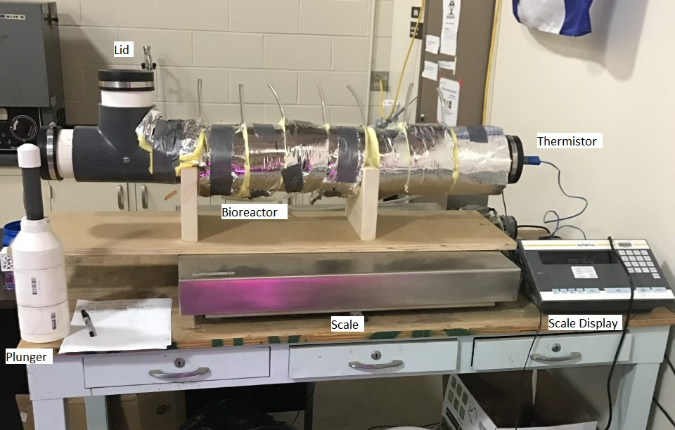
Figure 1: Bioreactor and Equipment
The design of the bioreactor and equipment setup can be found in Figure 1. Material is inserted through the lid on the left and packed into the bioreactor at another opening at the far left end of the bioreactor using the plunger. The thermistor inserted at the far right end is connected to a data acquisition system and breadboard, which is hooked up to a computer. This allows for continuous tracking of temperature data. The entire design sits on top of the scale which was used to measure the mass of the bioreactor prior to being filled with material, and subsequent mass measurements are being taken twice daily to track decomposition.
In order to achieve the optimum moisture content of 60% moisture, the raw material needed to be dried before insertion into the bioreactor. This process was completed using a food grade, experimental oven. To determine the time needed to reach 60% moisture, a preliminary drying experiment was executed in which raw material was shredded, weighed and placed in the oven at 90 C. The raw material was then weighed every 5 minutes until the mass stayed approximately constant, as seen in Figure 2, where the slope of the graph reaches an approximately constant slope of 0.
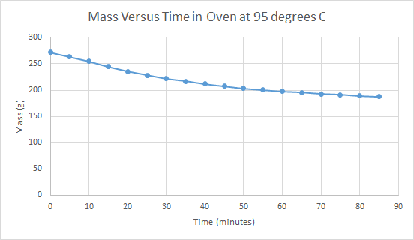
Figure 2: Mass vs. time in oven at 95 degrees Celsius
The approximate steady mass indicated there was 0% moisture, and from this, a 60% moisture calculation could be made to determine the time in the oven necessary to reach 60 % moisture, which was 20 minutes. A variable in this procedure was the heat loss from opening the oven door, however for the scope of the experiment, this variable was determined to be negligible. Figure 3 shows the results of the calculations.
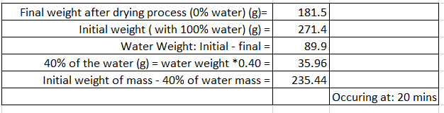
Figure 3: Time in oven calculations
After being packed into the bioreactor, the entire system was weighed, and an initial temperature reading was taken manually, until the data logger system was later inserted. Once the data logger system was inserted and running, the temperature readings were set to occur every minute. The optimum temperature is 134.6-159.8 F. The mass readings are still taken manually; the main emphasis on weight is the initial and final weight. These are the weights used in calculating the degradation value, k. Weights taken in between are to ensure the scale is properly functioning, and the compost is reducing in mass as it should due to water and carbon dioxide loss. (Compost Engineering) This data can be found in Table 1.
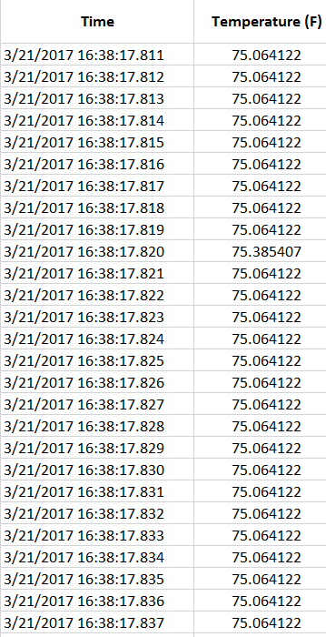
Table 1: Summary of Temperature and Mass Recordings as of March 21, 2017
To date, this is the complete collection of data obtained. The statistical analysis of the raw material drying time is complete and has met the success metrics that were set, in that a drying time and temperature were determined. Based on data collected so far, one recommendation that can be made is that the raw material should be broken down and pretreated before the drying process, as this is more efficient.
The data collected for the bioreactor temperature and mass are preliminary data in order to calculate the decomposition rate, k, using the equation in Figure 4. Once an optimum temperature is met, and held for approximately 7 days, an additional Carbon Nitrogen Ratio will be tested. Samples for the soil will be taken and tested at STAR Lab after 1 week to test for C:N ratio to confirm it has stayed at 30:1. If the test results show a 30:1 C:N ratio, the success metric has been met and a decomposition rate k, can be calculated and presented. The most recent temperature recording is 77.9 F, and the bioreactor internal temperature needs to increase by 62.1 F. The next design decisions made will be directly related to ensuring there is an increase in temperature in order to achieve the goal of the project. Once this is reached, the time of decomposition will be recorded.
Figure 4: Calculation for decomposition rate, K
Once all final data is collected, they will be used to calculate the final design metric, the decomposition rate, k. This can be seen in Equation 1.

Future Plans

After two weeks, material that was added to the bioreactor has not been able to decompose at the rate the team had anticipated. This is because the internal temperature of the bioreactor has not been able to reach its optimum range of 57-71 °C. Therefore, it is not likely the material will be converted to its final product within its 21 day timeframe. The team plans to continue taking internal temperature measurements of the bioreactor using the DAQ system, as well as recording the change in mass within the bioreactor over time. One of the next immediate steps is to add additional insulation surrounding the body of the bioreactor to help maintain optimum temperatures within the bioreactor and assist the decomposition process. Once optimum temperatures have been reached for a long enough period of time, a sample of the final composted product will be sent to Ohio State’s STAR lab for analysis. Completion of experiments and analysis of our final design will be by April 17, where final results and recommendations will be discussed in the final report.
The design of the system as well as current data analysis will be presented before IPAG on Wednesday, March 12. Though it will not occur until the completion of the capstone design class, future development of the system will be discussed and evaluated by the NASA sponsor contacts on May 10. A detailed schedule of upcoming project tasks can be found in the Gantt chart in Figure 5.

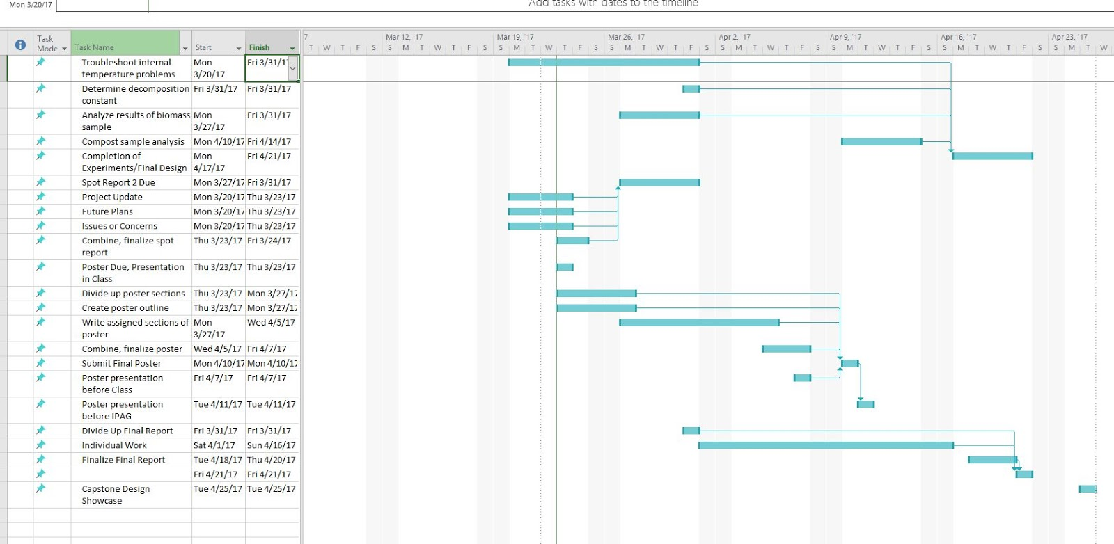
Figure 5: Gantt Chart

Issues or Concerns

The bioreactor reaching and maintaining a temperature of 57 to 71 °C (134.6 to 159.8 °F) is the main anticipated issue, and would cause a delay in keeping a schedule that allows the project deliverable to be met. Due to the small volume of the bioreactor, it is a concern that the temperature will be too low to achieve the necessary temperature range required to convert raw plant material into nutrient-rich compost. After two weeks of processing, the temperature of the organic material inside the bioreactor was at 77.9°F, 62.1 degrees less than the minimum necessary temperature. In an attempt to mitigate this issue, more insulation was added. However, it is possible the small, scaled-down volume of the bioreactor will prohibit the temperature achievement. If this is found to be true, it is out of the scope of the project to design, build and test a larger model of the reactor, but recommendations of reactor volume and organic material mass would be made based on information obtained from the pretreatment process and projection spreadsheet. To better understand the heat transfer and retention occurring with bioreactor and environment, the r-value of insulation which is a measure of the ability to suppress heat flow. With this information, a different type of insulation with a greater k-factor can be recommended to provide more sufficient heat retention. The calculation for the r-value of flat, fiberglass wall insulation is seen below in equation 1.
Equation 1: R-value = Thickness (in)/ k-factor (BTU-in/hr^2-°F)
14 = 3.5 (in)/ 0.25 (BTU-in/hr^2-F) or 3.8/in
Another potential issue is not achieving the proper C:N ratio of 30:1. Time is a limiting factor in the scope of this project, meaning if the ideal ratio is not achieved in the allotted 21 days it is not possible to vary the amounts of each type of raw material used and test the system again. Although the carbon and nitrogen ratios of each type of raw material was research to try to obtain the desired outcome, raw material sources were limited to food scraps from team members and the faculty break room. Recommendations for the amount of each type of raw material would be made based on the anticipated inedible plant biomass. In addition, a calculated projection of reactor processing time based on the actual C:N ratio obtained from experiment would be provided as a recommendation for the compost to reach the desired ratio
Additionally, a less severe concern is that temperatures recorded by the data logger are not being recorded often enough. Currently, the temperatures are being recorded at 1 minute intervals. If the data collection frequency is insufficient, the issue would be resolved by modifying the code to take readings at a more frequent interval, such as every 45 seconds. Due to the longevity of the project, it is not likely this issue will occur.

Works Cited

Compost Engineering Principles and Practices, Haug, Roger Tim, Ann Arbor Science
Publishers,First Edition 1994.
Compost Facility Operating Guide, The Composting Council, Alexandria, Virginia, 1994.
On Farm Composting Handbook, NRAES-54, Cooperative Extension Service, Ithaca, New
York, 1992

