SOILLESS STRAWBERRY SCHOOL
Greenhouse-focused Track*
- a virtual event —
March 26, 2021

Sponsor Registration
Company: Contact:
Street address:
City/State/Zip:
Phone: E-mail:

Fee Due
SPONSORSHIPS $400 $
Includes:
- Company logo on conference landing page
- Two-minute recorded video to be played during breaks
- Registration of one (1) person
Name of registrant:
TOTAL registration fee due $

Deadline to receive: March 15, 2021
Makes checks payable to: Ohio State University-Dept of Hort Crop Science

Send with form to:
Mark Kroggel
Department of Horticulture and Crop Science
2021 Coffey Rd., 202 Kottman Hall
Columbus, OH 43210
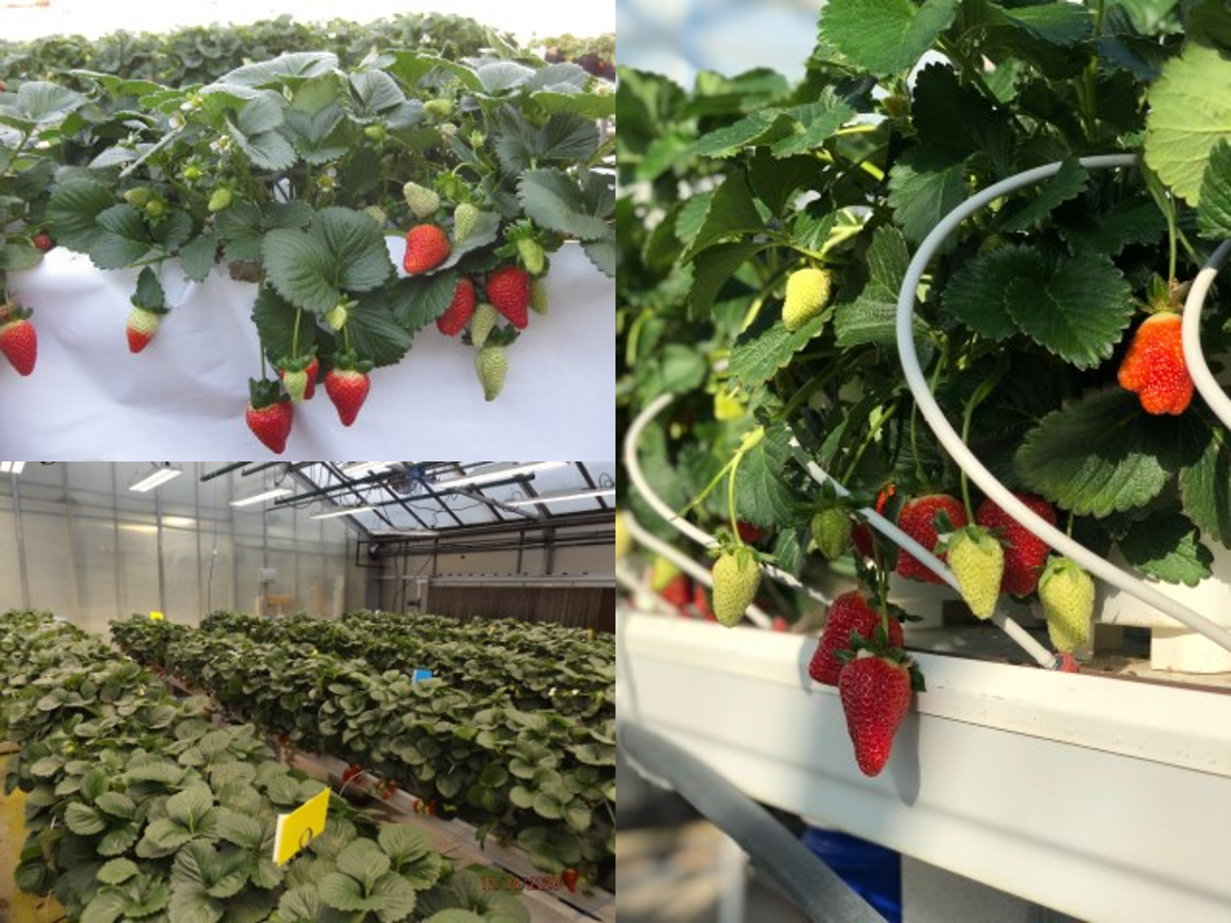
Questions? Contact Mark Kroggel at kroggel.4@osu.edu
or 614-292-4146

