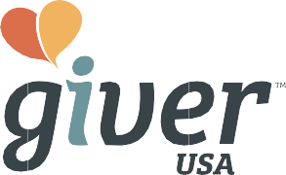

FREE STNA CERTIFICATION FOR STUDENT CAREGIVERS!

Do you enjoy providing care for those in need?

What about working for a company that cares about YOU?

We are looking for Caregivers who are team players and friends that believe in a mission to create value and happiness through caring for others!

Here’s how you can apply!
- Call us at (614) 408-9939
- Email us at info@caregiverusa.com
- Visit caregiverusa.com/careers

New caregivers will reimbursement after 600 hours completed!

* Terms & Conditions:
Must have completed the employment process. Must have passed all background checks and submitted all necessary documents. Must have completed 600 hours within 12 months with excellent client service. Must have STNA or CNA certification. Must begin employment before or on 09/30/2019.

