Hippo Project and Portfolio Management User Guide:
Contents
How to Log In – 2
Basics: 2
Navigation: 4
Resources: 4
What is a project management and how does PPM (Hippo) work with Trello? 5
Projects: 7
Portfolio Definitions: 7
Priority 8
Project Stage 8
Financial Information – 8
Roles and definitions: 9
HR Area 9
Project Status Fields 10
Export a Project 11
Import a Project (Uploading projects is the preferred method, see the next section of this document) 12
Upload a Project 14
Tasks and Schedules: 15
Scheduling in the Gantt Chart 16
Create Dependencies: 16
Delete Dependencies 18
Lead and Lag Time 18
TimeSheets: 20
Update the status of a task – 20
Reports: 20
Create a report – 20
Schedule a report – 21

How to Log In –
Open your browser and enter ‘https://na1.hippohub.com/osu’ in the address field
Enter your OSU email address and password, click on the Login button:
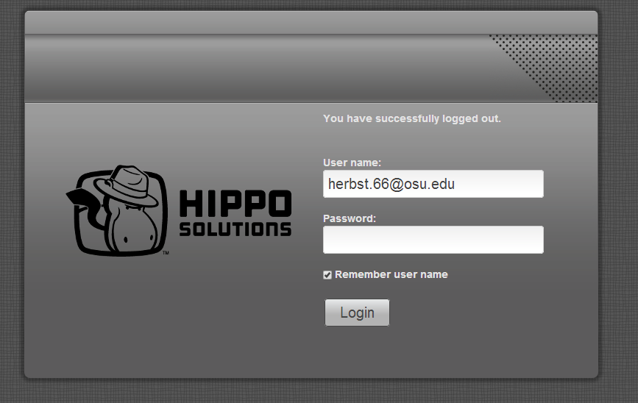
To change your password, click on the More menu and select My Account, a password window will pop up:

Basics:
What you need to know
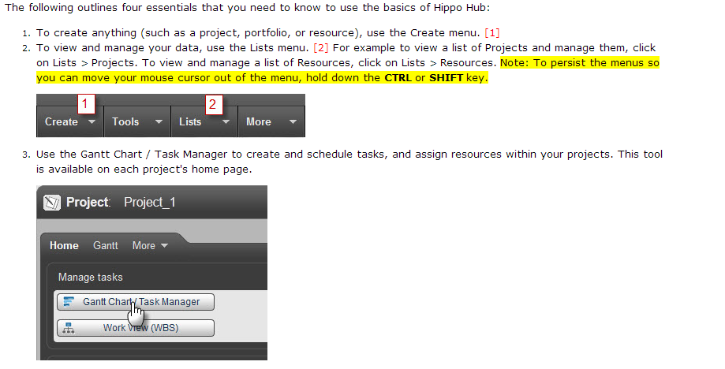
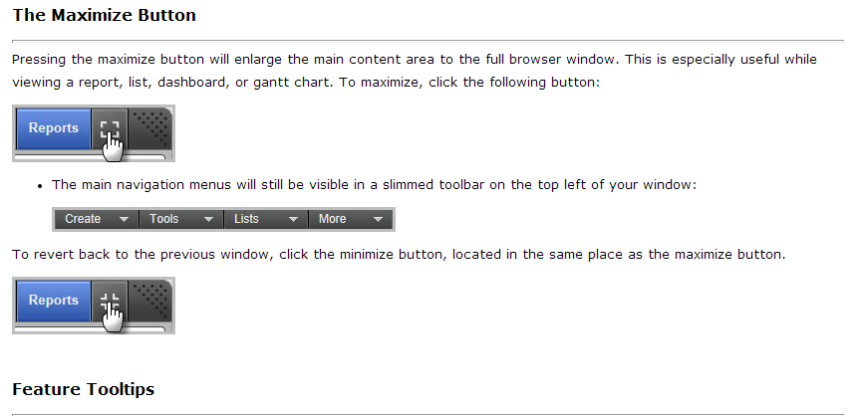
You can also access the online Help information from the More menu.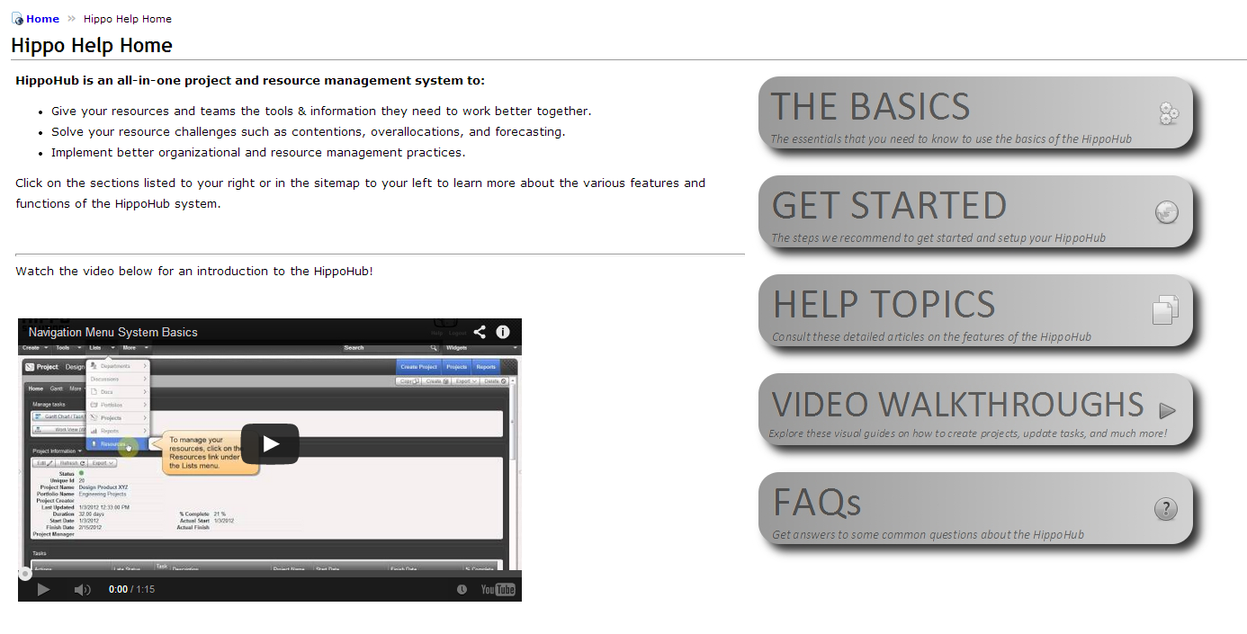

Navigation:
Quick links
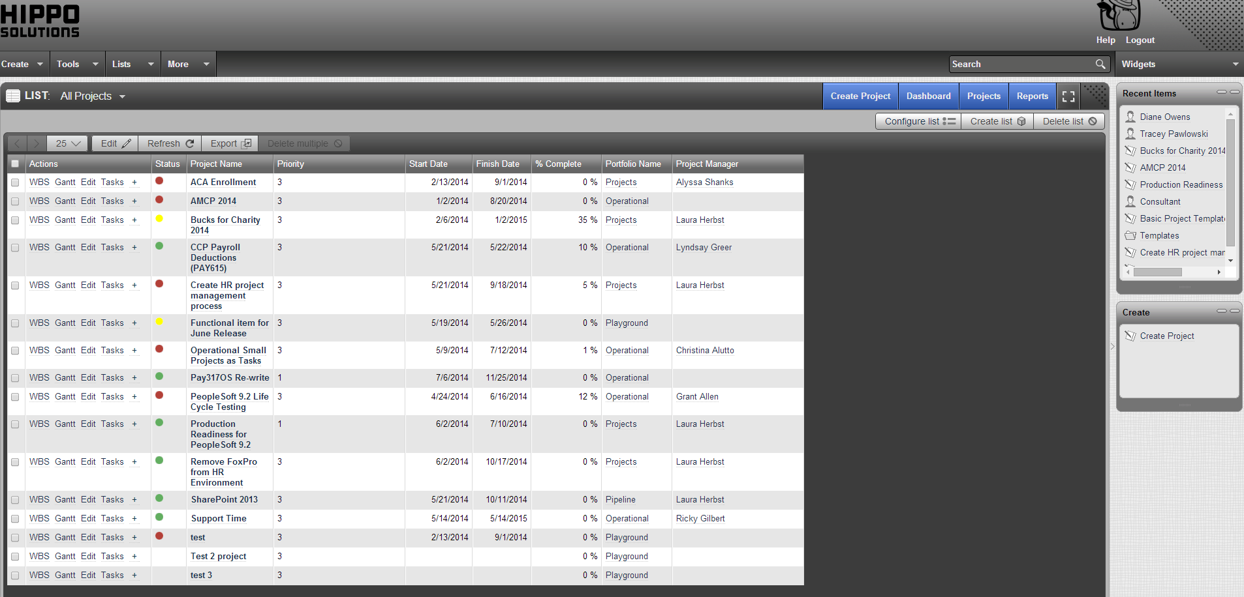
Recent Items
Refine search
Primary tool bar
Please see Laura Herbst if you have any questions or concerns about how to use the tool or how the tool is configured for our use.

Resources:
There are two types of resources; resources who have the ability to log into Hippo ($30/mo) and resources who have been set up to receive e-mail from Hippo ($0/mo). Due to the cost of licenses, resource who do not enter or modify information in the system should be set up to only receive data.
Initially, there are 15 employee licenses set up in Hippo:
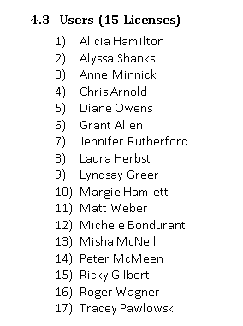

What is a project management and how does PPM (Hippo) work with Trello?

Project Management is the process and activity of planning, organizing, motivating, and controlling; resources, procedures and protocols. A project has a start and end date. It is undertaken to create a significantly modified product, service, or result which could require collaboration across functional areas.
Development tasks are tracked in Trello. Team members determine how the Developers tasks will be reflected in the PPM tool. In other words, a project has a specific start and end date, its purpose is to create a product, service or outcome. Projects are completed by a team of people who do not usually work together. SDLC (software development life cycle) is the process of implementing, maintaining and eventually terminating or replacing a system or program. Projects can be created to deploy a system or provide new functionality or a process within a system or program.

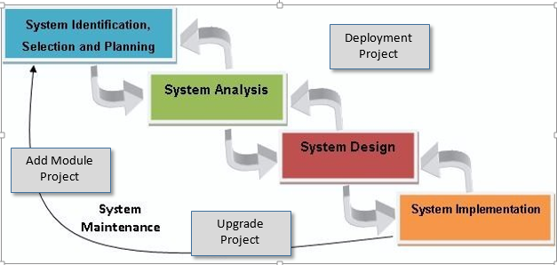

Projects:
To set up a project, select Create Project from the menu:
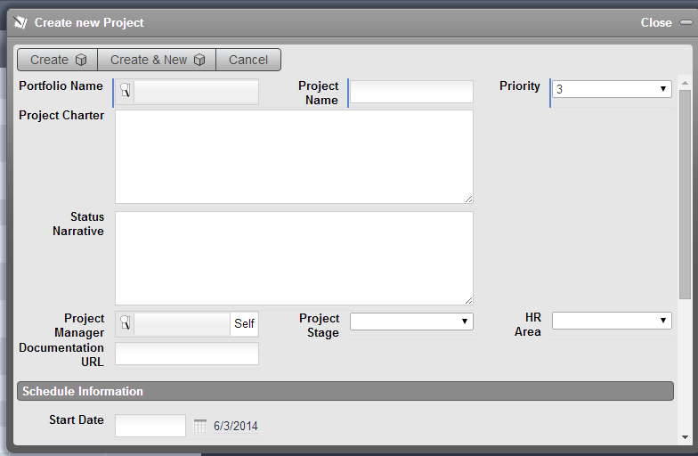
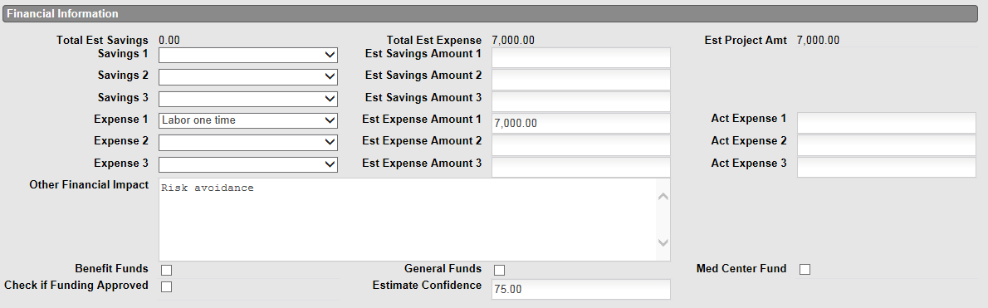
The Create New Project window will pop up. Complete the fields and click on Create. Creating the project occurs in conjunction with creating the Business Case. Enter financial information and schedule the Financial Evaluation meeting with the HR Fiscal Officer. Update the rest of the project Home page fields using the definitions listed below. Based on the outcomes from the Financial Evaluation meeting, update this page and the Business Case as needed.

Portfolio Definitions:
HR Project | HR projects
Pipeline | Ideas that have been defined in a business case but not yet approved to proceed
Operational | Work to modify, maintain or upgrade current programs and functionality in the environment
Templates | project templates that are used to create new projects to promote standards
Special Events | Special Events projects
The Pipeline portfolio holds all of the projects that are current in the Intake phase of the project. Shell projects are set up in Hippo as a holding facility. Each project is given a priority so the portfolio of projects can be properly managed:
Priority – Scale of ‘blank’ to 5
blank | no priority assigned
5 | Low priority project can be done as time and resources are available. Project can be put on hold to accommodate higher priority projects
4 | Moderately low priority. Can be scheduled within higher priority projects
3 | Medium priority. Schedule in the first open portion of the schedule
2 | High priority. Move schedule of lower priority projects around to accommodate this project
1 | Blue chip project. Must be done with the schedule and cannot be put on hold. Project must be complete to meet legal obligation and/or remediate immediate risk.

Project Charter is a concise description of why the project is being performed
Monthly Update is updated weekly by the Project Manager. It also contributes to the Monthly Active Project Status report that gets distributed to senior HR leadership and key project management resources.

Project Stage
Idea | Employee has an idea for a project. Discuss the project with appropriate people to socialize the idea and formulate high-level estimates for the cost, scope, resource requirements and deliverables
Propose | The Business Case document has been created and vetted with management and PMO. Area VP has reviewed and agreed to support the effort.
Financial Eval | Business Case is routed to HR Financial manager to review and validate the expected costs and benefits to complete the project
Approved | Senior leadership has reviewed the project proposal and approved the plan to proceed
Denied | Senior leadership has reviewed the project proposal and rejected the plan to proceed
Active | PMO has scheduled the project and assigned a project manager
On hold | Active project has been halted but is expected to re-activate at a date in the future. PM enters a ‘sleeper’ task to revisit the project
Closed | All tasks on the project are 100% complete, the project is changed to ‘closed’ and archived in the tool

Financial Information –
Estimated SAVINGS:
Time Savings | Value of the labor hours that will be reduced as a result of the project (hours * blended rate)
Cost Avoidance | Fees, penalties, or other expense that will be avoided once the project is complete
Cost Reduction | Any amount of expense that will be reduced as a result of the project
Reallocation
Estimated EXPENSE:
Labor one time | Labor costs to implement
Labor ongoing | Incremental labor cost to maintain project deliverables and functionality
Consulting fee | Outside worker fee
Hardware | Any hardware purchase to support the project and ongoing functionality
Software License | License Fee * Users
Software Maintenance | Annual cost of maintenance
FUNDING SOURCE:
Med Center | Medical Center has budget
Benefits Funds | Expenses charged to the Benefits Fund
General Fund (HR) | Expenses charged to the General Fund

Roles and definitions:
OHR Analyst – Any member from HRIT’s Analyst staff
OHR Comp Team – Any member of OHR’s Compensation team
Outside Consultant – Outside consultant
OHR Technologist – Any member from HRIT’s development department
OCIO – Anyone from OCIO who isn’t a BA, PM or Developer
OCIO BA – OCIO Business Analyst
OCIO PM – OCIO Project Manager
OCIO Developer – OCIO Developer
OHR Student Worker – Student employees
OHR PM – Project Manager

HR Area
HR Area – Define the primary department within HR that is championing the project
Talent & Org | Anne Nagy’s org
Total Rewards | Joanne McGoldrick’s org
Employee Relations Strategy & Risk Management | Alison Mincey’s org
HR Partners & Units | Kim Shumate’s org
HR Medical Center | Interim Kim Shumate’s org
VP Admin | AJ Douglass’s org

Project Status Fields
Status (project schedule) |  | One or more tasks have gone beyond their scheduled end date
 |  | One or more tasks is within 2 days of due date
 |  | All tasks are well before their due dates
Overall Status (project health) |  | Project has encountered a hurdle that requires immediate attention
 |  | Project has encountered risks and/or issues which must be communicated to the sponsor and monitored
 |  | Project is on track to finish on-time and within budget

The user may select a template project by selecting the magnifying glass next to the Source Project (optional) field.

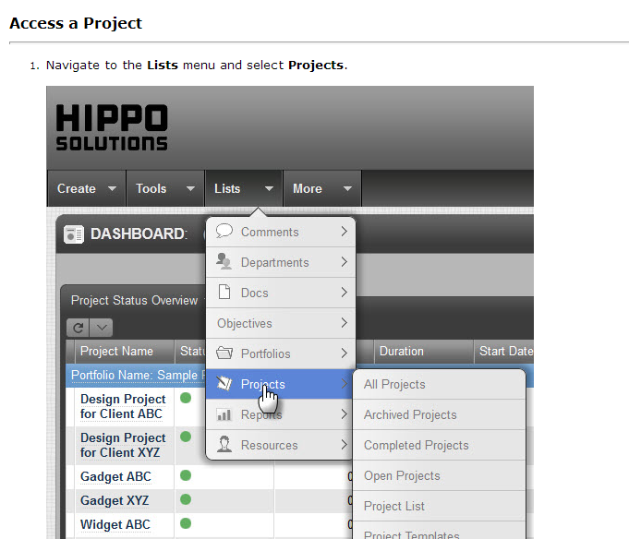
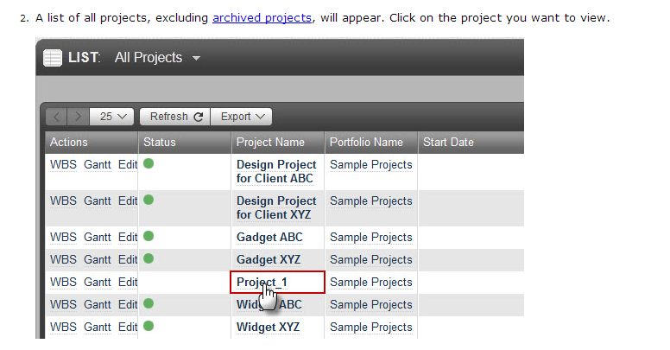

Export a Project

- Navigate to the main project page. (See Projects)
- In the project toolbar, click Export to reveal the export drop-down menu. Menu options include:
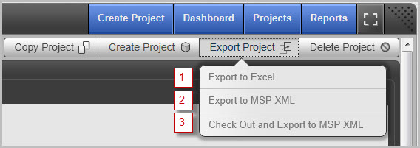
  - Export to Excel
  - Export to MSP XML
  - Check out and Export to MSP XML - The project can be checked in later after changes are made in MS Project. Note: Export to Excel requires MS Excel 2000 or above. Export to MSP XML requires MS Project 2002 or above.
- After making a selection, open or save the file onto your computer.

Import a Project (Uploading projects is the preferred method, see the next section of this document)

- From any page, go to Tools > Import Project.
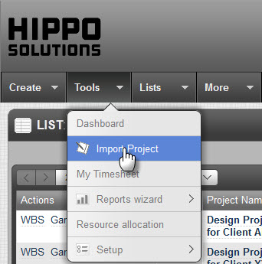
- The following pop-up window will appear. Fill out each field as follows:
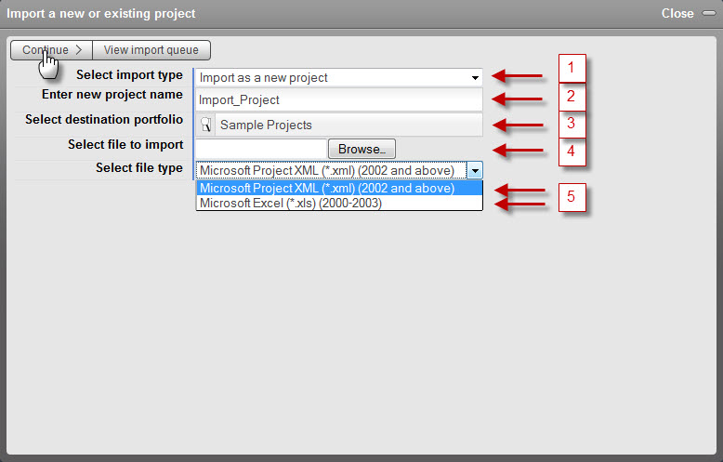
  - Select import type: Select either to import a new project or to update and check in an existing project.
  - If import as a new project is selected, enter a unique name for the project.
  - Select a destination portfolio for the project. For more on this topic, see Portfolios.
  - Select a file to import. Select either a Microsoft Excel .xls file or a Microsoft Project .xml file. Note: The Hippo Hub can import MS Excel files with a .xls file type only. XML files must be from MS Project 2002 or later.
  - Select the file type (Excel or Project).
  - Click Continue.

Upload a Project

The following are the steps to upload a project:
- Launch the Upload Tool.
  - The Upload Tool can be accessed from the main Tools menu or the Upload Project blue button.
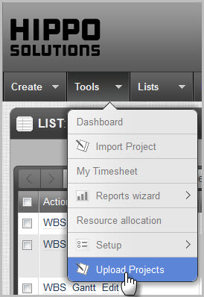
- Click the Choose Files button or drag and drop files into the upload area.
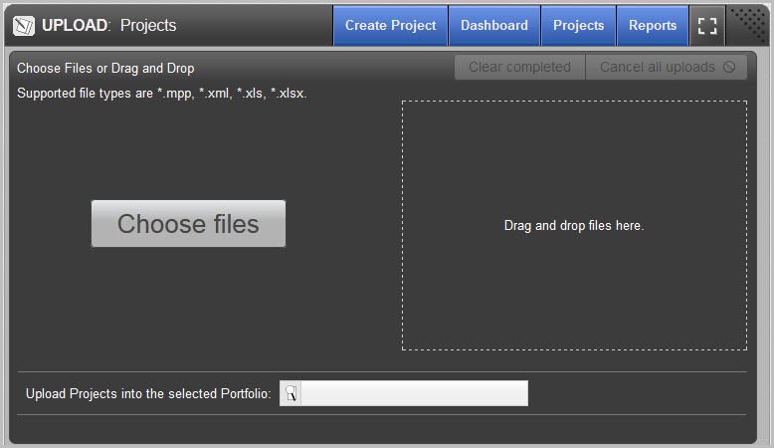
  - Note: Currently, only Firefox and Chrome support drag and drop.
  - Supported file types for upload are:
    - .xls
    - .xlsx
    - .mpp
    - .xml (Microsoft Project)
  - Click the check box to create new Resources in your files. To ensure these will be created for Excel files, make sure the resources are entered correctly. For more on this, consult the Formatting Excel Files for Upload tutorial.
- Your files will be processed into HippoHub. When the files have completed their upload, they will appear in the Recently Uploaded Projects list.

Tasks and Schedules:
There are several project schedule views in Hippo. Views can be personalized to fit your needs.
- Tasks and schedules can be managed in the Gantt view:
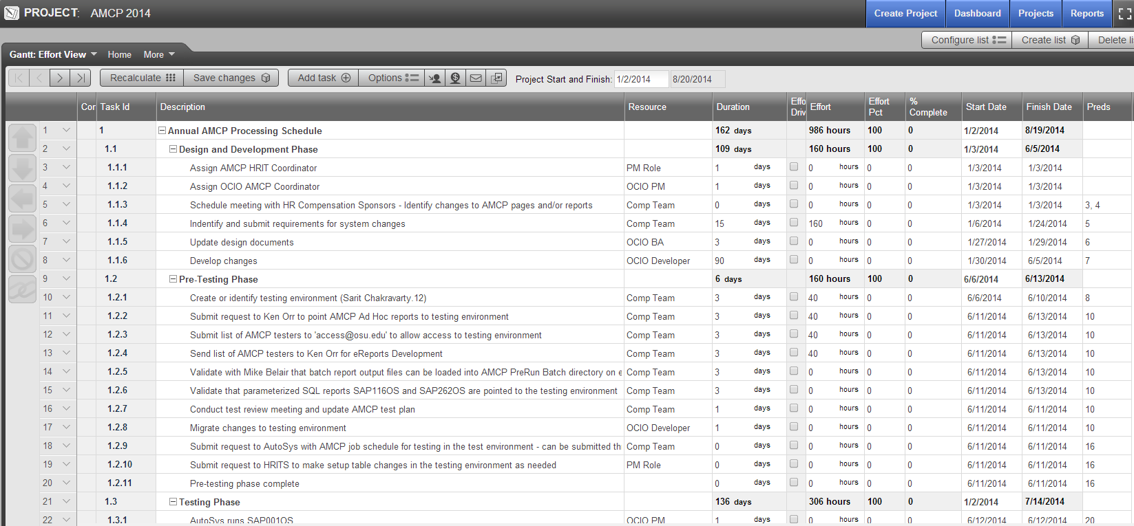
- or the Work (WBS) view:
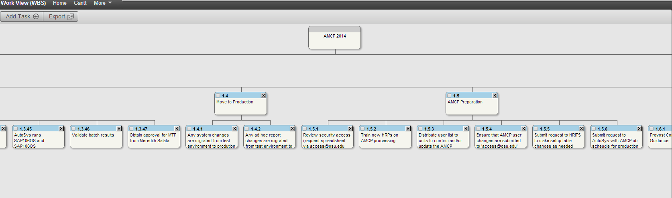

Options for modifying the schedule are found in the Gantt Options window. Click the Options button on the top menu bar in the Gantt view.

Scheduling in the Gantt Chart

Scheduling is the process of generating start and finish dates for the tasks in your projects (and thus the start and finish dates for your projects).
There are two primary methods of scheduling start and finish dates:
- Manually entering start and finish dates (see Scheduling with Manual Input).
- Letting the system calculate the start and finish dates through dependencies (see Schedule with Dependencies).
All scheduling is performed in the Gantt Chart. If you make a change that would warrant a recalculation of the schedule, the system will prompt you to recalculate the schedule. You may also click on the Recalculate button to force a recalculation of the schedule.
Scheduling Rules

The following rules govern how the system schedules the start and finish dates for the tasks in your project:
- All tasks must start on or after the project start date. If you want to enter a start or finish date for earlier than the project start date, first change the project start date.
- When you manually enter a start date for a task, the system will store that date as a constraint date, meaning that the task cannot start before the date that you entered.
- The start date for a task will be the later of the following dates:
  - The constraint date entered for the task (same as the start date you manually entered for the task).
  - The latest date that a predecessor task is scheduled to finish. See Schedule with Dependencies.
  - The start date of the task's summary (parent) task.
  - The start date of the project.
- The finish date for a task will always be the start date of the task plus the entered duration of the task.

Create Dependencies:
The following process outlines how to create dependencies using both the link button and the Preds column:
- Navigate to the project's Gantt Chart.
- Create a dependency using the link button. First, select the task for which you want to create a dependency (predecessor). Next, select the task with a control click (ctrl+click) that will create the dependency (successor). Click the link button. In this example, task Engineering will succeed task Research.
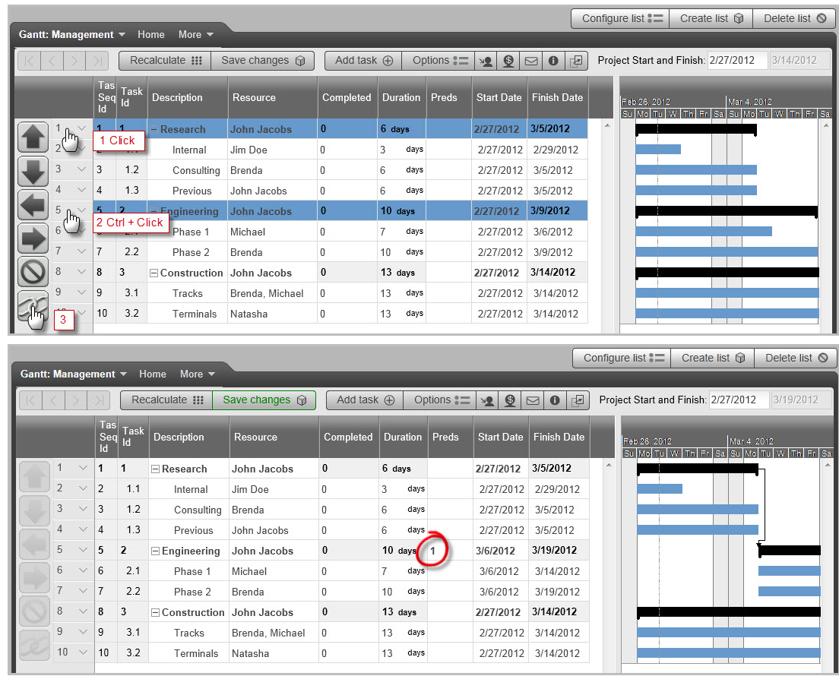
- Note: The order in which the tasks are clicked is important, as the first clicked task becomes the predecessor, and the second clicked task becomes the successor. For example, to specify that Task A will be performed before Task B, click Task A, and then ctrl+click Task B. Note: You can create dependencies between multiple, consecutive tasks at the same time by clicking on multiple tasks in the order they will be scheduled before clicking on the link button.
- Alternately, you can create a dependency by manually entering the dependency into the Preds column. Dependencies by default are Finish to Start, but can be changed to Start to Start or Finish to Finish by attaching "SS" or "FF" to the task number of the predecessor, respectively . Click Recalculate and Save changes.
- For example, this project was given a Start to Start dependency:
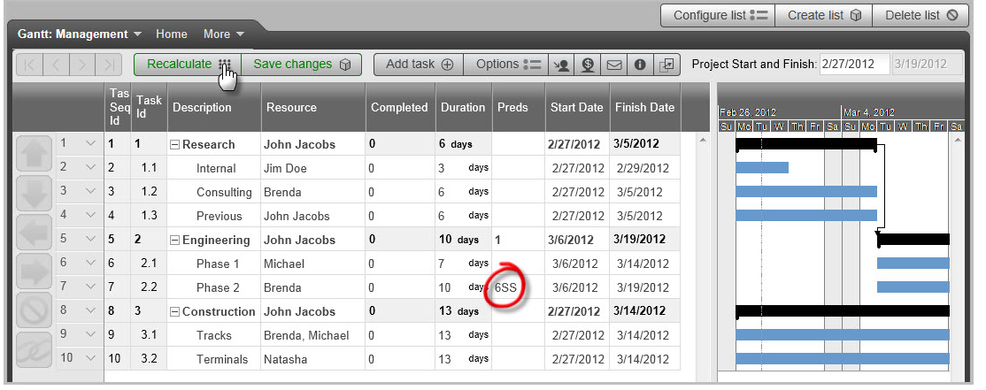

Delete Dependencies

Dependencies can be deleted using the following steps:
- Select a task from the Gantt Chart.
- Delete the number in the Preds column that represents the dependency you want to delete.
- Click Recalculate and Save your changes.

Lead and Lag Time

Tasks can be assigned dependencies that contain a lead or lag period.
- Lag time is the amount of time between two tasks. For example, after design is completed, there is a two day lag before development will start.
- Lead time is the amount of overlap time between two tasks. For example, development starts two days before design is complete.
Entering dependencies with lead or lag time is done as follows:
- Enter the predecessor task number into the Preds column followed by a "+#" for lag time or "-#" for lead time. Here, # represents the number of days to lead or lag.
- The following is an example of a task with a Finish to Start dependency with one day of lead time.
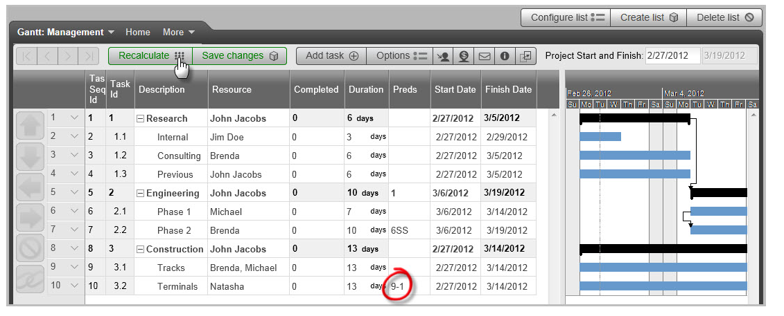
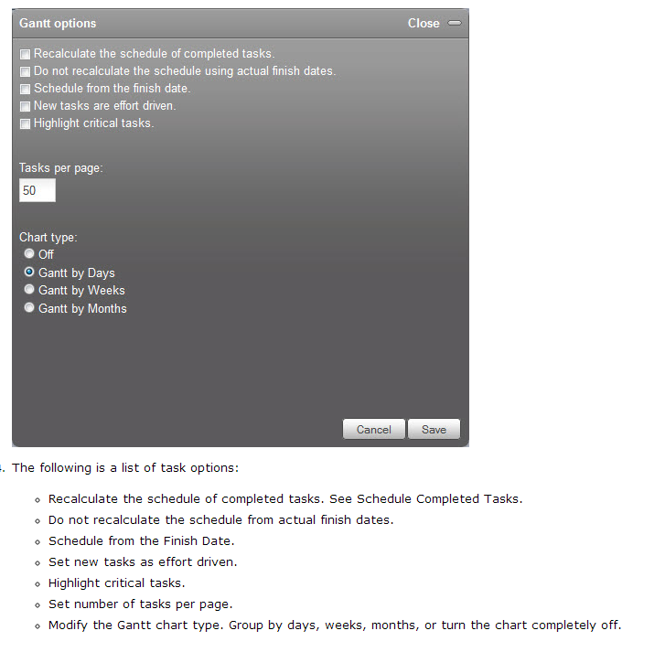

TimeSheets:

Update the status of a task –
Resources will see all tasks assigned to them for the current week on their My Timesheet page (Tools, My Timesheet). Tasks may be marked 100% complete by placing a ‘check mark’ in the box to the left of the task or entering “100” in the % Complete field.

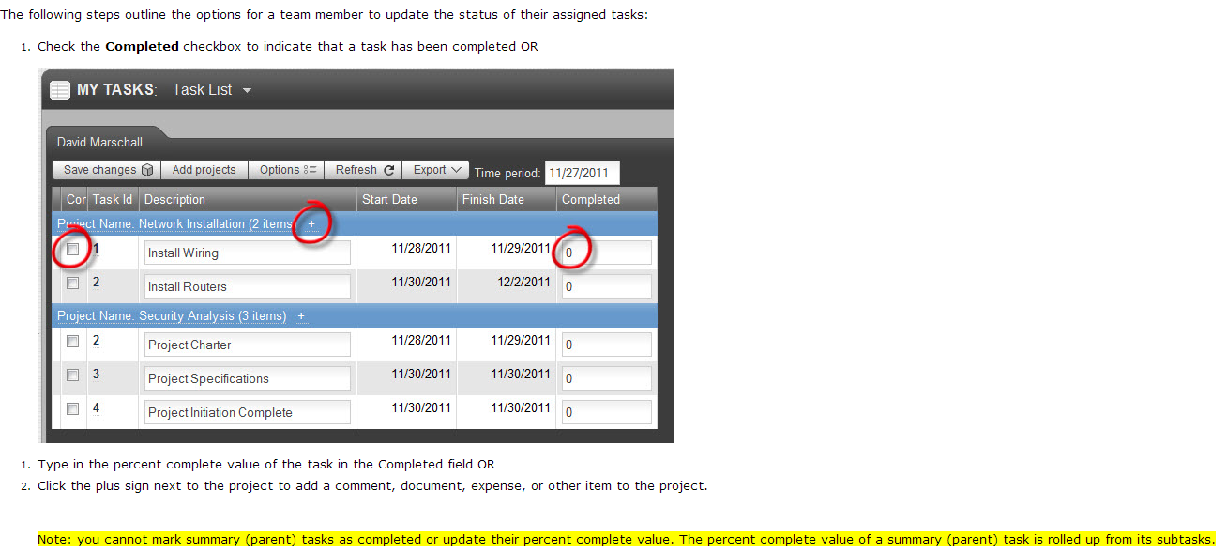
Dependent tasks will not be rescheduled until the Project Manager has recalculated and resaved the project.

Reports:

Users may go to the Reports tab and click on any report to run it.

Create a report –

Select the Reports window and click on Create New Report –
The reports wizard is a series of 5 to 9 steps (depending on the report type) to define the format for the report. To access the reports wizard, see Reports.
You can navigate the wizard by doing the following:
- Go back and forth between steps using the Previous Step and Next Step buttons.
- Click on the View sample button to run a sample of the report.
- Click on the Save changes button to save the report definition.
- Select a different step in the Report Step drop-down field to jump to a specific step.
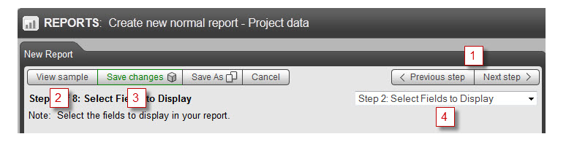
The reports wizard includes the following steps (some of these steps may not be available depending on the Report Type).
- Enter Report Information - enter essential information about the report
- (Matrix Report Only) Enter Matrix Options - format the matrix section of the report to either look like an Excel spreadsheet or an Excel pivot table.
- Select Fields to Display - select the fields to include in the report
- Select Field Display Order - select the order of the fields in the report
- Select Field Preferences - select the fields to sum and unit type; hide or display unit labels
- Select Sorting - select how the data in the report will be sorted
- Select Groupings - select how the data in the report will be grouped
- Enter Field Criteria - enter report filter criteria
- Enter Object Restrictions - restrict items included in the report
- Enter Chart Options - create a chart from the report data

Schedule a report –
Select the Reports tab and click on the Schedule link next to the report you want to distribute. Click on the Add Schedule button.
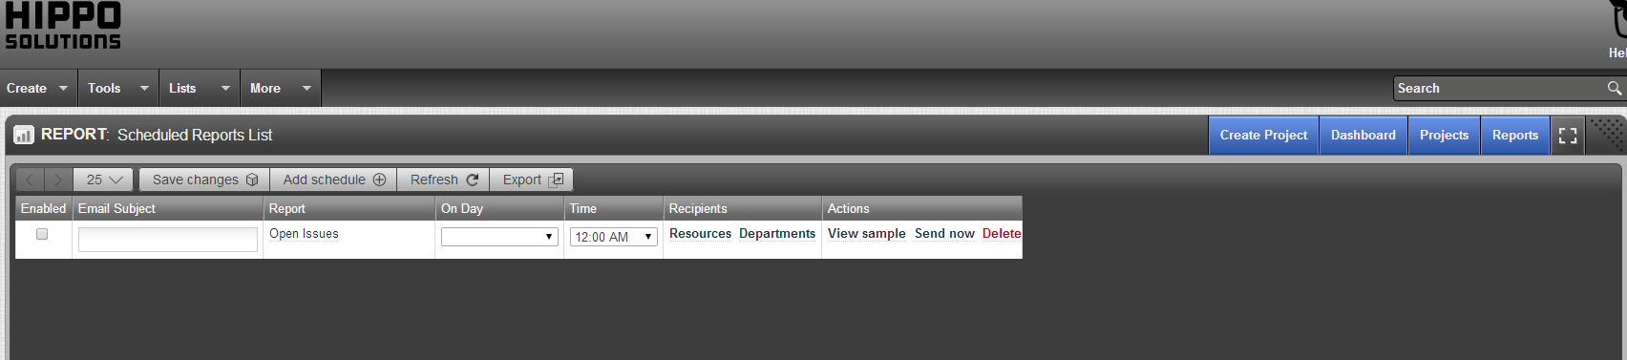
Check on the Enable box, enter the e-mail address and the schedule information. Resources or Departments can be selected from the Recipients column if the recipient has been set up in the tool. Once all appropriate information has been entered, click on the Save Changes button.

