Hi, my name is Zheng Guan, you can also call me Peter. I like sports like riding, swimming and playing table tennis. So, if you want to do some sports, you can find me in the RPAC. As I lived in China, I had been to many beautiful places as well. My most favorite place is the Great Wall, which is a super cool place to travel. As when you are traveling the Great Wall, you will be amazed by the hardness, which ancient people could build such a long wall without the machine.

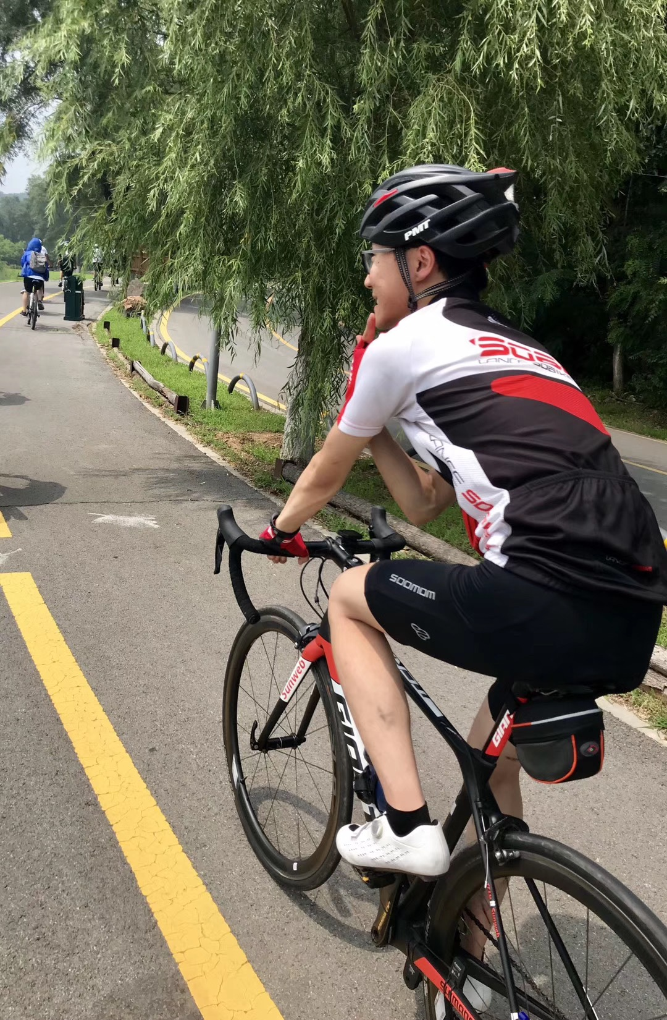
Riding on the road of Qipan Mountain
I come from Liaoning province, China. Liaoning is a great place to go, as it has many beautiful places to go, such as Qipan mountain, which is a great place to ride the bike as it has many fluctuate roads which also has a long river near the road, so that when you are riding bikes, you can watch some beautiful scene beside the river. Also, if you have a good road bike, you can join road bike teams, which could travel around this mountain at a really fast speed.

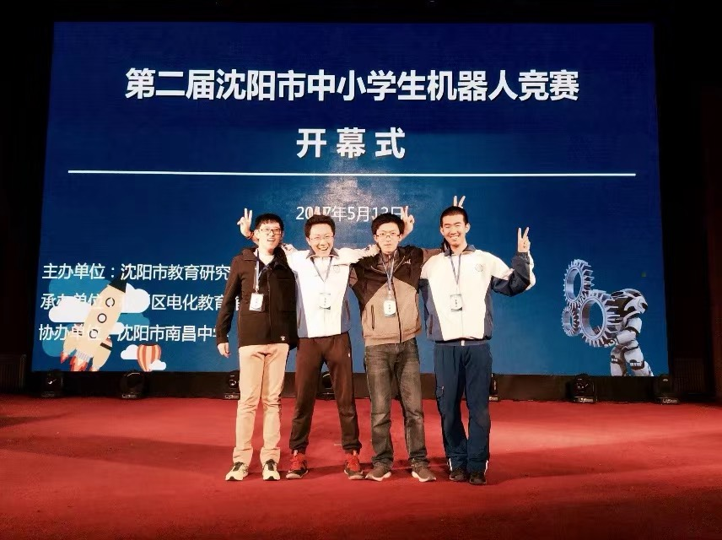
Picture of robot competition.

The reason why I choose OSU is that Ohio State is a great place to live, in winter, it is not as cold as the place I used to live, which the temperature will decrease to about -25 degree centigrade. The major that I want to choose is Computer Science, which related to Artificial Intelligence, which is a super hot major in the market. I choose this major mainly because of my interest in the robot, although I know how to build a robot a give some order to it, I still don’t know how to make it more intelligent, which could understand what I am talking about and do something by itself without giving the specific orders.

