Bienvenidos a Español 3

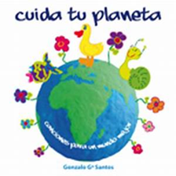
Unidad de la sostenibilidad global

This unit is about sustainability. Throughout the week the students will be learning about our need to protect our environment. They will end the week by working on their culminating sustainability project that we can pursue at our school.
Below you can find the links to the lesson plans and supplementary materials I have included all of the video clips that the students will be viewing during the week.

Lunes
Vocabulario del ambiente

Lesson Plan 1-Vocabulary
Ejercicio de calentamiento
Google Slide Unidad de la sostenibilidad global
Homework Natural catastrophes
Exit slip question 1

Martes
Natural Disasters in Latin America and the Caribbean-Relief Web

Lesson Plan 2
Ejercicio de Calentamiento
Exit slip question 2

Miércoles
The Water Crisis in Mexico
Lesson Plan 3
Ejercicio de calentamiento
Google Slide Anuncios para preservar el agua
Exit slip question 3

Jueves
Fixing the Environment
Lesson Plan 4
Ejercicio de calentamiento
Exit slip question 4

Viernes
What can we do for the environment?
Lesson Plan 5
Ejercicio de calentamiento
Prueba

Lunes a Miércoles
Homemade salsa-Homemade salsa

Lesson Plan 6
Material for Lesson 6
Ejercicio de calentamiento
Exit slip question 5

Vocabulario del medio ambiente: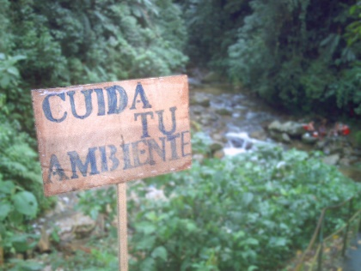
Environmental Vocabulary
Rationale: This unit will primarily focus on the environment, particularly environmental concerns. This lesson will introduce students to the basic vocabulary necessary to discuss the environment both in and outside of the classroom. Given that the environment is a growing concern worldwide it seems fitting for students to learn the vocabulary corresponding to this unit so that they may come up with a sustainable project for our Spanish class in order to teach them to be better citizens of our North High School global community.
Learning Goals: Students will be able to utilize the new vocabulary for the environment unit. Students will be able to understand environmental vocabulary when viewed in expository text and seen in
Learning Objectives: Students will be able to engage in basic conversation on the environment and environmental concepts.
Grade Level: 10th Grade -12th grade Spanish Level 3, 45-minute class
Ohio Learning Standards:
INTERPRETIVE COMMUNICATION:
1. Derive meaning from more detailed messages and texts using listening, reading and viewing
2. Analyze how authentic sources convey viewpoints and use authentic sources critically.
3. Comprehend and interpret more detailed information in authentic messages and
informational texts
4. Comprehend and interpret more detailed information about the main idea and
relevant details in authentic literary texts.
INTERPERSONAL COMMUNICATION:
- Negotiate meaning using more sophisticated requests, clarifications and conversation strategies.
- Interact with others using culturally appropriate language and gestures on familiar and some unfamiliar topics.

PRESENTATIONAL COMMUNICATION:
- Present information, concepts and viewpoints on familiar and some unfamiliar topics from across disciplines.
National Standards (ACTFL):
1.2 Students understand and interpret written and spoken language on a variety of topics.
3.1 Students reinforce and further their knowledge of other disciplines through the foreign language.

Teaching Methods: Internet resources, recitation and repetition- I will have the students repeat words I say aloud as we go through the new vocabulary terms and then go home and use the quizlet program to further practice in class. Their homework will be to review what we have learned in class using the quizlet we used in class. Direct instruction with visuals – I will use a Google slide presentation to give a visual representation of the new vocabulary words that the students will be learning while they take notes about the lesson.

References & Materials: Bell work: I will project in a Google Slide a warm up exercise with a series of blank spaces for verb tenses so that while the students are waiting for class to begin they can conjugate one of the verbs that they have previously been familiar with and will be reviewing in the new unit.
Procedures:
1. “Calentamiento/Bell work” Students are expected to take their seats and begin their calentamiento assignment (a routine that will already be established in my classroom). The verb to be conjugated will be projected on the whiteboard, for this lesson the verb will be: “destruir” (to destroy) in the “yo” form – 2 minutes
2. When students have finished conjugating the verbs on the handout, I will ask the first few students who finish and are correct in their conjugations to write up the answers on the whiteboard and/or out loud so that the rest of the students can check to see if they were correct. – 3 minutes
3. I will introduce the class to our new unit on the environment and using the Google Slide will ask them what words they think they may already know that relate to the environment. As a class we will compile a list of vocabulary words we are already familiar with. – 5 minutes
4. Next, I will discuss that most environmental vocabulary words are cognates and will proceed with the rest of the Google Slide by asking students to repeat words after I have said them and to take notes on the new vocabulary. – 25 minutes
5. We will end by playing a vocabulary game where I will split the class into 5-6 teams (my classes are very large usually I have 25-32 students), ask students to close their notes, and then I will say a vocabulary word either in English or in Spanish and call on the first student to raise his or her hand to say the word in the opposite language, The students will keep score in their notebook and I will keep score on my whiteboard. The winning team will get an extra credit for the current quarter. – 13 minutes
6. I will conclude class by asking students to review their new vocabulary words and reminding the students that I class notes are posted in Schoology so that they can review any words that they may have missed in their notes because there will be a mini vocabulary quiz on Friday (by this point in the year students will know that mini 10 question quizzes are routinely given every Friday). Students will also receive a handout on natural disasters that will be used in class on the following day, they will be asked to read the handout for homework. – 2 minutes

Assessment: For formative assessment: The students will be assessed on pronunciation and overall class participation. Also, the game will help me assess which vocabulary words and which groups need more clarification on the information learned on that day. A summative assessment will be given on Friday. This is a mini vocabulary quiz consisting of 10 vocabulary words that the students must identify. Additionally, at the end of the unit students will be evaluated based on their sustainability projects for our Spanish class.

Sources:
http://education.ohio.gov/getattachment/Topics/Learning-in-Ohio/Foreign-Language/FINAL_PreK-12_Standards_with_links_dec5_2018.pdf.aspx?lang=en-US
https://www.actfl.org/

Martes: Natural Disasters in Latin America and the Caribbean-Relief Web
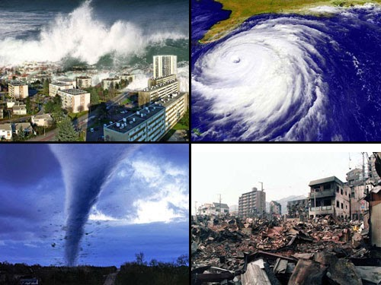
Rationale: This unit will primarily focus on the environment, particularly on recent environmental concerns in Latin American countries. This lesson will explore natural disasters in Latin America and will give students a better understanding of why it is important for us as humans to take care of our planet. The students will gain a better understanding of natural disasters in the world around them and their significance. They will also be able to practice their presentation and public speaking skills. By working in groups students will be able to engage in conversation about real events and issues that have taken place recently.
Learning Goals: Students will be able to use the new environmental vocabulary they have learned to present new material to the class. Students will be able to engage in dialogue with one another about the environment in Latin America, the Caribbean and in the world. Students will be able to research topics about Latin American countries and either be able to translate from English to Spanish or be able to read expository text in Spanish.
Learning Objectives: Students will have a better understanding of the effects of global warming and other damages to the environment through research on specific natural disasters. Students will also understand the significant damages that occur due to natural disasters. Students will understand how international events affect us globally.
Grade Level: 10th Grade-12th Grade Spanish Level 3, 45-minute class
Ohio Learning Standards
INTERPRETIVE COMMUNICATION
2. Analyze how authentic sources convey viewpoints and use authentic sources critically
f. Synthesize information from authentic sources to solve complex problems, complete multi step tasks or reinforce concepts across the curriculum.
g. Compare and contrast two or more literary selections that share the same topic but represent different genres.
PRESENTATIONAL COMMUNICATION:
l. Synthesize detailed interdisciplinary information and content to create and present more extensive reports, presentations and/or projects.

Cultures:
Gain and use knowledge and understanding of other cultures.
- As they participate in multilingual communities and various cultures at home and around the world, both in person and via technology, they come to understand and abide by the constraints and freedoms afforded to individuals in the target culture(s) and their own.
National Standards (ACTFL):
3.1 Students reinforce and further their knowledge of other disciplines through the foreign language.
1.3 Students present information, concepts, and ideas to an audience of listeners or readers on a variety of topics.
1.2 Students understand and interpret written and spoken language on a variety of topics.
1.1 Students engage in conversations, provide and obtain information, express feelings and emotions, and exchange opinions.

Teaching Methods: Traditional group work – Students will be assigned to groups of 3-4 students and will be asked to research and present on a specific natural disaster that has occurred in a Spanish speaking country.

References & Materials: Students will each have a Chromebook to work on. Students will already have read a handout on natural disasters that will have been given to them on the previous day and assigned as reading for homework.
Procedures:
1. Students will be assigned into groups as they enter the room and will be asked to sit in their groups of approximately 3-4 students. – 3 minutes
2. I will ask for a few students to summarize in English their own words the main points of the article that they read for homework the night before and then explain that they will be researching a specific natural disaster that has affected Latin America and the Caribbean and presenting that natural disaster to the class by the end of the period in a quick 2-3 minute presentation. – 7 minutes
3. Students will then begin working in groups reading the article they were assigned and creating a class presentation. During this time, I will be circulating the room to help students with any questions and also to make sure that everyone is actively involved in the group discussion and presentation. – 23 minutes

· Group 1: Natural Disasters in Costa Rica 2020

· Group 2: Puerto Rico, rattled by earthquakes, braces for flooding and landslides from Karen 2019

· Grupo 3: 2019 Climate crisis threatens Latin America’s food production model
· Group 4: Hurricane Dorian grazes Puerto Rico 2019

· Group 5: Climate variability and forest fires in central and south‐central Chile 2018

4. Students will present their 2-3-minute presentations in English. – 15 minutes
Students might not have time for their presentations so the lesson might have to be carried over the next day.
Assessment: Students will be evaluated in terms of class participation based on their overall involvement throughout the class period and also their public speaking during the presentation. In terms of summative assessment students will be evaluated at the end of the unit based on their contribution to our class sustainability project.
Sources:
https://costa-rica-guide.com/travel/health-safety/natural-disasters/
https://www.cnbc.com/2019/09/24/puerto-rico-rattled-by-earthquakes-braces-for-flooding-and-landslides-from-karen.htmlhttps://dialogochino.net/en/agriculture/29623-climate-crisis-threatens-latin-americas-food-production-model/
https://www.bbc.com/news/world-us-canada-49500643
https://esajournals.onlinelibrary.wiley.com/doi/10.1002/ecs2.2171
http://education.ohio.gov/getattachment/Topics/Learning-in-Ohio/Foreign-Language/FINAL_PreK-12_Standards_with_links_dec5_2018.pdf.aspx?lang=en-US
https://www.actfl.org/

Lesson Plan 3
La crisis de agua en México – The Water Crisis in Mexico

Rationale: This unit will primarily focus on the environment, particularly environmental concerns in México. This lesson will introduce the water crisis in Mexico, to the students so that they can understand issues of water conservation in relation to environmental awareness. The environmental vocabulary that they have learned from the previous classes will also be used in the video clips and therefore will also be reinforced through group discussion.

Learning Goals: Students will be able to discuss the water crisis in Mexico and have a basic understanding of the main issues with water conservation. Students will be able to use the new environmental vocabulary they have learned in applicable discussions. Students will brain storm on advertisements promoting water conservation. Students will also be able to apply their knowledge of the water crisis in Mexico to the greater global problem of water conservation.

Learning Objectives: This lesson will allow students to comprehend the significance of water conservation throughout the globe by focusing in on a specific Spanish speaking country, Mexico. Students will have a greater understanding of how words can have different meanings in different Spanish speaking countries.

Grade Level: 10th Grade-12th grade, Spanish Level 3, 45-minute class

Ohio Learning Standards

INTERPRETIVE COMMUNICATION
2. Analyze how authentic sources convey viewpoints and use authentic sources critically
f. Synthesize information from authentic sources to solve complex problems, complete multi step tasks or reinforce concepts across the curriculum.
g. Compare and contrast two or more literary selections that share the same topic but represent different genres.
PRESENTATIONAL COMMUNICATION:
l. Synthesize detailed interdisciplinary information and content to create and present more extensive reports, presentations and/or projects.
Cultures:
Gain and use knowledge and understanding of other cultures.
- As they participate in multilingual communities and various cultures at home and around the world, both in person and via technology, they come to understand and abide by the constraints and freedoms afforded to individuals in the target culture(s) and their own.

National Standards (ACTFL):
1.1 Students engage in conversations, provide and obtain information, express feelings and emotions, and exchange opinions.
1.2 Students understand and interpret written and spoken language on a variety of topics.
3.1 Students reinforce and further their knowledge of other disciplines through the foreign language.
3.2 Students acquire information and recognize the distinctive viewpoints that are only available through the foreign language and its cultures.

Teaching Methods: Video – I will show Mexican commercials promoting environmental concern as well as a video clip discussing the struggles to provide public with clean water using Edpuzzle.

Direct instruction with visuals – I will present the clean water issue in Mexico to the students for students to take notes on, but will include a multimedia presentation through pictures in a Power Point presentation that emphasize CONAGUA campaign advertisements.

References & Materials: At their desk’s students will work on their “Calentamiento”. While the students are waiting for class to begin, they will conjugate one of the new vocabulary verbs they have learned earlier in the week. I have created a Google Slide with advertisements to show to the class while having a discussion on each advertisement done by the Mexican government’s CONAGUA program. The Google Slide will include an Edpuzzle exercise on the crisis of water in Mexico. If I have time I will discuss the four video clips from YouTube that I have added to my Google Slide.

Procedures:
- “Calentamiento” students will be expected to take their seats and begin the Calentamiento exercise (a routine that will already be established in my classroom). The verb to be conjugated will be on the blackboard, for this lesson the verb will be: contaminar (to contaminate) in the usted form – 3 minutes
- I will call on students to state their answer to each of the verb conjugations on the handout just to be sure that everyone understands the new vocabulary word contaminar. – 4 minutes
- ¿Qué saben de la crisis de agua en México? I begin the discussion by asking students what they think they already know or have heard about relating to the water problem in México. Students will have time to give me their input and background knowledge on the topic – 5 minutes
- Google Slide– I will then pull up my Google Slide presentation using the first slide with the video clip of the lack of water in Mexico – 3 minutes
- ¿De qué habla? After the video clip I will ask the students what the was discussed in the video and I will ask them to share with me their thoughts on the problem. Then I will ask the students to do an Edpuzzle exercise to further discuss understanding of the video. – 14 minutes
- The slide show will then continue with popular advertisements from the Mexican Conagua program. I will ask the students what each advertisement says and what type of audience each ad would be targeted at. – 8 minutes
- ¿De qué se trata? There will also be seven commercials that we will watch along with the slide show. After each video I’ll ask the students what the a couple of commercials were about and ask them if there are similar commercials here in the United States. – 8 minutes
- ¿Es la escasez del agua sólo un problema para México? To conclude the class, I will ask the students what their opinion is on whether or not the water problem is and will only be a problem for Mexico or if it is a greater global problem and what our responsibility entails. I will also remind students that they will have a mini quiz on environmental vocabulary on Friday. – 5 minutes
Assessment: As a form of formative assessment students will be assessed on their participation in class discussion and whether or not students understand the media presentation that they will be watching. Their understanding of the clip using Edpuzzle will be another formative assessment for this lesson. In terms of summative assessment students will be evaluated at the end of the unit based on their sustainability project for our Spanish class.
Sources:
http://www.cienciamx.com/index.php/ciencia/ambiente/24452-la-crisis-del-agua-en-mexico
https://www.youtube.com/watch?time_continue=3&v=LgNfJG2SFDE&feature=emb
https://www.gob.mx/conagua
https://www.youtube.com/watch?v=BFZD27U3zYM
https://www.youtube.com/watch?time_continue=4&v=pET0Fx6RlR8&feature=emb_logo
https://www.youtube.com/watch?time_continue=142&v=xDKpLhmimX4&feature=emb_logo
https://www.youtube.com/watch?v=obUVJ7BnvpI
https://www.nestle-waters.com/stories/water-use-awareness-campaign-in-mexico
https://docs.google.com/presentation/d/1pGIzOoXGd3dsQXWVb5fPbGUK_axTX7U4TGw3WoBmMxg/edit#slide=id.p9
https://edpuzzle.com/media/5f14de5800f25b3f2f0b3c28/edit

Lesson Plan Day 4
Jueves
Fixing the Environment

Reparando el medio ambiente– Fixing the Environment

Rationale: This unit will primarily focus on the environment, particularly environmental concerns in Latin American countries. This lesson will introduce students to environmental advancements that have occurred recently in relation to Spanish speaking countries. The articles will show students examples of expository text from Latin America, specifically Costa Rica.

Learning Goals: Students will be able to use the new environmental vocabulary they have learned in applicable discussions. Students will be able to read aloud text relating to the new unit of the environment. Students will be able to summarize the purpose of a literary text and the focus of a media clip. Through the video clip from….. , students will be able to discuss the variation in accents of different Spanish speaking countries.

Learning Objectives: This lesson will allow students to understand the ways in which Spanish speaking countries have attempted to become more environmentally conscious and environmentally friendly. Students will also be exposed to expository text and will be able to comprehend the significance of expository text, which revolves around everyday life. Students will understand how international events are significant globally and also domestically.

Grade Level: 10th Grade-12th grade, Spanish Level 3, 45-minute class
Ohio Learning Standards
INTERPRETIVE COMMUNICATION
2. Analyze how authentic sources convey viewpoints and use authentic sources critically
f. Synthesize information from authentic sources to solve complex problems, complete multi step tasks or reinforce concepts across the curriculum.
g. Compare and contrast two or more literary selections that share the same topic but represent different genres.
PRESENTATIONAL COMMUNICATION:
l. Synthesize detailed interdisciplinary information and content to create and present more extensive reports, presentations and/or projects.
Cultures:
Gain and use knowledge and understanding of other cultures.
- As they participate in multilingual communities and various cultures at home and around the world, both in person and via technology, they come to understand and abide by the constraints and freedoms afforded to individuals in the target culture(s) and their own.
National Standards (ACTFL):
1.1 Students engage in conversations, provide and obtain information, express feelings and emotions, and exchange opinions.
1.2 Students understand and interpret written and spoken language on a variety of topics.
3.1 Students reinforce and further their knowledge of other disciplines through the foreign language.
3.2 Students acquire information and recognize the distinctive viewpoints that are only available through the foreign language and its cultures.

Teaching Methods: Reading Activity – For this lesson I will use the reading of one source from Costa Rica. The text will be read aloud by having each student read a paragraph going down the room in order.

Video – I will play a video clip concerning wind energy in Spain and then the class will discuss what the video focused on. Lecture/Direct Instruction – I will introduce the latest advancements in environmental action specifically related to Spanish speaking countries.

References & Materials: Mini quiz on environmental vocabulary, 2 articles on Costa Rica’s reduction of military spending, and YouTube video clip on Spain’s solar energy (handouts are attached and sources for video and articles are listed at the bottom).

Procedures:
- “Calentamiento/Bell work” Students are expected to take their seats and begin their calentamiento assignment (a routine that will already be established in my classroom). The verb to be conjugated will be projected on the whiteboard, for this lesson the verb will be: “Utilizar” in the “tú” form – 2 minutes
- When students have finished conjugating the verbs on the handout, I will ask the first few students who finish and are correct in their conjugations to write up the answers on the whiteboard and/or out loud so that the rest of the students can check to see if they were correct. – 3 minutes

- I will ask the students to pair off and discuss the text and look up and define any words that they did not know before reading the article. – 20minutes
- Students will be asked to summarize the main arguments of each article and to compare and contrast each article while I take notes in a compare/contrast diagram on the board. – 8 minutes
- The students will then watch a YouTube video clip “¿Qué es energía elógica?.” – 6 minutes
- I will then ask what the students to answers the questions on an Edpuzzle on “¿Qué es energía elógica?” – 8 minutes
- To conclude the class, I will ask students to begin thinking of ways that we can make a difference in our environment in our high school in preparation for the following days lesson. – 4 minutes

Assessment: For formative assessment students will be evaluated on class participation and discussion. I will be looking to see if students volunteer to read the text aloud and if students are engaged in group discussions. In terms of summative assessment students will be evaluated at the end of the unit based on their class project on sustainability

Sources:
http://education.ohio.gov/getattachment/Topics/Learning-in-Ohio/Foreign-Language/FINAL_PreK-12_Standards_with_links_dec5_2018.pdf.aspx?lang=en-US
https://www.actfl.org/
http://www2.eie.ucr.ac.cr/~jromero/sitio-TCU-oficial/boletines/grupo01/numero-10/Boletin-10.htm

https://edpuzzle.com/media/5f14faeab5f0303f0d467cd2

Lesson Plan
Jueves y Viernes
Fixing the Environment
Video Clip in youTube
https://www.youtube.com/watch?v=X0B5HcheNIA

Video events
00:25
- Multiple-choice question
¿Cuándo se inauguró la primera presa hidroeléctrica de México?
00:35
- Multiple-choice question
¿Cuántos molinos de viento hay en el parque eólico Pier 2?
00:47
- Multiple-choice question
¿Qué es la energía eólica?
00:59
- Multiple-choice question
La energía eólica también es llamada energía __________.
01:14
- Multiple-choice question
What does the word vientomeans?
01:42
- Multiple-choice question
¿Cuáles son los elementos utilizados para generar energía alterna?
02:10
- Multiple-choice question
¿Cuántos parques eólicos ha construido la empresa española en México?
02:32
- Multiple-choice question
¿Cuántos parques más piensa crear la empresa española en México?
Lunes a Miércoles
Homemade salsa-Homemade salsa

Homemade Salsa-Salsa casera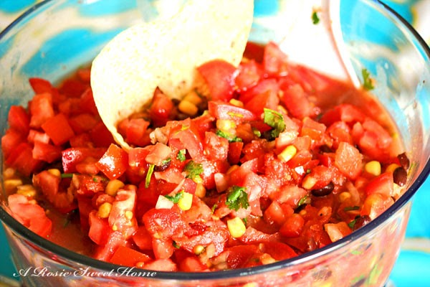
Rationale:
My goal is to have my students learn about ingredients in order to make homemade salsa. This is a 3 day lesson that will end the unit of environmental awareness and will serve to tie together what the students have learned throughout last week. Students will be able to better understand how they can make a small difference in the world.
Learning Goals: Students will be able to use the new food vocabulary they have learned to present new material to the class. Students will be able to engage in dialogue with one another about . Students will be able to research topics about how to prepare salsa and either be able to translate from English to Spanish or be able to read expository text in Spanish.
Grade Level: 10th Grade -12th grade Spanish Level 3, 45-minute class
Ohio Learning Standards:
INTERPRETIVE COMMUNICATION:
1. Derive meaning from more detailed messages and texts using listening, reading and viewing
2. Analyze how authentic sources convey viewpoints and use authentic sources critically.
3. Comprehend and interpret more detailed information in authentic messages and
informational texts
4. Comprehend and interpret more detailed information about the main idea and
relevant details in authentic literary texts.
INTERPERSONAL COMMUNICATION:
- Negotiate meaning using more sophisticated requests, clarifications and conversation strategies.
- Interact with others using culturally appropriate language and gestures on familiar and some unfamiliar topics.

PRESENTATIONAL COMMUNICATION:
- Present information, concepts and viewpoints on familiar and some unfamiliar topics from across disciplines.
National Standards (ACTFL):
5.1 Students use the language both within and beyond the school setting.
3.1 Students reinforce and further their knowledge of other disciplines through the foreign language.
1.3 Students present information, concepts, and ideas to an audience of listeners or readers on a variety of topics.
1.2 Students understand and interpret written and spoken language on a variety of topics.
1.1 Students engage in conversations, provide and obtain information, express feelings and emotions,
and exchange opinions.
Teaching Methods: Traditional pair work. Students will be asked to research and make a video preparing a homemade salsa.
References & Materials: Students will each have a Chromebook on their desk to work on the research for their topic as having accessibility to teachers Class notes in Schoology.

Procedures:
- Monday through Wednesday Students will have a “Calentamiento/Bell work” Students are expected to take their seats and begin their calentamiento assignment (a routine that will already be established in my classroom). The verb to be conjugated will be projected on the whiteboard, for this lesson the verb will be: “____ ” in the “ ella” form – 2 minutes
2. On Monday students will be assigned into pairs as they enter the room and will be asked to sit in their partners. – 3 minutes
3. I will introduce the class to our review food vocabulary (Spanish 2 review) and using the Google Document will ask them to
play quizlet live with the vocabulary we have reviewed. – 10 minutes
4. Next, I will proceed with the rest of the Google Doc by asking students to read outloud the instructions for the project.
– 25 minutes
5. Students will work in class and then at home on day 3 on preparing their video presentation.
Assessment:
FORMATIVE ASSESSMENTS:
Homework
Discussions
Observations during class activities
Oral class participation

SUMMATIVE ASSESSMENTS:
Vocabulary Quiz
Final Project: Video “Salsa Casera” Rubric 1: Communication
Sources:
https://www.youtube.com/watch?v=SPiCToYtUzo&feature=youtu.be
https://quizlet.com/516166716/lista-de-ingredientes-de-una-salsa-casera-flash-cards/?new
https://quizlet.com/516167881/utensilios-y-platos-flash-cards/?new
https://laespatulaverde.com/2017/12/27/chips-pan-pita-con-salsa-hecha-casa/
https://quizlet.com/516168497/instrucciones-para-hacer-una-salsa-casera-flash-cards/?new
https://quizlet.com/516174325/verbos-en-las-instrucciones-de-la-salsa-casera-flash-cards/?new
https://quizlet.com/516175861/regular-and-irregular-formal-command-endings-flash-cards/?new
https://docs.google.com/document/d/1Q2TnKfKqR4DmE8BLPBEkcqkML-EOgTvo-BomOEdJxlU/edit

VIDEO RECETA PARA SALSA CASERA
UTENSILIOS Y PLATOS
Quizlet

TENEDOR | CUCHILLO | TABLA DE CORTAR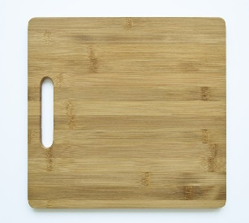 | CUCHARA

LICUADORA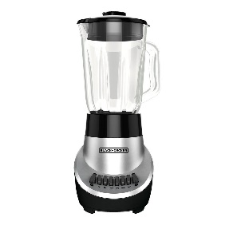 | PLATO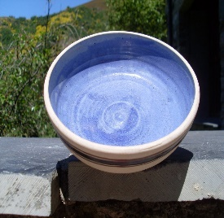  HONDO | 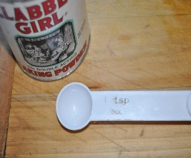  ½ CUCHARITA | 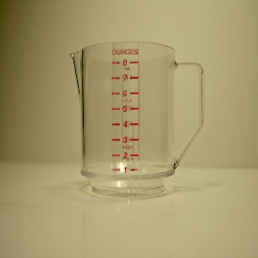  ¼ DE TAZA

RECETA PARA SALSA CASERA

LISTA DE INGREDIENTES
Quizlet

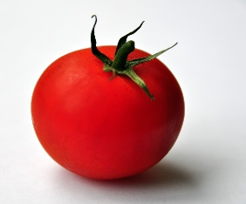  JIMOTE  O  TOMATE | SAL | (optional) AGUA
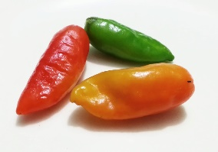  CHILE JALAPEÑO | 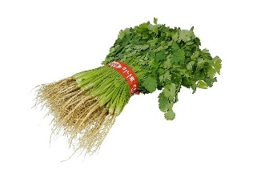  CULANTRO O CILANTRO | 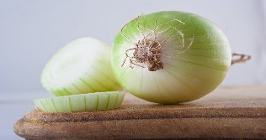  CEBOLLA
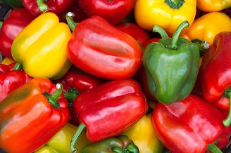  CHILE (opcional al chile jalapeño) | 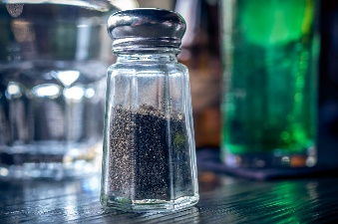  PIMIENTA  (opcional) | 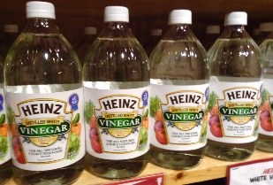  VINAGRE BLANCO

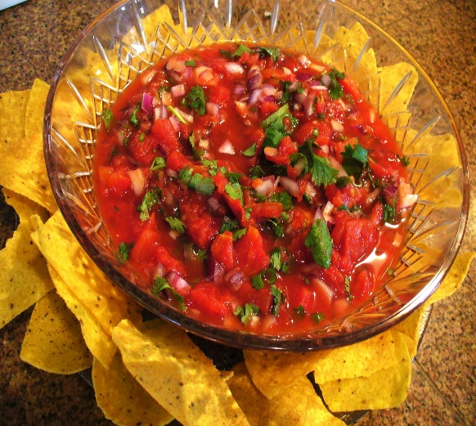

PROYECTO Salsa Casera This is for Day 1-5, correct?

1. Introducción a la comida y el país de origen: A partner and you will research a salsa from any Spanish speaking region of the world. In your research, you must find the answer to all of the following questions, and write them in one- two paragraphs using complete English sentences.
a. ¿Origen de los ingredientes que se usan para esa salsa?
b. Escribe una descripción detallada de esos ingredientes.
c. ¿Cuales son las influencias culturales de la comida?
d. Cite all sources used to gather information.

2. La receta: After researching a particular salsa dish, you must write out a 5 (minimum) to 10(maximum) step recipe telling exactly how one makes this food using formal commands and the vocabulary studied in class.
a. If it is a simple dish, you must expand it to 5 steps.
b. If it is a complicated dish, you should condense to 10 steps maximum.
c. You must use formal commands.

3. La presentación: Tape yourselves doing this assignment. Please memorize the steps you do not read. Edit this at home and post your assignment in Schoology. There is no limit to how short or long the presentation is, however it must include the following pieces:
a. A step-by-step walkthrough of how you make the dish in Spanish
b. A brief explanation of where it comes from and the food in that country in Spanish.
c. Each group member must have roughly the same number of lines.
d. Some sort of visual display of the food/ drink being made. (You can use real food for this part, or you can create props using pictures, play food, etc)
e. The presentation must be in Spanish.

CRÉDITO EXTRA: Bring in la comida for the class to try. You can either bring what you have prepared yourself, or you can buy la comida at a grocery store or Spanish/ Latin American restaurant. (5 points)
 | Ehm… (0-69) | Más o menos (70-79) | Bien (80-89) | Excelente (90-100)
Project Completion | Does not complete any of parts fully | One part is completed OR parts are not completed according to instructions | Two parts are completed OR parts are not completed according to instructions | All three parts of the assignment are completed according to guidelines
Writing Portion | Barely understood by the teacher. OR Translator used. | Writing portions are understood with much effort by the teacher. Student conjugates some verbs correctly for context, pays notice to noun-adjective agreement in some cases and uses appropriate grammar here and there | Writing portions are understood with some effort by the teacher. Student mostly conjugates verbs correctly for context, pays notice to noun-adjective agreement and uses appropriate grammar | Writing portions are easily understood. Student conjugates verbs correctly for context, pays notice to noun-adjective agreement and uses appropriate grammar
Speaking Portion | Not prepared. | Students’ speech is comprehensible, but only with interpretation with few extended pauses. Students take presentation seriously and present with confidence. | Students’ speech is comprehensible, with extended pauses. students mostly take presentations seriously and present with confidence. | Students’ speech is natural and comprehensible, with few extended pauses. students take presentation seriously and present with confidence.
Use of class time | Students are not on task | Group needs several reminders to be productive. | Group goofs off from time to time but mostly uses time wisely. | Group uses all class time wisely and focused on project

Tiquete de Salida

Sustainability Unit/Environment Unit
- Write down 3 vocabulary words in Spanish from our global sustainability Unit.
- Write in English 3 things you learned about Natural Disasters in Latin America and the Caribbean.

- Write in English what is the problem is water in Mexico.
- Write 3 ways to fix the environment in Spanish
- Write 3 ingredients to make a homemade salsa in Spanish

Submit

