Introduction to Food Sourcing: Favorites and Footprints
English Proficiency Level in This Unit:

Novice Level: High Intermediate: Low, Mid, & High
* Appropriate for use with high beginner, intermediate, and advanced ESL students
Theme or Topic (s):

Introductory lesson > in a PBL unit > on Food Access and Implications > with Text Structures as the Language Target
What How Content Language Target

This lesson introduces a unit with the theme: Our Food and the Relationship to Needs and Footprints
Three aspects within the unit are:
- Sources of Food
- The transportation of our food. *Alternative Path: Could be specific to cafeteria foods
- Comparing our food sources and challenges of food access with those of other cities and countries.

Essential Question (s):
- How do our food choices relate to food availability?
- How do challenges with sourcing food impact our lives?
- What are the biological, ecological, and economic benefits of consuming locally grown foods?

Learning Targets for Language Acquisition | Content Objectives:  A. Read and comprehend grade-appropriate informational vocabulary and text.  B. Organize new vocabulary and concepts through semantic mapping.  C. Identify cause and effect relationships related food sourcing  D. Use text structures accurately  Language Objectives:  Reading  A. Read a variety of passages (grade-level-appropriate and at both independent and instructional level)  Listening  A. Watch and Listen to information (formulate new understandings)  Writing  A. Write thoughts and responses to new information and questions posed  B. Create comparative sentences (similarities and differences)  C. Create sequenced and cause and effect structures to explain issues.  D. Write an informative extended response about specific content  Speaking  A. Discuss claims using unbiased evidence and support  B. Prepare and give oral information on specific content using a variety of text structures (language for at least 3 purposes)
Ohio Standards and Competencies  NOTE: You do not need to do all of these in this one lesson  Grade levels: 7-8 | - LEP (Limited English Proficiency) + CCSS (tie to Common Core ELA State Standards)  Reading  6-8.3 + SL 3-1 – Identify a speaker’s argument and specific claims.  6-8.8 + L 7a - Use context clues to determine meanings of new academic words/phrases.  6-8.1/10 + CCRA.W.7. Research to build information and share knowledge by comparing and synthesizing information from content-rich text. Use English language structures to communicate specific information.  Listening  6-8.3 + SL 3-1 – Identify a speaker’s argument and specific claims.  Writing  6-8.1 + RI.7.1. Support analysis of complex texts with evidence.  6-8.3 + W.2 d, e – Produce clear informative text with specific purpose and vocabulary; establish and maintain a formal style (text structures)  6-8.10 + L1b – Choose among various types of sentences to show different relationships among ideas.  6-8.1/10 + EP4. Research to build information and share knowledge by comparing and synthesizing information from content-rich text. Use English language structures to communicate specific information.  Speaking  6-8.7 + RI7-7 – Compare and contrast a text or audio to a multimedia version.  6-8.9 - create clear and coherent grade-appropriate speech to introduce and develop a topic with facts and details.
Formative Practice and Assessments: How/when will I check for understanding (interpretive, interpersonal, presentational, culture, vocab, grammar) and guide my instruction to ensure that students are progressing toward the learning outcomes for the unit? (IE activities, quizzes, bell ringers, games, exit tickets, etc.)

Beginning of the lesson
- Independent: Students will record a response, or responses to the favorite food prompt (Appendix A, if not using personal journal)

Middle of the lesson
- Pairs/Groups: Check maps (Appendix B and/or C) for understanding of the directions and purpose of the activity.
- Pairs/Groups: Check A-Z Charts (Appendix D) for appropriate content and alignment to task objective.
- Pairs/Groups: Check Semantic Maps for student understanding of the task as well as ability to make connections and justify/explain how terms/phrases are connected.
- Independent/Class: Socrative game responses will serve to assess background knowledge of individuals and the class as a whole.
  - At the end if the whole unit, the responses will serve as a summative assessment (in addition to the performance-based written essays and presentations).

End of the lesson
- Independent: Responses for student independent surveys will highlight understanding of the questions and content (literal language comprehension and topic comprehension).

Review of lesson
- Independent/Class: Closing activity (Everybody Think or 3-2-1- depending on time available) will allow students to reflect on what they have learned and what they have questions about.
- Independent: Quizlet vocab/concept quiz (from Day 1 homework) serves as a formative assessment in the first 3-5 days so clarification of important terms and ideas can occur well before project work begins.

Pre-Assessment of Prior Knowledge: How will students show what they already know about the topic of this unit? What activities will be used?

Hook
- Favorite Food Prompt:
Students will respond in their journals or on the sheet (Appendix A): What are your favorite foods/dishes?
- Students will list between 1 and 3 foods
- Students may list a specialty/holiday food, but at least one should be something eaten regularly.

- Try:
- What are the ingredients in each food/dish?
- Where do you get the ingredients from? (Be specific)
- Mapping:
- Students mark each food/dish on their paper one color
- Using a labeled world map for reference, on their map worksheet(s) (Appendix B and C) they will fill in where they think the ingredients in each dish come from (their origin before any packaging, store, etc.) making sure favorite dish colors match the colors used on the map.

Activities (in class, in the target language) / Instructional Strategies and Resources: Overview of helpful instructional strategies for this unit (tech integration, native/heritage speakers, students with disabilities, gifted students, career connections, etc.) NOTE: What audio, video or text will we use throughout this unit for practice?
Block: 90  1 min  2 min  7 min  2 min  10 min  10 min  10 min  15 min  20 min  8-10 min  3-5 min | Instruction and Products expected in English – Tool Tip: Project a timer  Hook: Worksheets on desks or prompt presented: students will list favorite foods  Ask & show question: What ingredients are in your food? Students will list ingredients  Pass out maps and have students map where they believe their foods come from.  Learning Activities  Provide the Food Origin Google Slides (Canvas, Schoology, etc.) and pair/group students.  Students will use the resources to try and fix and/or complete maps.  BEG MOD: Model entire process and project slide 4 (crop origins map)  Write/Project vocabulary: food, issues, challenges, nutrients, nutrition, farming, sourcing food, preparing food, health, transportation, availability, etc.  BEG MOD: Words displayed in native languages of class as well as English  Pass out the A-Z chart (Appendix D) and have students write any words/thoughts related to food they can. Their goal should be 1 word per letter. More than 1 is fine if necessary.  BEG MOD: Students may use word:word dictionary/glossary and may write in native language  Semantic Mapping: Give each pair/group chart paper with the word FOOD in the middle. They should work together to make a word web displaying their terms of knowledge about food and where any terms from their A-Z chart are interconnected.  Provide students with the independent Food Sourcing Survey regarding their knowledge of food production, perceptions on food issues, and what (and where) they have the most interest.  BEG MOD: Interpreters invited to help translate 1:1 and help scribe responses where necessary  Play Socrative to check pre-existing knowledge on foot sourcing and ecological footprints associated with food production, transport, and consumption  BEG MOD: questions and responses pushed tri-lingually  Closing: Students may start homework: Independent Quizlet practice of new vocabulary (with images) for unit.  Beginner Intermediate / Advanced  - Agriculture Agriculture  - Crop Crop  - Origin Origin and Source  - Produce Produce  - Plant Harvest (n & v)  - Product Commodity  - Farm Scarcity  - Scarcity Apartheid  - Transportation Import  - Export  Closing Activity (Everybody Think or 3-2-1)

Closing/Reflection Activity: How are students engaging with ideas from another culture? What it means for them? (in the target language)

Closing for the introduction lesson specifically:
Time Dependent:
- 4-5 minutes available: “Everybody Think” – Teacher asks a closure question on the content and/or activity, everyone gets about 45 seconds to think, and then 3 students are randomly asked for their thoughts
- Question: How does the movement of food in the community/nation/world impact your eating habits?
- 2-3 minutes available: “3-2-1” – Journal response: What are three things you learned, 2 things you have questions about, and 1 thing you did well today?

Day 2 Starting Review: Play Quizlet Live in groups to practice vocab from homework

Goal: Closing for entire unit: Students will have created an informative infographic or diagram (Newcomers), passage (Beginners), or multi-paragraph essay (intermediate and advanced) based on a research interest of their own choosing (region, challenges to access, sustainable agricultural efforts, transportation of food, alternatives, and footprints, etc.), after participating in writing lessons during the unit. Then, students will use their texts to plan an appropriate action to aid their focus (website, community participation, physical environment or habit change, PSA, posters in the cafeteria ,etc.). Then, with their research and an action plan in mind, students will create visuals and a presentation (individual, in pairs, or groups) sharing their focus, what they have learned, and steps forward in striving to make a positive impact.

Appendix A: Favorite Food Sheet
What are your favorite foods/dishes?

#1: | #2: | #3:
_____________________________________________________?

_____________________________________________________?

Appendix B: Food Source Map Worksheet
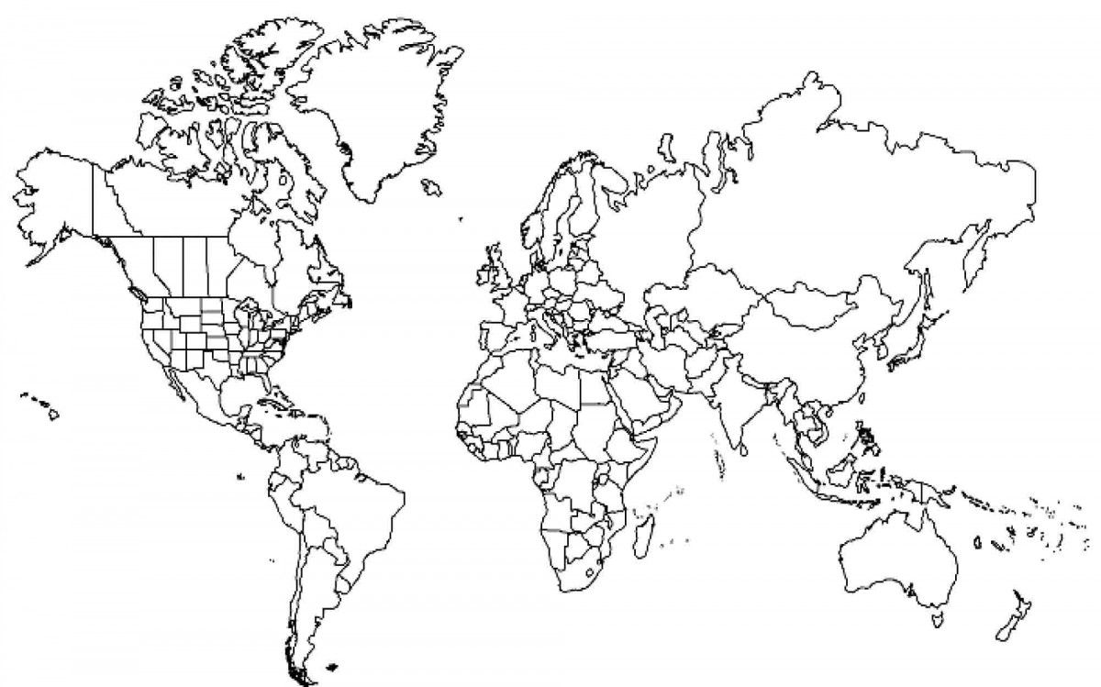
Appendix C: Food Source Map of States Worksheet
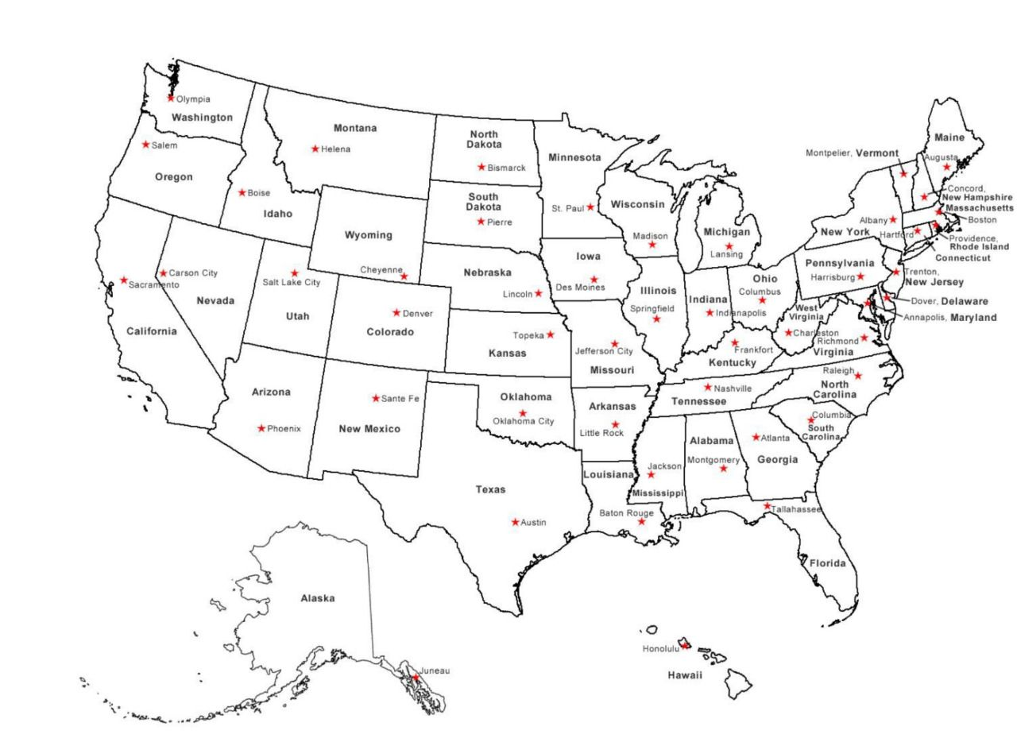
Appendix D: A-Z Chart
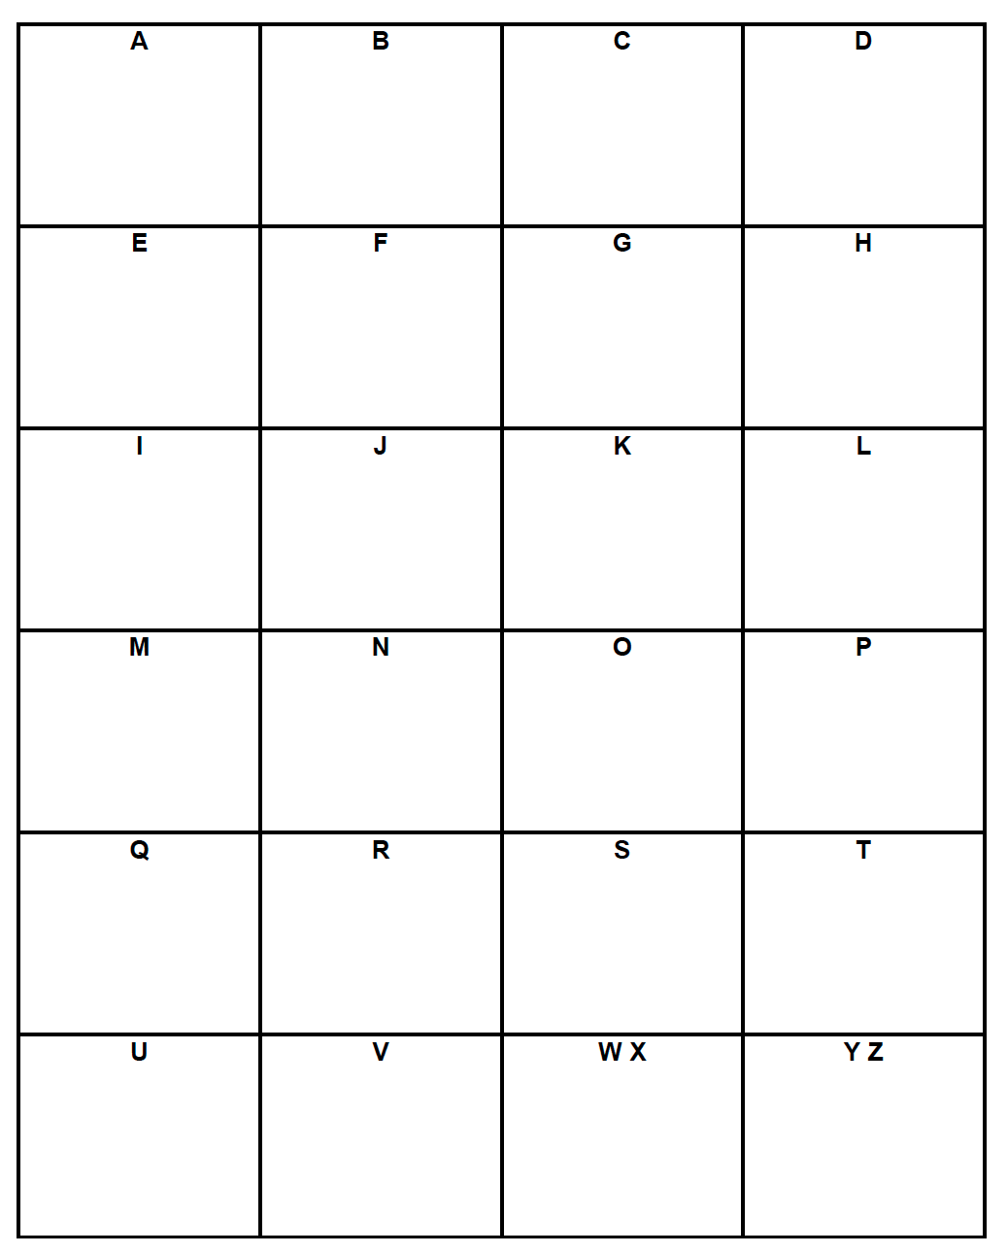
Citations:

Appendix B: Food Source Map Worksheet
Found at: https://www.freeusandworldmaps.com/html/World_Projections/WorldPrint.html
Appendix C: Food Source Map of States Worksheet
Found at: https://www.timvandevall.com/social-studies/us-states-and-capitals-map-pdf/
Appendix D: A-Z Chart
Found at: https://www.teacherspayteachers.com/Product/ABC-Brainstorming-Chart-4879762
ELA Common Core State Standards: http://www.corestandards.org/ELA-Literacy/
Ohio LEP Standards: https://education.ohio.gov/getattachment/Topics/Other-Resources/Limited-English-Proficiency/ELL-Guidelines/Ohio-English-Language-Proficiency-ELP-Standards/ELP-Content-Standards-20150824.pdf.aspx
Google Slide deck: Just for Fun: Favorite Foods by State
Ward, Alvin. 7, 2014. The Signature Food of Each State. https://www.mentalfloss.com/article/59015/signature-food-each-state
Google Slide deck: Just for Fun: Most Hated Foods
Shoemaker, Allison. 10, 2018. This map of each state’s most-hated food is equal parts amusing, suspect, and cheese. https://thetakeout.com/this-map-of-each-state-s-most-hated-food-is-equal-parts-1829467618
Google Slide deck: Where Do These Foods Grow Naturally? Interactive map
Cherfas, Jeremy. 6, 2016. A Map of Where Your Food Originated May Surprise You. https://www.npr.org/sections/thesalt/2016/06/13/481586649/a-map-of-where-your-food-originated-may-surprise-you

