Lesson Plan Design Template
Proficiency Level of Tasks in This Unit:
Novice Low (first month learning Chinese)

Theme or Topic (s):

Do you have a green thumb? 你擅长园艺吗？

***Please note, this is a “Special Feature” of this lesson/project, it is designed to be a "10 min per day warm-up/review activity" for a whole week; thus, the total project time will be about 50 minutes (it is not meant to be taught in one day).***

Essential Question (s):
How do I plant a tomato seedling? When and how often do I water it? How do I record the plant’s growth using a bar graph? What conclusions can I make about planting?

Learning Target for Intercultural Communication  - Culture:  Intercultural  Can-Do Statements  - (Optional)  Communication:  Interpretive, Interpersonal and Presentational Can-Do Statements | Here is the link of “Novice Low – Standards Alignment Tool for Communication”, and a link of Can-do statement rubrics  Can-do statements  - I can plant a seed/seedling  - I can keep a journal of the plant growing by watering and taking a picture everyday  - I can record the journal with a bar graph  - I can report to my teacher everyday of my observation in Chinese, by using daily dates, time and weather conditions.  - I can make a conclusion of my seed planting on Friday
Standards and Competencies  NOTE: You do not need to do all of these in this one lesson  Grade levels:  6–12 | Interpretive: study lesson 1 – 5 vocab and sentences  Chinese textbook audio file  https://static.ecoesc.org/mandarin_lessons/  Chinese textbook:  https://drive.google.com/open?id=1qKZC_EAUFjGtZL0bLKq7MrwkpT8Zhn1W  Interpersonal: Students use lesson 1 to 5 sentences to ask each other the Qs and practice the conversation in the target language.  Presentational: Students show and tell teacher their bar graphs and their pictures/videos using daily dates, time and weather conditions in the target language.  Intercultural: appreciate each other’s planting pictures
Formative Practice and Assessments: How/when will I check for understanding (interpretive, interpersonal, presentational, culture, vocab, grammar) and guide my instruction to ensure that students are progressing toward the learning outcomes for the unit? (IE activities, quizzes, bell ringers, games, exit tickets, etc.)
ATTACH ALL MATERIALS AT END OF LESSON PLAN
Verbal assessment: ask students question 1 to 4 every morning, when asking about the time, ask about the time when they observe the plant, and also ask about the time when they are in my class reporting to me. By reporting the seed/plant growth to me every day I can assess students’ ability to express daily dates, time and weather conditions in the target language.

- What’s today’s date? 今天几月几号？
- What day of the week is it today? 今天星期几？
- What time is it? 现在几点？
- How is the weather today? 今天天气怎么样？
- Answer all the questions together:
Today is 2020 year, June 5th, Friday, I looked at the plant at 6am and right now is 9am, today’s weather is sunny.

Pre-Assessment of Prior Knowledge: How will students show what they already know about the topic of this unit? What activities will be used?
ATTACH ALL MATERIALS AT END OF LESSON PLAN
Students’ prior knowledge is vocab and sentences from lesson 1 to lesson 5.
Digital textbook and audio files:

Chinese textbook audio file:
https://static.ecoesc.org/mandarin_lessons/

Chinese textbook: https://drive.google.com/open?id=1qKZC_EAUFjGtZL0bLKq7MrwkpT8Zhn1W

Activities (in class, in the target language) / Instructional Strategies and Resources: Overview of helpful instructional strategies for this unit (tech integration, native/heritage speakers, students with disabilities, gifted students, career connections, etc.)
NOTE: What audio, video or text will we use throughout this unit for practice?
ATTACH ALL MATERIALS AT END OF LESSON PLAN
***Please note, this is a “Special Feature” of this lesson/project, it is designed to be a "10 min per day warm-up/review activity" for a whole week; thus, the total project time will be about 50 minutes (it is not meant to be taught in one day).***

Class Background:
There are many students who are immigrants in my classes; they are from Mexico, Nepal, and different countries in Africa. Students can choose any seeds to grow, likely a plant represent their cultural daily food. For myself, Chinese often season food with garlic, so I’ll use a water bottle to grow garlic

Day 1 (Friday):
- Show students a short video:
https://www.youtube.com/watch?v=JdGh06gZoWs ) then show the below two pictures to reinforce the memory. Ask students how many bottles of garlic they can find in each picture.

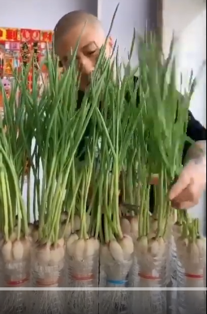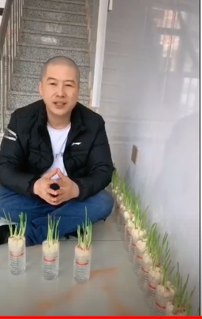
- Teacher’s demonstration of planting vegetable:

My friend gave me tomato seedlings which I put in small containers of soil. The first three days they did fine, yet the fourth day they started weathering, the fifth day they looked dead. I’ll show my pictures to my students and explain failure does happen and it’s ok to start again, on my bar graph shows the growth and the changes of my plant, even the result is not what I desired, yet I recorded the journal of my “green thumb” project.

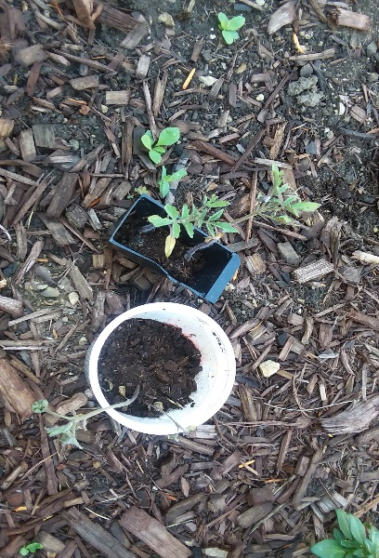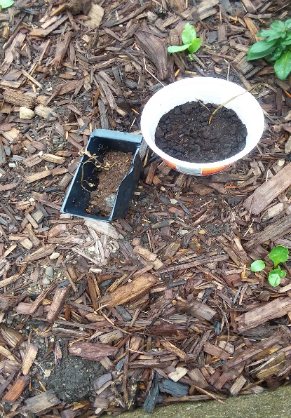

- Teacher’s tomato plant growth Bar Graph
(the green color indicates the tomato plants were doing fine, the yellow and brown colors indicate the plant weathered and finally died)

 | 07/06 |  | 07/07 |  | 07/08 |  | 07/09 |  | 07/10
 | Mon |  | Tue |  | Wed |  | Thu |  | Fri
 | 6:00am |  | 5:50am |  | 6:05am |  | 6:15am |  | 6:08am
 | sunny |  | cloudy |  | rainy |  | rainy |  | rainy
7
6
5
4
3
2
1
0

- Students are assigned for homework to find their seedlings/plants to grow.

Day 2-5 (Monday-Thursday of the following week):
Students will plant their seedling and start journaling, using the model presented the previous Friday.
1. What is today’s date? 今天几月几号？
2. What day of the week is it today? 今天星期几？
3. What time is it? 现在几点？
4. How is the weather today? 今天天气怎么样？
5. Answer all the questions together:
Today is 2020 year, June 5th, Friday, I looked at the plant at 6am and right now is 9am, today’s weather is sunny.

Students take turns to report their plant growth to me in Chinese language, it will take about 10-15. They will also draw an image of the growth, for the more visual learners. Afterwards I will continue with my new lesson/content teaching each day.

Day 6 (Friday of the following week):
Students will give me the final result on Friday, using the phrases in the target language they have been practicing throughout the week (see days 1-5). This final day will be their assessment in which they will not use notes (compared to days 1-5 in which they could).
The rubric of the assessment:
- Students need to summarize their project by giving me the duration dates
e.g. project time is from Sept. 14th to Sept. 18th
2. Students need to summarize the weather in the duration time
e.g. 3 days sunny, 2 days rainy
3. Students need to show me the bar graph they recorded

The strategies including:
- Scaffolding: everyday build up the listening and speaking skills with scaffolding strategy
- Interesting and Meaningful : instead of boring repetition of reciting numbers and dates, students are presenting new info to me everyday
- Support comprehension and production through visual aide
- Fun, Hands-on: students draw on the bar graph and take a picture everyday

Closing/Reflection Activity: How are students engaging with ideas from another culture? What it means for them? (in the target language)
ATTACH ALL MATERIALS AT END OF LESSON PLAN
Chinese culture is very practical. During this pandemic, we have experienced food shortage and illness. I chose garlic to grow due to these two reasons; garlics can season food and also increase our immune system. While students could have different reasons for their choice of seeds. Watching the video on how to grow the garlic is actually fascinating. I also want my students to know that even though my tomato plants died on me, yet I can always start over again, there’s a Chinese saying refers to, “Our greatest lessons come from our mistakes and failures”. Ideally I’d love to have a result like the below bar graph, yet the reality was the bar graph posted on page 2, I learned from my mistake that I put too much water in the containers.

Activity as a journal prompt:
- Why did you pick the seedling you chose? Think about the Chinese saying, “Our greatest lessons come from our mistakes and failures”—how would you apply this to your experience with your plant?
- What other seedlings/plants might be useful to plant in a garden? Consider being from different areas and countries: how might this affect the seedlings/plants you choose any seeds to grow? How might this affect food choices?

Bar Graph example

 | 09/14 |  | 09/15 |  | 09/16 |  | 09/17 |  | 09/18
 | Mon |  | Tue |  | Wed |  | Thu |  | Fri
 | 6:00am |  | 5:50am |  | 6:05am |  | 6:15am |  | 6:08am
 | sunny |  | cloudy |  | rainy |  | rainy |  | rainy
7
6
5
4
3
2
1
0

