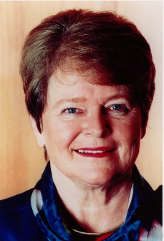
Dr. Gro Harlem Brundtland Addresses Global Sustainability
-Cheryl Fladung
The Ohio State University had the privilege of having Dr. Gro Harlem Brundtland speak about global sustainability in the 21st century. In her lecture, she emphasized three aspects of global sustainability: economy, society, and the environment. Currently, the gap between the rich and the poor is widening, environmental degradation continues, and climate change is beginning to take effect. Implementing sustainability goals will therefore be crucial in solving these issues.
One of the most important points of the lecture was that “poverty is the greatest polluter.” Eradicating poverty and inequality along with empowering women are necessary in order for environmental and developmental concerns to be addressed. We have to extend our moral responsibility by acting carefully, as we need to consider the welfare of future generations. In regards to current lifestyles, tipping points will be reached regarding Earth’s capabilities to provide for the global population. Markets must establish price signals that will make the consequences of action or inaction transparent. Harmful emissions should be taxed (such as in Norway), fossils fuels should be phased out, and supply chain transparency should be included in business practices. Businesses must also consider scientific information in order to make informed decisions. Cooperation by all countries is vital, and the US has to be a driving force along with other emerging economies to spark a global transition towards sustainable development.
A significant aspect of sustainable development involves the maximization of resource productivity and reduction of waste by the private sector. This means investing in sustainable technology to build more resilient and equitable societies. Policies need to stimulate markets and have clear objectives and targets for renewable energy and energy efficiency. Advances in scientific knowledge have allowed us to better understand risks, but we are now all responsible to take our part as citizens to increase public welfare through sustainable actions and avoid potential damaging impacts.

