RPAC| One of the nation's largest stadiums
The 2019 freshman draft - 2019年7月23日

By. Li. Xinyi
the photo of RPAC

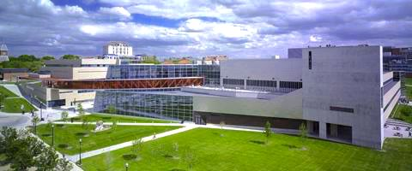

Introduction

PRAC：The Recreation and Physical Activity Center

1. WHAT IS RPAC?
As one of the largest stadiums in the United States, RPAC is equipped with the best sports facilities and the most intimate fitness service.

Built-in 2005, RPAC is located in the center of the school, not only an OSU landmark, but also a treasure trove of Buckeye's perfect body.

RPAC is located between Morrill Tower and Thompson Library and has a total area of 600,000 square feet. Panoramic glass window design of the atmosphere and bright, modern facilities layout comfortable and elegant. So that RPAC can serve as OSU landmark as well as full-service Buckeye.

There are four levels of RPAC, each with its own set of gym equipment. Let's take a look at RPAC in its entirety

2.WELCOME CENTER

Purchase fitness passes, guest passes, register for towel service and find any information you need. （Lost and Found：located at the Welcome Center. For additional information regarding lost items, please view the document on this page.）

3.GROUND FLOOR

4.FIRST FLOOR
food court/equipment area/fitness consulting room

RPAC's stalls have two simple meals, one on each side of the main desk, serving healthy snacks casual dining

Fitness Space： The RPAC offers approximately 27,500 square feet of fitness space featuring state-of-the-art cardio and weight equipment.

Fitness consulting room can help students to carry out professional and thorough physical examination for free. And have a staff of certified personal trainers ready to help meet member fitness goals.
Aerobic / Weight Training Area / Ball Court / Storage Bath

The ground floor has a treadmill, stair-climbing machine, elliptical instrument, basketball, squash, badminton, golf, and other ball venues.

The Locker room is also located on the ground floor and interconnects with the school's swimming pool. Not only can you check in here for free, but you can take a shower after your workout.

Buckeye who don't want to buy sporting goods can also go to the information office to rent a variety of ball games, foam rollers and elastic band and other fitness equipment

7.THE NATATORIUM
The Bill and McCorkle Aquatic Pavilion
Water center connected to RPAC's Ground Floor locker room

6.THIRD FLOOR
Indoor track/course/rowing machine
RPAC's third-floor airstrip has panoramic glass Windows overlooking the OSU campus, as well as equipment such as golf courses and rowing machines, and locker, which can store personal belongings.

5.SECOND FLOOR
Scarlet Walkway/Scarlet Walkway

There are table tennis, equipment on the field and sandbag area
Scarlet Skyway connects the RPAC with the Department of Human Sciences academic building. There is a swipe access point from the Department of Human Sciences building into the RPAC.

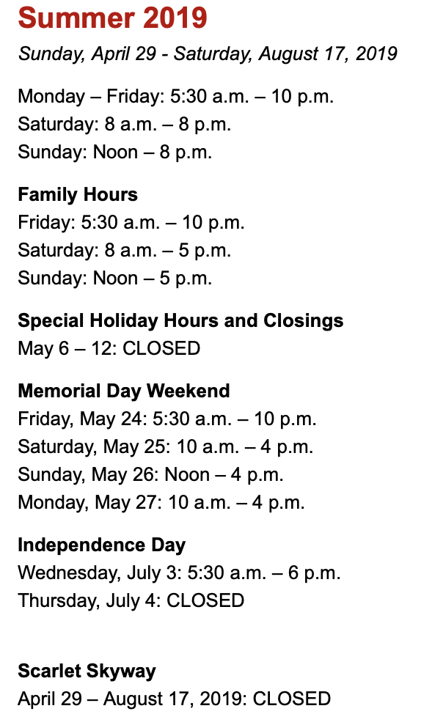
2019 Opening hours
Main Fitness Floor
The photo of RPAC, opening hours and main fitness floor are from:
https://recsports.osu.edu/facilities/recreation-and-physical-activity-center-rpac

