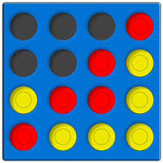  Connect 4  Matlab version  MATLAB Connect 4  Everyone’s favorite game, Connect 4 is back but this time, an online version! This fun, two-player game allows you and a friend to go head to head in this battle of wits. All you must do is enter 2 to start! MATLAB is easy to navigate and will do all the work for you, just sit back and enjoy the game! | All it takes is four in a row to win!  ────  Anyone can play as long as you have a computer!  ────  Designed by top engineering students at OSU  ────  You can play anytime, anywhere!  ────  Do you have what it takes?  Engineering 1181 Group G  Maia Bates  Leo Bernier  Caleb Moraw  Xinyi Zhang

