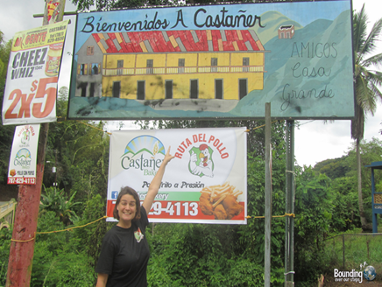
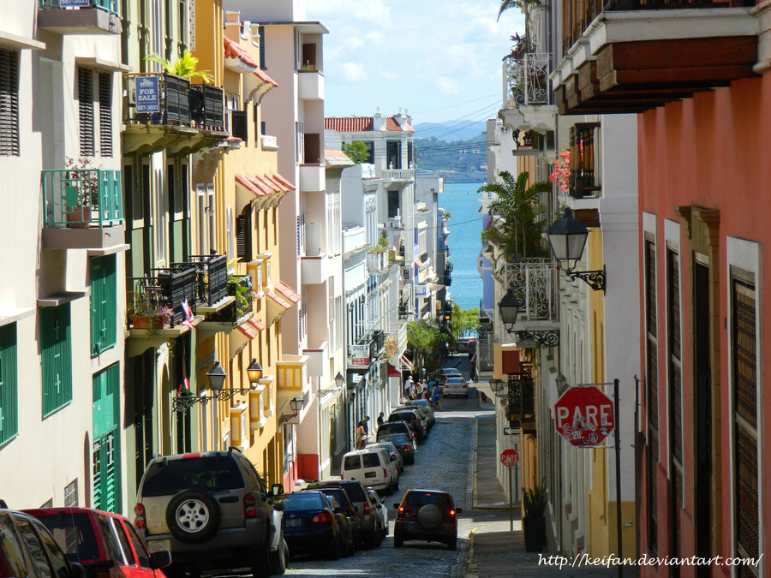
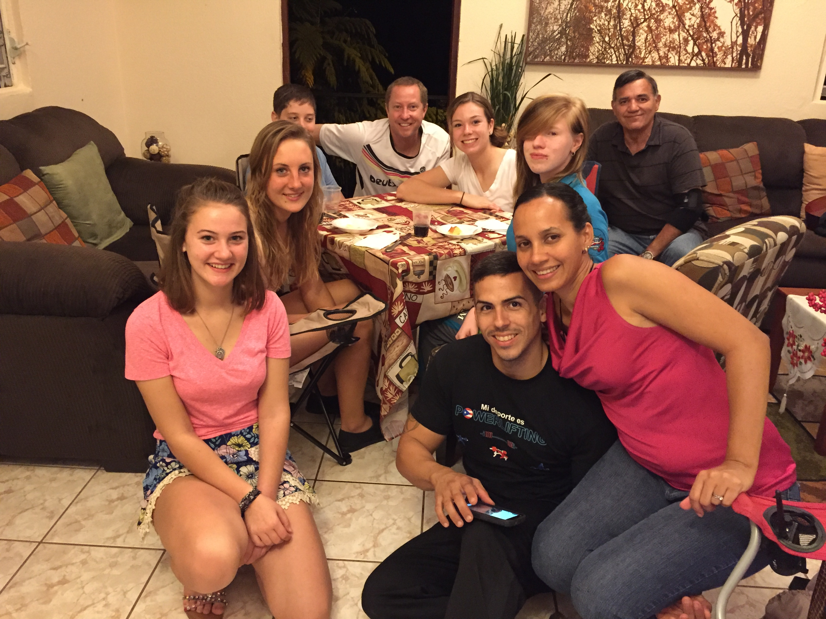


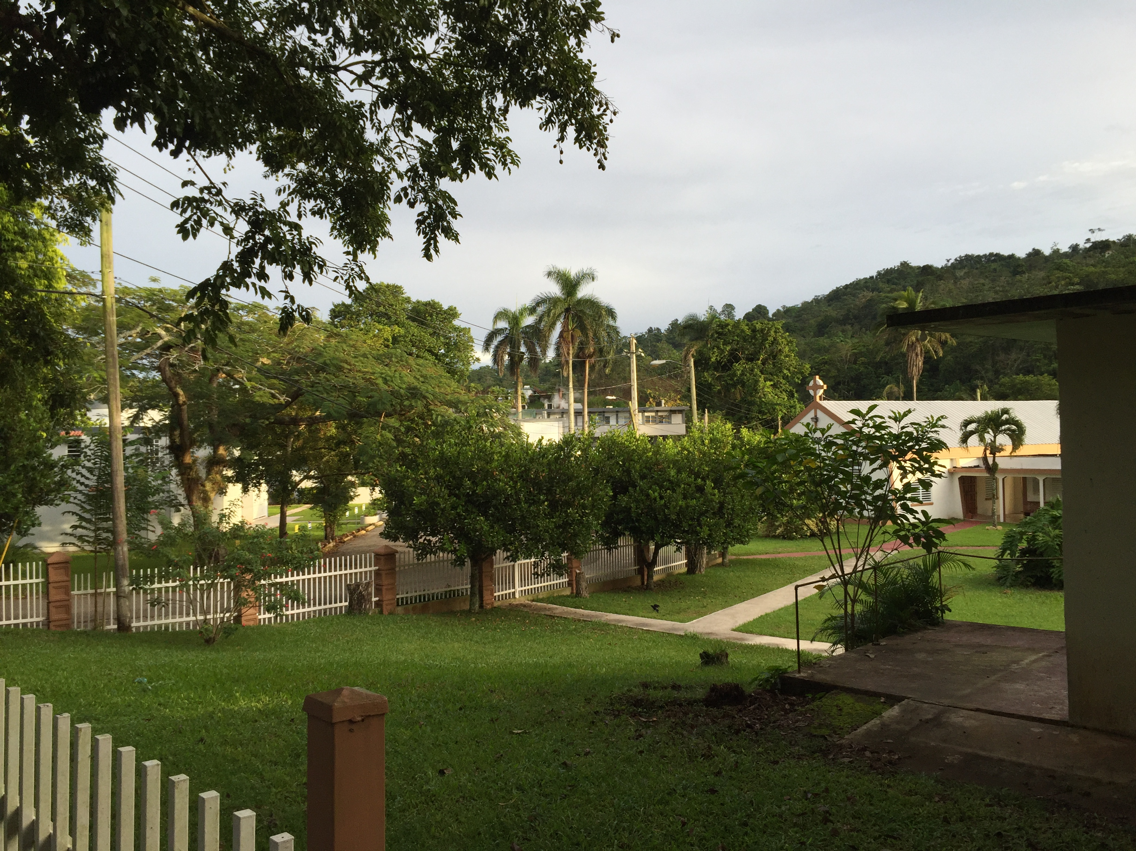
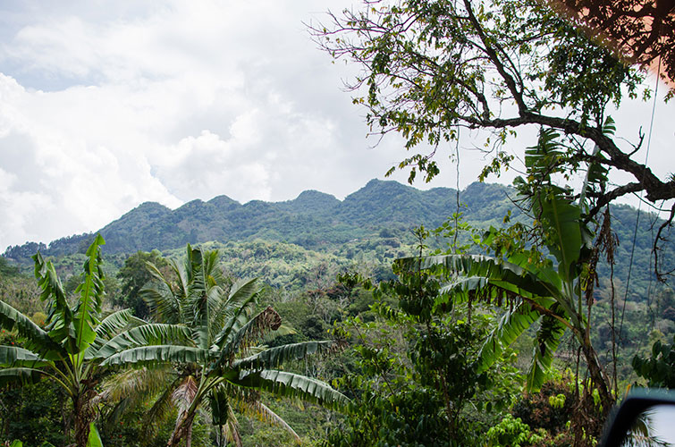

4-H Cultural Immersion Project – Puerto Rico
Tuesday, November 23 – Wednesday, December 1, 2021 – Castañer, Puerto Rico

The best way to understand a different culture is to immerse yourself in it. Apply to be part of the Cultural Immersion project experience in Puerto Rico. You will build multicultural skills and understanding, as well as an increased ability to communicate in the increasingly diverse society that we live in. You will experience both the Old San Juan urban area as well as life in the remote mountain town of Castañer. We will also be working with 4-H youth from Puerto Rico in joint service projects.

Teens ages 15-19 (as of date of trip) are eligible for this 8-day service-learning experience. The cost of the experience is $500 plus airfare (est. $600). Limited scholarship funds are also available.

Who: Teens ages 15-19 (by the date of the trip)
Where: Puerto Rico (San Juan and mountain village of Castañer)
When: November 23 – December 1, 2021
Application Deadline: August 10th, 2021
Cost: $500 plus airfare -- (Approximately $600)
(Includes most meals, program fees, overnight lodging and transportation)

Name Birth date

Address City Zip

Cell Phone Email

School Grade (2021-2022)

Why are you interested in the Cultural Immersion Project (CIP)?


Please describe any previous leadership experiences and skills you have had that would prepare you for joining the CIP Team.

What do you hope to learn by participating in this experience?

Briefly describe an experience or situation where you felt uncomfortable or out of place. How did you handle it?

NOTE: All applicants will have an additional zoom interview before trip final selections. Final Selections will be made in late August.



Email or Mail Applications to:
OSU Extension Warren County
Attn: Steve Brady
320 E. Silver St., Suite 101 Email: Brady.111@osu.edu
Lebanon, OH 45036 Phone: 513.695.1311

