DocuSign Access Request Tutorial
A guide for ordering DocuSign roles through OCIO Self-Service

Intro
This tutorial covers the steps necessary to request specific DocuSign permissions within the Self-Service portal operated by the Office of the Chief Information Officer. This guide will provide step-by-step instructions with visual aids to assist both in navigating the web client and choosing the correct options.

Requirements
Please use the latest version of Google Chrome or Mozilla Firefox as your web browser for this process. Internet Explorer may have issues processing the Self-Service form.

Trainings
Three training courses must be completed to be eligible to send documents in the DocuSign system. If you do not meet these requirements, please click the links below to be taken to the respective BuckeyeLearn course pages.
- Institutional Data Policy (IDP) Training
  - Click here for accessible alternate version of IDP Training
- eSignature Overview
- eSignature Sender
If you also require the ability to create custom templates and/or create envelopes from scratch, please complete the eSignature Author training.
- eSignature Author

Start
- Navigate to the OCIO Self-Service portal by clicking here or copying and pasting the following URL:
https://osuitsm.service-now.com/selfservice/#/

- On the left-hand side of the portal, click on the option “Order Services”
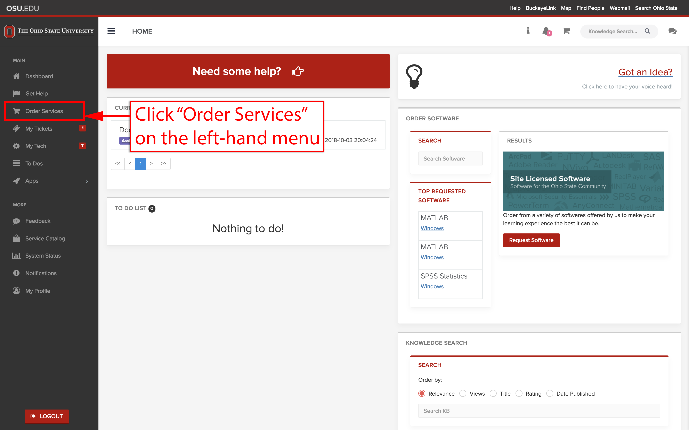

- Under “Order Services”, click the link for “Access Management”. Alternatively, you can input the keyword “docusign” into the search box to quickly narrow down the selection.
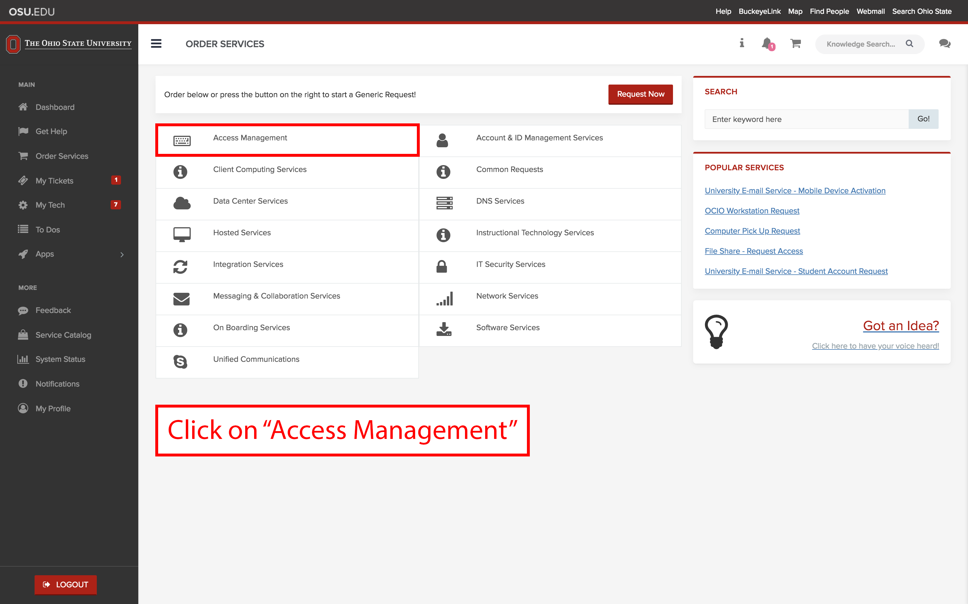

- After either clicking on “Access Management” or searching the keyword “docusign”, you will be able to see a link named “DocuSign Access Request”. Click on the link to proceed.
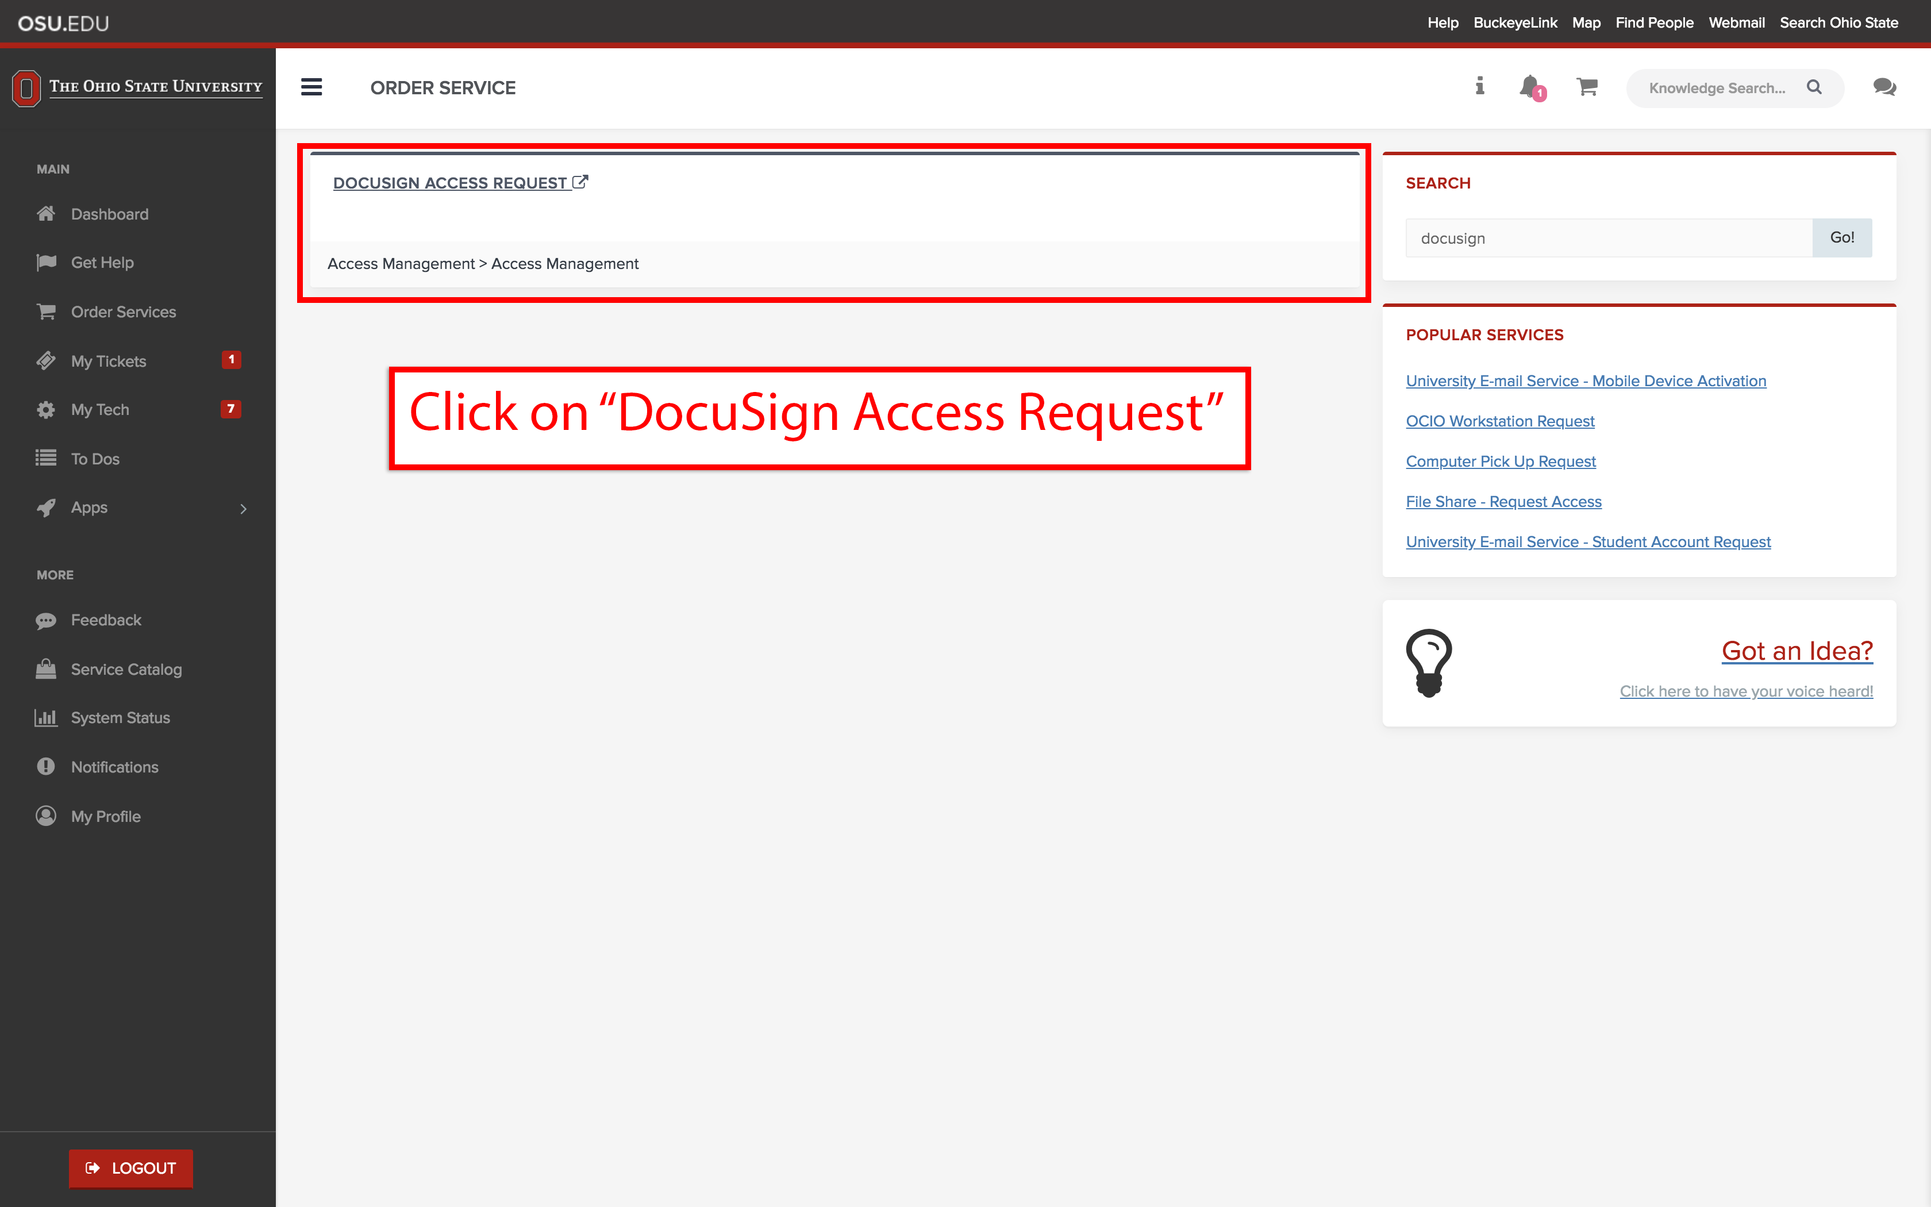

- After clicking on the access request link, you will see a form containing various fields. Verify the information is correct and proceed to the next step.
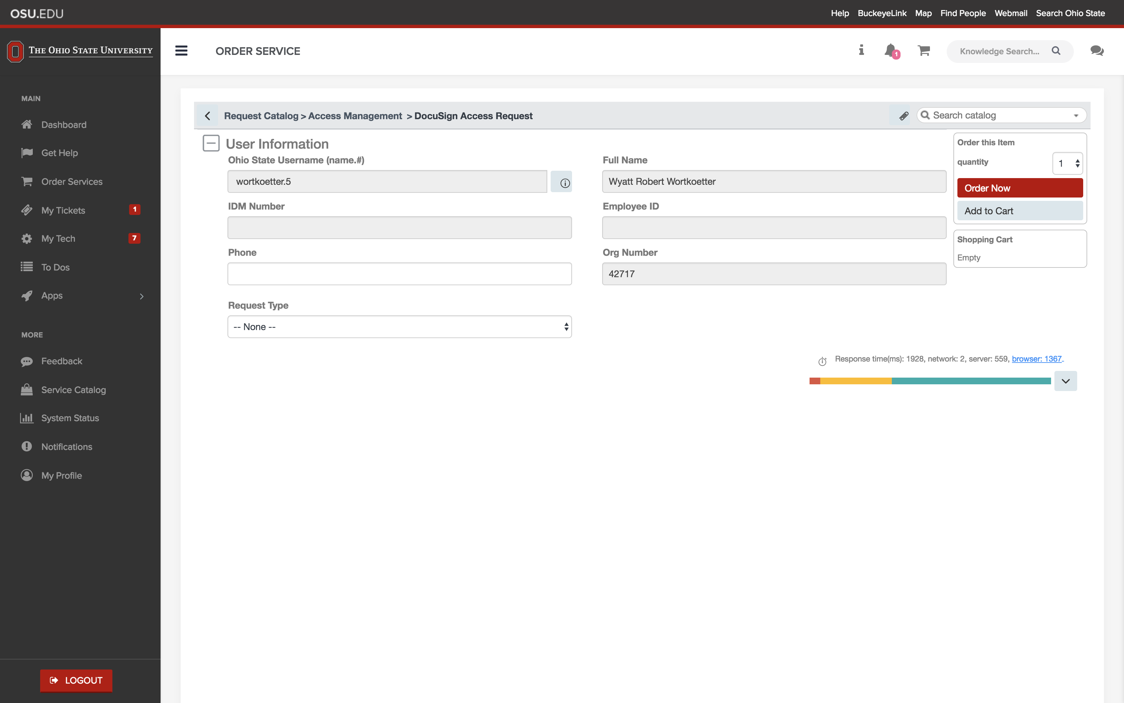

- Select the request type that best applies to your needs and respond to the question regarding IDP training. If you are requesting a role, you will select the “New or Modify Account/Access” option under Request Type.
Note: Annual completion of the Institutional Data Protection training is required to request or maintain access to this system.
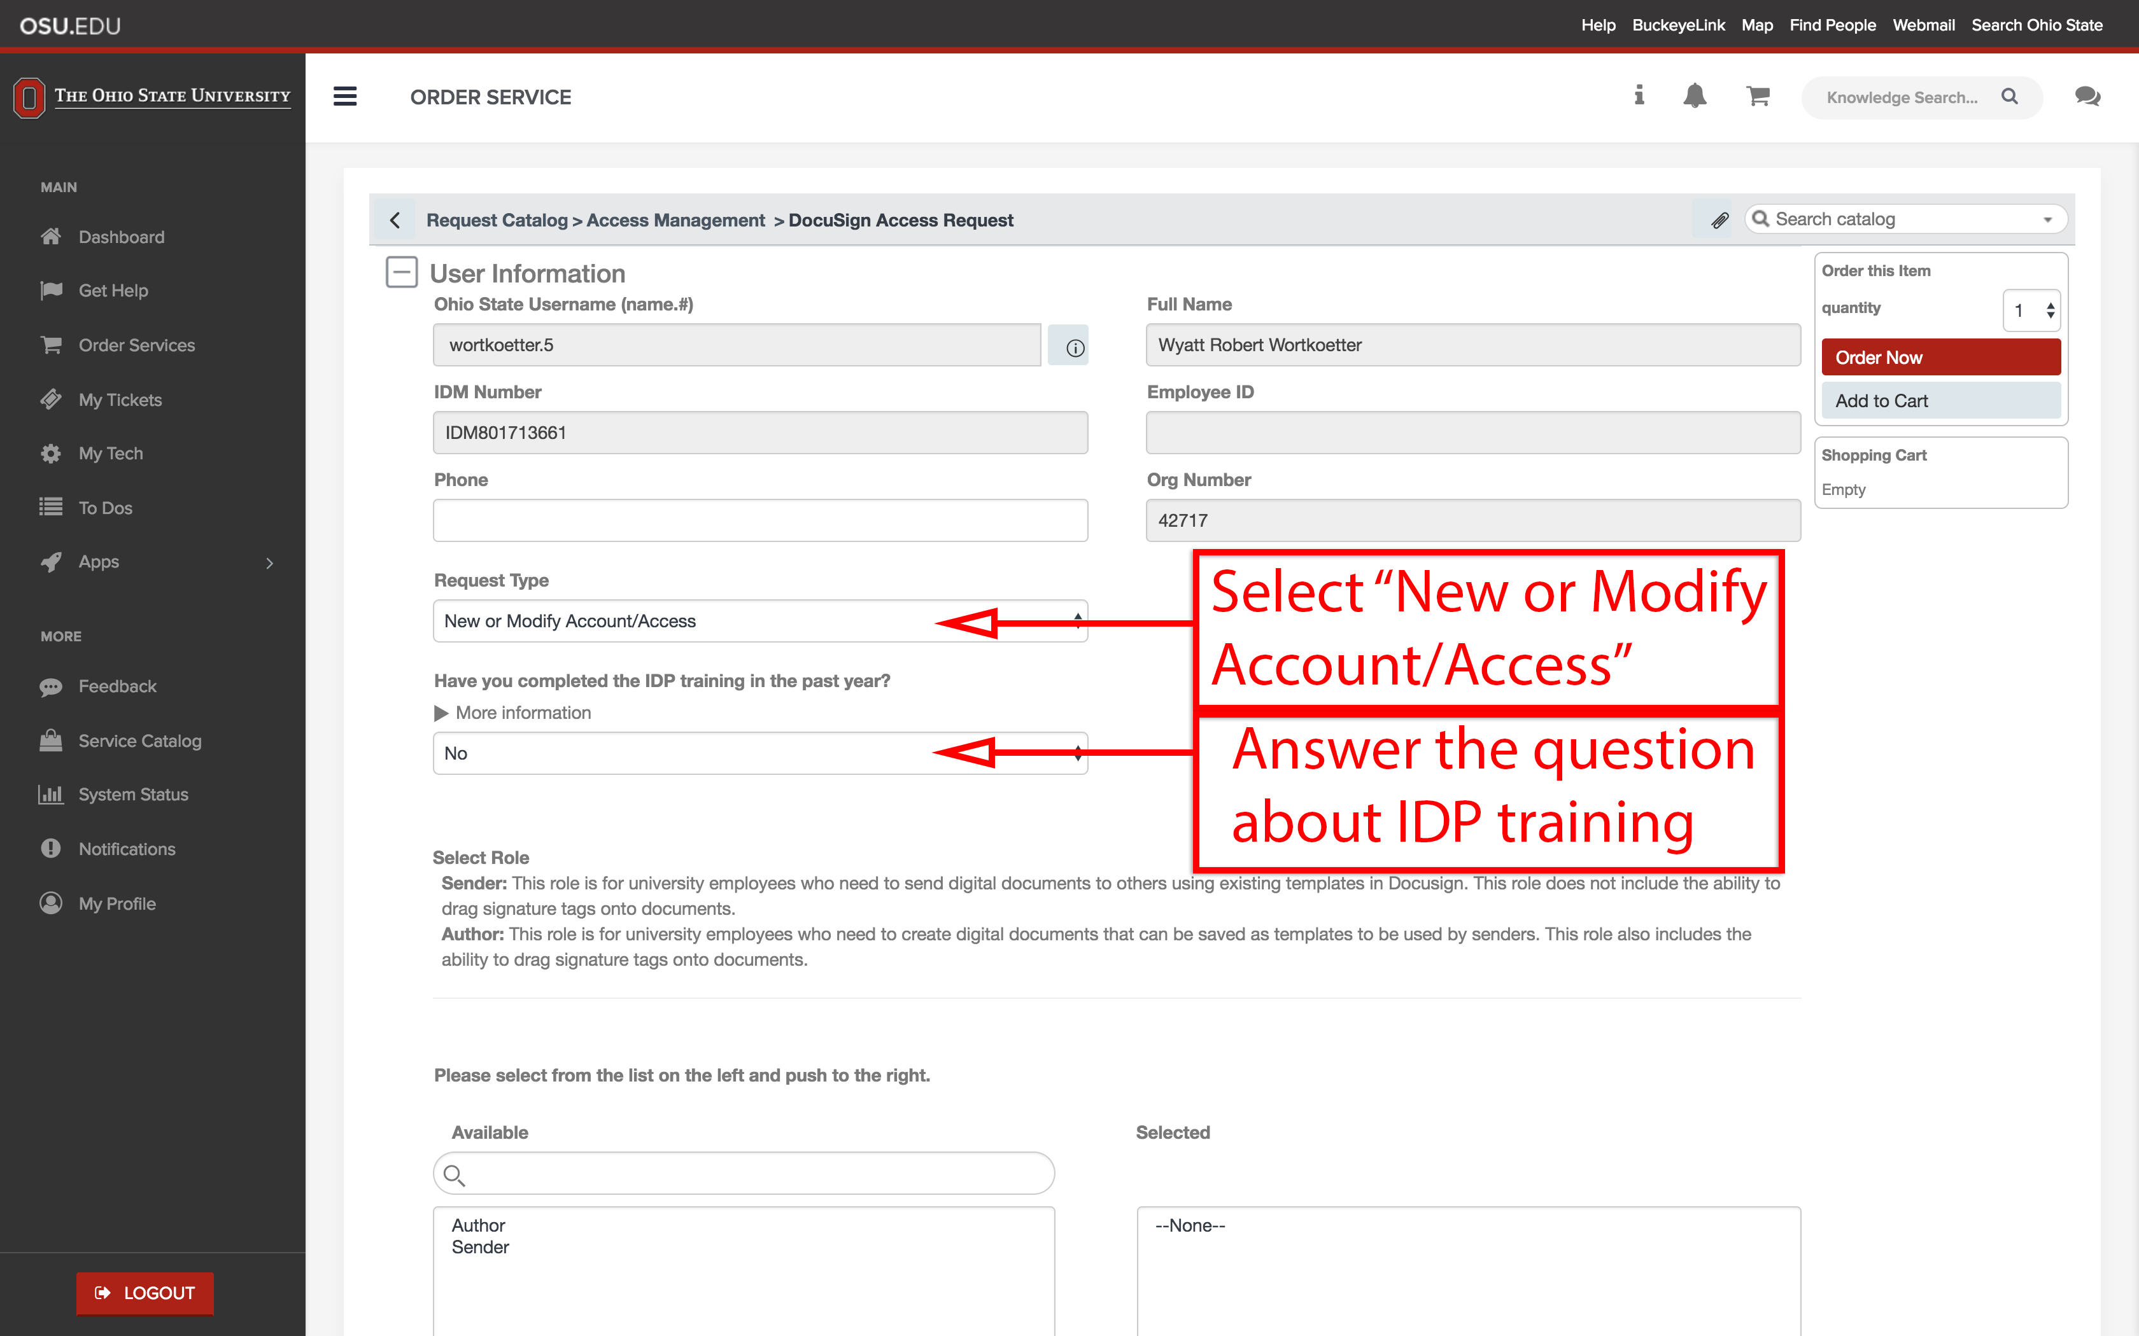

- At the bottom of the form, there are two white boxes named “Available” and “Selected”. Click the desired role(s) in the left box to highlight it, then click the right-facing chevron to move the item to the right box. After moving the item, scroll back up and click the red “Order Now” button on the top-right of the page to place your request.
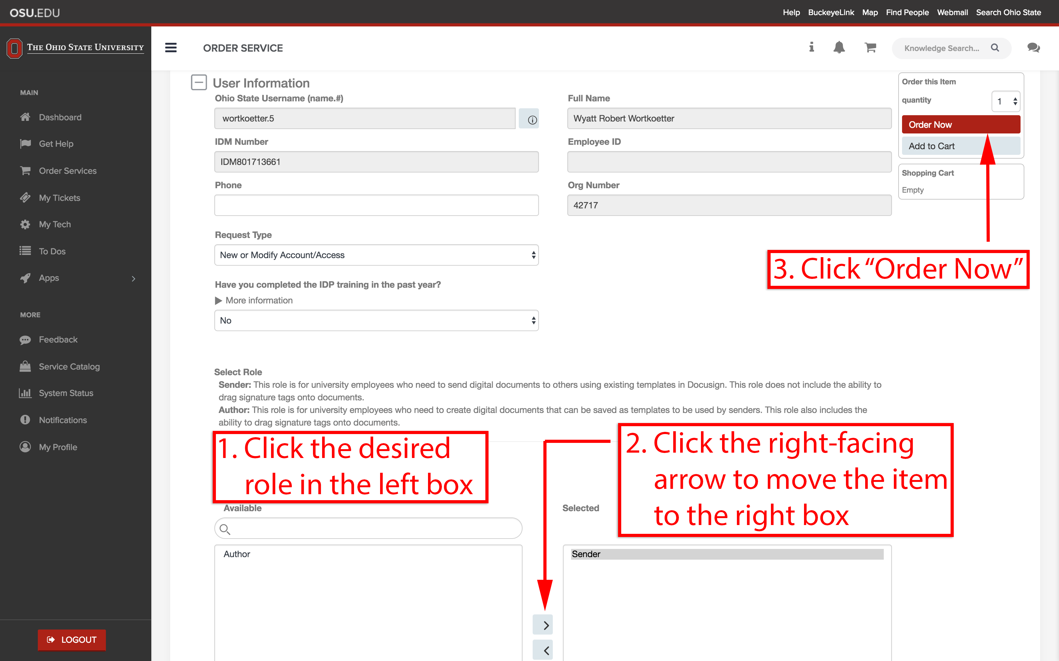

At this point you are finished and the order is ready to be processed.

If you have any questions or comments regarding this process, please send an email to esignature@osu.edu for help.

