**How-to: Quality Assurance Spreadsheet/Scorecard**

Every month, the OSU evaluation team exports data from the Needs Portal to perform Quality Assurance. In other words, we are reviewing the Needs Portal data to ensure that information has been entered correctly by the users throughout the implementation process. Counties receive a Data Scorecard and Quality Assurance Spreadsheet:

**Data Scorecards:** Counties receive a “scorecard” of the status of their progress on data entry in the Needs Portal. The scorecard provides counties with an exact percentage of complete data for a particular indicator. The screenshot below contains an example of a Quality Assurance scorecard for a county in a particular month. The scorecard documents the range of scores (green, yellow and red) as well as the exact percentage of complete data. Counties do not need to fill-in anything in the scorecard, this is just a tool to measure your progress for each fidelity indicator.

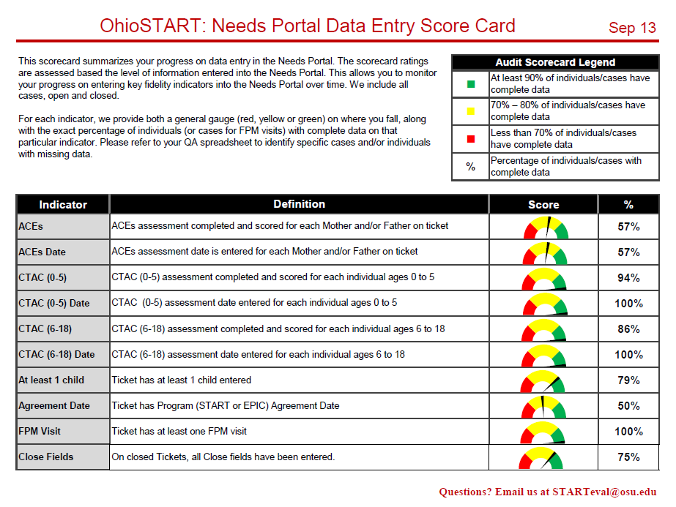

**Quality Assurance Spreadsheet**: Based on the scorecards, counties use the Quality Assurance spreadsheet below to locate missing data on each case. Each column shows different components of each assessment (UNCOPEs, CTACs, and ACEs) that need to be entered into the Needs Portal where a “1” means that information is complete and a “0” means it is missing. The next three columns show (Y/N) whether there are kids listed on the case, there is an agreement date, and at least one FPM visit is documented. The final columns show whether all fields indicating a case closure have been documented (status, date, and reason). Counties use this as a guide to locate and correct any missing items directly in the Needs Portal. The goal is only to have “1”s and “Yes”s for all cases.

