World News Network Breaking News Report
The National Government has announced that an oil discovery has been made in and around the northern border of the National Park! The discovery was made by two competing energy firms, one based in community D and the other in community C. Geologists from the university in community B identified the “Buckeye Shale Formation” many decades ago, but only until recently did these two private companies develop the technology necessary to extract the crude oil from the Buckeye Shale Formation.
These two competing firms are currently developing rival oil refining and export processing facilities near the international shipping ports of community D and C, respectively. Their goal is to provide petroleum products that service both domestic and international markets. Both energy firms are currently lobbying the National Government for drilling rights in and around the National Park.
In addition, to move the extracted crude oil from the Buckeye Shale Formation to the refining facilities at global ports in community D or C will require at least one major pipeline. These firms have discussed with natural resource extraction-based companies in community E and other communities about using their services in efforts to gather land leases and permits to install the necessary inter-community pipelines to move the crude oil from the northern hinterlands of the nation to the ports.
The map below demonstrates where the preferred path of each of the three proposed pipelines:
- nDrect Line
- HAD Express
- C to Sea Pipeline

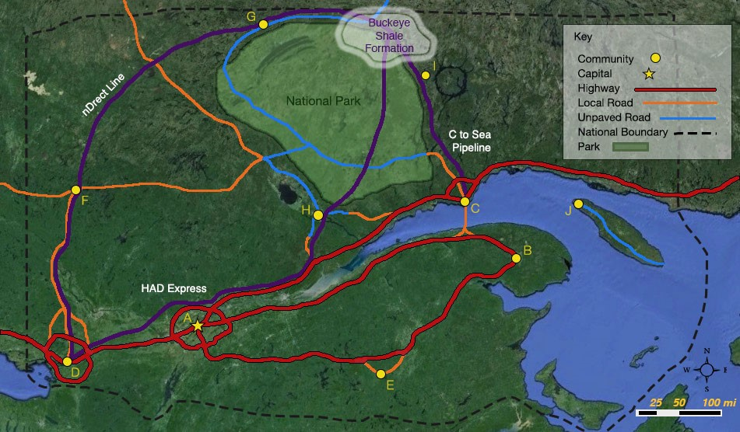
It is not clear what stance the National Government will take on the issues of approving the rights of the energy companies to drill in the park.
In addition, the National Government has yet to take a position or intervene in whether local communities can prevent private companies from gathering leases on private and public land for pipeline installation.
For communities across the nation, debates are raging over whether drilling should be allowed in the National Park and whether one or all of the pipelines should be permitted. Industry and university researchers have produced differing reports on the impact that these proposed developments (oil drilling, pipeline installation, and land leasing) could have on the economy, jobs, and the environment.
In three weeks the Representatives of the National Government will hold hearings as to whether to permit these activities, which will be overseen by the President, through the Secretary of Community Development. The President and Secretary want to know how your community will respond.
How will your community respond?!

Assignment 2
Section 1 = 30 points
- Describe how your community responded to the unconventional oil discovery in and around the northern border of the National Park and to the proposal to install up to three pipeline projects to transport the crude oil to potential processing facilities in the communities of C and D. Specifically, your team needs to explain how your community’s response relates to key aspects of your community’s prior history,
- Identify and differentiate the community organizations, businesses and/or individuals that support the National Government in allowing private extraction of the oil in the National Park and/or the pipeline construction,
- Identify and differentiate the community organizations, businesses and/or individuals that are against the National Government allowing private extraction of the oil in the National Park and/or the pipeline construction.

Section 2 = 20 points
- Describe any community development processes that your community is adopting to inform their two National Representatives of their reaction to these policy questions. If any single community response is identified, then it is important to list any opposing factions that exist within the community who are individually or collectively organized against the identification and communication of your community’s policy views.
- Also list how your community will continue to work to achieve its community development goals (through your listed action steps). Explain how these efforts relate to (or do not relate to) your development goals and action plans.

Section 3 = 30 points
- Explain how the unconventional oil discovery and pipeline proposals have affected the stock of each of the seven community capitals (natural, cultural, human, social, political, financial and built capital) in your community; specifically, your team needs to address each community capital using bulleted points written in complete sentence form.
- Speculate on how the community will “spiral up” or “spiral down” following this scenario, paying specific attention to the community’s stock of each of the seven community capitals (natural, cultural, human, social, political, financial and built capital) and the interactions across them.

Section 4 = 20 points
- Provide in-text citations and full references for at least four references that influenced your team’s work. A minimum of two course and two non-course materials are required.
- These influences should be used to directly inform and justify your team’s decision-making. References in the form of in-text citations (e.g., Campbell 2016) should be featured within the body of the document.
- Make sure your speculations are realistic and draw upon course materials, real-world examples and non-course, independent research.

