Ray: Good evening everyone, welcome to our podcast! It is my honor to have Mr. Chen as my guest for this conversation. As you know, that though the technology is developing rapidly and the society becomes much stabilized than past, issues among races are still a widely debated topic. There are also a lot of discrimination based on the bias and stereotypes. How do you think about the existence of these cases?

Mr. Chen: Yeah, you know, I’m also quite concern about these phenomenon existing in our present society, but I think we cannot solve the problems unless we know its origin and people’s mind behind it.

Ray: Wow! You seem really know a lot. When preparing for this show, I’ve read some academic papers on analyzing discrimination. I’ve noticed an interesting term in explaining it, which is called Systemic Racism. Have you heard about that term before?

Mr. Chen: Absolutely, well, firstly I would like to explain the meaning of racism. Racism is based on the comparison among different races. These races may show different physical appearances, religions, cultures. Racism is the mind of superiority of hierarchy when comparing to people of other races with different traits. Systemic Racism, also known as Institutional Racism, can be categorized as a form of racism performed as normal practices within a specific type of organizations, societies, or even groups.

Ray: So you mean that systemic racism does not target to one person or several people, instead, it focuses to a group of people, right?

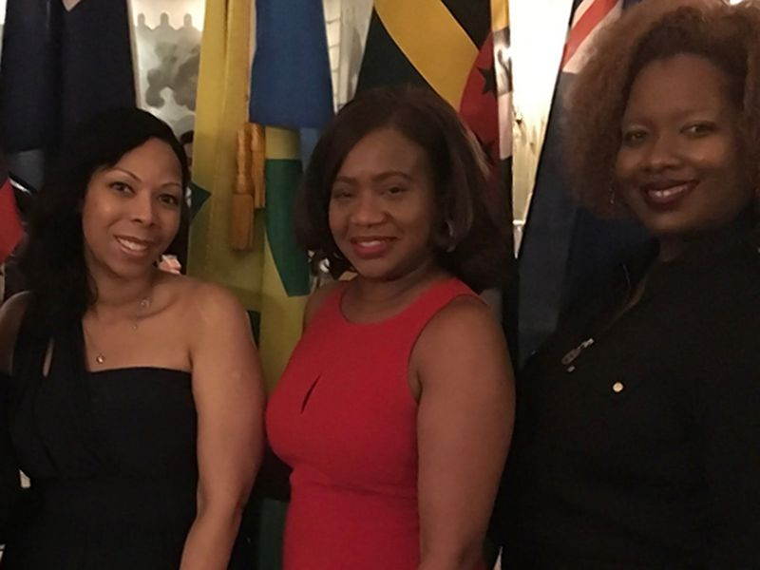
Mr. Chen: That’s correct! Recently I’ve seen a piece of news from New York Daily reported that some African - American woman say a worker in Harlem eatery racially profiled and falsely accused them of dining. One of the women, named Fitzgibbon, walked to a bar with her friends. As they ordered the drink, an employee asked them how they pay for the dish. The employee shouted at Fitzgibbon and said that she was in the restaurant last week and slipped away without payment, while according to Fitzgibbon, she remembered it was the first time she came to this bar. She was confused by the hostility and felty dehumanized. After the closely scrutiny check on the recording, the result showed that the woman who slipped away last week looked totally different from Fitzgibbon.

“(from left to right): Tara Fitzgibbon, Sharon Jones and Tamara Young. The three women allege they were racially profiled at the Angel of Harlem restaurant on Feb. 10 (Obtained by Daily News)”
Link: https://www.nydailynews.com/new-york/manhattan/harlem-restaurant-staff-accused-racially-profiling-black-women-article-1.3830000

Not only black people in cities, but also black people in rural area are receiving unfair treatments. USDA is a kind of programs which help to improve the economic conditions and living standards of rural Americans. However even today, black farmers are still treated unfairly in this USDA program. Recently House Agriculture Committee started to hold a testimony to the unfairness received by black farmers during their interactions with U.S. Department of Agriculture on Thursday. What is more astonishing is that this issue has remained unresolved for more than decades. Committee’s chairman Scott said “This festering wound on the soul of American agriculture must be healed”. Some data shows that only 0.1% of black farmers has received economic help in Trump administration USDA program, which is much lower than levels of white farmers.
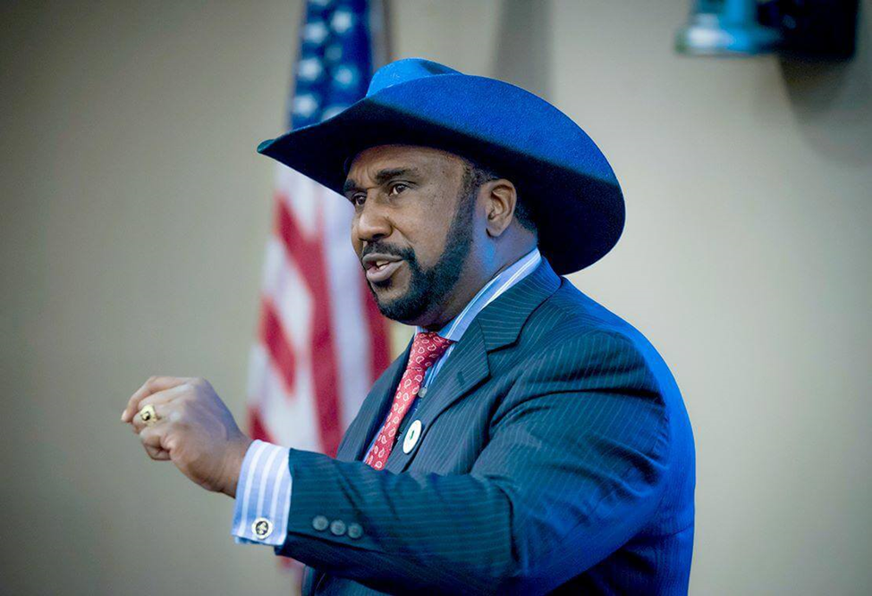
“For decades, John Boyd Jr. of Baskerville, president of the National Black Farmers Association, has been an advocate for black farmers. (Image courtesy of Terence Penister https://www.terencepenister.com/ )”
Link: https://www.virginiamercury.com/2021/03/26/house-agriculture-panel-probes-systemic-usda-discrimination-against-black-farmers/

Ray: Why do you think that black people, I mean as a whole race, are receiving unfairness and discrimination even in the present society?

Mr. Chen: Well, I think everyone who lives in the society has his or her own social identity, and the identity is a kind of measurement for constructing a person or a group of people. To be more specific, a psychological identity is how a person models itself, while a social identity is the identity of this person in the society. It determines which social group does this person belong to.

Ray: But how do these identity conceptions relate to racism?

Mr. Chen: Just as I said, social identities define people’s belongings to social groups. This implies that people with different identities will be united, or bounded, to different groups. For instance, we can use the simplest cultural backgrounds as identities to divide people into different groups. Imagine there is an Asian boy who born in America speaks English, play with American friends, and read U.S. literature in his lifetime. He will regard his identity as an American though his parents may be immigrants from Asian countries like Korea. Just like the Asian boy case, a person, or a group of people’s identities, are hard to change in others’ perceptions. From a historical perspective, black people, as a whole group, has the identity of subordinate race in white people’s impressions, since they were imported as slaves and were suppressed by the white local landlords. This fact might be quite tough, but I think that’s the origin of racism in U.S. society.

Ray: You mentioned that subordinate race in white people’s perception is one of the identities of black people, but besides the historical aspects, do you think that there are other factors that contribute to black people’s identities which implicitly lead to systemic racism in present society? Because I think as the society develops and time goes on, the influence of history to a race is gradually disappearing, so there must be some other causes.

Mr. Chen: You mentioned the development of society. Yeah, as the time goes on the identities of races are also changing. I do think the historical factor is the most reason which build black people’s identities, but I also think there are some social reasons which causes black people still receive unfairness and injustice nowadays.

Ray: Can you talk more about those social reasons?

Mr. Chen: Sure! Continue my description of the black farmer news. Despite black farmers are receiving injustice and unfairness, neither the society and government care about their rights and voices. The majority are not the victims, so even if they know the injustice to black people, they still consciously ignore the issue. That is the reason why the issue remained unresolved for decades. Since the issue is ignored, some white people nowadays still hold stereotype toward black people. Furthermore, the government even does not care about the black citizens, just because black people are not the majority comparing to white people and will not harm the government’s domination. This inequal treatment is not to one or several black people. Instead, this inequality and injustice is to black people in every city and every village in U.S. as a whole group, which illustrates the Systemic Injustice. We should not deny that the majority in U.S. society are white people, but I don’t want to see that black people are viewed as the so – called “other” group by white people. Just as Aijaz Ahmad mentioned in his article, when the conception of “otherness” is formed due to race, religion, or ethnicity etc, there will be no kindness or friendship. Instead, oppression and revolt will appear.

Ray: Wow you do give very professional analysis to reasons of systemic racism. We all wish the society to become a much more fair and better place for every member in it, but as you see, the resources and opportunities nowadays are still very unbalanced among different races. If we can eliminate racism, bias and stereotypes within people’s minds, do you think our society will become more cooperative and fair?

Mr. Chen: Sure! I think the rise of the conception of othering is the basic reason of dividing people into groups, while the systemic racism is based on the conflicts among various divergent groups. In order to build a better society, we must firstly downplay the consciousness of small groups within people’s minds.

Ray: So the first step is to erase the systemic racism society within present society, do you have any suggestion for the solutions?

Mr. Chen: Well I think firstly we must let people know that it is unnecessary to be racists. Changing young people’s minds is the first step. Since when they teach their children, their children may not have the concept of being a racist. If the group of racists no longer exist in future through education, the systemic racism will be eliminated. At that time, everyone will start to know that we are all same because we are all human. No matter what race we belong to, we share many identical physical traits, so there is no need to discriminate others. Besides, changing the social system is also very important. We must let our next generation enjoy the same rights of receiving education. We can do this by lowering the interest of college loan to a very low percentage at around 0.001% and offering a long time span for returns. By giving more chances of education to black families who cannot afford the tuitions, we can see more intelligent black youth enter the best universities in our country, and these youth will be the force that breaks the boundary of the hierarchy of society in the future.

Ray: After hearing your suggestions, I feel more confident to our society. I can’t wait to see what will happen if everyone become friendly and kind to each other! Just as a social activist named Martin Luther King once said: “We must learn to live together as brothers or perish together as fools.” At last, thanks for your presence to this live chat Mr. Chen, and that’s the end of our podcast. See you next week!

Reference:

Institutional racism. (2021, April 01). Retrieved April 05, 2021, from
https://en.wikipedia.org/wiki/Institutional_racism
Ahmad, A. (1987). Jameson's rhetoric of otherness and the "national allegory". Social Text, (17), 3. doi:10.2307/466475
Ariana Figueroa, V. (2021, March 26). House agriculture PANEL probes 'systemic' USDA discrimination against black farmers. Retrieved April 05, 2021, from https://www.virginiamercury.com/2021/03/26/house-agriculture-panel-probes-systemic-usda-discrimination-against-black-farmers/
Sommerfeldt, C. (2018, April 07). Black women say harlem Eatery staff RACIALLY PROFILED, falsely accused them of dining and dashing. Retrieved April 06, 2021, from https://www.nydailynews.com/new-york/manhattan/harlem-restaurant-staff-accused-racially-profiling-black-women-article-1.3830000
PS: Individual submission

