Accessibility Guide

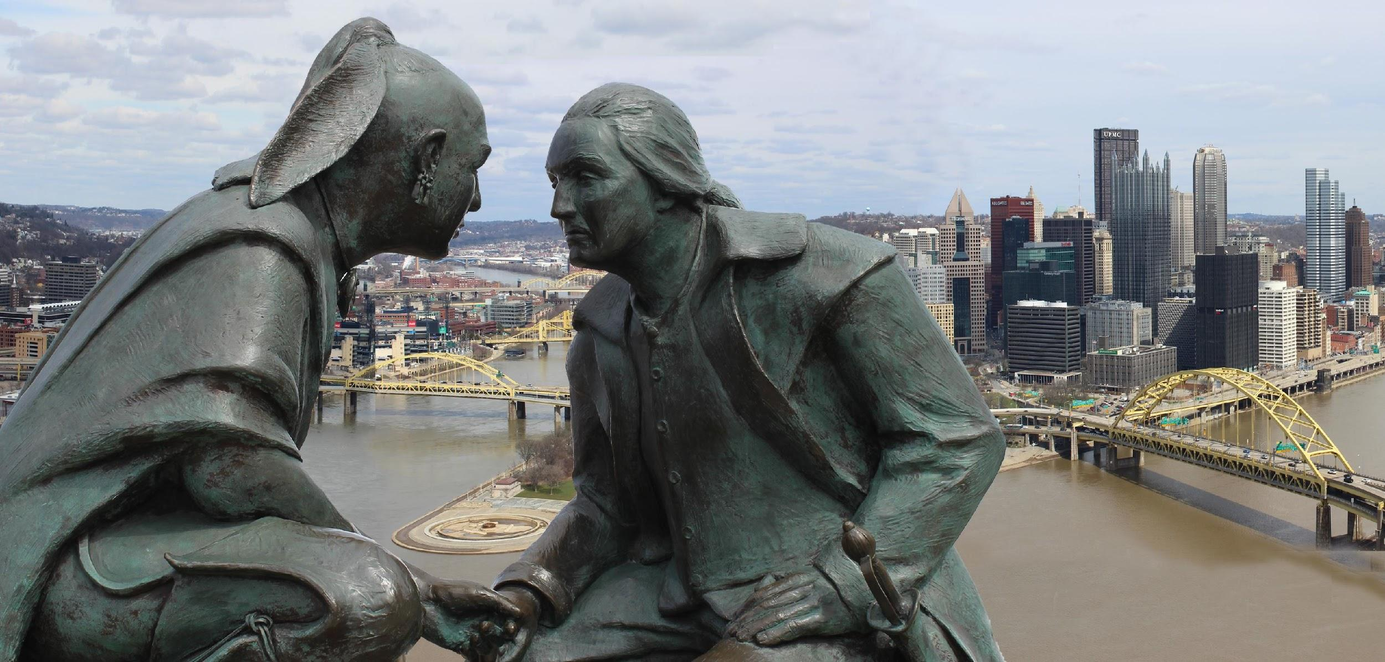
Image 1: This bronze sculpture, entitled Points of View, sits atop Mount Washington in Pittsburgh. According to a plaque underneath the statue, it was the intent of the sculptor, James A. West, to capture a 1770 meeting between Seneca leader Guyasuta and George Washington that “had a huge impact on Pittsburgh, Southwestern Pennsylvania, and the country that would become the United States of America.”

Note: The Duquesne Incline trolley, which carries passengers up the ridge to Mount Washington, is inaccessible for wheelchairs or scooters despite signs indicating that it is accessible.

Table of Contents

Welcome to Pittsburgh! 11
Conference Contacts 12
2019 Conference on College Composition & Communication (CCCC) 12
Local Arrangements Committee 12
National Council for Teaching English (NCTE) 12
Advance Accessibility Requests, Sign Language Interpreters, and CART 12
CCCC Committee on Disability Issues in College Composition 12
Local Accessibility Committee 13
Additional Contacts 13
Before the Conference 14
Accommodation Requests 14
Creating Accessible Presentations Requires Planning 14
Plan for the Weather 14
Long Distance Transportation 15
Train 15
Bus 15
Airport 17
General Information 17
Online Information 18
Discounted Airfare 18
Wheelchair Assistance 18
Sensory Room 18
Mothers Room 18
Elevators 19
Tram 19
Service Animals 19
TTY 19
Visual Paging 19
Braille Signage 19
Restrooms 20
Other Issues 20
Transportation Security Administration (TSA) 21
Local Transportation: Accessible Vehicle Rentals, Buses, Shuttles Service and Taxis 22
Accessible Vehicle Rental 22
Mobility Works 23
Public Transportation Services 23
Bus 24
ACCESS ADA Paratransit Service 24
Bicycles 25
Private Transportation with Accessible Service 25
SuperShuttle 26
Vet Taxi 26
Air Star ACCESS 27
Pedestrian 27
David L. Lawrence Convention Center 28
General Information 28
Online Information 28
Entrances 29
Distances and Signage 30
Restrooms 31
Pathways, Presentation Rooms, and Other Spaces 31
Wheelchairs and Scooters 32
Registration and Access Table 32
Interaction Badges 33
Sign Language Interpreters and Communication Access Realtime Translation (CART) 33
Quiet Room 32
Mother’s Room 34
Family Room 34
Parking 34
Street Metered Parking 35
Hotels 35
Primary Hotels 39
Westin Convention Center Hotel 39
Online Information 39
General Information 39
Getting to the Entrance 39
Lobby 39
Accessible Rooms 40
Parking 40
Shuttle Service 41
Restaurants and Bars 41
Elevators 41
Business Center 42
Exercise Room 42
Pool Area 42
Animals 42
Patterns 42
Scents 42
The Omni William Penn Hotel 42
Online Information 43
General Information 43
Accessible Rooms 43
Parking 43
Shuttle Service 43
Entrance 43
Lobby 44
Space to Maneuver 44
Restaurants and Bars 44
Business Center 44
Exercise Room 44
Pool and Spa 44
Animals 44
Patterns 45
Scents 45
Problems with Access 45
Secondary Hotels 46
Renaissance Hotel 46
Online Information 46
General Information 46
Entrance 47
Lobby 47
Accessible Rooms 47
Parking 48
Space to Maneuver 48
Restaurants and Bars 48
Business Center 49
Exercise Room 49
Pool and Spa 49
Animals 49
Patterns 49
Scents 49
Shuttle Service 49
Problems with Access 49
Marriott City Center 50
General Information 50
Online Information 50
Parking 50
Getting to the Entrance 50
Lobby 51
Elevators 51
Shuttle Service 51
Elevators 51
Accessible Rooms 52
Space to Maneuver 52
Restaurants and Bars 52
Business Center 52
Exercise Room and Pool 53
Animals 53
Patterns 53
Scents 53
Problems with Access 53
Double Tree by Hilton 53
General Information 53
Online Information 53
Getting to the Entrance 54
Lobby 54
Elevators 54
Accessible Rooms- 55
Parking 55
Shuttle 55
Space to Maneuver 56
Restaurants and Bars 56
Business Center 56
Exercise Room 56
Pool and Spa 56
Animals 56
Patterns 56
Scents 56
Access Problems 57
Additional Hotels in the Vicinity of the Convention Center 57
Courtyard by Marriott 57
Getting to the Hotel Entrance 58
Lobby 58
Elevators 58
Accessible Rooms 58
Braille Signage 59
Parking 59
Shuttle 59
Space to Maneuver 59
Restaurants and Bars 59
Business Center 60
Exercise Room 60
Pool and Spa 60
Animals 60
Patterns 60
Scents 60
Overall Access 60
Drury Plaza Hotel Downtown 60
Online Information 61
Getting to the Hotel Entrance 61
Lobby 61
Elevators 62
Accessible Rooms 62
Shuttle 62
Parking 62
Space to Maneuver 62
Restaurants and Bars 62
Business Center 63
Exercise Room 63
Pool and Spa 63
Animals 63
Patterns 63
Scents 63
Other 63
Hampton Inn & Suites Downtown 63
Getting to the Hotel Entrance 64
Lobby 64
Elevators 64
Accessible Rooms 64
Parking and Shuttle 65
Space to Maneuver 65
Restaurants and Bars 65
Business Center 65
Exercise Room 65
Pool and Spa 65
Animals 65
Patterns 66
Scents 66
The Priory Hotel 66
General Information 66
Accessible Rooms 66
Parking 66
Shuttle 67
Entrance 67
Lobby 67
Space to Maneuver 67
Restaurants and Bars 67
Animals 67
Access Problems 67
Homewood Suites by Hilton 67
Accessible Rooms 68
Shuttle 68
Parking 68
Getting to the Entrance 69
Lobby 69
Space to Maneuver 69
Restaurants and Bars 69
Business Center 69
Exercise Room 69
Pool and Spa 69
Animals 70
Patterns 70
Scents 70
Kimpton Hotel Monaco 70
Getting to the Entrance 70
Lobby 71
Accessible Rooms 71
Shuttle 71
Parking 71
Restaurants and Bars 71
Business Center 71
Exercise Room 71
Pool and Spa 72
Animals 72
Patterns 72
Access Problems 72
Pharmacies in the Vicinity of the David L. Lawrence Convention Center 72
Rite Aid 72
CVS 73
Rite Aid 73
Restaurants 74
Restaurants in the Vicinity of the Convention Center 75
Jimmy Johns 75
General Information 75
Online Information 75
Hours 76
Ten Penny 76
General Information 76
Online Information 76
Hours 76
Distance and Accessibility 77
August Henry’s Burger Bar 78
General Information 78
Online Information 78
Hours 78
Distance and Accessibility 78
Sienna Mercato 79
General Information 79
Online Information 79
Distance and Accessibility 79
Subway 80
Restaurants Offering Halal 81
Salam Halal 81
General Information 81
Hours 81
Online Information 81
Distance and Accessibility 81
Thank You! 82

Welcome to Pittsburgh!

The Pittsburgh Local Accessibility Committee wishes you a wonderful experience at the 2019 Conference on College Composition & Communication (CCCC)! We hope you are able to enjoy all that the “Steel City” has to offer.
This guide was created with the support of the National Council of Teachers of English (NCTE), the Committee on Disability Issues in College Composition (CDICC), the Local Arrangements Committee (LAC), and with the input of individuals who personally experience disability in all of its manifestations. Together, we realize that disability affects us everybody beyond the inevitable realities of body and mind. This guide was designed with the hope that conscientious conference attendees will be committed to making their presentations, pedagogy, publications, and social interactions accessible.
Supporting inaccessible establishments through our patronage perpetuates inequality and is contrary to the mission of CCCC. Like teachers and administrators, many proprietors may not realize that they are non-compliant in relation to disability-related laws. Nor may they understand that these laws are simply a good starting place, but often do not go far enough in creating accessible environments. Hence, we make no legal claims in this guide. Facilitating access goes beyond laws. Of course, disability rights are civil rights! We all can do more.
We acknowledge that it is impossible to consider every aspect of disability access. Individual bodies and minds are unique, and personal experiences vary. It is also impossible for us to examine every business establishment or space in Pittsburgh. Our aim here has been to consider accessibility issues in the general vicinity of the conference site and, in the spirit of mutuality, we invite you to contact us and/or other conference organizers to address any individual concerns you may have in advance of or during the conference.

Conference Contacts

2019 Conference on College Composition & Communication (CCCC)
Vershawn Young, Program Chair
Email: vershawn.young@uwaterloo.ca

Local Arrangements Committee
Brenda Whitney, Chair
Email: pitt.whit@verizon.net
The Local Arrangements Committee website includes additional information about Pittsburgh neighborhoods, venues, and attractions to help you plan your visit. This website also includes information about disability accessibility. You can access the website using the following link: https://4cspgh.wordpress.com/.

National Council for Teaching English (NCTE)
Kristen Suchor, NCTE Director of Affiliated Groups
Email: ksuchor@ncte.org
Marlene Knight, NCTE Director of Events
Email: marleneknightevents@gmail.com

Advance Accessibility Requests, Sign Language Interpreters, and CART
Lori Bianchini
Email: lbianchini@ncte.org

CCCC Committee on Disability Issues in College Composition
Tara Wood, Co-chair
Email: tara.wood@unco.edu
Christina V. Cedillo, Co-chair
Email: cvcedillo@gmail.com

Local Accessibility Committee
John Grant, Accessibility Guide Coordinator
Email: j.grant3@iup.edu
Ya-Huei Chen, Accessibility Guide Volunteer
Email: ya_huei100@hotmail.com
Noel Tague, Accessibility Guide Volunteer
Email: net16@pitt.edu

Additional Contacts
Dial 311 to report disability-related problems to the city. This number is not for reporting potholes.

Before the Conference

Accommodation Requests
Conference organizers are committed to proactive action to make sure CCCC is accessible for all presenters and attendees. If you need to request accommodations such as sign language interpreting, Computer Assisted Real Time Captioning (CART), or any other help that may require advance planning on the part of NCTE/CCCC staff, please contact Lori Bianchini by email at lbianchini@ncte.org as soon as possible and no later than March 1, 2019.

Creating Accessible Presentations Requires Planning
This guide focuses on access issues at the convention center, hotels, nearby restaurants, and in relation to transportation. The commitment to making CCCC accessible, however, extends beyond physical access. Another dimension of access involves ensuring that conference presentations are accessible for all types of minds and bodies, which requires advance preparation. Again, it is impossible to address every disability-related scenario proactively because there are infinite embodied experiences. Nevertheless, it is important for all presenters and session chairs to carefully plan presentations with access in mind to ensure inclusivity for all attendees.
Information about creating accessible presentations is available at the Compositing Access website, which may be accessed using the following link: https://u.osu.edu/composingaccess/
There will be presenters and attendees at the conference, as well as administrators and colleagues back home who are unaware of issues surrounding disability. The Composing Access Website is a terrific way to inform them. Please share the link, and remember: disability affects us all!

Plan for the Weather
In March, Pittsburgh can be very cold, rainy and snowy—or the region might experience an early burst of warm spring weather. Plan for a wide range of weather conditions when you pack. Gear for wet weather, like boots, umbrellas, and raincoats, will likely be necessary. Sweaters and light jackets might be nice to have on hand inside the conference site.
The Westin Hotel is connected to the David L. Lawrence Convention Center by a skywalk bridge. All other recommended hotels, discussed below, require conference attendees to travel outside to and from the conference site.

Long Distance Transportation

Train
The Amtrak station is about two blocks from the convention center East Lobby entrance. The Amtrak website is a bit confusing because there are two Pittsburgh train stations listed: Pittsburgh Amtrak and Grant Street. These stations are about 400 feet apart; travelers to Pittsburgh will want to arrive and depart from the Pittsburgh Amtrak station.
Depending on the city of departure, some routes may have transfers with a shuttle or bus, which are reported to be wheelchair accessible.
Online Information
Additional information about accessibility is available at the following link to the Amtrak website:
https://www.amtrak.com/home.html
If booking an Amtrak reservation online, you will be offered disability options after you choose your itinerary. You have a choice of Adult (Disability) and Adult (Companion of Disabled Person or CDP). You may also book your ticket/s with an agent using the following phone number:
Reservations & Customer Service
1-800-USA-RAIL
1-800-872-7245
More specific information about Amtrak’s disability access is available at the following link:
https://www.amtrak.com/accessible-travel-services

Bus
Pittsburgh Bus Station
55 11th St, Pittsburgh, PA 15222
(412) 392-6514

Distance to the Convention Center: The long-distance bus terminal or Greyhound Station is about one block away from the East Lobby entrance of the David L. Lawrence Convention Center. It is between the Pittsburgh Amtrak station and the convention center. A huge sign on the building shows Greyhounds trademark “running dog.”

Greyhound National Customer Service Phone Number:
1-800-752-4841 TTY/TDD: 1-800-345-3109
Spanish/Español: 1-800-531-5332

Greyhound Customer Service Representatives will waive the convenience fee for people who experience disability, but according to their website, you will need to confirm “that your inability to book electronically is due to your disability.”

Hours
Monday – Sunday: 12:00 AM - 11:59 PM

Bus Ticketing Office:
Monday - Sunday
12:00 AM - 11:59 PM

Online Information
The following website offers information about the Pittsburgh Intermodal [BUS} Station:
https://locations.greyhound.com/bus-stations/US/Pittsburgh/bus-station/bus-station-171150?utm_source=google&utm_medium=distrib&utm_campaign=google-distrib
The following website offers information about accessibility in relation long distance bus travel:
https://www.greyhound.com/en/help-and-info/travel-info/customers-with-disabilities
Greyhound also offers additional support for people who experience disability-related problems, which may be accessed using the following link:
ADA.support@greyhound.com.

Airport

Pittsburgh International Airport (PIT)
Landside Terminal, 4th Floor, Mezz
PO Box 12370
Pittsburgh, PA 15231-0370
Phone: (412) 472-3500
Fax: (412) 472-3636
Email: info@flypittsburgh.com
Customer service representatives who staff the Airport Information Desk can connect passengers to wheelchair escorts, provide tools for language barriers, or page passengers. They may be contacted using the following phone numbers:
(412) 472-3525
(412)472-3526
Airport Parking Information: (412) 472-5050
Airport Lost and Found: (412) 472-3525
The emergency number and number for police is 412-472-5700.
Also, for any general questions related to accessibility at Pittsburgh International Airport, please contact Samantha Stedford using the following email address: sstedford@flypittsburgh.com.

General Information
Pittsburgh International Airport (Code: PIT) is a medium-size airport with one terminal. Distances at the airport between check-in, security, concourses, gates, baggage claim, etc., are expansive. Accessibility and disability accommodations are handled by each individual airline. Airlines typically have contracts with other companies to help with pushing wheelchairs or providing porter services. But you need to make requests directly with the airline. The Travel and Transportation Administration (TSA) has their own requirements (below).

Online Information
General information about the Pittsburgh Airport may be accessed using the following link: http://www.flypittsburgh.com/
General information about accessibility at the airport may be accessed using the following link:
http://www.flypittsburgh.com/terminal-information/accessibility.

Discounted Airfare
NCTE/CCCC has arranged for discounts on Delta and United Airlines.
In order to get this discount on Delta Airlines, enter “NMSCZ” in the “Meeting Event Code” box when accessing the following website: https://www.delta.com/flight-search/book-a-flight
In order to get this discount on United Airlines, enter “ZFND508299” in the Offer Code box when you link to the following website: https://www.united.com/web/en-US/apps/booking/specials/meetings/default.aspx

Wheelchair Assistance
Wheelchair reservations, a porter (for hire), and curbside assistance can be arranged in advance by calling your specific airline.
Information about wheelchair services may be accessed using the following link: http://www.flypittsburgh.com/programs-services/services/wheelchair-services.

Sensory Room
A Sensory Room is currently being constructed in the airport and is expected to be completed before the conference. It will be located on concourse A by the Southwest gates. Information about the sensory room may be accessed using the following link: http://www.flypittsburgh.com/programs-services/services/sensory-room.

Mothers Room
There is a “Mothers Room” on the C concourse across from the Kidsport play area.

Elevators
There are two centrally located elevators by the baggage claim area (ground floor) and the check-in area (second floor). Within the secure area, there are elevators that go to and from the airport tram and the concourse gates.

Tram
There is an accessible airport tram that goes to and from the concourse area. It is a good idea for all passengers to hold on to railings, poles, or hand-holds; stops are mostly smooth, but can be abrupt at times. It is not necessary to strap a wheelchair to the floor for this short trip, but it is a good idea to use a wheelchair brake/lock while riding.

Service Animals
Service dogs on a leash have routinely been welcome in the airport. However, recent updates affecting specific disabilities (e.g. comfort service animals) are now being implemented by a few airlines. Travelers should contact their airline to get specific information closer to the time of the conference. Beyond service animals, other pets need to be in a portable kennel/pet box. The airport has a designated pet relief area located outside, adjacent to the Landside Baggage Claim area, and inside in Concourse D next to the Post Office. Information about the pet relief area may be accessed using the following link:
http://www.flypittsburgh.com/programs-services/services/pet-relief-area

TTY
TTY is located throughout all terminals at various locations.

Visual Paging
Visual Paging monitors are located throughout the terminal. The monitors provide taxi and security alert information, and public announcements are displayed by request.

Braille Signage
Braille signage exists in most public areas. However, as with almost everywhere, it is usually insufficient.

Restrooms
All restrooms have accessible features. Two restrooms on concourse D and one on concourse C are designated as “special” needs restrooms that offer additional features for accessibility.

Other Issues
There are some charging kiosks at the Pittsburgh Airport that are quite high and may not be accessible for some people. There are many locations with conflicting patterns: wall tile, ceiling tile, carpets, etc. may be disorienting for some people. In several places, only one water fountain is available, which may be problematic depending on whether or not you need a higher or lower fountain.
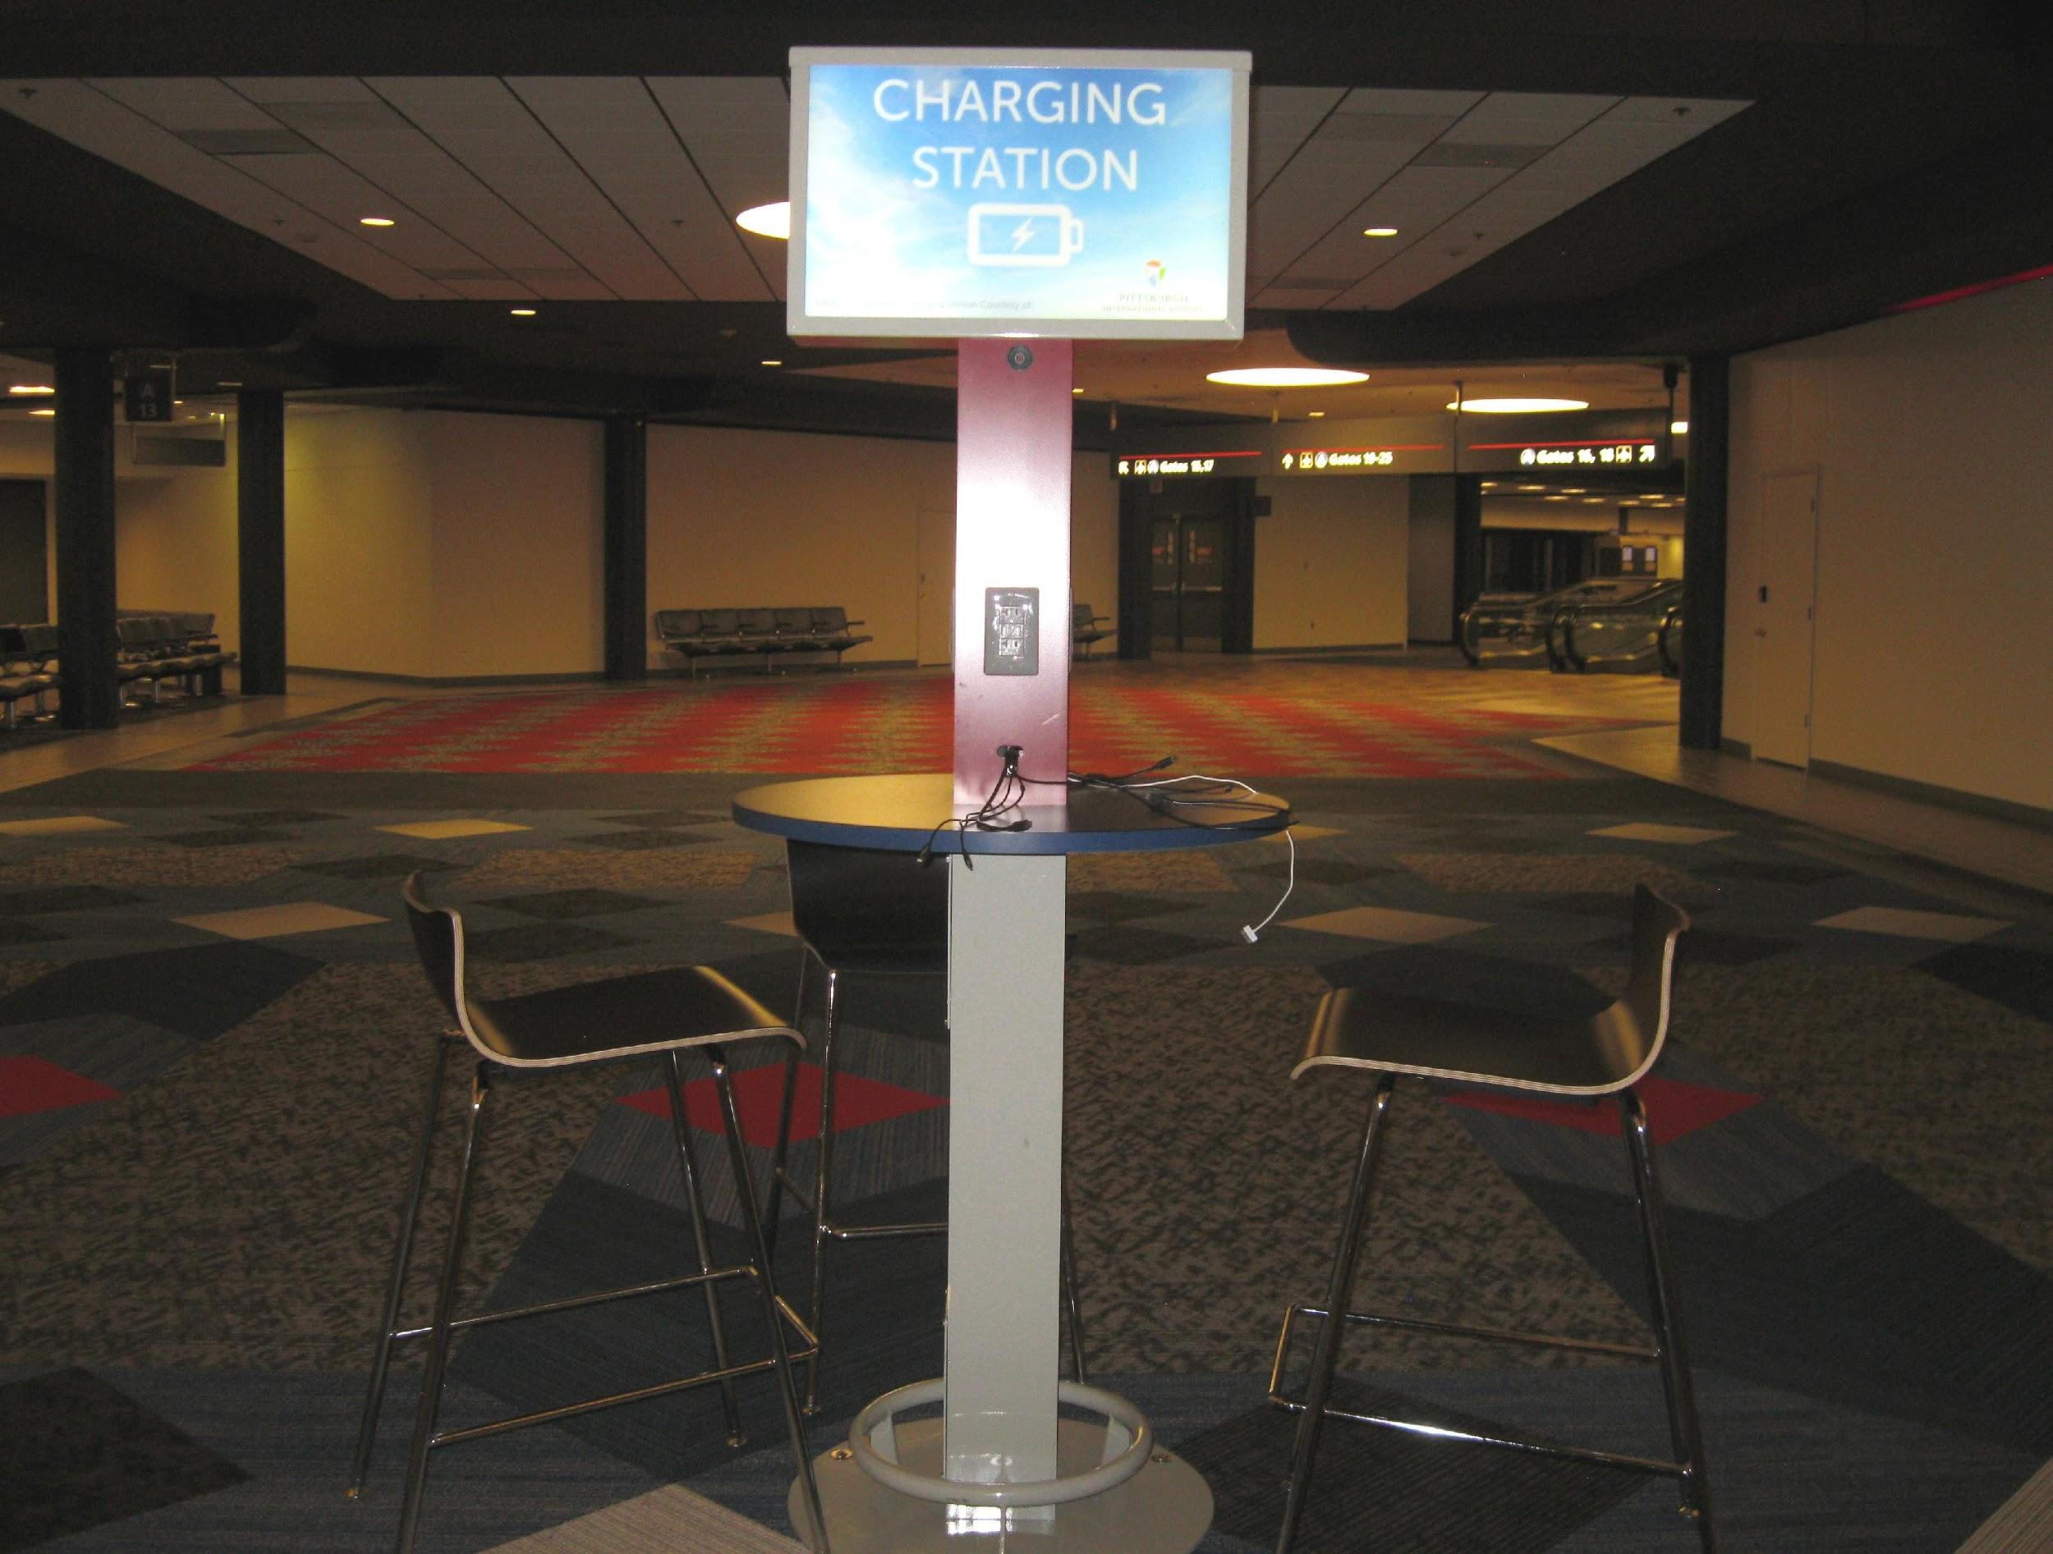
Image 2: Charging stations at the Pittsburgh Airport have high seats and tables that may hinder accessibility.
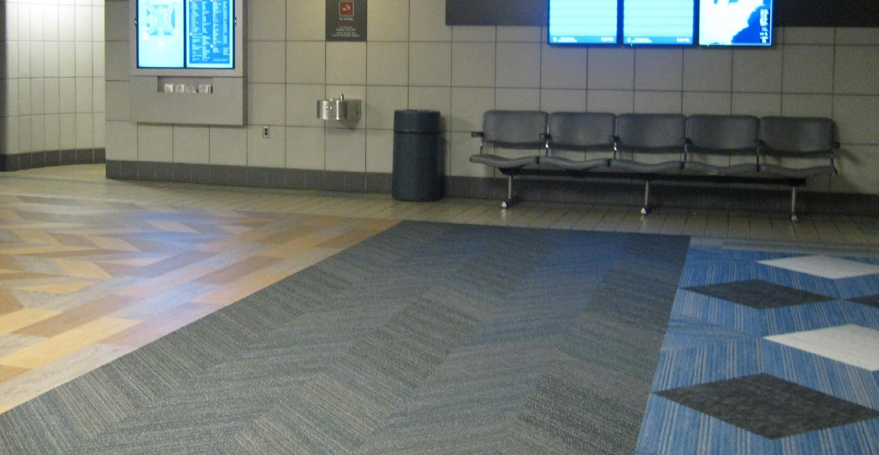
Image 3: The Pittsburgh Airport’s use of different patterns on the walls and floor may be disorienting. Armrests on seats prevent people from lying down, and there is only one water fountain.

Note: The exit for ground transportation (taxis, shuttles, etc.) at the Pittsburgh Airport is directly opposite from the exit for those getting picked up by a private party. The airport is about a 30-minute drive from the David L. Lawrence Convention Center.

Transportation Security Administration (TSA)
The TSA has a website designed to assist travelers who experience disability. This website discusses “special” procedures and may be accessed using the following link: https://www.tsa.gov/travel/special-procedures
Additionally, TSA has another website with information about TSA Cares. This website may be accessed using the following link:
https://www.tsa.gov/travel/passenger-support
You may email TSA Cares using the following link: Email TSA Cares
Travelers may also request a Passenger Support Specialist ahead of time by calling the TSA Cares hotline at 1-855-787-2227 ET.
Travelers who are deaf or hard of hearing can use a relay service to contact TSA Cares or can email TSAContactCenter@tsa.dhs.gov. Or you may call TSA using a relay at (855) 787-2227, Federal Relay: 711
TSA Hours Weekdays:
8 a.m. – 11 p.m. ET
Weekends/Holidays:
9 a.m. – 8 p.m. ET
TSA recommends that passengers call 72 hours ahead of travel for information about what to expect during screening.
TSA Cares serves as an additional, dedicated resource specifically for passengers with disabilities, medical conditions or other circumstances, as well as for traveling companions and loved ones who want to prepare for the screening process prior to flying.
When a passenger with a disability or medical condition calls TSA Cares, a representative will provide assistance either with information about screening that is relevant to the passenger’s specific disability or medical condition, or by referring the passenger to disability experts at TSA.

Local Transportation: Accessible Vehicle Rentals, Buses, Shuttles Service and Taxis
Public and private transportation is available not only to serve the airport, but also the Pittsburgh metropolitan area. The following information focuses on accessible vehicle rentals, buses, shuttles and taxis in the Pittsburgh area. No hotels in this guide provide shuttle service to or from the airport. However, some hotels have shuttles for getting around within a one or two-mile radius of the hotel, but none are wheelchair accessible. A few hotels do provide complimentary vouchers for accessible private shuttles or taxis so that disabled people can get the same services as other guests at no charge.

Accessible Vehicle Rental
Mobility works offers Wheelchair Van Rentals with hand controls and transfer seats, and they deliver to the airport.

Mobility Works
1012 Seco Rd.
Monroeville, PA 15146
Local Phone Number: 412-824-8220
National Phone Number: 1-877-275-4915
Mobility Works requires the following documents and information in order to rent a wheelchair accessible van:
- Current driver’s license for all drivers.
- Insurance card complete with agent’s name and contact information.
- Flight information if applicable.
- Pick-up dates, times, and location.
- Debit card or major credit card to hold reservation (no deposit required on card).
Inform your rental coordinator if your wheelchair is exceptionally wide or tall.
Cancellations
Full refunds are provided if a 24-hour advance notice is provided. For any notice under 24 hours, a $75 cancellation fee applies.
Payment
Payment is due in full at the time of delivery. All airport rentals will be charged 72 hours or 3 days prior to the rental delivery.

Public Transportation Services
Pittsburgh Port Authority Customer Service
Phone: 412-442-2000
TTY: 412-231-7007
The Pittsburgh Port Authority operates city buses, ACCESS Paratransit, and a public bicycle service. The Port Authority provides the following:
- Wheelchair-accessible buses with disability priority seating
- Braille and large print schedules
- Bus identifier kits: handheld signs designed for blind people or individuals with visual impairments to let drivers know which bus route they need
- Braille vehicle number identification
- ACCESS Paratransit Service
Online Information
General information about public transportation is available on the Pittsburgh Port Authority website, which may be accessed using the following link: http://www.portauthority.org/paac/.
The Pittsburgh Port Authority website also contains information about accessibility, which is available using the following link:
http://www.portauthority.org/paac/RiderServices/RidersWithSpecialNeeds.aspx.
To request schedules or an identifier kit, contact

Bus
All buses are equipped with either wheelchair ramps or lifts and are designed to “kneel,” lowering the first step. Priority seating is in the front of the bus. The Port Authority’s 28X bus will take passengers from the airport to downtown Pittsburgh.

ACCESS ADA Paratransit Service
650 Smithfield St., Suite 440
Pittsburgh, PA 15222
Phone: 412-562-5353 or PA Relay 711
Hours
Monday—Friday 8:00 a.m.—4:30 P.M.,
Online Information
Information and a video about ACCESS is available at the following website: https://www.myaccessride.com/.
The following link provides information about how people not from the Pittsburgh area may apply for ACCESS:
http://www.flypittsburgh.com/parking-transport/access-ada-paratransit-service
Additional information about how to apply for ACCESS is available using the following link:
http://www.portauthority.org/paac/RiderServices/ACCESSParatransit.aspx.
General Information
ACCESS is a public door-to-door, advance reservation, shared–ride transportation service provided throughout Pittsburgh. Access typically runs 7 days a week, 365 days a year from 6:00 A.M. to midnight, but service is also available “to ADA eligible people before 6 A.M. and after midnight if the Pittsburgh Port Authority fixed route service is in operation at that time at both the origin and destination” (Pittsburgh Port Authority).
People with disabilities “who are functionally unable to independently use Port Authority bus service, either all of the time, or under certain circumstances” may use this public service, but this service has requirements for eligibility and you will need to plan in advance.
ACCESS fares are paid from an electronic account (ePurse) where deposits are made online using a secure website, by mail, or in person at the ACCESS Office. You may use a Mastercard, Visa, or bank debit card. All fares are predetermined and based on trip length.
Note: People who meet the aforementioned requirements who are not from the Pittsburgh area are still eligible for services provided by ACCESS. Contact ACCESS far in advance to make arrangements.

Bicycles
Pittsburgh has public bicycles and bike lanes throughout the city. There is a bicycle kiosk on the southwest side of the David L. Lawrence Convention Center on 10th Street.

Private Transportation with Accessible Service
As with any big city, taxis hover around numerous designated areas near the airport, hotels, bars and convention centers. To get a wheelchair-accessible shuttle or taxi, though, you or your hotel will likely need to call the company in advance to arrange a ride. The following taxi companies offer wheelchair-accessible service:

SuperShuttle
SuperShuttle is a national company that offers rides directly to and from the airport to your chosen destination in Pittsburgh. Private rides costs about $60 each way; shared rides cost about $30 each way.
SuperShuttle is primarily designed for traveling to and from the airport, but they also provide rides within the city. However, you will need to pre-arrange an accessible shuttle. No matter where you want to go, SuperShuttle recommends that you make a reservation at least 24 hours in advance, particularly when arranging for a wheelchair-accessible shuttle.
Online Information
NCTE has arranged for a 10% discount with SuperShuttle. The discount code is “QNQEV”. Information about these rates may be accessed using the following link to a pdf document:
http://cccc.ncte.org/library/NCTEFiles/Groups/CCCC/Convention/2019/CCCC2019_SuperShuttleDiscount.pdf
You may also book these NCTE discounted fares using the following link:
https://www.supershuttle.com/?GC=QNQEV
There is an option for wheelchair users to select when booking online.
General information about SuperShuttle may be accessed using the following link: https://www.supershuttle.com/locations/pittsburghpit/.
You may also book your ride by phone using the following phone numbers:
Reservations: (800) 258-3826
TDD Reservations: (877) 215-9262

Vet Taxi
Phone: 412-481-8387
Online Information
The website for Vet Taxi may be accessed using the following link: https://www.vetaxi.com/
Vet Taxi is operated by military veterans and open to the public, including people who use all types of wheelchairs. Vet Taxi has a 24-hour dispatch service, metered rates & an online VETaxi app. Their website says that they can accommodate a push “wheelchair, power wheelchair or scooter and seat four passengers comfortably.” Vet Taxi is quite busy during weekday hours. It is best to pre-arrange airport pickups or other rides in advance.

Air Star ACCESS
412-381-7230
Online Information
The website for Air Star Access is at the following link: http://www.startransportationgroup.com/contact.html
Air Star Transportation has 15 wheelchair-accessible vans. Each Air Star bus can accommodate 4 wheelchairs or 12 passengers.

Pedestrian
Negotiating the terrain in the vicinity of the David L. Lawrence Convention Center, the conference hotels, and nearby restaurants may be hazardous due to loose/removed bricks in sidewalks, uneven pavement, deteriorating concrete, and inadequate crosswalks with inconsistent accessibility features such as truncated curb cuts. Suffice it to say, there are many trip hazards around the convention center and the hotels.
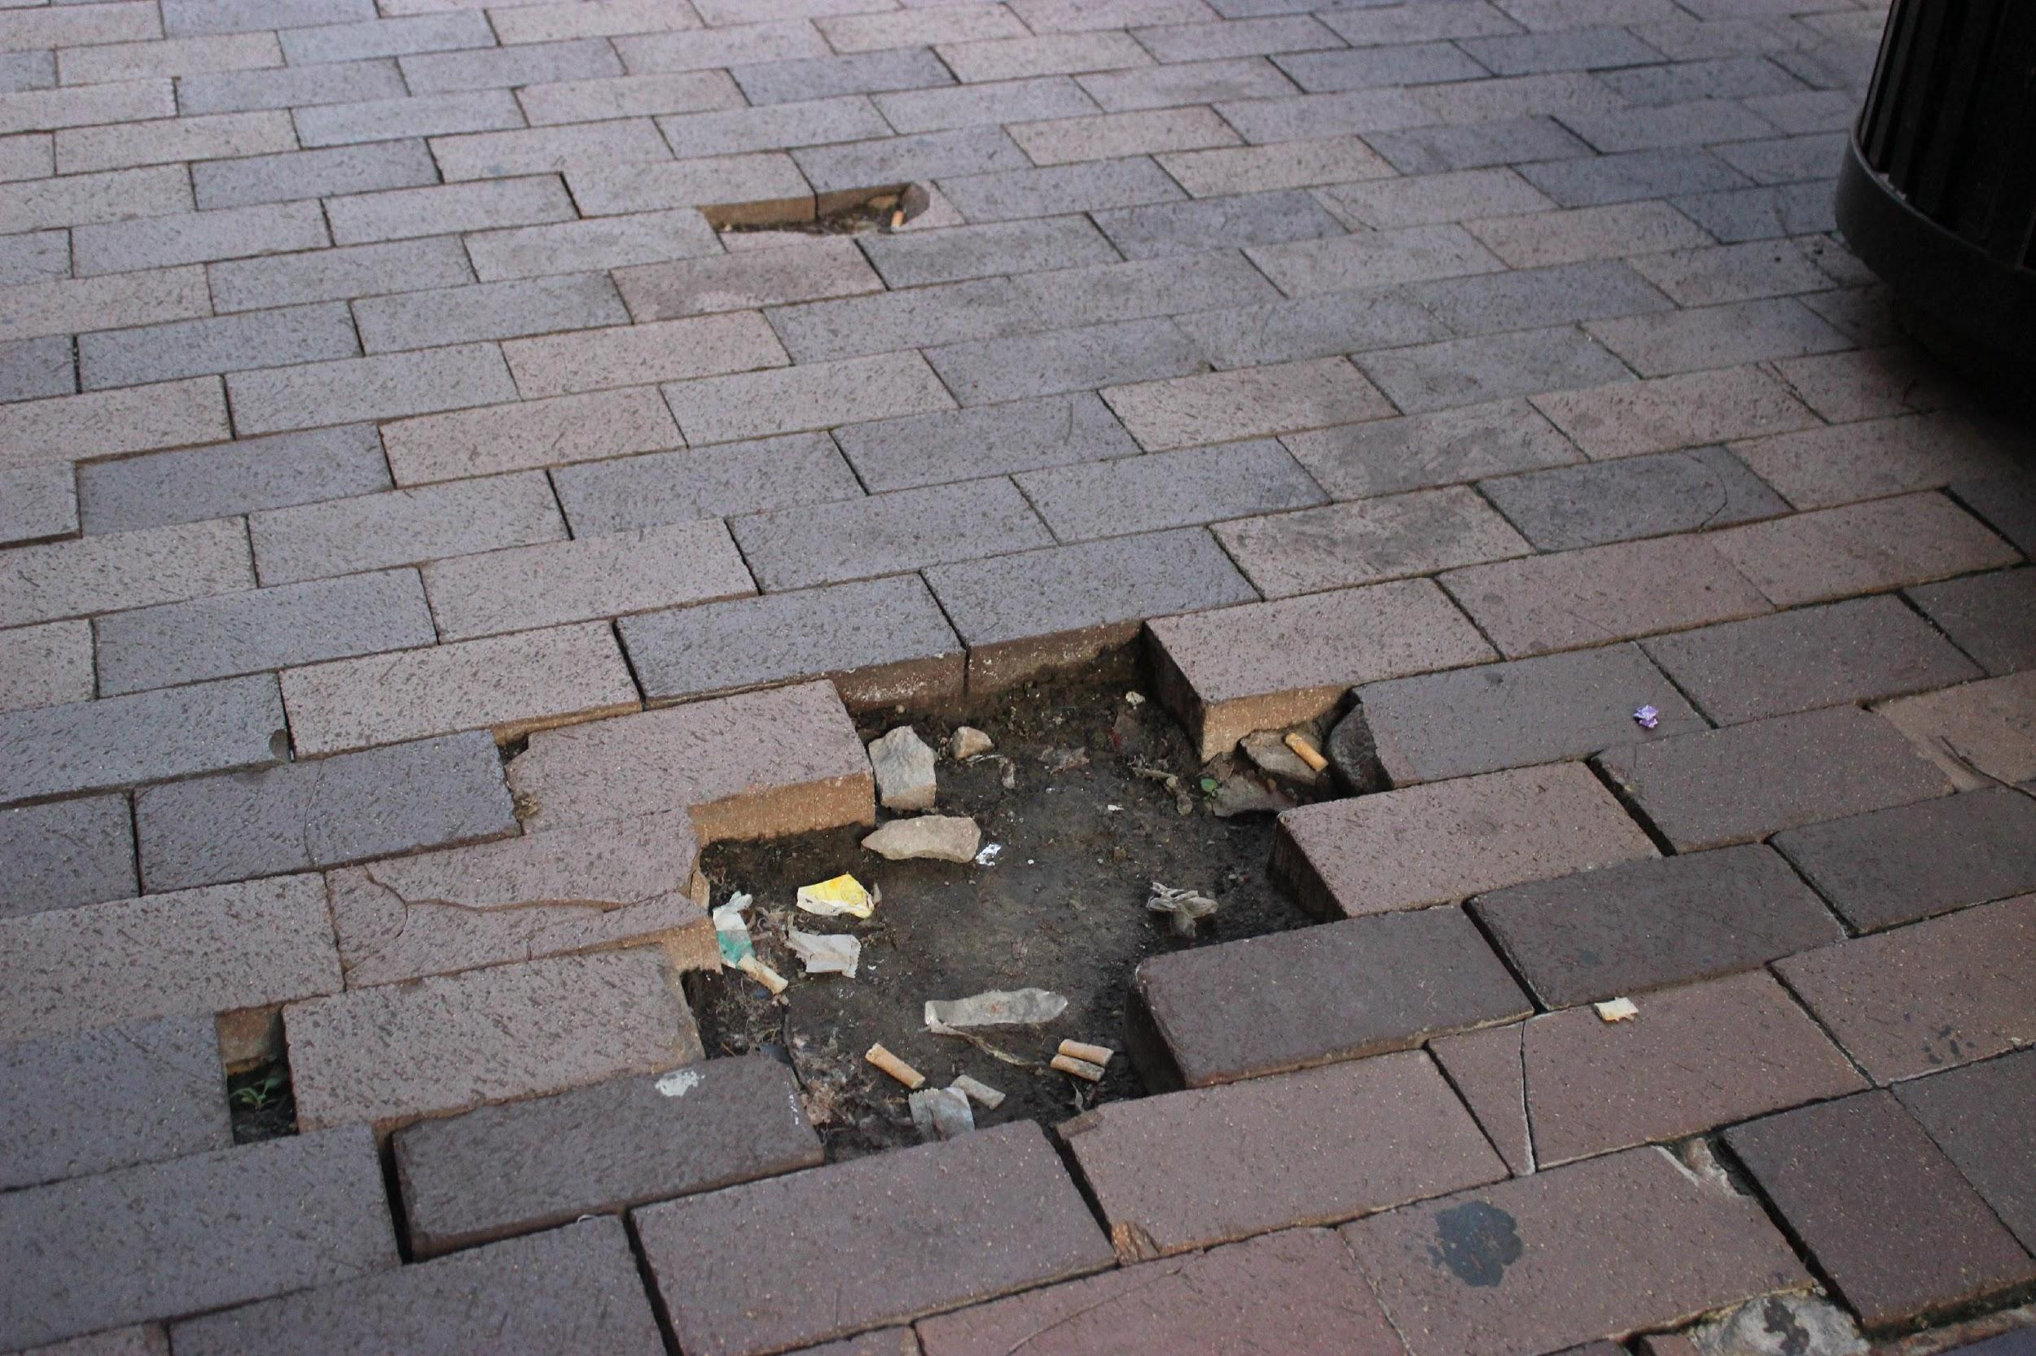
Image 4: Missing bricks pose safety risks near the convention center.

The main crosswalk near the convention center is at the intersection of 9th Street and Penn Ave. This crosswalk has audio/visual countdowns indicating when it is safe to cross. But most intersections in Pittsburgh do not have this feature. Some crosswalks have truncated domes or bumps to assist blind or visually impaired people, but many do not. After it rains, there are often puddles covering the bottom of curb cuts/ramps. May sidewalks are extremely uneven, particularly next to the northeast side of the Westin Hotel. The angle is not quite enough to tip over a wheelchair, but it is close. Leaning in the opposite direction or using a wheelchair or scooter in the street may be the only recourse. Of course, neither are good options, so use the skywalk to the Westin Hotel if possible. If you are staying in other hotels you may be able to still use the Westin elevator (to the left when entering the lobby) to get to the skywalk. Take care to recognize lopsided sidewalks.

David L. Lawrence Convention Center

General Information
1000 Ft. Duquesne Blvd.
Pittsburgh, PA 15222
(412) 565-6000

Online Information
The website for the David L. Lawrence Convention Center may be accessed using the following link: http://www.pittsburghcc.com/
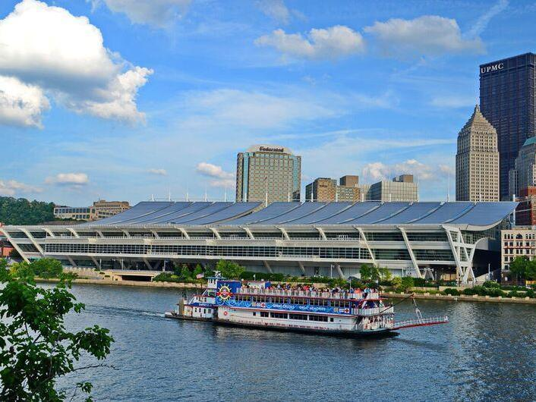
Image 5: A steamboat drifts down the river past the Convention Center.

Information about accessibility and on the convention center website may be accessed using the following link: http://www.pittsburghcc.com/dlcc-accessibility-info/.
According to the website, the convention center has an evacuation plan with specific information related to guests with disabilities. You may request a copy of this plan using the following email: info@pittsburghcc.com.

Entrances
There are two street-level entrances to the convention center on opposite sides of 10th Street, which runs under the second floor of the building. These entrances are marked as “East Lobby” and “West Lobby”. A crosswalk runs across 10th Street between the East Lobby and West Lobby entrances. While there are “Yield to Pedestrian” signs on display, it may be easier to access different sides of the building via the upper floors rather than crossing the busy street. The East Lobby entrance is on the same side of 10th Street as the convention center parking garage and the Westin Hotel. Upon entering the East Lobby, there are escalators directly ahead: ascending escalators are on the right; descending on the left. Next to the escalators is an information desk staffed by convention center security personnel. Beyond the information desk toward the right are two elevators. To the right of those elevators is a sitting area/lounge. Still further to the right is a coffee stand. To the right of the coffee stand is a souvenir stand.
There is also a 2rd floor skywalk entrance to the convention center accessible from the 2nd floor of the Westin Hotel. When going from the Westin to the convention center, there is an elevator directly ahead after crossing the skywalk. Go to the 3rd floor and there are wheelchairs available to borrow just outside of the elevator. From the elevator, head left/west to get to the registration area located in the West Atrium.
There are no additional public entrances to the convention center on Ft. Duquesne Blvd. (north side of building), Penn Ave. (south side of building) or on 11th Street (east side of building). There are emergency exits in those locations, though.

Distances and Signage
The David L. Lawrence Convention Center is vast and distances between various destinations may be far for some people. High contrast signs direct attendees using words, symbols, and, at times, Braille.
Outside, the Westin Hotel entrance/drop off area is 846 feet heading north to the East Lobby entrance of the convention center. It is 91 feet from the East Lobby entrance to the elevator toward the right at 2 o’clock, heading north through the lobby. Getting off the elevator on the third floor, you need to turn right and go 118 feet. On the right is a glass elevator that goes to the rooftop terrace on the 4th floor or to the 2nd floor: the glass elevator does not go to the 1st floor. Turning left, go 397 feet across a long corridor. Take a right for 65 feet to get to the access table and the registration area.
Inside, the Westin Hotel has a skywalk leading to the convention center. Exiting the skywalk elevators on the second floor of the Westin, go forward/north for 240 feet across the skywalk and through some automatic doors to get to the convention center elevator directly ahead. Take the convention center elevator to the 3rd floor. As you exit the elevator, go forward about 25 feet, then turn left toward 1 o’clock and go about 166 feet to get to the access table and the registration hub.
Note: The elevator on the convention center side of the skywalk also goes directly to the convention center parking lot. In other words, if you park in that lot, you can take the elevator by the entrance of the lot and go to the third floor; you will be near registration, which will save some back-tracking.

Restrooms
Throughout the convention center, there are restrooms assigned for Men, Women, and Accessible/Family. The Men’s and Women’s restrooms have standard accessible features: an additional stall with a higher toilet, grab bars, and (some) room to maneuver. However, sinks in the restrooms designated for Men and Women may be high for wheelchair users. The Accessible/Family restroom sinks are different from other restrooms and may be a bit more accessible as there is more room to maneuver. Changing tables are also available in these Accessible/Family restrooms. Near the restrooms are one high and one low water fountains marked with Braille. High fountains are on the left.

Pathways, Presentation Rooms, and Other Spaces
Pathways to all presentation rooms provide ample room to maneuver. Main halls are spacious with plenty of room to maneuver. As with any event, though, non-permanent obstacles may pose safety and maneuverability problems. Many people, the placement of tables, portable signage, and other obstacles may interfere with access/safety.
The convention center has a wonderful rooftop terrace with lots of space to roam around outside and enjoy views of the city. However, there are some hazardous areas on this 4th floor terrace: there are places where the concrete is deteriorating; there are a few electrical cover boxes in unexpected places; and four pathways seem to be ramps at first, but as a person proceeds, the ramps become stairs (warning signs on the pavement are difficult to read and insufficient as a caution).

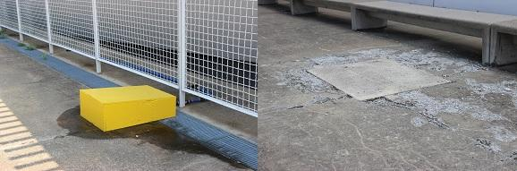
Image 6: Material obstructions and deteriorating concrete can make areas risky.

Wheelchairs and Scooters
There is plenty of room to maneuver wheelchairs or scooters in any part of the convention center, including the rooftop terrace, parking lot, and sidewalks surrounding the building. Of course, newly developed hazards (decaying concrete), temporary obstacles (tables, signs, people) may cause problems. The Convention Center offers complimentary (non-electric) wheelchairs for conference attendees on a first-come-first-serve basis. These wheelchairs cannot be reserved prior to arrival and they may not be taken outside the convention center property. A driver’s license is required and will be held until the wheelchair is returned.

Registration and Access Table
Conference Registration is on the 3rd floor on the south side of the building. If you enter using the East or West Lobby entrances, you will need to traverse down a long corridor that overlooks large auditorium spaces on both sides in order to arrive at the registration area. Another way to get to registration is by the skywalk connected to the Westin Hotel. The skywalk is on 2nd floor of the Westin and leads to the 2nd floor of the convention center. An elevator at the north side of the skywalk will take you to the 3rd floor the registration area and the Access Table are on the left when exiting the elevator.
The CCCC Access Table faces the registration area in the West Atrium of the 3rd floor of the convention center. The Access Table is staffed by scholars whose work focuses on disability. Volunteers will be available during regular conference hours to offer assistance with mobility and other access issues. Their services include but are not limited to helping solve problems with space, sound, scent, or lighting; helping conference attendees navigate from session to session; and connecting attendees to resources.

Interaction Badges
Interaction or communication badges will be available at the Access Table. These badges offer a colored-card system for indicating how you prefer to socialize. Interaction badges are red/pink, yellow, green, and blue slips of paper that can be slid into name badge holders and indicate the following:
- Red/pink: Please do not initiate interaction with this person.
- Yellow: One should initiate interaction only if given prior permission to do so.
- Green: This person would like to socialize but has difficulty initiating and would like others to initiate communication.
- Blue: This person will initiate their own interaction. While blue is the suggested color for “I will regulate my own interaction,” it is not necessary to use any interaction badge at all.
A video about interaction badges is available using the following link to the Composing Access website: https://u.osu.edu/composingaccess/for-organizers/

Sign Language Interpreters and Communication Access Realtime Translation (CART)
Sign Language interpreters and CART services are provided at no cost. Lori Bianchini is the contact person for inquiries about interpreters and CART. Her email is lbianchini@ncte.org.
Also, you may want to refer to the following link for the Registry of Interpreters for the Deaf: https://www.rid.org/. For additional information about CART, please refer to the Communication Access Realtime Translation page on the National Association of the Deaf website by using the following link: https://www.nad.org/resources/technology/captioning-for-access/communication-access-realtime-translation/.

Quiet Room
The Quiet Room will be located on the third floor of the David L. Lawrence Convention Center in Room 322. The Quiet Room is intended to provide a quiet, calm space where attendees can spend time away from the noise, lights, and other stimuli of conference spaces. This room may be used for silent prayer. The Quiet Room is not available for conversations or meetings.
Earphones used at a considerate volume may provide calming music or other ambient sounds, but please realize that sound from earphones is sometimes audible to people sitting nearby. Information about ambient and noise-canceling sound can be found through MyNoise.net (free and available via web browser and app) and SleepPillow (free trial version).

Mother’s Room
A Mother’s Room is located in the convention center on the second floor near the West Elevators. This is a dedicated space provided by the convention center.

Family Room
A Family Room is located on the third floor of the convention center in Room 337. This room is for CCCC attendees who bring children with them to the conference. Children are welcome to bring their own toys and activities. There are no childcare providers available in this room and all children must be accompanied by a parent or guardian.

Parking
The David L. Lawrence Convention Center parking lot entrance is located on the southeast side of the convention center on 10th Street. The entrance to the convention center lot is between the Westin Hotel and the convention center. During the day, there is often a sign noting that the lot is full. However, if you have a disability placard or license plate, you should ask an attendant about availability because accessible parking spaces are often available when the “lot is full” sign is posted. Remember to bring your ticket with you as you pay at a machine at entrances to the parking garage, not at a booth on the way out of the parking lot.
There are several parking lots in the vicinity of the convention center. Keep in mind that these might be full because many people commute to downtown Pittsburgh and there might also be sporting events affecting availability.

Street Metered Parking
There are very few metered parking spaces in the vicinity of the David L. Lawrence Convention Center. People who use a disability placard or license plate may park in any space, but you still need to pay at a kiosk. While kiosks have a blue “wheelchair guy” button designed for disability access, the function of this button is unclear. You will get one additional hour for free if you display a disability placard or have a disability license plate. There are also (few) spaces specifically designated for people with disabilities and the same rules apply: again, pay for the initial time at a kiosk; get an addition hour for free.
Please note the following accessibility issues with street parking:
- If you use a ramp, parking on one-way streets might require you to exit on the traffic side, not the curbside. For example, this is an issue at valet parking at the William Penn Omni Hotel and he Kimpton Hotel Monaco.
- Benches, bus shelters, poles, garbage cans, and other inappropriately placed obstacles sometimes interfere with the ability to fully extend a ramp out of a vehicle.
- Digital parking meters are interspersed along the street, which can require extra walking. For example, you might find yourself needing to go half-a-block in the opposite direction of where you are headed to pay for parking first. Please note that all meters require a license plate number.

Hotels
Most hotels seem to comply with the Americans with Disabilities Act of 1990 (ADA) and subsequent related laws—a good starting place. The primary focus of this guide is to address overall accessibility and the creators of this guide make no legal claims.
A few important things apply to all hotels:
- Accessible rooms in hotels are not reserved in ways accessible parking spaces are reserved i.e. you cannot park in an accessible parking space if you do not have a state-issued disability placard or license plate. Hotels, on the other hand, hold accessible rooms open for those who need them, but when other rooms are filled, accessible rooms are up for grabs to anyone, whether they need/request it or not. It is important, then, to request and reserve an accessible room if you need it ASAP.
- During site visits, only a few accessible rooms were available to inspect and accessibility features may be inconsistent with all accessible rooms in any given hotel. Some rooms might best accommodate a person who uses a wheelchair, while other accessible rooms might be better for people who are deaf. Generally, most hotels in this guide offered accessible rooms with space to maneuver, lower peepholes, tubs with handrails, roll-in showers, “visual” doorbells and TTY kits. Some accommodations need to be requested in advance so that rooms can be retrofit or made “accessible” according to the specific needs of a guest. For example, people who are sensitive to the smell of detergents should contact the hotel in advance to make sure the room is cleaned using scent-free products. \
- Typically, rooms are only distinguished according to “accessible tub room” and “accessible roll-in shower” room. Some hotels have a third type of accessible room designated for deaf people, which may mean you get a TTY Kit from the front desk. In the spirit of Universal Design, we did our best to think outside these confines, considering the widest range of possibilities.
- Most of the hotels highlighted in this guide provide valet parking. Some hotels only offer valet parking and there is no self-parking close. One hotel only has self-parking (Hampton Inn & Suites). Some have both valet and self-parking. Distances to public parking lots may be an important consideration. In/out privileges offered with valet service may save money, too. Winter weather in Pittsburgh—typically cold, snowy, icy, slippery—may be an important consideration as you choose a hotel.
- Carpeting in hotels in low pile.
- No hotels highlighted in this guide offer shuttle service to/from the airport. Some hotels provide complimentary shuttle service within one or two miles of the hotel. No hotels, however, have wheelchair/scooter accessible shuttles. Those with shuttles, though, will pay for and arrange a private wheelchair/scooter accessible shuttle. It is recommended that guests confirm all arrangements because wheelchair/scooter accessible taxi and shuttles may require long waiting times. It is important to note that hotel staff are often not aware that their hotel pays for/reimburses the cost for wheelchair/scooter transportation. Ask to speak with a manager if necessary.

Finally, it is important to note that blocks of rooms at several hotels in the vicinity of the convention center have been reserved for CCCC attendees. The primary hotels are The Westin Convention Center Hotel (connected to the convention center by a skywalk) and the William Penn Omni Hotel have the largest blocks of rooms set aside for the conference. Secondary hotels have smaller blocks of rooms put on hold: the Renaissance Hotel, the Marriott City Center (not the Courtyard by Marriott), and the Double Tree by Hilton.
For information about reservations and discounted rates at these primary and secondary hotels, refer to the following 2019 CCCC website: http://cccc.ncte.org/cccc/conv/hotel
In addition to these primary and secondary hotels, this guide outlines accessibility at some other hotels: the Courtyard by Marriott (not Marriot City Center); the Drury Hotel; the Hampton Inn & Suites; Homewood Suites by Hilton; the Priory Hotel; and the Kimpton Hotel Monaco. These hotels are included because, with the exception of the Westin, they are closer to the convention center than the aforementioned hotels where blocks of rooms have been reserved. Some of these “additional” hotels are very nice, have terrific accessibility, and would be a closer alternative for disabled people if the Westin is full e.g. the Courtyard by Marriott, the Hampton Inn & Suites, and the Homewood Suites by Hilton, while not full-service hotels, all have very good accessibility features.
Note: No rooms have been reserved at discounted rates at these “additional hotels.”
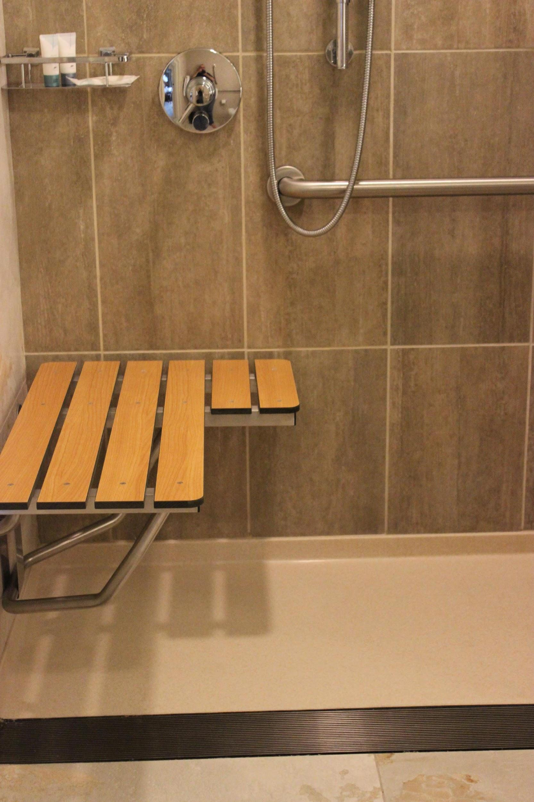
Image 7: Hotels in this guide have accessibility features such as benches in the shower.
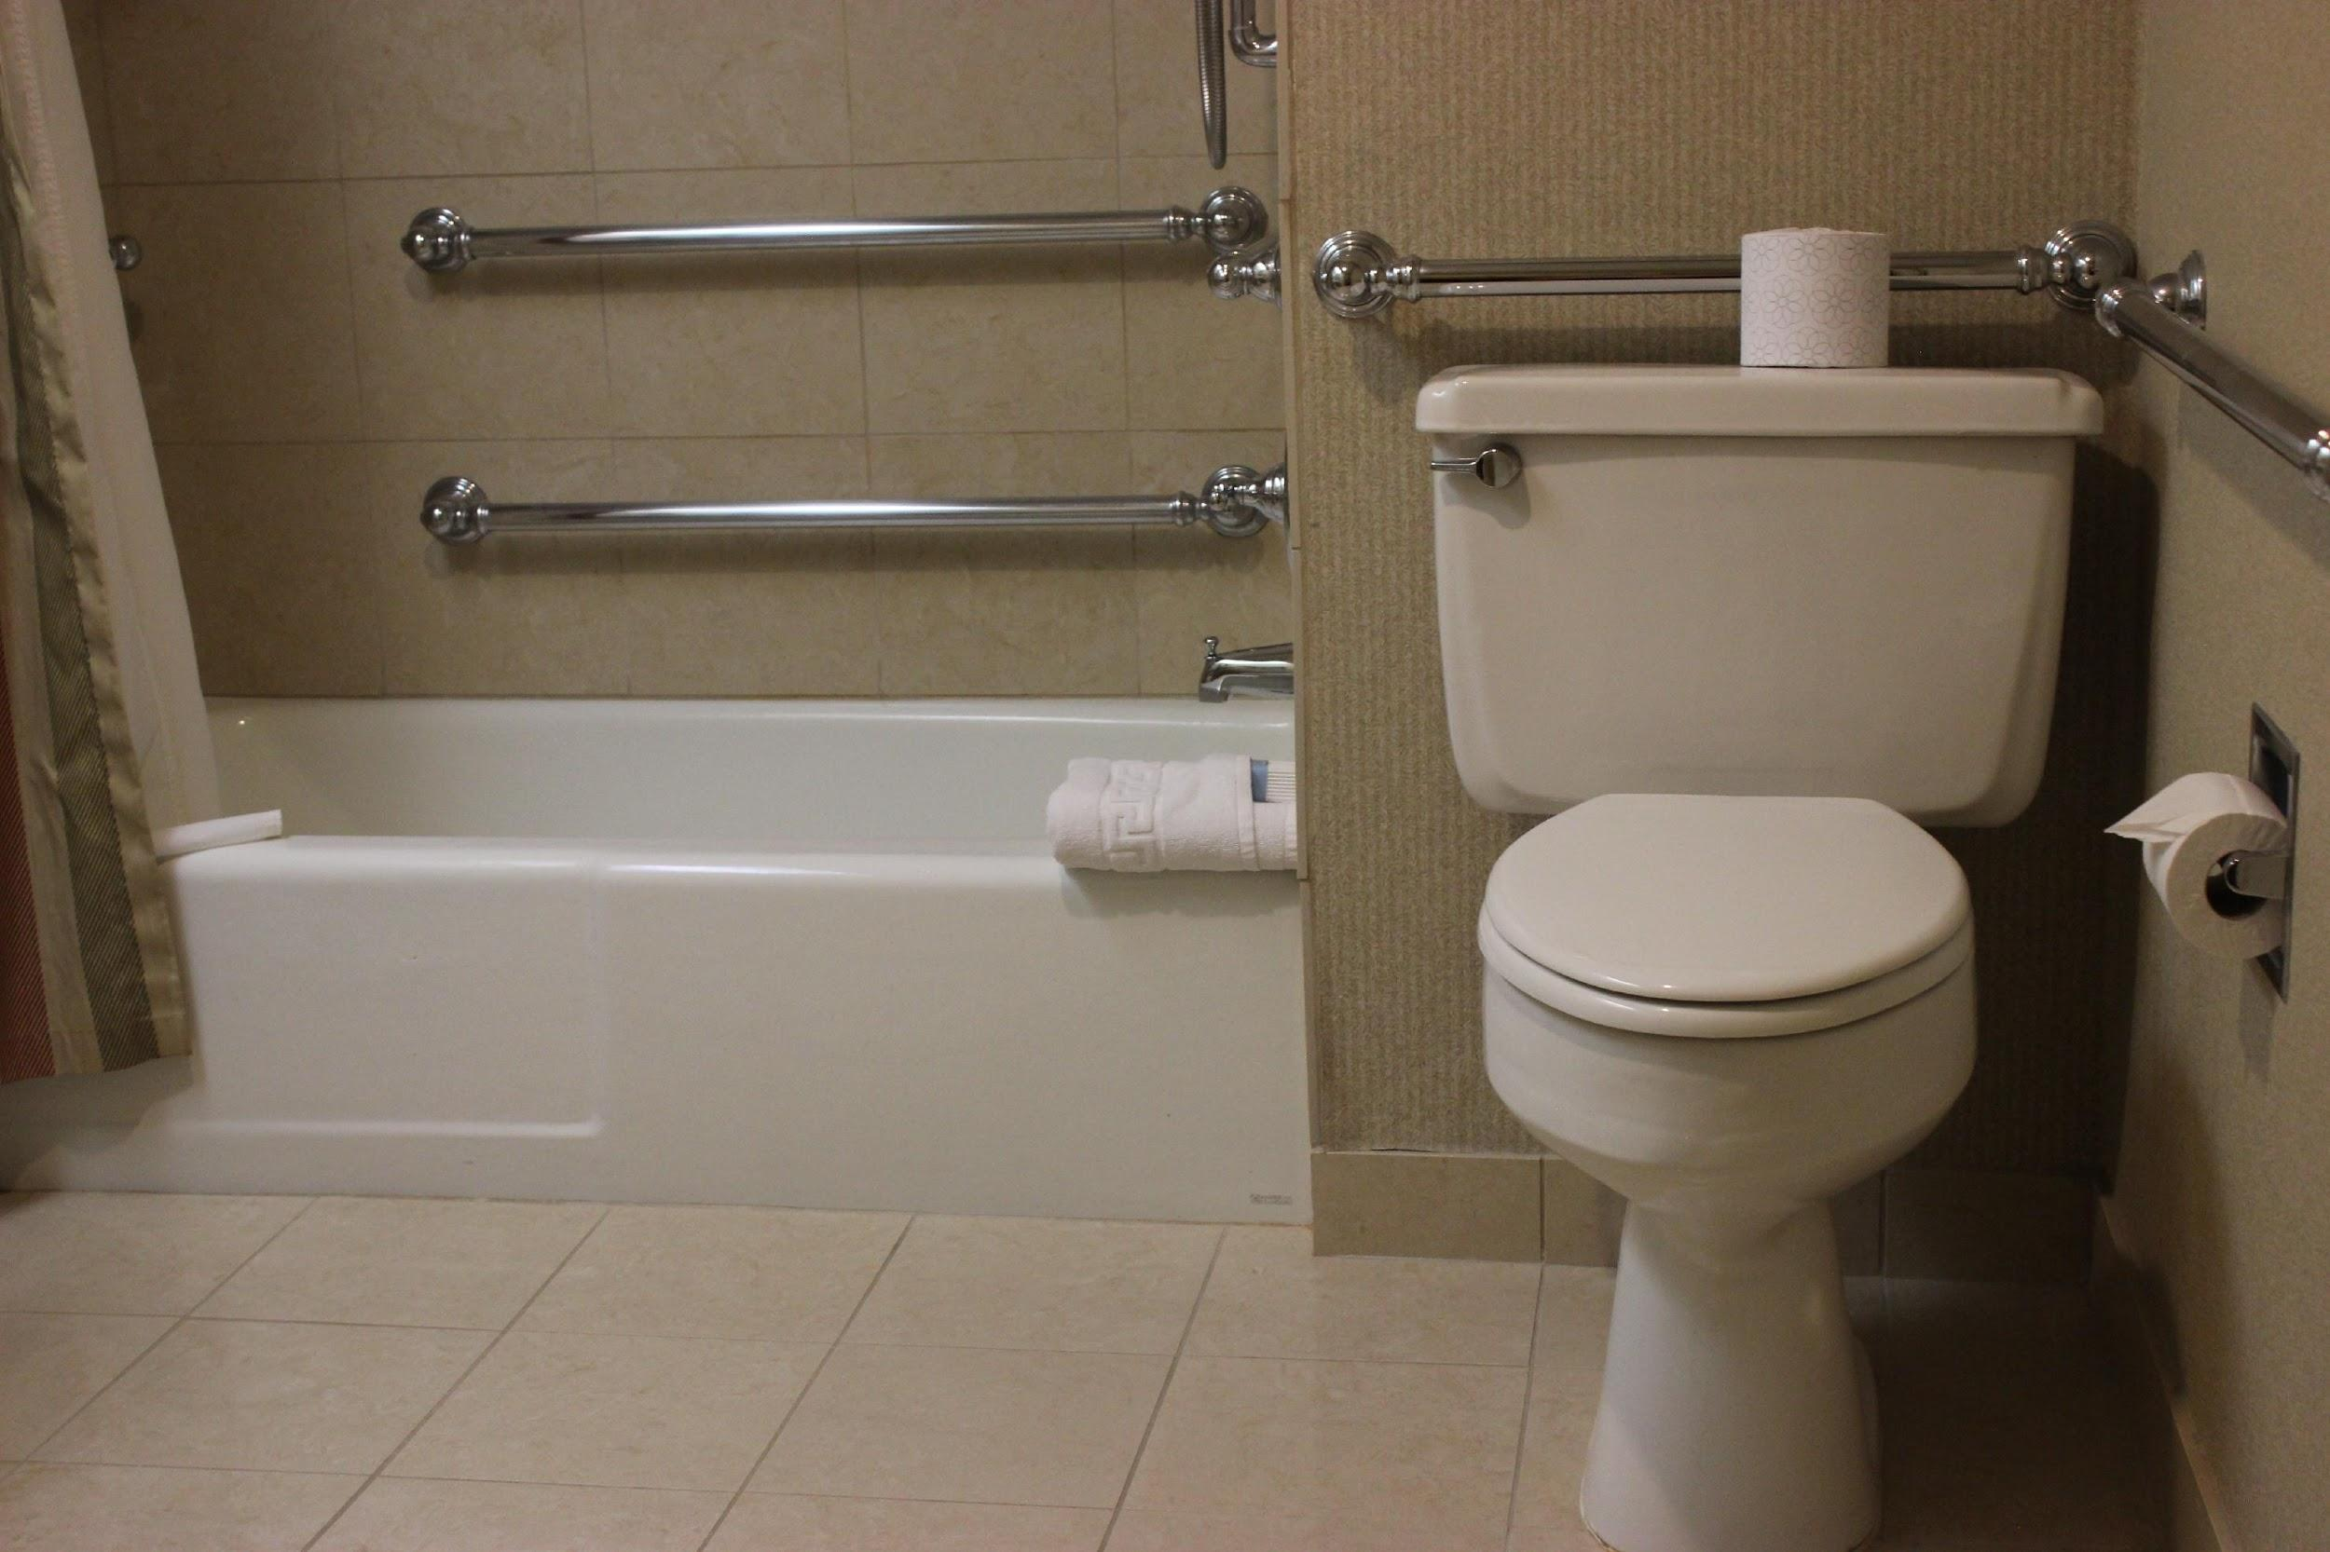
Image 8: Accessible hotel rooms have bathrooms with handrail grab bars.

Primary Hotels

Westin Convention Center Hotel
1000 Penn Ave.
Pittsburgh, PA 15222
(412)-281-3700
Distance to Convention Center: connected via 2nd floor skywalk; closest hotel to conference.

Online Information
The general website for the Westin may be accessed using the following link: http://www.westinpittsburgh.com/?SWAQ=958P
The Westin website includes information about accessibility at the following link: http://www.starwoodhotels.com/westin/property/features/index.html?propertyID=1370&language=en_US&ES=LPS_1370_EN_WI_NAD.

General Information
The Westin is a full-service hotel with 14 accessible rooms. It is connected to the convention center by a second floor skywalk and is the only hotel with direct, indoor access to the convention center, which may be an important consideration in Pittsburgh in March. Staying indoors, guests can also access several businesses in the concourse connected to the hotel, including a Starbucks, a juice store, a candy store, a souvenir store, and a post office.

Getting to the Entrance
As with many places in downtown Pittsburgh, sidewalks are not level near the Westin. Loose, broken, or lost bricks pose hazards. Uneven sidewalks are particularly problematic on the south side of Penn Ave. from 9th Street up to 6th Street and on Duquesne Ave. from 9th to 5th Streets. Puddles of water can accumulate at curb-cuts near the Westin and at other nearby crosswalks. The pathway from the sidewalk to the Westin entrance is also tricky. There are some “dead end” sidewalks that pose problems. There is also minimal signage to direct people to the entrance, however, staff kindly offered assurances that signage would be improved before the conference. To avoid dead-end sidewalks and the busy valet/drop-off area, the following pathways are best:
On the middle of the block on Penn Ave. between 10th and 11th Streets, there is a narrow ramp that leads to the Westin and the connected concourse. This ramp is on the convention center side of the hotel. On the opposite side of the hotel (not adjacent to the convention center) there is another walkway toward the middle of the block on Liberty Ave. between 10th and 11th Streets, which leads to the Westin entrance.
When facing the Westin from the driveway in front of the hotel, there are three entrances:
- a valet entrance on the left (often used by guests)
- a revolving door in the center, which can be slowed by pushing the blue accessibility button one meter from the ground;
- and an automatic door on the right (this area sometimes has porter carts partially obstructing the pathway)

Lobby
When entering the lobby, go toward the right and pass Bill’s Bar and Burger to get to the front desk. To the left of the restaurant are couches and comfortable seating. In front of those, beyond the restaurant to the left is the front desk and check-in area. On the left after entering the lobby is (from left to right) a public TV and sitting area with tables and sofas; the concierge’s desk; a souvenir shop (directly behind the concierge’s desk); and the entrance to the concourse (just to the left of the souvenir shop).
While there is space to maneuver throughout the lobby, there are typically a lot of people in this area.

Accessible Rooms
The Westin has fourteen rooms designated “accessible.” Each of these rooms has different accessibility features. For example, some accessible rooms have roll-in showers, while others have tubs. All accessible rooms have grab-bars. Devices are available to retrofit rooms for deaf or hearing-impaired guests. Guests should ask for specific accommodations when reserving an “accessible” room to ensure that the room is best suited to their needs.

Parking
The Westin has self-parking with accessible spaces, but these may be full as the lot leases spaces to non-guests. The entrance to the parking garage is in the front of the building on 10th Street, to the right after entering the u-shaped driveway. There is also valet parking. It is easy to confuse the convention center parking lot with the Westin parking lot because they are next to each other, but note that they are separate lots.

Shuttle Service
Westin does not provide an airport shuttle service. It does offer shuttle service within a one-mile radius of the hotel, however, the shuttle is not wheelchair-accessible. The hotel will arrange for a wheelchair accessible van or taxi and provide guests a voucher free of charge. Planning ahead for this wheelchair accessible transportation from and back to the hotel is strongly recommended.

Restaurants and Bars
Bill's Bar & Burger is adjacent to the lobby, on the right when facing the front desk. Guests have a choice of eating in the bar area or places isolated from the bar. The front entrance requires patrons to pass through the bar to get to these isolated areas. Alcohol is displayed and can be smelled if you use the front entrance. There is another entrance to the right of the front desk and the restrooms. There is accessible seating on the far side of the bar, and there are average height tables throughout the restaurant. Gluten free options are available upon request. There is an exit in the back of the restaurant that leads to the concourse with a Starbucks, candy store, post office, ATM machine, and vending machines. That “mini mall” concourse area may also be accessed by an exit in the northeast side of the lobby just past the elevators to the skywalk. Wet floor signs indicating slippery surfaces are common in the concourse area.
The Penn City Grille is on the 2nd floor of the Westin. This breakfast restaurant is open Monday – Sunday 6:30 a.m. to 11 a.m. Gluten free items are available upon request.

Elevators
There are two groups of elevators toward the left side of the lobby when entering the Westin. The left group of elevators goes to the skywalk level that accesses the convention center; a few feet to the right of those elevators is a group of elevators that go to rooms.
Elevators are operated by touch screens from the outside of the elevator only. Once you are in an elevator, you cannot change the floor that you are going to. Instead, you will have to get out of the elevator and select a new floor from the hallway outside of the elevator. The touch screens are equipped with audio and Braille. Touch screens may be problematic if there is a lot of noise. Additionally, guests need to wait to be directed to the elevator that will go to the desired floor, which may be a problem for people who experience mobility, vision, or hearing issues.

Business Center
A room key is needed to access the Westin Business Center on the second floor. The internet, a printer, and a copy machine are all available for a charge. Copies and printouts are 25 cents per page (black and white) or 30 cents per page (color). The three computers use Microsoft platforms.

Exercise Room
The exercise room has an array of modern equipment. Pathways leading to the exercise area are extraordinarily wide and there is enough to maneuver between machines.

Pool Area
The pool at the Westin just beyond the exercise room. There is room to maneuver around the pool, but guests are advised to use caution in order to avoid falling in the pool. There is a portable lift designed to help people who need assistance to get in and out of the pool.

Animals
Both service animals and dogs are welcome in the hotel.

Patterns
The patterns throughout the hotel are not busy.

Scents
There is a mild smell of cleaning products and fragrances throughout the hotel, but nothing overwhelming. Of course, sensory experiences related to smells and odors vary, so guests are advised to make arrangement with the hotel to ensure rooms are not cleaned with detergents with strong odors.

The Omni William Penn Hotel
530 William Penn Place
Pittsburgh, PA 15219
(412)-281-7100
Distance to convention center: 0.5 mile

Online Information
The following website offers general information about the Omni Hotel: https://www.omnihotels.com/hotels/pittsburgh-william-penn?utm_source=GMBlisting&utm_medium=organic
The website includes information about accessibility at the following link: https://www.omnihotels.com/accessibility

General Information
The Omni William Penn is an ornate historic full-service hotel. One side of the hotel omits “Omni” from the name at the entrance, apparently to preserve the historic value of the hotel.

Accessible Rooms
The Omni William Penn Hotel has a total of 13 accessible rooms (4 roll-in shower; 9 tub style) Bathrooms are standard, though the beds are quite high. The rooms are spacious in terms of maneuverability. Phones do not have a visual ring, and doorbells do not have a visual bell. There are low and high peepholes on the doors, and door width is 36 inches. Braille signage is minimal.

Parking
Valet parking at the front main entrance is problematic for two important reasons: First, the front entrance has valet parking on a one-way street, which is problematic for accessible vehicles with passenger side ramps, which will have to open out onto the traffic side. During the site visit, the valet attendant had to go into the street and stop traffic in order for the auditor to get out of his vehicle. Second, the front entrance has a flight of stairs immediately inside the revolving doors, which is obviously problematic for people who use wheelchairs, scooters, or anyone else who does not use stairs.

Shuttle Service
The Omni William Penn Hotel does not offer shuttle service.

Entrance
The front entrance has stairs leading to the lobby, which make this entrance inaccessible for people who cannot use stairs. There are side and rear entrances. Just inside the side entrance is a flight of stairs on the right and a ramp on the left. Both lead to the lobby. There is not a lot of space to maneuver between the doors and the stairs and ramp.

Lobby
The lobby is spacious and elegant. It must be noted that there are no restrooms on the lobby floor. Restrooms for those in the lobby are located on the floor below; stairs lead to these restrooms, and there is a lift on the stairs designed to carry down people who cannot use the stairs. However, the auditor noted two major issues with this lift. First, lift users need to use a nearby phone to call staff to operate the lift. It is not self-operable. Staff did arrive promptly, though. Second, the lift did not work and according to the operator, had not for a long time. Perhaps this problem will be solved by the time of the conference.

Space to Maneuver
There is plenty of room to maneuver in the lobby. But the side entrance is tight and stairs close to the ramp in that location need to be approached with caution.

Restaurants and Bars
There is a coffee shop adjacent to the lobby that has been retrofitted with a ramp for access. Designers did a terrific job with retrofitting the ramp, as it blends into the original, historic design of the hotel. The hotel’s Tap Room bar is near the lobby, but can only be accessed inside the hotel by stairs. Patrons using wheelchairs and others who cannot use stairs must go outside and around the building to the rear entrance to enter the bar.
The Terrace Room restaurant is up the stairs, to the left of the front entrance, through the lobby. Gluten free options available request. Reservations for this restaurant may be necessary, but are not required.

Business Center
The Conference level has a business center with several computers. A room key is needed to access this room and the door may be difficult to open.

Exercise Room
The exercise room is located on the lobby level, next to the side entrance by the ramp.

Pool and Spa
There is no pool or spa in the Omni William Penn Hotel.

Animals
The Omni William Penn Hotel allows dogs weighing up to 25 lbs. There is a non-refundable $50 deposit for dogs, but this fee is waived for service animals.

Patterns
Some busy floor patterns conflict and may be disorienting for some people.
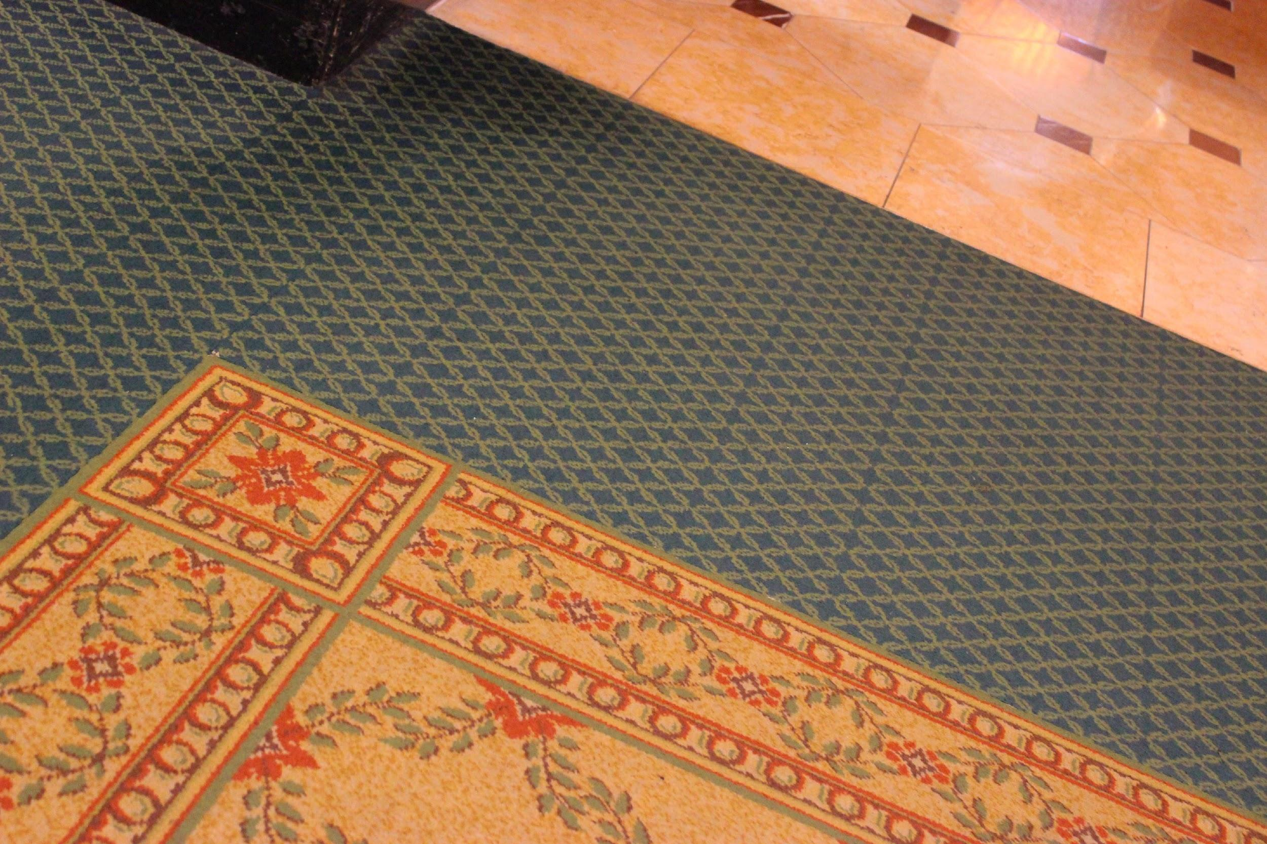
Image 9: The Omni has patterned carpeting that may be unsettling.

Scents
Scents are not overbearing, but as with most hotels, soaps and shampoos are scented. The smell of cleaning supplies is also in the air.

Problems with Access
While the hotel is beautiful in many ways, there are a variety of disability access problems: valet parking is seriously problematic for accessible vehicles, the front entry is inaccessible for wheelchair/scooter users, the beds are very high in accessible rooms, some floor patterns are very busy/disorienting, the wheelchair/scooter lift inoperable, some areas of the hotel are inaccessible for wheelchairs/scooters, requiring (some) guests to go outside and around the building. And there is no shuttle service, which may be a problem considering the distance to the convention center.

Secondary Hotels

Renaissance Hotel
107 6th St.
Pittsburgh, PA 15222
(412) 562-1200
Distance to convention center: 0.4 miles

Online Information
The Renaissance Hotel’s website may be accessed using the following link: https://www.renaissancepittsburghpa.com/?scid=bb1a189a-fec3-4d19-a255-54ba596febe2
The website includes minimal “handicap accessible options” at the following link:
https://www.renaissancepittsburghpa.com/room-types/
When booking a room online, there is no choice to reserve an accessible room. Apparently, accessible rooms need to be reserved over the phone. Accessibility at the Renaissance Hotel may come at a price, too, as some accessible rooms are in more expensive suites.

General Information
The Renaissance Hotel is a retrofit historic building with great views of the city and the baseball stadium (depending on what floor and what side of the building you are on). They offer accessible rooms, but some of these come at an extra price. This full-service hotel offers an on-site restaurant and bar. When traversing to the convention center, the sidewalk is uneven in places and the T-intersection at Garrison Place might be confusing to cross e.g. there are no truncated curb cuts. Considering the weather, the distance to the convention center may be problematic.
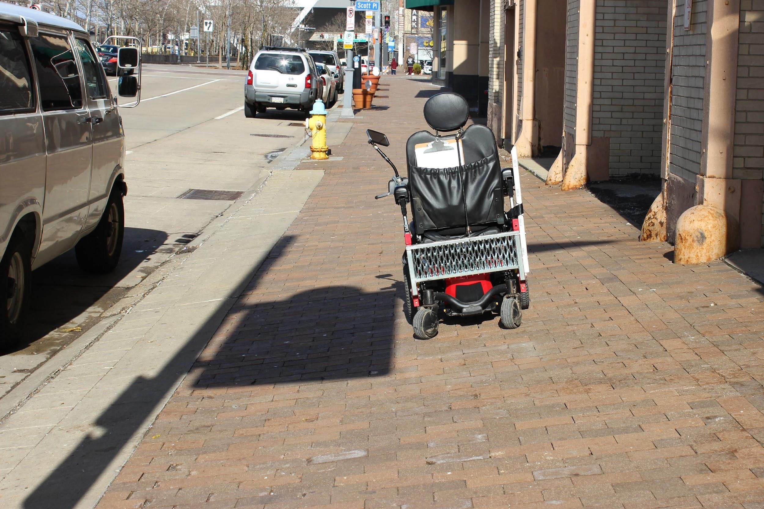
Image 10: The wheelchair tilts to the left, toward the street lined with parked cars, due to how unlevel the sidewalk is, which is particularly problematic around the Westin and Renaissance hotels.

Entrance
The entrance to the hotel has several doors that are automatic. Hotel staff quickly and politely opens doors for guests.

Lobby
After going through the front entrance doors, the front desk is to the right at about two o’clock. Straight forward across the lobby with many comfortable chairs, is the hotel restaurant. To the left of the entrance is a cozy nook with comfortable seating. Taking a sharp left from the entrance, through the lobby only a few feet is the hotel bar.

Accessible Rooms
There are 8 accessible rooms in the Renaissance Hotel (4 roll-in shower; 4 tub style). Accessible rooms have the standard grab bars by toilets and in tubs and roll-in showers. The room and the bathroom have adequate space to maneuver and beds are average height. A wheelchair can roll under the desk and the lamp next to the desk has a foot operated option. The phone has a “light” ring feature, as does the doorbell. Peepholes are low and high. Door Width is adequate to get a medium size wheelchair through.

Parking
The Renaissance Hotel offers valet parking for $37/ per 24 hours with in-out privileges. Self-parking is available in the public lot across the street from the hotel: an hourly/daily rate applies. There is also public accessible parking space around the corner from the Renaissance Hotel on Fort Duquesne Blvd. You need to pay at a pay station, which is in the opposite direction of the hotel. If you are headed to the convention center, the pay station is on the way, but you will need to backtrack if you are going to the Renaissance Hotel. The sidewalk on that section of Fort Duquesne Blvd. is not level. Consequently, it may be difficult or impossible to open a passenger-side ramp. Also, this accessible parking space and other spaces on that street are routinely blocked off by police during sporting events.

Space to Maneuver
There is space to maneuver in the lobby and restaurant. It may be difficult to maneuver a wheelchair or scooter in the bar if it is crowded. Hallways leading to the accessible rooms are narrower than most hotels, probably because this building was not initially designed to be a hotel. Regardless, there is still room to maneuver.

Restaurants and Bars
The Renaissance Hotel has an in-house restaurant, Braddock’s Pittsburgh Brasserie. When entering the hotel, this restaurant’s entrance is straight ahead on the far end of the lobby.
The website for the hotel has information e.g. menus for Braddock’s Pittsburgh Brasserie, which may be accessed using the following link:
https://www.renaissancepittsburghpa.com/cocktails-dining/
Braddock’s Pittsburgh Brasserie also has its own, separate website, which may be accessed using the following link:
http://braddocksrestaurant.com/
Like many restaurants in the area, no gluten free options are posted on the menu. However, gluten free, vegan, or vegetarian options may be available upon request.
The hotel also has a bar—Braddock’s Street Side—which may be accessed through the lobby, just left went entering the building, or through an outside door immediately to the left of the main entrance doors when facing the building. The outside entrance was inaccessible because chairs were stacked in a way that would make it difficult for a wheelchair to enter.

Business Center
Door width is a bit narrow and may be problematic for a large wheelchair or scooter.

Exercise Room
This fitness center has modern equipment and room to maneuver a wheelchair or scooter. Yet, the very loud music competes with the equally loud TV, which is a bit disturbing.

Pool and Spa
There is no pool in the Renaissance Hotel. There is a whirlpool/spa in the presidential suite, but it is expensive.

Animals
The Renaissance Hotel is pet friendly in the building, but only on designated floors. There is a $50 charge and 2 pet maximum. A sign is provided to alert staff about pets in your room. You will need to ask for a floor with no pets when making a reservation, that is, if pets are a problem.

Patterns
Some of the patterns may be problematic, particularly were different styles of flooring connect.

Scents
As with several hotels, the scent of cleaning detergents was apparent, particularly in hallways and accessible rooms. These were no overbearing, though.

Shuttle Service
None

Problems with Access
The Renaissance Hotel is several long blocks from the convention center and sidewalks around the hotel are not level, missing bricks, and are otherwise in disrepair. Other hotels closer to the convention center may have similar problems, however, those other hotels may have shuttle service or pay for wheelchair accessible transportation. Again, the Renaissance Hotel has not shuttle service.

Marriott City Center
112 Washington Pl.
Pittsburgh, PA 15219
(412) 471-4000
Distance to convention center: 0.8 miles. It is not very close to the convention center or restaurants. But they have a shuttle. While the shuttle is not wheelchair/scooter accessible, the hotel will pay for an wheelchair/scooter accessible shuttle or taxi upon request.

General Information
The Marriott City Center is a new hotel. If you use visual cues to get there (not GPS) it may be a bit difficult to find because the sign on top of this hotel reads Marriott Chatham City Center. But it is referred to as the Marriott City Center. Also, this hotel is not the Courtyard by Marriott Hotel. The Courtyard by Marriott is not a full-service hotel and is much smaller.

Online Information
General information about the Marriot City Center may be accessed using the following link: https://www.marriott.com/hotels/travel/pitdt-pittsburgh-marriott-city-center/?scid=bb1a189a-fec3-4d19-a255-54ba596febe2
Information about accessibility at the Marriot City Center may be accessed on the following website by scrolling down to the bottom of the webpage: https://www.marriott.com/hotels/fact-sheet/travel/pitdt-pittsburgh-marriott-city-center/#accessbility

Parking
The Marriott City Center offers valet parking for $26/per day with in-out privileges. You may self-park across the street for $20/per day with no in-out privileges when events are taking place or for $18/per day with no in-out privileges when there are no events taking place. There are accessible parking spaces in that self-park lot. After you get your ticket, the hotel will validate it so you can get in-out privileges for $22/per day in the self-parking area.

Getting to the Entrance
The driveway, valet area, and drop-off zone at the Marriott City Center are spacious compared to all other hotels. There are a few accessible parking spaces in that zone, too. The entrance has accessible doors leading to the lobby. When facing the hotel, there is also outdoor seating for the restaurant/bar inside.
However, sidewalks and thoroughfares leading to that area are like many other pathways throughout Pittsburgh—inconsistent in relation to pavement/concrete, crosswalks, curb cuts, truncated curb cuts, water hazards at curb cuts, slanted/not level sidewalks, etc. These issues may be an important consideration in the winter. The convention center is almost a mile away.

Lobby
After entering the lobby of the building:
- the front desk is toward the left, at about 10 o’clock.
- The restaurant is on the right, at about 3, o’clock.
- Elevators are straight ahead, then to the right. When facing the front desk, the elevators are behind you.
- The (inaccessible) heavy, saloon-style doors leading to the Starbucks are to the right of the front desk

Elevators
There is enough room to maneuver. Braille buttons and beeping.

Shuttle Service
The Marriott City Center shuttle does not go to the airport. The shuttle does take guests (who can use a few stairs) to downtown destinations within 2 miles. But this shuttle is inaccessible for guests who use wheelchairs or scooters. The hotel will call a private shuttle or van with wheelchair accessibility and pay for the trip within the 2 mile allowance.
The Marriott City Center shuttle operates during the following time periods:
Monday-Friday 6:30 a.m. – 10:30 a.m.
Monday-Friday 3:00 p.m. – 11:00 p.m.
Saturday 9:00 a.m. – 11:00 p.m.
Sunday—no shuttle service

Elevators
There is enough room to maneuver. Braille buttons and audio (beeping) indicates the floor.

Accessible Rooms
The Marriott City Center has a total 15 accessible rooms (8 roll-in shower; 7 tub). One room is not designated as an “accessible” room, but instead is designated as a “deaf or hearing impaired” room). Rooms have standard accessible features e.g. grab bars, wide door, low towel hanging hook. Beds are average height. Rooms are moderately spacious and there is enough space to maneuver a wheelchair or scooter, but they are slightly cramped. Like most hotels, there is minimal Braille signage; outside door and on the elevator leading to the room. Accessible rooms have lower and higher peepholes. There is a low clothes hanging bar in closet; split-level shelf i.e. lower/higher. There was no overwhelming smell at time of site-visit. Patterns are moderately intense, but no too bad compared to a few of the older hotels. ADA assistance kits (visual/vibrating alarm clock, telephone amplifier, etc.) are available for guests who experience hearing differences.

Space to Maneuver
The drop-off/valet area, lobby, bar and restaurant areas are all very spacious. It was a bit difficult on one pathway in the breakfast area, which was accessed when that dining area was closed. This breakfast space may be problematic when there are lots of people eating.

Restaurants and Bars
The Crafted North is a hotel bar on the right when you enter the Marriott City Center. The bar itself is split-level so people using wheelchair can access the bar/counter. Beyond that bar is the Steelhead Brasserie and Wine Bar. These establishments seem to converge and they share many accessible tables both inside and outside, depending on the hours of operation. There are also some cozy private booths by the front windows that would be a great place to chill. The breakfast buffet is in the back past the bar. While there is room to maneuver, space between table may be a problem when the room is full of people. Information about the restaurants at the Marriot City center may be access using the following link: https://www.marriott.com/hotel-restaurants/pitdt-pittsburgh-marriott-city-center/steelhead/113173/home-page.mi

Business Center
There are a few computers in the lobby on the left side when facing the front desk. The area is essentially part of the lobby i.e. it’s not in a separate room requiring a key.

Exercise Room and Pool
The fitness center and pool are both on the 11h floor. The fitness center has room to maneuver between equipment. The pool does not have a lift, which disables some guests.

Animals
No pets other than service animals are permitted in the Marriott City Center.

Patterns
There were no significant problems with patterns.

Scents
There were no obvious odors or scents apparent in the Marriott City Center. Like most hotels, toiletries in bathrooms are scented, but these can be removed upon request. It is possible to ask for rooms to be cleaned with unscented products.

Problems with Access
Several signs lead guests to the Starbucks connected to the building. You need to go through double doors (imagine old saloon doors) to get there and back. These doors are not automated. They are very heavy to open. Opening these doors while maneuvering a wheelchair or scooter is impossible. Guests may need to ask for assistance to use this particular doorway. This doorway is near and to the right of the front desk.

Double Tree by Hilton
1 Bigelow Square
Pittsburgh, PA 15219
(412) 281-5800
Distance to convention center: 0.8 miles

General Information
The Double Tree is a nice, newer hotel. Overall, the accessibility is quite good. Distance may be an important consideration for people who want to be close to the convention center.

Online Information
The following website offers general information about the hotel:
http://doubletree3.hilton.com/en/hotels/pennsylvania/doubletree-by-hilton-hotel-and-suites-pittsburgh-downtown-PITDTDT/index.html
The following additional website link offers information about overall accessible features of the hotel:
http://doubletree3.hilton.com/en/hotels/pennsylvania/doubletree-by-hilton-hotel-and-suites-pittsburgh-downtown-PITDTDT/about/amenities.html
The following website offers specific information about accessible rooms:
http://doubletree3.hilton.com/en/hotels/pennsylvania/doubletree-by-hilton-hotel-and-suites-pittsburgh-downtown-PITDTDT/accommodations/accessible.html
Note: Some information on the aforementioned websites contradicts itself. For example, the Double Tree by Hilton’s website says there is no self-parking. This information was solidified by a manager. But their website about accessibility says, there are no “accessible parking spaces for cars in the self-parking facility” and there is no “Van-accessible parking in the self-parking facility.” It seems there is self-parking, just not owned by the Double Tree; it is a public lot.
Additionally, incorrect information was supplied in relation to the overall number of accessible rooms. Indeed, one manager was politely confrontational when asked for a specific number of accessible rooms and the how many were tub style, roll-in, deaf/hearing impaired, etc.

Getting to the Entrance
This front entrance is wheelchair accessible with automatic doors. The check-in/front desk area is through the lobby, toward the left of the entrance at about 11 o’clock. Guests arriving by taxi or other shuttle services will likely be dropped off in front of the building. When using this front door, the restaurant/bar is on the right. People using the underground valet service can use the elevator to get to the lobby area.

Lobby
The lobby is spacious. There is comfortable seating available in the lobby area. The front desk does not have split-level check-in, however, there are some lower shelves to write on.

Elevators
Good maneuverability; Braille signage; low buttons

Accessible Rooms
After much ado, it was verified that there are 8 accessible rooms in the Double Tree by Hilton (2 double bed roll-in shower; 4 king-size with an accessible tub; and 2, two-room suite with 1 king-sized with roll-in accessible bathroom and 1 queen 1 with a standard, non-accessible bathroom). The rooms examined during the site visit had standard accessible features e.g. grab bars in both roll-in shower and tub rooms, low towel hanging hooks in bathroom, average height beds, and a moderate amount of space to move around. Like most hotels, there is minimal Braille signage. Braille signage is used outside accessible room doors and on the elevator buttons leading to rooms. There are strobe lights for the alarm system, door “bell” and phone. Accessible rooms have lower and higher peepholes
The accessible room shown during the site visit had a door width of 35 ½ inches, however, the hotel’s website claimed that accessible rooms and suites have “a minimum 40-inch clearance on all doorways and between furnishings ….” Regardless, getting into the room in a medium sized wheelchair and moving around in the room was not a problem during the site visit. One room had low clothes hanging bar in closet; split-level shelf i.e. lower/higher, but another “accessible” room did not. Again, it is typically impossible to examine every room because they are often occupied. Rooms had a faint smell of cleaning supplies and hand soap had strong scent.

Parking
Finding the valet parking for the Double Tree by Hilton was a bit difficult and required a few trips around the building. Valet parking is in the back of the building and requires drivers to go a driveway leading to an underground area where valet’s can be found. Valet parking costs $26.00/per day.
The Double Tree by Hilton website has “no self-parking,” but there is a public parking garage nearby, which is the same public garage used by the Marriott City Center for self-parking. The Double Tree by Hilton is across the street from the Marriott City Center.

Shuttle
The Double Tree by Hilton shuttle does not go to the airport. The shuttle does take (some) guests to downtown destinations within a 2-mile radius. But this shuttle is inaccessible for guests who use wheelchairs or scooters. However, the hotel will call a private shuttle or van with wheelchair/scooter accessibility and pay for the trip within the 2-mile allowance.
Note: staff members insisted that the hotel would not pay for an accessible shuttle or taxi, but the manager acknowledge they were wrong, and wheelchair rides within the 2-mile radius would be complementary.

Space to Maneuver
There is room to maneuver a wheelchair or scooter within the hotel and its facilities. There are not too many obstacles in common areas.

Restaurants and Bars
The Bigelow Grille offers mostly organic food procured from local farms. Ice cream or other dairy products are not organic. Gluten free, vegan and vegetarian options are available. The host/restaurant manager demonstrated competence and understanding related to how food may affect a diverse variety of minds and bodies. This restaurant offers a terrific menu. The website for the Bigelow Grille may be accessed using the following link: http://www.bigelowgrille.com/

Business Center
There are a few computers adjacent to the front desk area. These are not in a separate room and are accessible for people using a wheelchair or scooter.

Exercise Room
The fitness center is located on the 3rd floor. It has modern equipment and there is adequate space.

Pool and Spa
The is an indoor pool on the 3rd floor, but no lift for people who need one to get in.

Animals
Pets, including service animals are allowed. There is a $50, non-refundable deposit for pets and a maximum weight of 50 lbs. Dogs only. Any pet must be less than 50 lbs.

Patterns
Patterns were not intense.

Scents
There were no overwhelming scents in public areas at the time of the site visit.

Access Problems
Distance to convention center may be a problem, but they do offer shuttle service and are willing to pay for wheelchair/scooter accessible transportation within 2 miles. Self-parking may be problematic. This hotel is a bit off the beaten path and beyond the facilities in the hotel, there are no restaurants or stores in the immediate vicinity.
The manager who conducted the site visit was polite, courteous, friendly, and competent. However, other staff members contacted during a fact-check process were curt and indifferent about disability access. It took many phone calls to verify some basic information and some information was simply incorrect.

Additional Hotels in the Vicinity of the Convention Center
The following hotels do not have pre-reserved blocks of rooms designated for the conference. You need to make your own arrangements. These hotels are not considered full service hotels: the primary and secondary hotels listed above are considered full service hotels. A couple of these additional hotels are new and/or were not in business when the choice was made to hold the conference in Pittsburgh. These additional hotels may be better suited for some people, depending on access needs and budget. Notably, some of these additional hotels are much closer than Primary or Secondary Hotels (excluding the Westin).

Courtyard by Marriott
945 Penn Ave.
Pittsburgh, PA 15222
(412) 434-5551
Distance to Convention Center: adjacent to the southwest side of the convention center; about one block away from the West Lobby entrance. This hotel is the next closest to the convention center, after the Westin.
General Information
The Courtyard by Marriott is not only close to the convention center, it is very close to many restaurants and bars. It seems as if it may be noisy at night. However, though there was a lot of outside noise during the site visit in the daytime, it was not loud inside the hotel.
Online Information
The following website page offers general information about the Courtyard by Marriot Hotel at this link: https://www.marriott.com/hotels/travel/pitcy-courtyard-pittsburgh-downtown/?scid=bb1a189a-fec3-4d19-a255-54ba596febe2.
A second website page offers minimal information about accessibility at the Courtyard by Marriot Hotel; using the following link, scroll down to the very bottom of the list titled “Hotel Details”: https://www.marriott.com/hotels/fact-sheet/travel/pitcy-courtyard-pittsburgh-downtown/#accessbility.

Getting to the Hotel Entrance
The drop-off area for the hotel is where parking would usually be on a busy city street. Penn Avenue is a one-way street with traffic moving east to west. When facing the building, there are pull style doors with self-operated automation. After going through these initial doors, there is a small foyer, then a set of automated sliding doors.

Lobby
Upon entering the lobby, there is furniture on the left in a TV area and an open space to the center and right. The front desk and check-in area is forward and to the right. There are no spit-level counters at the front desk.

Elevators
When facing the front desk and check-in area, the elevators will be behind you and to the left.

Accessible Rooms
The bathroom has standard accessible features e.g. grab bars, a semi-wide door, low-hanging towel hooks. Beds are of average height. As far as maneuverability goes, the rooms are not as spacious as some of the larger hotels, but there is still room to move around, and pathways pose no major obstacles. However, the hotel will be upgrading its furniture soon, so this may change. Accessible rooms do not have visual doorbells but do have lower and higher peepholes. Door width is 32 inches. Closets have lower shelves and low-hanging bars. The smell of cleaning supplies is masked by a sweet-smelling deodorizer. The pattern on the carpet and drapes is moderately intense. TDD/TTY/ADA assistance kits, which include a visual/vibrating alarm clock and a telephone amplifier are available to guests with mobility or hearing impairments.

Braille Signage
Like most hotels, there is minimal Braille signage, which can be found outside the doors of accessible rooms and on the elevators used to get to the rooms.

Parking
There is valet parking in front of the building. There is not much space in that area, which also serves as a drop-off zone. Self-parking is located in the David L. Lawrence Convention Center lot.

Shuttle
The Courtyard by Marriott does not provide shuttle service to/from the airport. It does provide service within 1 mile of the hotel. But, like other hotels, it is not wheelchair accessible. The hotel will reimburse guests who use wheelchairs or scooter, though, as long as the trip is within the 1-mile radius.

Space to Maneuver
Maneuverability is a bit tight in the foyer between the entrance doors. Otherwise, maneuverability is manageable for a scooter or medium-sized wheelchair, though there is not as much room as in some of the larger hotels.

Restaurants and Bars
There is no restaurant in the Courtyard by Marriott. However, an a al carte continental breakfast is served in the seating area just past the elevators toward the back of the hotel opposite the entrance. If you come down from your room using the elevators, the restaurant will be immediately on your left as you exit the elevator. Hours of operation are:
Monday—Friday 6:30—10:30 a.m.
Saturday and Sunday 7:00—11 a.m.
When facing the front desk, there is a snack shop on the left. There are accessible bathrooms to the left of the snack shop. There are many good restaurants on the same block as the Courtyard by Marriott (Penn Ave between 10th and 9th Streets and many more heading west, particularly on 6th Street.

Business Center
This is not a closed “business center” requiring a key. Basically, it’s a space in lobby with a computer for guests to use.

Exercise Room
Exercise machines on the 3rd floor are a bit close together and may pose problems for maneuverability.

Pool and Spa
None

Animals
Service animals with documentation only.

Patterns
At the time of the site visit, carpets, drapes, bedding, and furniture had no unusually busy patterns. However, the hotel will undergo some interior updates, so this might change by the time of the conference.

Scents
As with most hotels, the odor of cleaning supplies was in the air. Soaps, shampoos, and other toiletries were all scented.

Overall Access
Like the other hotels in this section, the lobby is not exceptionally large. There may be maneuverability problems depending on the time of day, particularly when many guests are checking in and going to breakfast. This is an older hotel and a lot has been retrofit. Still, the overall accessibility is not too bad. If distance to the convention center is an issue and there are no rooms in the Westin, this is the next closest option. It is also closer to many of the restaurants and nightlife venues that downtown Pittsburgh has to offer.

Drury Plaza Hotel Downtown
745 Grant St.
Pittsburgh, PA 15219
(412) 281-2900
Distance to the Convention Center: 0.3 miles

General Information
The Drury Hotel is a remodeled bank and it has a lot of character. It is about 2 blocks from the east entrance of the convention center; about one block south of the Westin Hotel. It is the third-closest hotel in this guide to the convention center after the Westin and Courtyard by Courtyard by Marriott. The Drury is not a full-service hotel, but it does have accessible rooms and some amenities typically offered by hotels considered full-service. In some ways, the hotel is a bit run down i.e. not too modern. This hotel requires you to go outside to get to the convention center, so March weather will be an important consideration.

Online Information
The following website page offers general information about the Drury Plaza Hotel Downtown: https://www.druryhotels.com/locations/pittsburgh-pa/drury-plaza-hotel-pittsburgh-downtown.
A second website page offers information about the Drury Plaza Hotel’s commitment to web accessibility: https://www.druryhotels.com/content/webaccessibility.
While there is no link or additional website about accessibility, guests are able to choose accessibility options when booking a room, e.g. “mobility accessible” or “hearing accessible.”

Getting to the Hotel Entrance
The entrance to the Drury Hotel is up a small hill. There are stairs and a ramp that lead to the front entrance on Grant Street. A driveway off Grant Street also goes up to the front entrance. There is valet service up that driveway on top of the hill. If you are getting dropped off by a taxi or shuttle, make sure you are dropped off at the top of the driveway; otherwise, you will need to lug your stuff up the ramp or stairs to get to the entrance. The doorways are automated.

Lobby
The lobby is in a corner of the building. If you are arriving from the Grant Street side (stairs or ramp), the front desk and check-in area will be directly in front and slightly to the right of you. When arriving from the valet and drop-off area, the front desk is on the right at 3 o’clock.

Elevators
Elevators have Braille signage and lower buttons. They are located to the left when facing the front desk.

Accessible Rooms
The bathrooms in accessible rooms have standard accessible features, e.g. grab-bars, low-hanging towels hooks, and either tubs or roll-in showers. Beds are of average height. The rooms are spacious, with room to maneuver a wheelchair or scooter. Braille signage is located outside the doors of accessible rooms and on the elevators leading to and from rooms. Accessible rooms’ doors have low and high peepholes and are standard width. Closets have low and high shelves and a low-hanging bar for clothes. Carpet, bedding, and drapery patterns are not too intense. Some rooms have TDD capability and TDY kits are available upon request.
The smell of cleaning supplies masked by a sweet-smelling deodorizer was apparent in accessible rooms. Soaps, shampoos, and other toiletries were scented. You can call ahead and ask for unscented cleaning supplies to be used in your room and for scented soaps to be removed.

Shuttle
The Drury Hotel has no shuttle.

Parking
There is no self-parking for the Drury Plaza. Valet parking is $29 per day with in/out privileges.

Space to Maneuver
Overall, there is a lot of space to maneuver throughout the hotel. However, some areas may pose problems e.g. the lobby, the bar, and the pool area, particularly when there are a lot of people around.

Restaurants and Bars
There is a bar on the third floor, which has lower tables and counters. A large part of the lobby also serves as a dining area, where a buffet-style breakfast is available. There is also a “kickback” time from 5:30 to 7 p.m. when snacks, salads, soups, and cold beverages are served buffet-style. An example of the “kickback” menu is available using the following link:
https://www.druryhotels.com/content/kickback.

Business Center
An accessible business center is adjacent to the main lobby eating area.

Exercise Room
There is a fitness center on the eighth floor. There is space to move around.

Pool and Spa
The Drury Plaza has a pool on the eighth floor. It is one of only two hotels that have both a pool and whirlpool/hot tub for all guests to use (the other is the Hampton Inn). It is necessary to use stairs or a self-operable lift to get into the pool/hot tub area. Hotel staff were readily available to help operate the lift is asked.

Animals
Animals are permitted in the hotel, but there is an extra charge of $35.

Patterns
Patterns are not too intense. However, some areas have old-fashioned black and white checkered tile that may pose problems for some people.

Scents
Beyond the accessible rooms, there were no obvious scents or strong odors in the common areas of the hotel.

Other
It is easier to use the side entrance when going back and forth to the convention center.

Hampton Inn & Suites Downtown
1247 Smallman St.
Pittsburgh, PA 15222
(412) 288-4350
Distance to convention center: 0.4 miles
General Information
The hotel’s website says that it is only 1 block from the convention center, which is a bit deceptive because there is no entrance on the east side of the convention center, so you will need to go around the building to the East Lobby entrance. This makes the distance between the Hampton Inn and the convention center more like 3-4 blocks. Nevertheless, it is closer than the primary and secondary hotels, the exception being the Westin.
The Hampton has many features that make this hotel a good choice in terms of access. Accessible rooms go beyond typical ADA standards and they seem to be designed to suit many varieties of access. There is a hot tub and pool, both with accessible hoists. The staff is knowledgeable about disbaility issues. It is close to the convention center (3-4 blocks), but may still be too far for some people, particularly considering the weather in Pittsburgh in March. There is no shuttle. But there is free parking.
Online Information
The following website offers general information about the Hampton Inn & Suites in Downtown Pittsburgh: http://hamptoninn3.hilton.com/en/hotels/pennsylvania/hampton-inn-and-suites-pittsburgh-downtown-PITDNHX/index.html.
If you scroll down to the bottom of the web page at the following link, there is information about accessibility: http://hamptoninn3.hilton.com/en/hotels/pennsylvania/hampton-inn-and-suites-pittsburgh-downtown-PITDNHX/about/amenities.html.

Getting to the Hotel Entrance
There is a drop-off area in front of the Hampton with carts that guests may bring out their car and use for luggage. The entrance has automatic sliding doors. After entering the hotel on the ground or lower lobby (LL) floor, it is necessary to turn right to get to an elevator to the lobby (L).

Lobby
As you enter the lobby, the front desk is immediately on the left. To the right is a communal area with lots of seating. This area also serves as a dining area for a complimentary breakfast.

Elevators
Elevators have Braille, low buttons, and room to maneuver a wheelchair or scooter. They also beep and verbally indicate the floor they are on.

Accessible Rooms
The Hampton Inn has seven accessible rooms: two with roll-in showers; four with tubs; and one suite with a roll-in shower. All bathrooms have standard accessible features, e.g. grab-bars, wide doors, low-hanging towel hooks. Rooms are spacious in terms of maneuverability. Braille signage can be found outside the doors to accessible rooms and in elevators leading to rooms. Phones have a visual ringer and doors have a visual bell with low and high peepholes. TDD capability and TDY kits are available. Closets have low-hanging bars and shelves.

Parking and Shuttle
The hotel does not provide a shuttle, and there is no valet parking. There is free self-parking, though, with two accessible spaces about 30 feet from the front entrance and additional accessible parking in the rear of the building.

Space to Maneuver
There is plenty of space to maneuver throughout the Hampton. While the lobby and other common areas are not small, they are not exceptionally large either. Common spaces may become crowded during check-in and check-out times and at breakfast.

Restaurants and Bars
There are no restaurants or bars in this hotel, but there are places to dine within a few blocks. Lidia’s Italian Restaurant, for example, is one block east of the Hampton. There is a free hot/cold breakfast, and complimentary fruit, tea, and coffee are available at all times. It may be difficult to access the food, as it is on an average height counter and some food requires you to open a chafing dish. Snacks are also available for purchase.

Business Center
The business center requires a room key to enter and the door may be difficult to open as it is not an automatic door. Space is a bit tight, but doable in a wheelchair or scooter.

Exercise Room
The exercise room has modern equipment and enough room to maneuver a wheelchair or scooter.

Pool and Spa
The pool and whirlpool/hot tub room is much better than any hotel in this guide. Notably, there are hoists for both pool and hot tub. The pathway around the pool is adequate to navigate a wheelchair or scooter, though one must take caution.

Animals
Only service animals are permitted.

Patterns
The carpeting in the hallways is moderately busy and might be problematic for some guests.

Scents
There were no overwhelming smells or odors, though, like many hotels, there is the smell of cleaning detergents or deodorizers.

The Priory Hotel
614 Pressley Street
Pittsburgh, PA 15212-5616
(866) 3PRIORY
(412) 231-3338
Distance to convention center: 0.8 miles

General Information
The Priory is a quaint family-owned hotel located across the river from the convention center on the Northside. It is an ornate historic building. Like other older hotels, accessible rooms have been retrofit. The Priory is a bit far from the convention center.
Online Information
The following website offers general information about the Priory Hotel:
http://www.thepriory.com/

Accessible Rooms
There are three accessible rooms at the Priory Hotel, all are tub style (no roll-in showers). Bathrooms have standard accessible features, e.g. grab-bars, wide doors, and low-hanging towel hooks. Beds are of average height, and rooms are spacious in terms of maneuverability. Doors wider than most hotels, but some spaces in rooms may be difficult to maneuver in a larger scooter. Patterns in the room are moderately intense. Scents in rooms were not overtly evident.

Parking
There is self-parking across the street from the Priory.

Shuttle
The Priory offers a free shuttle service to downtown Pittsburgh, but it is not wheelchair or scooter accessible. The hotel does not pay for alternate transportation.

Entrance
When facing the hotel, the main entrance is up a few steps leading to the foyer area next to the lobby. There is another entrance with a ramp about 30 feet to the left. Using this wheelchair/scooter accessible entrance puts guests next to accessible rooms, however, you will need to go right about 35 feet to get to the lobby/front desk.

Lobby
The lobby and the adjacent front desk area are very small.

Space to Maneuver
There is not a lot of space to maneuver in the lobby, front desk area, in the bar, or in rooms.

Restaurants and Bars
There is no restaurant in the Priory Hotel. To the left of the main front entrance is the Monk's Bar, which is has a lot of charm. It is very, small and cozy. It is wheelchair and scooter accessible, but spaces are very tight, and the bar itself is quite high.

Animals
Service animals only.

Access Problems
The outdoor patio is accessible only by stairs. As a retrofit, staff will get portable ramps so that guests using wheelchairs or scooters may sit outside.

Homewood Suites by Hilton
1410 Smallman St.
Pittsburgh, PA 15222
(412) 232-0200
Distance to convention center: 0.5 miles

General Information
The Homewood Suites by Hilton is a new hotel with very good accessibility and in fact may be perfectly suitable for some guests who prefer to cook their own food. They offer a complimentary breakfast and an evening social hour with free drinks.
Online Information
The following website offers general information about the Homewood Suites by Hilton:
http://homewoodsuites3.hilton.com/en/hotels/pennsylvania/homewood-suites-by-hilton-pittsburgh-downtown-PITDOHW/index.html.
Using the following link, you can find additional details related to the hotel’s accessibility:
http://homewoodsuites3.hilton.com/en/hotels/pennsylvania/homewood-suites-by-hilton-pittsburgh-downtown-PITDOHW/about/amenities.html.

Accessible Rooms
Homewood Suites by Hilton has thirteen accessible rooms; six are tube-style accessible and accessible feature for deaf people; 5 are tub-style; and 2 have roll-in showers. All of these rooms are spacious. They have a bedroom, sitting area, and a kitchen. The bathrooms have the most space of any hotel. Sinks in the kitchen have roll-under sinks for wheelchair access. Couches are comfortable. Drapes have circular handles designed with access in mind.

Shuttle
The Homewood Suites by Hilton has a shuttle service, but the shuttle itself is not wheelchair accessible. Like the Westin, Marriott City Center, and Double Tree by Hilton, they will arrange for an accessible taxi or van and provide a voucher, so you don’t have to pay within a two mile radius.

Parking
Valet parking is available for $22.00 per day with in/out privileges. The website says that there is no self-parking and specifically mentions no self-parking in relation to cars and vans. However, staff say that there are accessible self-parking spaces under the building, but these cost the same as valet service.

Getting to the Entrance
The entrance to Homewood Suites by Hilton is on Smallman Street directly in front of the building. There is a drop-off zone with signage just past the valet area. This area is a bit confusing because the valet zone is marked off with blue paint and a wheelchair icon on the pavement, which makes it seem as if there are two accessible parking spaces in that area. In other words, the accessible parking spaces directly in front of the hotel entrance have been eliminated and are now a valet parking area. Automatic doors lead to an elevator that leads to the lobby.

Lobby
As you exit the elevator from the street level, the front desk and check-in area is forward and to the right.

Space to Maneuver
There is plenty of space to maneuver a wheelchair or scooter in the common areas.

Restaurants and Bars
There is no restaurant, but there is a complimentary breakfast and social hour that offers free drinks. Snacks are also available left of the front desk. Rooms have small kitchens with wares and utensils for cooking. Also, Lidia’s restaurant is next to the hotel (Lidia is famous for several restaurants and cooking program on PBS). This hotel is also in Pittsburgh’s strip district, which is famous for many restaurants and food markets.

Business Center
While there is no room serving as a “business center,” there are a few computers opposite the front desk connected to a printer.

Exercise Room
The fitness center is on the left when you exit the elevators on the lobby level. There is plenty of room to maneuver a wheelchair or scooter.

Pool and Spa
There is a nice accessible pool with a lift to help get in. Door entering the pool area are heavy, though. There is a scent of cleaning detergents and typical smells associated with pools.

Animals
Pets weighing 50 lbs. or less are allowed in the hotel. They require a non-refundable deposit of $100.

Patterns
There are no busy patterns in rooms or in public areas.

Scents
Other than the pool area, scents throughout the hotel and in the rooms are neutral.

Kimpton Hotel Monaco
620 William Penn Place
Pittsburgh, PA 15219
(412) 471-1170
Distance to convention center: 0.4 miles.
The Kimpton Hotel Monaco is one block closer to the David L. Lawrence Convention Center than the William Penn Omni Hotel.
General Information
The Kimpton Hotel Monaco is a historic hotel with beautiful décor. It has many of the same amenities offered by larger full-service hotels, e.g. onsite restaurant/bar, room service, laundry services, valet parking.
Online Information
The following webpage offers general information about the Kimpton Hotel Monaco: http://www.monaco-pittsburgh.com/?&utm_source=Google%20My%20Business&utm_medium=organic&utm_campaign=GMB&utm_term=monaco%20pittsburgh.
You can learn more about accessibility at the Kimpton Hotel Monaco using the following link: http://www.monaco-pittsburgh.com/boutique-hotel/accessible-rooms/.

Getting to the Entrance
There is a choice of doors or ramp to enter the Kimpton Hotel Monaco. The ramp is to the right of the doors. At the time of the site visit, the ramp was partially blocked by a statue. It was possible to get by the statue, but there is very little excess room.

Lobby
The lobby at the Kimpton Hotel Monaco is very small, which may be problematic during busy times when lots of people congregate. Spaces throughout this historic hotel are tight.

Accessible Rooms
The Kimpton Hotel Monaco has 11 accessible rooms: 6 tub-style; 4 with roll-in showers; and 1 suite with a roll-in shower. Bathrooms have standard accessible features, including grab-bars, wide doors, and low-hanging towel hooks. Beds are a bit high, though. Rooms are moderately spacious in terms of maneuverability. Braille signage can be found outside hotel room doors and in the elevators. Door width is 36 inches. No TDD capability or TDY kits. There are low and high peepholes. As with other hotels, toiletries are scented.

Shuttle
The Kimpton Hotel Monaco has no shuttle service.

Parking
There is valet parking available at the Kimpton Hotel Monaco for $38 per night with in/out privileges. This hotel is on a one-way street, which means a passenger side ramp in an accessible vehicle will extend into the traffic side of the street.
There is also hourly parking available: 0–2 hours: $15; 2–4 hours: $20; and 4–12 hours: $28. For visitors of the onsite Commoner restaurant, parking is $12.

Restaurants and Bars
The Commoner restaurant does not require reservation, but it is recommended. Gluten free options are available upon request. This restaurant is often crowded and may pose maneuverability problems for wheelchair/scooter users. The website for The Commoner may be accessed using the following link: http://www.thecommonerpgh.com/

Business Center
The Kimpton Hotel Monaco has no business center, but the staff will print and fax documents upon request.

Exercise Room
The Kimpton Hotel Monaco has a fitness center on the 3rd floor.

Pool and Spa
The Kimpton Hotel Monaco has no pool or spa.

Animals
This is a pet-friendly hotel.

Patterns
Patterns were not overtly busy.

Access Problems
Valet parking is on a busy one-way street and the hotel entrance is on the left, driver’s side. Accessible vehicles with ramps on the passenger side require passengers using a wheelchair or scooter to get out into traffic. The ramp into the hotel was partially blocked by a statue. The very small lobby is very noisy because of the restaurant.

Pharmacies in the Vicinity of the David L. Lawrence Convention Center
The closest pharmacies to the David L. Lawrence Convention Center are several blocks away. It is wise to call any pharmacy to double-check hours, allow for ample time to make sure they can fill your specific prescription, and check if they will delivery to your hotel.

Rite Aid
General Information
623 Smithfield St.
Pittsburgh, PA 15222
(412) 471-8882
Distance to Convention Center: 0.3 miles.
Hours
Monday—Friday 7 a.m. – 8 p.m.
Saturday—9 a.m. – 6 p.m.
Sunday—11 a.m. – 4 p.m.

Nearby Hotels
William Penn Omni; Kimpton Monaco Hotel

CVS
General Information
Address: 226 6th St.
Pittsburgh, PA 15222
Phone: (412) 281-0403
Distance to Convention Center: 0.5 miles
Hours
Monday—Friday 6 a.m. – 9 p.m.
Saturday—8 a.m. – 9 p.m.
Sunday—10 a.m. – 9 p.m.
Nearby Hotels
Renaissance Hotel

Rite Aid
General Information
Address: 519 Penn Ave.
Pittsburgh, PA 15222
Phone: (412)-391-0969
Fax—(412)-391-1071
Distance to Convention Center: 0.6 miles
Hours
Monday—Friday 7 a.m. – 7 p.m.
Saturday—9 a.m. – 6 p.m.
Sunday—10 a.m. – 4 p.m.
Nearby Hotels:
Renaissance Hotel
Note: This Rite Aid at the Penn Ave. location will deliver medicine directly to any downtown hotel on Monday, Wednesday, and Friday. They need to get your prescription before 9 a.m. on those days, and then it will be delivered by noon. The pharmacist encourages customers to fax their prescription the night before (Tuesday or Thursday) in order to be certain to have it the next day.

Restaurants
Pittsburgh offers an abundance of restaurants ranging from street vendors to fine dining. This section of the Accessibility guide focuses on issues related to disability at restaurants in the immediate vicinity of the Convention Center. These nearby restaurants are mostly on Penn Ave. from 10th street and 7th street. A few restaurants in the area are no longer in business, so there may be additional restaurant options by the time of the conference. Every restaurant has some sort of accessibility issue. Most comply only with legal obligations, while other problems exist beyond laws. For example, no restaurant had a Braille menu. That said, restaurants in the vicinity of the convention center demonstrated a wide range of access: some were unapologetically inaccessible and some went way beyond the letter of laws to include disability, a reality that reflects pedagogy in many ways. Some restaurants only disabled certain customers. For example, a person using a wheelchair may not be affected if there are no gluten-free options on a menu. Or a deaf person may not be disabled by stairs at restaurants. Many restaurants have extremely poor pathways, which disables people who use a wheelchair or scooter.
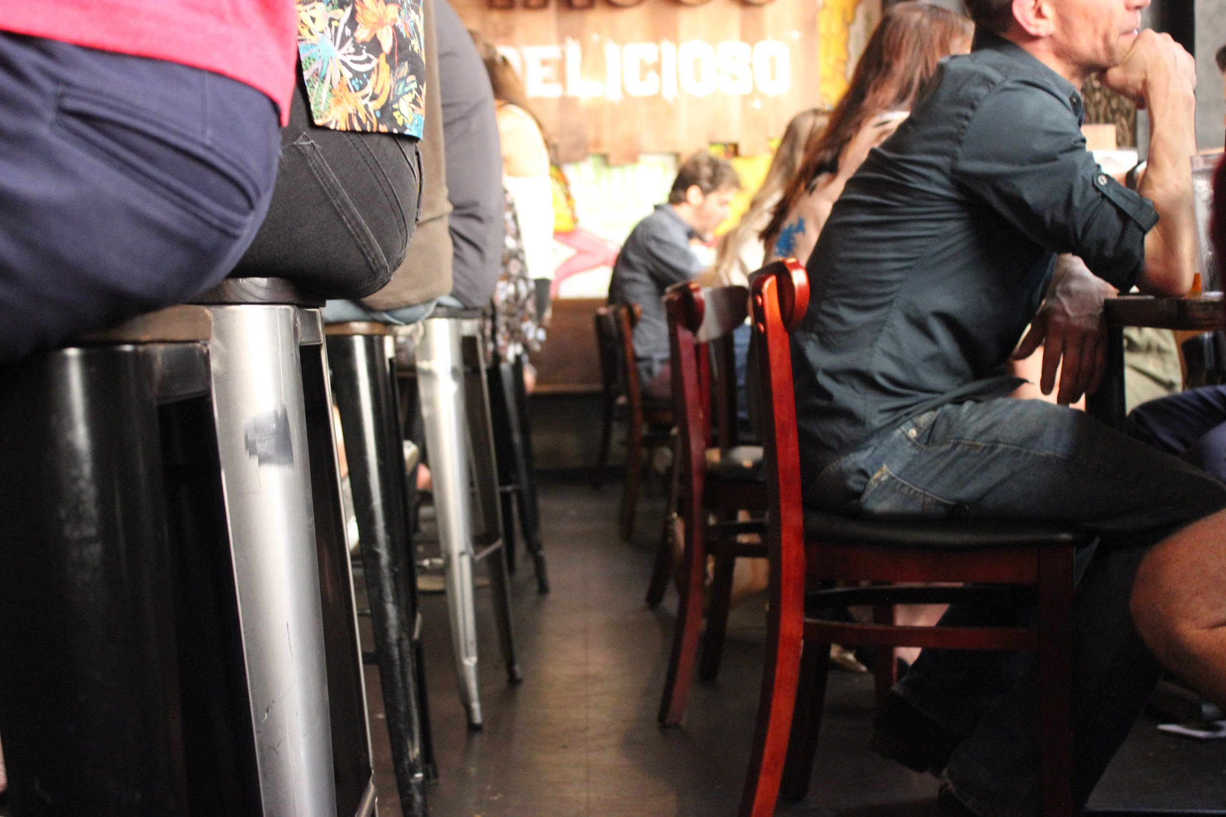
Image 10: Customers sit back-to-back in a restaurant/bar. The pathway is inaccessible for people using a wheelchair or scooter.

Conference attendees who consider disability from a civil rights perspective understand their patronage supports both accessible and inaccessible businesses—a choice.

Restaurants in the Vicinity of the Convention Center

Jimmy Johns

General Information
1027 Penn Ave, Pittsburgh, PA 15222
(412) 224-6440

Online Information
For online ordering use the following link to Jimmy John’s website:
https://www.jimmyjohns.com/menu/#/
For a menu use the following pdf link
https://www.jimmyjohns.com/downloadable-files/jj_menu_no_prices.pdf
For allergen information use the following link to a pdf doc:
https://www.jimmyjohns.com/downloadable-files/AllergenInformation.pdf\

Hours
Monday—Sunday 11 a.m. – 9 p.m.
Jimmy Johns is known for speedy delivery. This store is located about ½—1 block away from the East Lobby entrance of the convention center on Penn Ave. It is between the Westin Hotel and the convention center under the skywalk on the convention center side of Penn Ave.
They do not have menu items specifically marked as gluten free, however, they do have an “unwhich” or lettuce wrap available i.e. lettuce is used instead of a tortilla. The store and its bathroom are accessible for wheelchairs and scooters, however, during busy lunch or dinner hours there are typically a lot of customers, which may cause problems with maneuverability and pathways.

Ten Penny

General Information
960 Penn Ave.
Pittsburgh, PA 15222
(412) 318-8000

Online Information
The website for Ten Penny may be accessed using the following link:
https://www.tenpennypgh.com/
For a menu of Ten Penny use the following pdf link:
tenpennypgh.com

Hours
Monday and Tuesday: 11AM to 10PM
Wednesday - Friday: 11AM to 12AM
Saturday - 10AM to 12am
Sunday - 10AM to 9PM

Distance and Accessibility
The Ten Penny is about one block from the West Lobby entrance of the convention center on the southwest corner of Penn Ave. and 10th street.
Crossing the intersection at 10th and Penn Ave. may be problematic when it rains because water sometimes pools up at the bottom of curb cuts. Also, truncated or bumped surfaces are inconsistent at that intersection. There are audible and visual countdown indicators, though.
This restaurant had several accessibility problems. As you enter this bar style restaurant there is a flight of stairs directly in front of the entrance, which is a bit scary. There is a barn style door at the top of these stairs that closes, which would have made the entrance less hazardous. But it was open during the site visit. Turn left to enter the bar area and a host will seat you. It is necessary to pass through the bar area to get to accessible seating. Of course, this area has a strong scent of alcohol, which may be triggering to some people. There is no entrance that bypasses the bar area. There is no wheelchair accessible seating in the bar area i.e. the bar/counter itself is high, as are the bar-style tables and bar stools. The pathways in this bar area and in the dining area are not wide enough to get around without bumping into things or asking people to move or stand up from their seats. The site visit was conducted during the lunch hour and there were not too many people at the restaurant. However, problems with maneuvering through the bar and restaurant area are likely worse when it is full of people and chair backs are closer. Also, there is a room with a long table and a TV that can be reserved for parties of 6-20 people. But there is a step leading to that room, making it inaccessible for people who use wheelchairs, scooters or otherwise do not use steps. Ten Penny does have a gluten free menu, but there are no prices listed, so you will need to refer to these items on the regular menu. In some cases, items on the gluten free menu were not on the gluten free menu, so you will need to ask how much things cost. Also, if you don’t like germs, this place may not be for you: glasses and water bottle were very dirty (I know MLA style discourages the use of 2 “very’s”). The food ordered was cold; not lukewarm, but very cold (it was supposed to be a hot dish … soup).
Below the Ten Penn, using the same entrance, is an after-hours bar, the Penn Society Social Club. It is open from 7 p.m to 3:30 p.m, Thursday, Friday and Saturday. This is a members only club; however, it is open to the public on Thursdays, that is, if you are able to use stairs. There is not elevator access; only stairs.

August Henry’s Burger Bar

General Information
946 Penn Ave.
Pittsburgh, PA 15222
(412) 765-3270

Online Information
A website with menus for August Henry’s Burger Bar may be accessed using the following link:
http://www.augusthenrys.com/index.php#menu

Hours
August Henry’s Burger Bar is open for food as follows:
Monday-Thursday 11 am - 9 pm
Friday & Saturday 11 am - 11 pm
Their website says the bar is “OPEN LATE EVERY NIGHT,” which probably means the bar closes at 2 a.m.

Distance and Accessibility
After exiting the West Lobby of the convention center, head about one block south and cross the intersection at 10th and Penn Ave. Crossing this intersection may be problematic when it rains because water sometimes pools up at the bottom of curb cuts. Also, truncated or bumped surfaces are inconsistent at that intersection. There are audible and visual countdown indicators, though. After you get across the street, reaching the southwest corner of 10th and Penn Ave., head west and you will reach August Henry’s Burger Bar after only a few paces. It is just past Ten Penny.
As you enter the restaurant /bar on the left when headed west on Penn Ave., there is a double door entryway. That is, you need to open a first door to get into a small foyer, then you need to open another door to get inside. This foyer area is very small and it may be difficult to maneuver.
As the name suggests, August Henry’s Burger Bar is a place to get burgers, sandwiches, wings, salads and alcoholic drinks. There are no gluten-free options designated on their menu and staff offers apologies and directs patrons to a salad.
August Henry’s Burger Bar is also a bar, perhaps primarily. This restaurant/pub, of course, has a strong smell of alcohol, so this place may be a trigger for some people. Not much distinguishes the bar from any separate dining area. There is a half wall, though, that minimally separates some tables from the bar. Most tables are lower and most wheelchairs would be able to scoot in Ok, but it depends on size of wheelchair. Pathways were OK, too, with room to maneuver a wheelchair or scooter. However, maneuverability may be more difficult later in the day or a night when the tone of this establishment and its clientele focus on alcoholic beverages. The men’s bathroom has very high urinals with no lower options. At the time of the site visit, the primary grab bar in the “accessible” stall was broken: there were screw holes indicating that a grab bar was once there. But it was not fixed. This reality was curious, particularly because this restaurant/bar welcomes veterans (photos of veterans, awards and such are on display at the entrance), many of whom experience disability and may need good access.

Sienna Mercato

General Information
942 Penn Avenue, Pittsburgh, PA 15222
(412) 281.2810

Online Information
Sienna Mercato’s website may be accessed using the following link:
http://www.siennamercato.com/

Distance and Accessibility
Sienna Mercato is about one and 1/2 blocks from the West Lobby entrance of the convention center. Head toward the southwest corner of Penn Ave. and 10th street. Crossing the intersection at 10th and Penn Ave. may be problematic when it rains because water sometimes pools up at the bottom of curb cuts. Also, truncated or bumped surfaces are inconsistent at that intersection. There are audible and visual countdown indicators, though. After crossing the street, head west and go about ½ block to get to Sienna Mercato. Enter on the left when heading west on Penn Ave.
Sienna Mercato is the umbrella name for three establishments serving different things: Emporio is on the first floor and specializes in meatballs; Mezzo, an Italian restaurant, is on the second floor; El Tetto is a rooftop bar that serves food.
In terms of disability access, Sienna Mercato is hands down as good as it gets in Pittsburgh. Of course, every experience of mind and body are unique and there will always be circumstances this not considered. The point is, Sienna Mercato make a huge effort toward access. While there were no Braille menus (like most everywhere) the server understood salt goes on the right and pepper on the left so that blind people are able to distinguish these condiments. The server had a lot of expertise about gluten free, vegan, and vegetarian options. Notably, he pointed out that one vegetable might seem to be vegan, it was not listed on the menu as such because it was cooked in a certain type of oil … beyond me. The host and manager were learning sign language. The entrance to the restaurant had automatic doors. Pathways to bathrooms were excellent i.e. a separate wide hallway was created for better access. Bathrooms had good overall accessible features, but sinks, particularly faucets, may still be high for some wheelchair or scooter users. There was an elevator installed so that patrons of Mezzo and El Tetto who use wheelchairs can get upstairs.
Note: The only way to get to El Tetto is by elevator. This is not self-operable because the owners need to control crowd levels in El Tetto and don’t want El Tetto’s crowd getting off on the second floor restaurant. People dining at Mezzo may choose to use the stairs to the second floor, too.

Subway
During the site visit and for over a year, this popular restaurant chain was inaccessible. The auditor chose not to review this restaurant. Remember, Disability Rights ARE Civil Rights! Patrons choose to either support access or inaccessibility.
Note: This problem will likely be solved by the time of the convention i.e. Subway headquarters was contacted about this problem. Civil rights advocacy and willful indifference are also choices.

Restaurants Offering Halal

Salam Halal

General Information
2923 Penn Ave.
Pittsburgh, PA 15201
(412) 235-7828
Distance to Convention Center: 1.7 miles

Hours
Market
Monday- Saturday 9 a.m.–8 p.m. (Halal butcher section closes at 7 p.m.)
Sunday 10 a.m.–6 p.m.
Grille
Monday- Saturday 11 a.m.- 8 p.m.
Sunday 12 - 6 p.m.

Online Information
The website for Salam’s Market and Grille may be accessed using the following link: https://www.salemsmarketgrill.com/

Distance and Accessibility
This restaurant is not close to the convention center (1.7 miles), however, it is within the range of shuttle service provided by some hotels (above). It is closer to Homewood Inn & Suites and the Hampton Inn.
This restaurant has great food and it is not very expensive. Portions are huge. Salam Halal is community oriented and adds a lot of diversity to the Pittsburgh community. In addition to the great cafeteria food, there is a wonderful market featuring Halal, special drinks, spices, dry goods, and other items you may not find in typical grocery stores.
There is plenty of room to maneuver in the restaurant with some pathways wider than others. Bathrooms have accessible stalls. But it was not too clean.
Salam Halal has prayer on Fridays. Unfortunately, prayer is upstairs on the second floor and there is no elevator. If you need help, I am certain the will find a way.

Thank You!
Many people helped create this guide. Past Local Accessibility Committee members offered advice, templates and encouragement. Marlene Knight and Kristen Suchor, both NCTE staff, helped facilitate meetings with the convention center and hotels. They also facilitated the site visit along with Vershawn Young, this years Conference Chair. The Committee on Disability Issues in College Composition co-chairs, Tara Wood and Christina V. Cedillo, were patient, offered advice, and support. Christina also works relentlessly in support of disability rights as a member of C’s Executive Committee. Along with Tara and Christina, Sushil Oswal and Stephanie Kirschbaum reviewed this guide in order to make it as accessible as possible.
Notably, Local Arrangements Committee Chair, Brenda Whitney, included elements of this guide into the wonderful website focusing on Pittsburgh and the conference in broader contexts. Brenda understands that disability affects us all; she took a major step toward future integration of information provided by the Local Arrangements Committee and the Local Accessibility Committee.
As members of the current Local Accessibility Committee, Noel Taghe and Ya-Huei Chen volunteered a huge amount of their time to discuss important accessibility issues, edit drafts of this guide, and go on site visits to examine accessibility issues important to all conference attendees. Noel also volunteered for the Local Arrangements Committee.
Hotel, convention center, and restaurant personnel spent a lot of time on tours and answering questions about disability-related issues and problems. Notably, several proprietors made changes to improve access to their establishments.
All your help is sincerely appreciated! You all realize that Disability Rights ARE Civil Rights! Hopefully, conference attendees will take what you learn about disability back home and in order to make your institutions, classrooms, pedagogy, websites, and all spaces more accessible by confronting the disablism and ableism omnipresent in higher education.
THANK YOU!

