“Defining and Designing Human Dignity in a Posthuman World”
Stora Hörsalen, IKDC, Sölvegatan 26, Lund
Christa Teston, Ohio State University | August 7, 2018

“Whereas recognition of the inherent dignity and of the equal and inalienable rights of all members of the human family is the foundation of freedom, justice and peace in the world…”
–Universal Declaration of Human Rights, Preamble

“Design is fundamentally grounded in human dignity and human rights.”
-Buchanan, 2001, p. 36

Drawing on the universal declaration of human rights’ preamble, Richard Buchanan’s oft-cited assertion about design is that it “is fundamentally grounded in human dignity and human rights” (2001, p. 36). Human dignity is perhaps one of the most theorized and philosophized constructs ever—the ways we conceive of human dignity as an intrinsic part of what it means to be human comes from Thomas Hobbes; the ways that many understand human dignity as bestowed upon us from a divine creator comes from ancient Judeo-Christian traditions; Kant and Locke contribute to contemporary conversations about human dignity a sense that dignity is an individual quality that enables autonomy; Aquinas would say dignity hinges on rationality and reason. But how is human dignity practiced? How is human dignity practiced in these perilously precarious times?
As an ideological commonplace, “human dignity” is invoked frequently in contemporary speeches, covenants, and declarations between nations as an argumentative warrant that encourages audiences to act or behave in particular ways. Like universal design, human dignity is a persuasive ideal because it strives toward a sense of commonality, sameness, or equality. That is, its suasiveness can be located in its generalizability. And yet, like universal design, “human dignity” is a somewhat ambiguous construct.
For example, consider the way human dignity is mobilized as argumentative grounds for opposing sides of the same debate. Which is the more egregious violation of human dignity? Physician-assisted suicide? Or policies that criminalize physician-assisted suicide? Both sides mobilize “human dignity” as their warrant for why either the right-to-die side or the right-to-life side is correct. This is no doubt an extreme example, but it illustrates how human dignity’s ambiguity is especially problematic in medical(ized) contexts. Given that “human dignity” is deployed differently depending on the rhetorical situation (which includes not just context, but also interlocutors, power differentials, time, place, etc.), I hypothesize that it’s the practice of human dignity that requires our analytic attention, not (just) the construct, itself.
The goal of the project I’ll describe just a bit of today is to analyze how human dignity is enacted in real time. In so doing, I hope to produce what I’m calling a “practice account” of human dignity. I hope that this project will help to illuminate new ways of understanding the construct, not just in terms of its definition, but also in terms of its deployment—especially in contexts where universal design is professed as a priority.
As technologies used in the contemporary medical-industrial complex become less and less invisible, “human dignity” and “technologies” are frequently framed as in habiting separate ideological domains, and thus at odds with one another. To explore that tension, I investigate the relationship between human dignity and biomedical technologies in one medical(ized) context, in particular: a wheelchair seating and mobility clinic.
Findings from this project are shaped by Indigenous, posthumanist, and more recently, feminist materialist scholars’ assertion that we have never been fully human; rather, we have always been enmeshed with more-than-human things (cf. Alaimo; Barad; Bennett; Braidotti; Haraway; Kimmerer; TallBear). Our charge now is to figure out what it means and looks like to honor those enmeshments. In such an assertion, I’m also standing on the shoulders of Alison Kafer, who frames disability as both relational and political (see also Schalk, 2018, p. 27). What can those of us who seek to mobilize universal design as a methodology (cf. Hamraie) learn from posthuman dignity in practice? How might a practice account of human dignity help us to build more livable worlds?

A Case Study of Human Dignity in Practice
Data I describe from this point on represent a small portion of an ethnographic study of a wheelchair seating and mobility clinic (WSMC) at Ohio State University. Located in their Assistive Technology Center, the WSMC “conducts personalized assessments of each client’s needs, condition and abilities…The goal is to improve each person’s mobility, productivity, comfort and quality of life” (cite). [note: This study was approved by OSU’s Institutional Review Board in May 2017.] Physical therapists who work at the WSMC screen and invite patients whom they know met the eligibility criteria; I now have 15 hours of video data after attending willing patient participants’ wheelchair fitting appointments. Today, I’ll describe a bit of what happened from one patient’s appointment.

***

“But what does your butt say?” This question—posed by a physical therapist to a semi-nonverbal, 70-year old patient in the WSMC, whose pseudonym is Jesse—signals one type of care-taking activity involved in fitting patients for a wheelchair. Ultimately, the physical therapist’s question is rhetorical in that no human is expected (or could, verbally, at least) to reply. Rather, it’s answered by a sensor-filled seat cushion placed beneath Jesse’s sit bones and connected to a nearby laptop’s pressure-mapping software. Standing alongside Jesse, the physical therapist observes the laptop’s screen as one way to witness how making adjustments to how Jesse’s seat, spine, shoulders, and feet interact with the technological apparatus of which he is now a part (figures 1a & 1b).

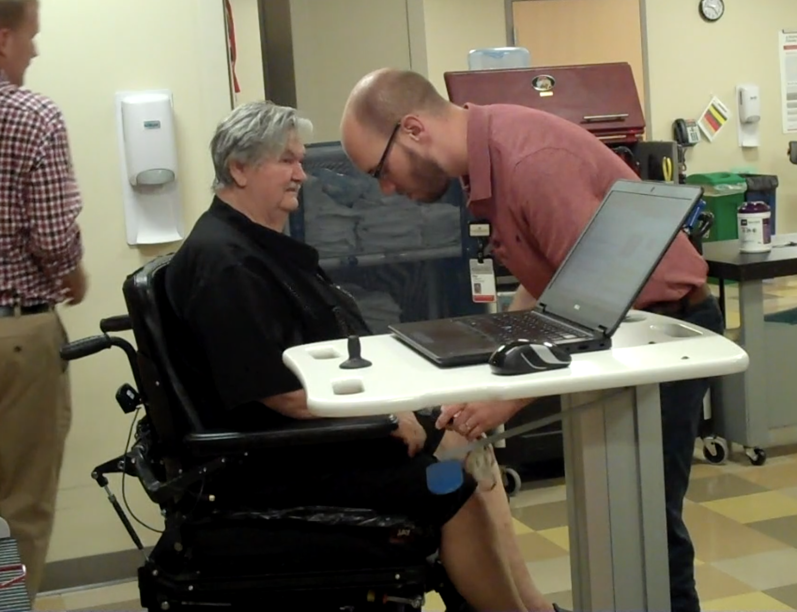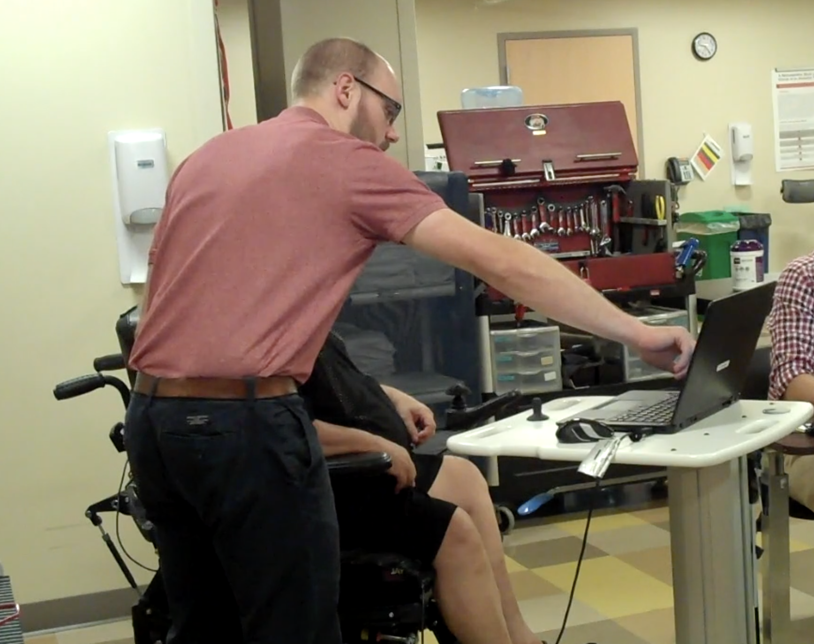

Figs. 1a, 1b. Jesse and his physical therapist observe pressure points.

Such an apparatus includes not just the wheelchair, but also a sensor filled seat cushion, laptop, and the WSMC’s space, in general (figure 2).

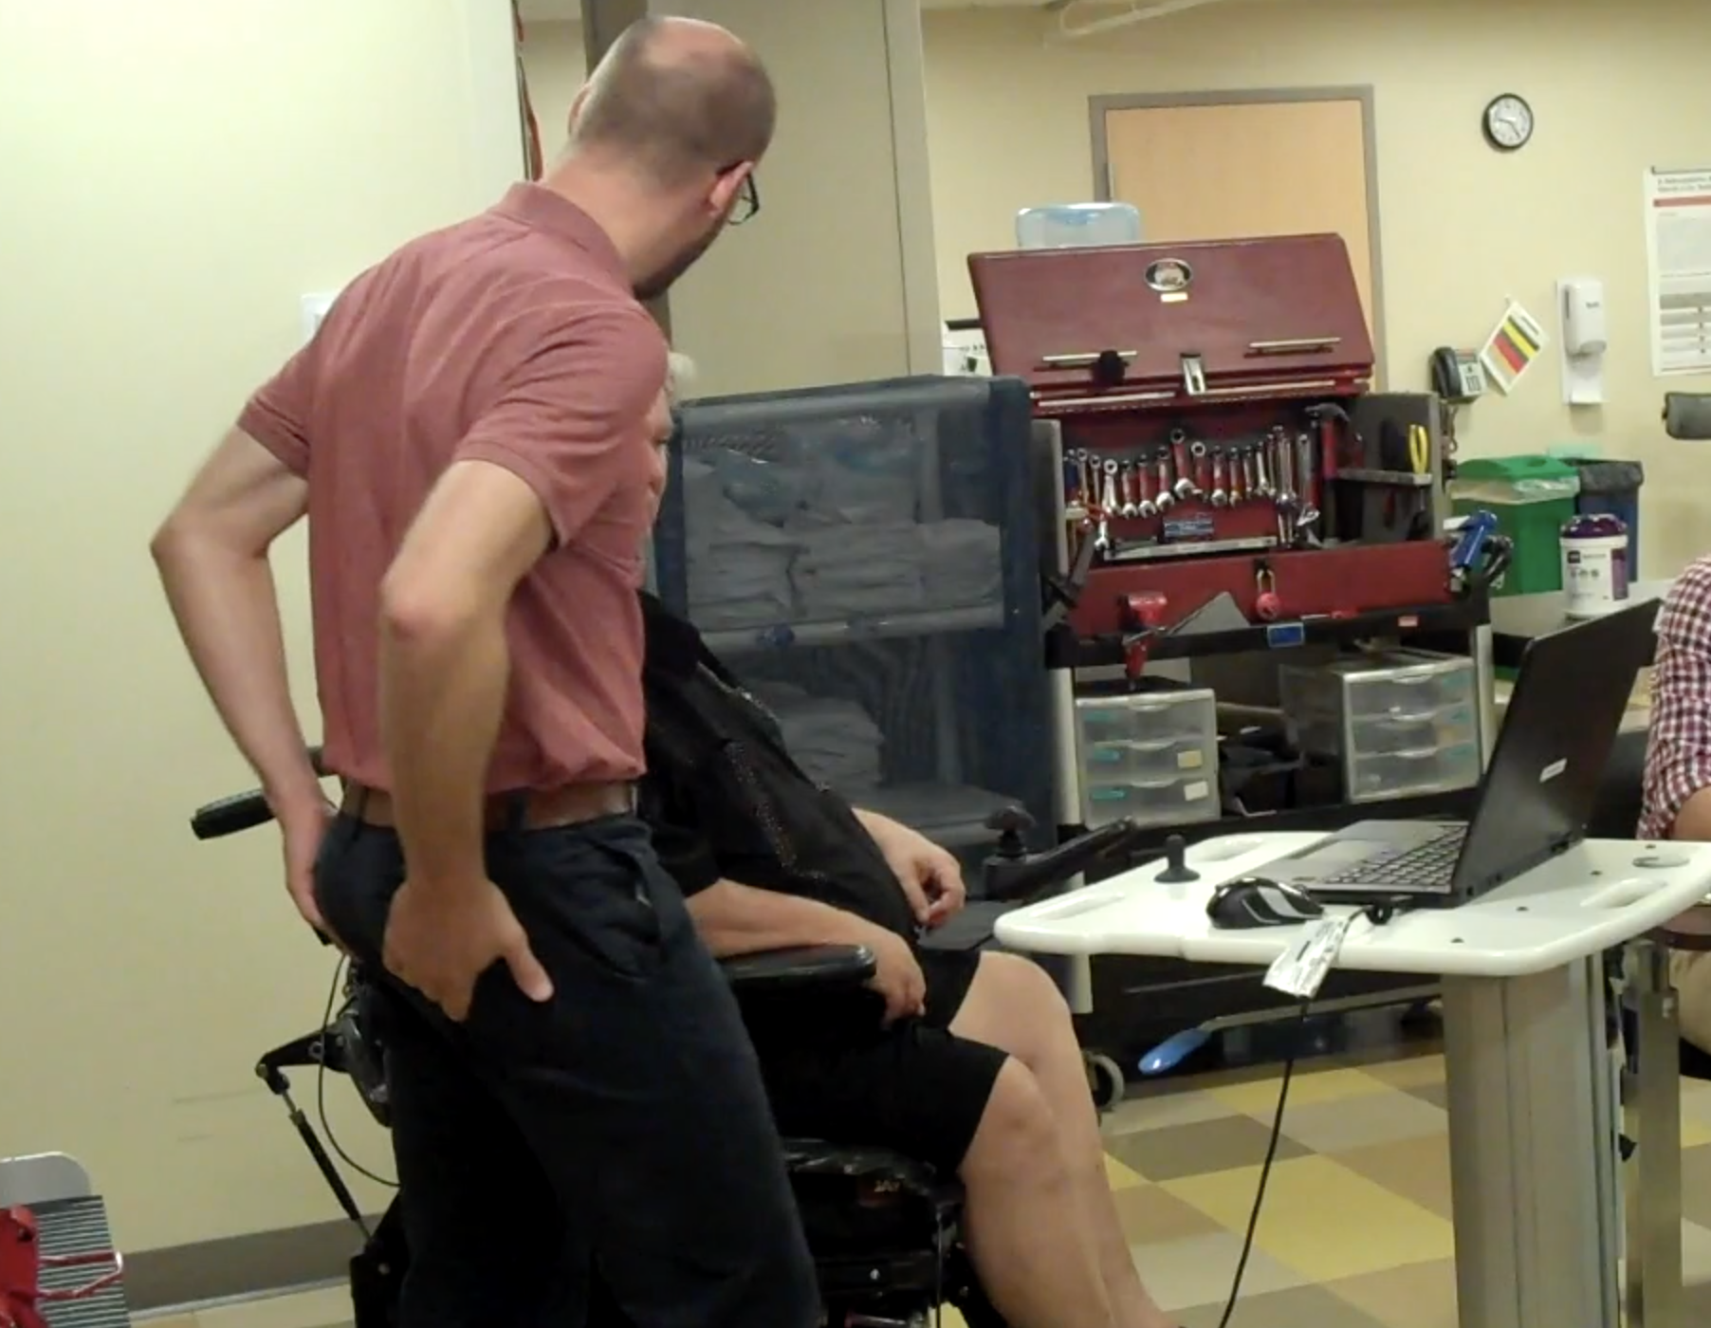

Fig. 2. Jesse’s physical therapist describes the effect wheelchair positions have on his sit bones.

To find the right(-enough) fit, the emerging and evolving arrangement between Jesse’s body and his wheelchair is visualized along the way: Bright red hotspots portend the potential for sores; cool greens and blues foreshadow fit (figure 3).

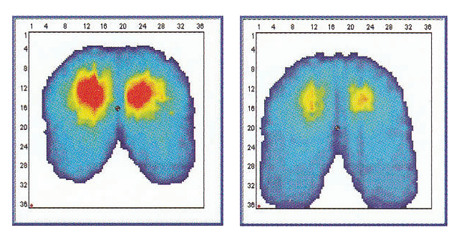
Fig. 3. Pressure mapping technology.

In this assemblage of humans, objects, and screens, bodies talk. And medical practitioners learn to listen, watch, tinker, and adjust. After about the third wheelchair fitting appointment I attended, I started to realize how important the large red toolbox was. It sits close by, propped open, always ready to hand so that pieces and parts can be removed, added, slid to the side, taped down, bulked up with foam, and so on (figure 4).
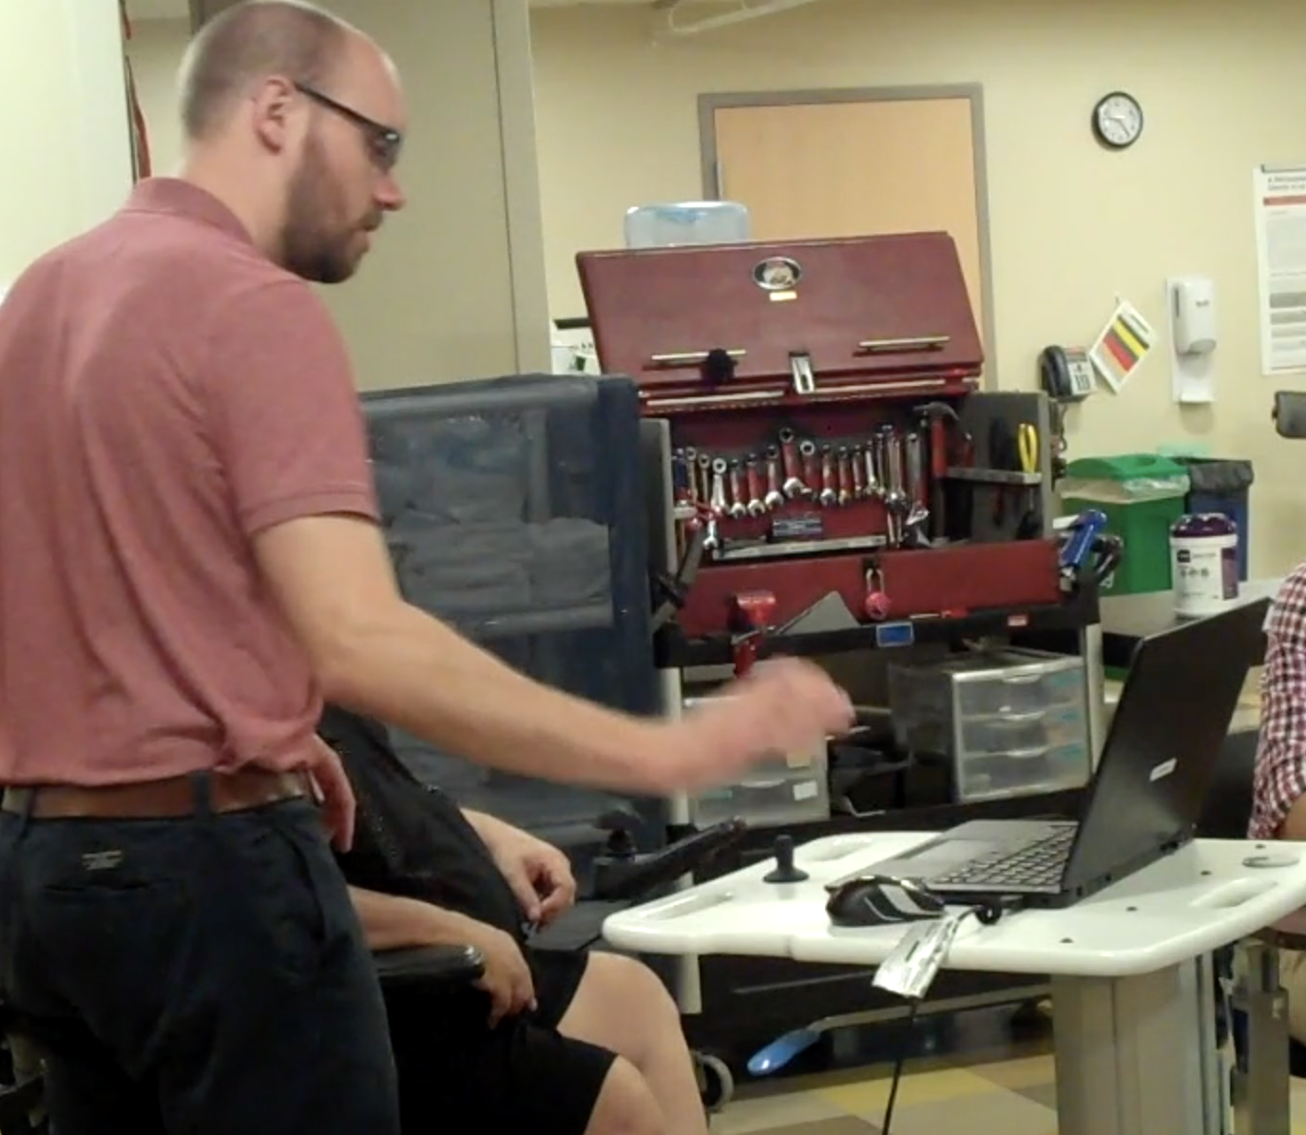

Fig. 4. The toolbox.

In figures 5a-5c, you can see that the physical therapist is showing Jesse how to move his wheelchair back as a tactic for alleviating some of the pressure experienced by his sit bones—pressure that could cause sores and painful infections. This process of finding a good fit is just one example of the care-taking labor involved in what I’m calling the practice of posthuman.

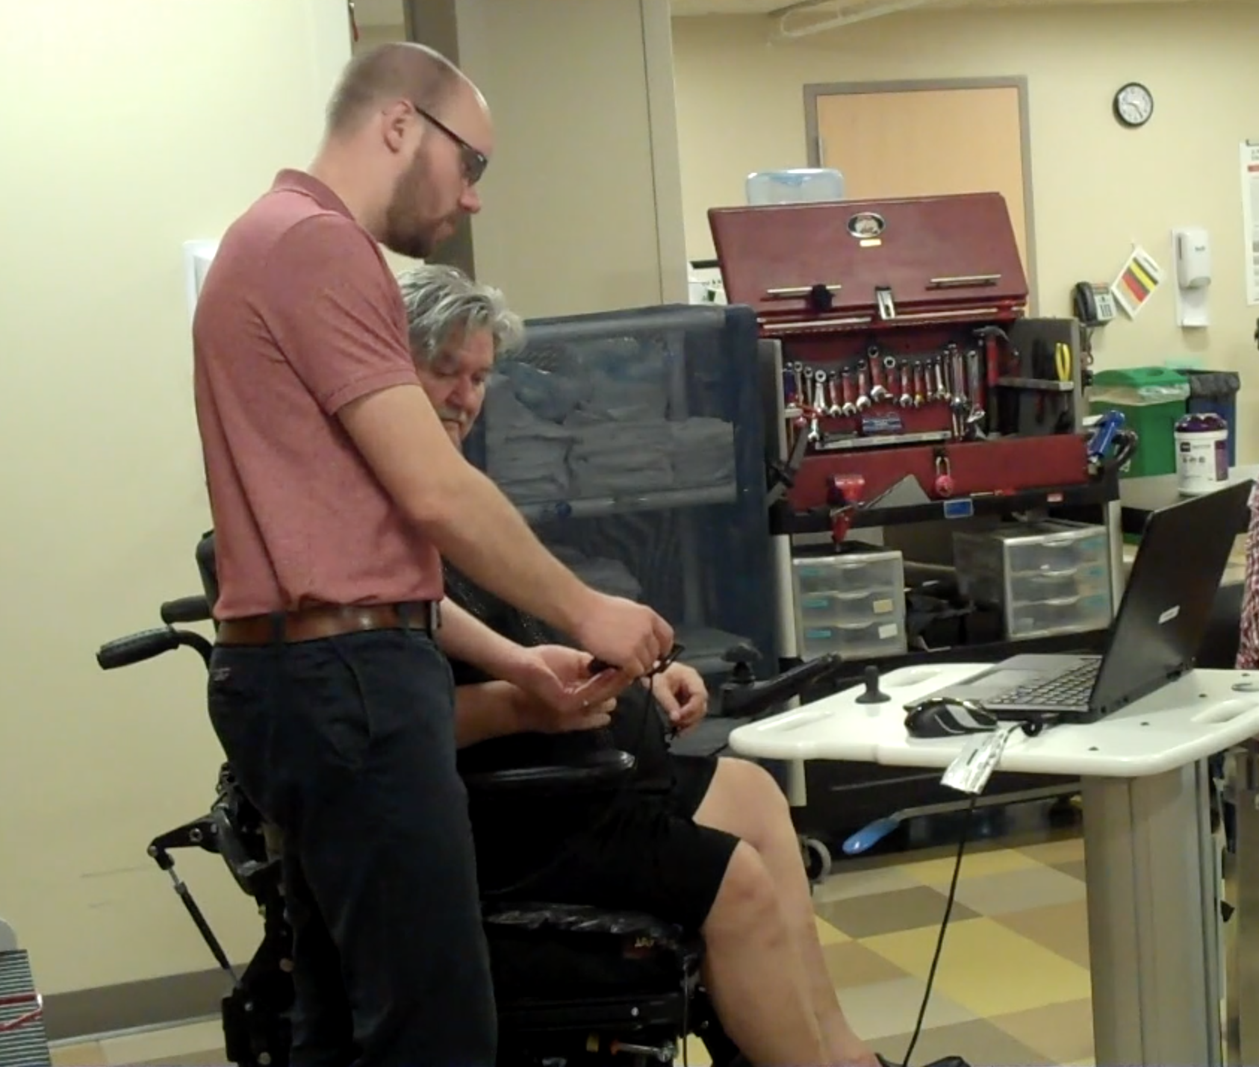 | 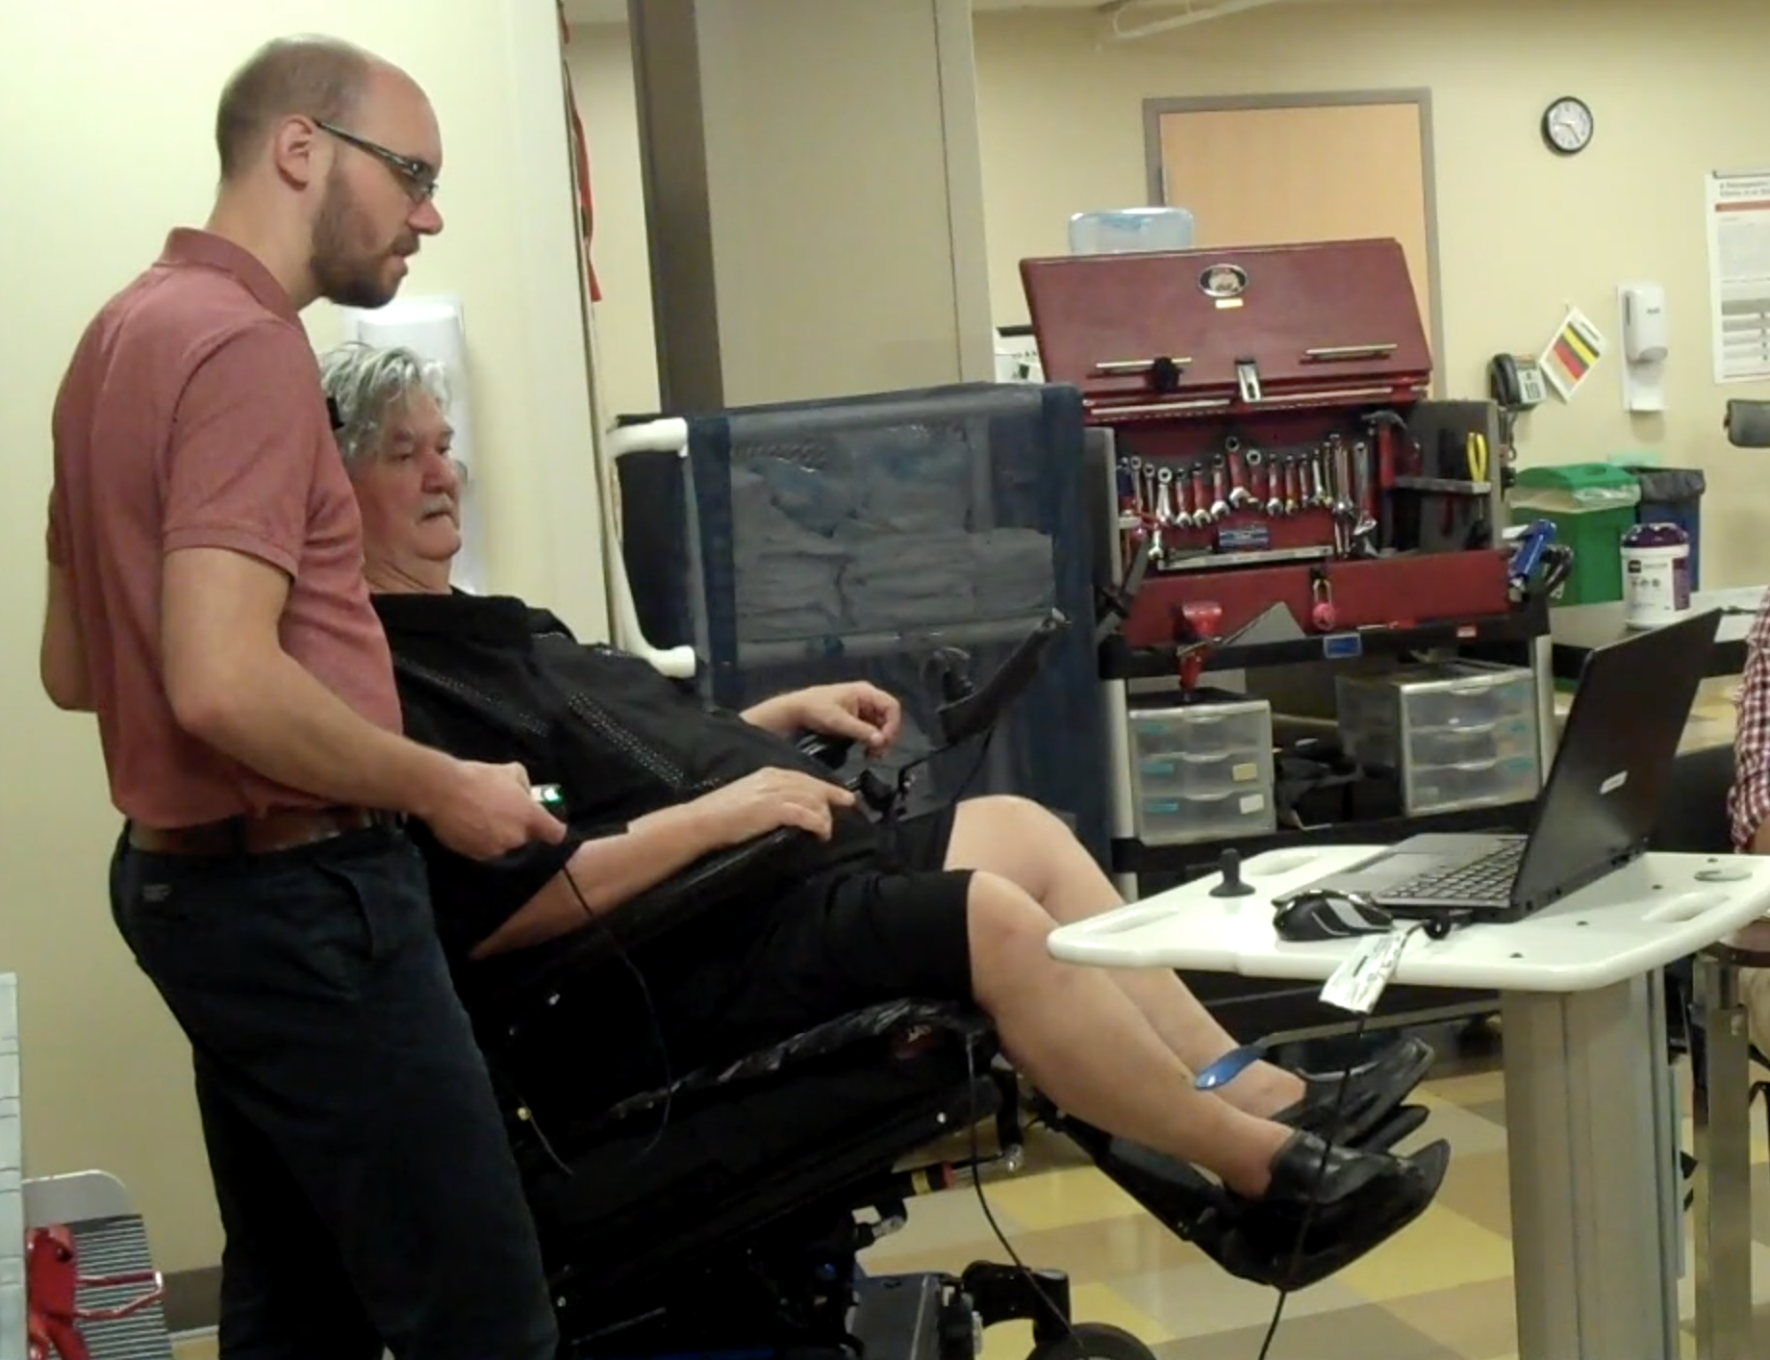 | 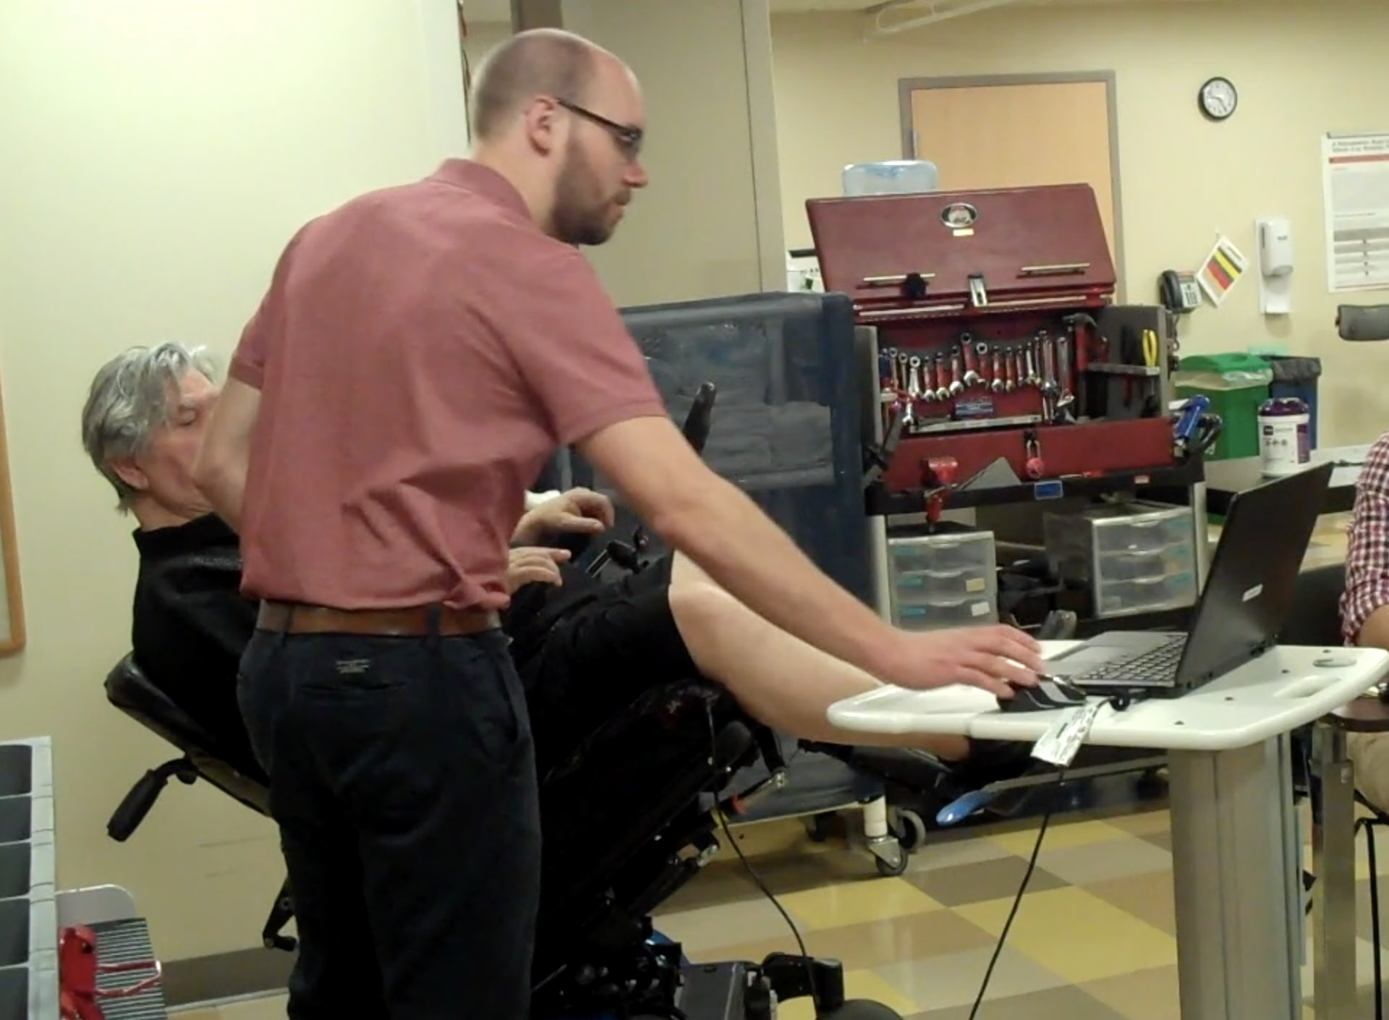

Figs. 5a, 5b, 5c. Jesse’s physical therapist demonstrates what happens on the pressure mapping software screen when he repositions his chair.

***
In her ethnography of contemporary nurses’ footwashing practices, Jeannette Pols argues that “care practices are...material parables for moral questions that may emerge in societies where people give and receive care and negotiate about matters of dignity” (p. 188). This brief example from Jesse’s appointment illustrates how the practice of performing posthuman dignity is fundamentally a matter of fit. And “fit” is a “temporary result in the process of caring” (Pols, p. 39); “the goodness of the intervention…is contingent on the relation…Fitting is a relational activity, a way of interacting rather than an effect of machines. Users and devices have to continuously establish what may fit where” (Pols, 2012, p. 39). To practice posthuman dignity, then, means that we recognize ourselves and others as a part of “a living assemblage...such an understanding of the body undermines the political myth of self-authorship and the privileged ethical status of humans as cognitive, communicative subjects” (Whatmore, pp. 43-44). Rather than defining human being in terms of individual autonomy, rational and reasonable thought, and exceptionalism, Whatmore argues that humanity is sustained by recognizing and enacting “relational senses of self and responsibility” (Whatmore, p. 44).
Witnessing how practitioners navigate “relational senses of self and responsibility” is perhaps no more apparent than when medicalized evidence simply does not or will not suffice. Or when bodies communicate in ways that, at least for now, go undetected. Another full time wheelchair user in my study plays the piano, hems the marching band uniforms at her granddaughter’s high school, and works part time in a medical office. She regularly has to hack her chair, her clothing, her seat back, and foot rests so that she can perform these activities. How her physical therapist responds to her needs by putting the pressure maps away and learning to listen in other ways—this, too, is what posthuman dignity looks like in practice.
A theory of posthuman dignity, then, requires a bit of an overhaul of the conceptual structure of human dignity that I alluded to at the beginning of this talk. It requires ethical praxis, not just ideological and/or philosophical musings about humans’ unique capacity for reason, autonomy, and individual choice.

- Whereas human dignity is framed, at least by Hobbes, as intrinsic to human being, the practice of posthuman dignity is a matter of contingency.
- For the stoics, human dignity was immaterial, but for posthumanists, you cannot escape the way practice of dignity hinges on material conditions.
- While human dignity from a Judeo-Christian tradition seems to suggest dignity is bestowed upon us from on high or from some divine, heavenly being, the practice of posthuman dignity is grounded and earthy.
- Whereas Kant and Locke might suggest that human dignity hinges on an individual person’s autonomy, practicing posthuman dignity eschews individual notions of choice and in its place, emphasizes relationality.
- Whereas Kant and Aquinas might frame human dignity as indicating an individual’s capacity for rationality and reason, to practice posthuman dignity involves an attunement to, ambient relations.
- Whereas human dignity is concerned with ends and means, posthuman dignity practices consider effects and consequences.
- And whereas dignity, at least for transhumanists such as Nick Bostrom, embodies an anticipatory if not hopeful focus on potential futures, posthuman dignity embodies a radical hyperfocus on present predicaments.

My hope is that the theoretical contributions this project makes might, ultimately, be more than theoretical—they might be actualized in our homes, our classrooms, communities, and all of the many built worlds through which we maneuver every day. I look forward to sharing intellectual space with all of you over the next day and a half. Thank you.

Here we might also consider Black feminist epistemologies’ (cf. Hurston; Andrews; Combahee) notion of “minor empiricism,” which, akin to scientific empiricism, produces “knowledge from the senses” Andrews 2015, p. #). But in the case of minor empiricisms, “they do not take the organization of the senses, and especially the privileging of vision, as a given for converting perception to knowledge. Nor do they assume the value-neutrality of machine mediation and quantification” (Andrews 2015, p. #).

