3 BOOKS YOUR CHILD SHOULD BE READING IN MIDDLE CHILDHOOD (AGES 9-11 YRS)
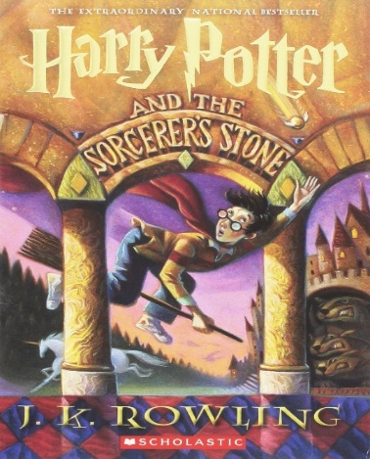
Harry Potter
The book is long but not too hard to follow and has many magical creatures which usually intrigues children and encourages them to keep reading. There is some inappropriate language, but it is mostly acceptable for the middle child age group and there is some violence. There is little diversity with mostly male main characters, but Hermione is a high achiever and does it through hard work, proving that girls can be successful too.

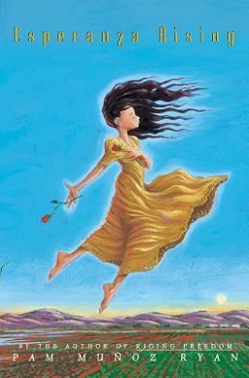
Esperanza Rising
This is about the Mexican farm workers which gave me a new perspective on the hardships of immigration. It has accurate history from the 1930s and is culturally accurate since many Mexicans had to migrate for better opportunities. Children learn about discrimination and harsh living conditions.

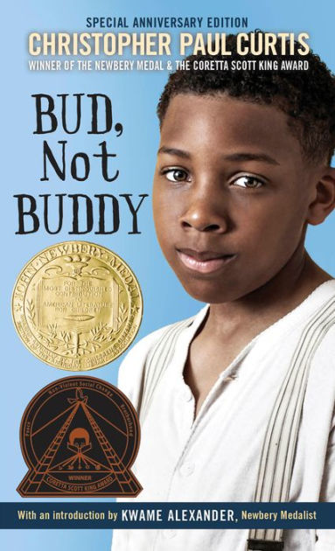
Bud, Not Buddy
This book is culturally accurate about the hardships of African Americans. Bud is abused by his foster family, which was common in the 1930s, when blacks were (and are) discriminated against. It is also historically accurate since it takes place in the Great Depression.

References
“50 Books All Kids Should Read Before They're 12.” Common Sense Media: Ratings, Reviews, and Advice, 1 Jan. 1970, www.commonsensemedia.org/lists/50-books-all-kids-should-read-before-theyre-12.

