Dr. Norm Scott, Former Vice President for Research at Cornell, to speak on Sustainability on April 5.
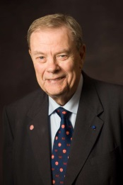
All are invited to attend Dr. Norman Scott’s seminar entitled: “Transitioning toward a sustainable world: Role of sustainability and converging technologies” on April 5, starting at 1:45 PM in Room 219 of Agricultural Engineering Building in Columbus. The presentation will be video linked to Room 200 of the FABE Building in Wooster campus of the OARDC.
Dr. Norman Scott is Professor Emeritus and former Vice President for Research at Cornell. Prior to serving at this capacity, he served as Chair of the Agricultural Engineering Department; and Director of Research, College of Agriculture and Life Sciences at Cornell. He served as President of ASABE (American Society of Agricultural & Biological Engineers). He is a member of the National Academy of Engineering. He received numerous national-level awards for his scholarly work and service to the society. He is currently Chairing the Board on Agriculture and Natural Resources, a major program unit of the National Research Council, a nonprofit institution that provides expert advice on agriculture, forestry, fisheries, wildlife, and the use of land, water, and other natural resources. They provide information designed to address the most pressing challenges facing the nation and world, help shape sound policies, inform public opinion and advance the pursuit of science, engineering and medicine.
More information on this event is available at: http://fabe.osu.edu/news/featured-fabe-seminar-former-cornell-vp-research-speak

Contact Person:
Prof. Erdal Ozkan
ozkan.2@osu.edu
292-3006

