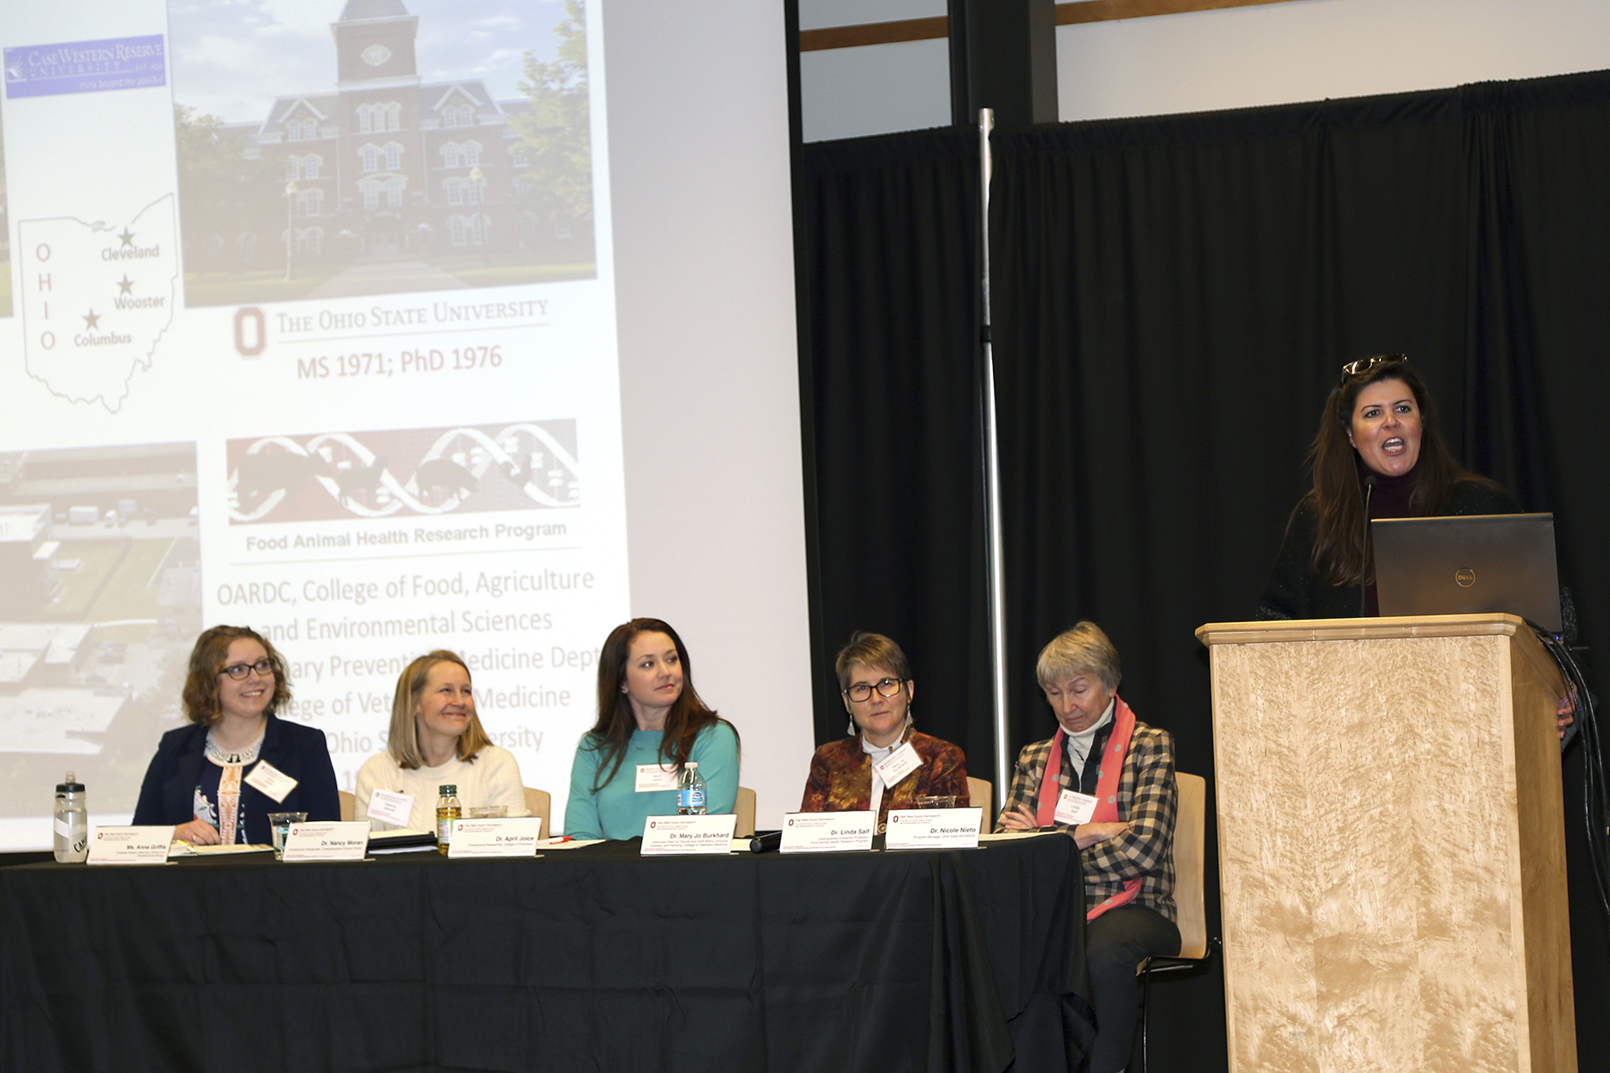

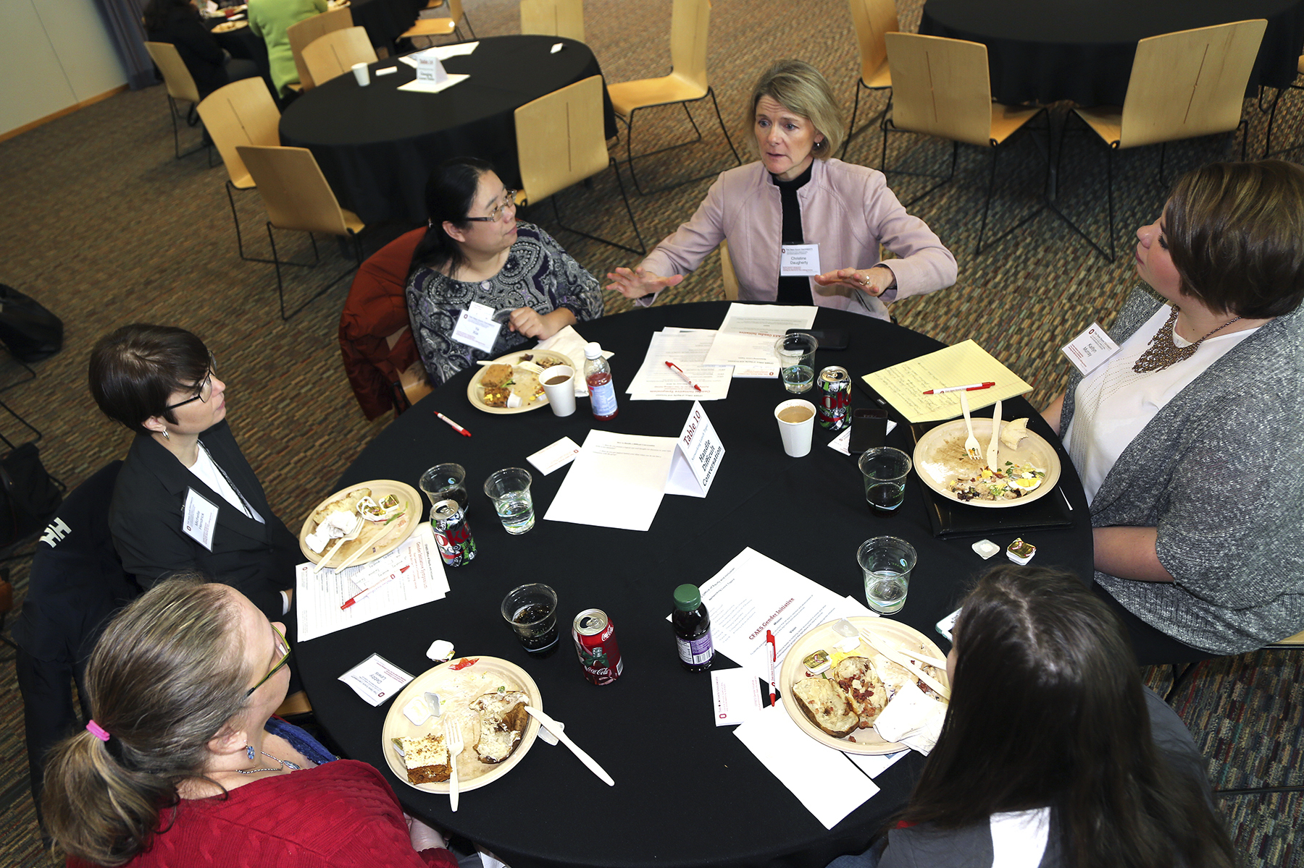

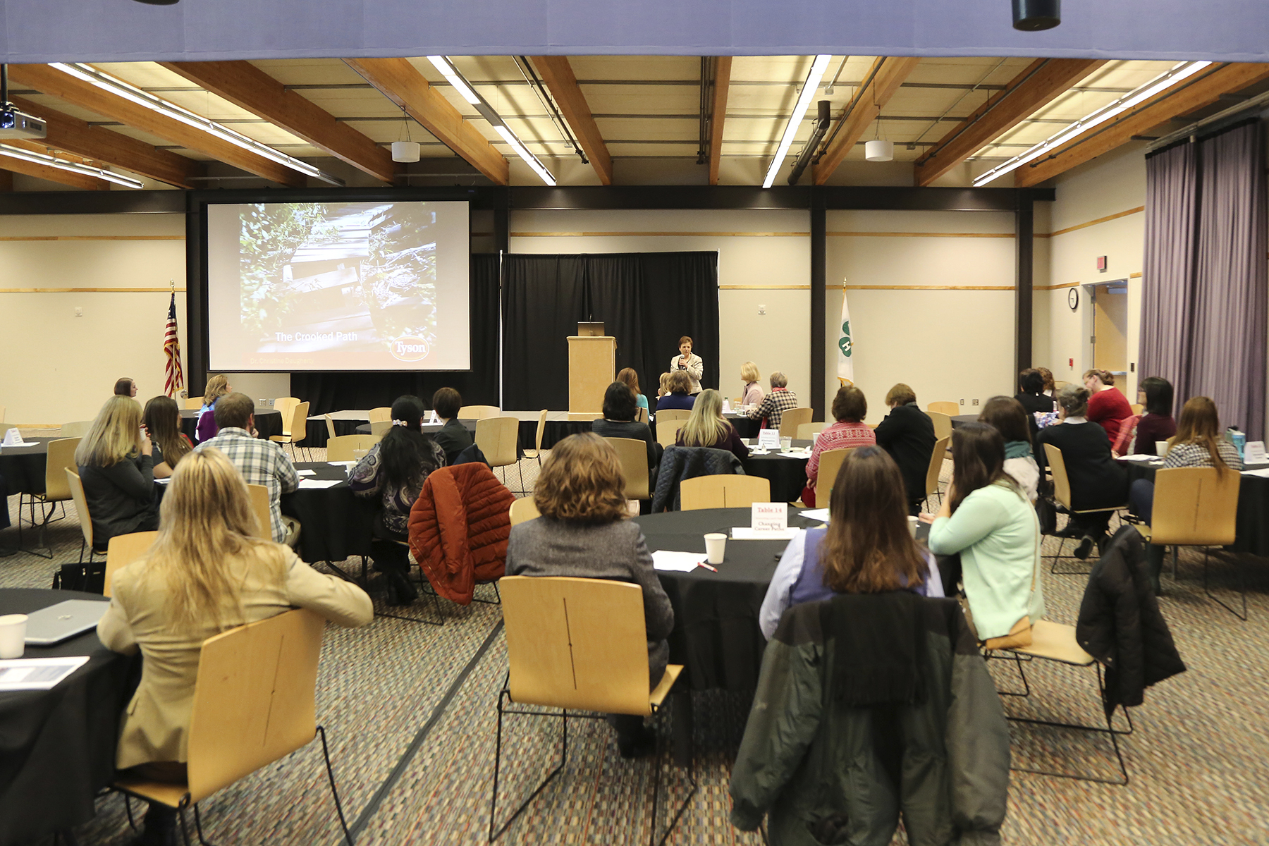

CFAES Office of Equity and Inclusion-Gender Initiative Symposium

**Save the Date**

**Gender Initiative Skill Workshop**

**Effective Negotiation: Strategies to help avoid, “I wish I would have asked” syndrome**

**Facilitator: Ana C. Berrios Allison, PhD, LPC**

**Agenda:**

***1. Skill of negotiation in academia and outside academia***

***2. Building confidence in negotiating***

The workshop supports the goals of the CFAES Gender Initiative to build a pipeline for women in the agricultural and natural sciences who want to enter the academy or other professional professions.

Dr. Sandy Velleman is the lead faculty working with the CFAES Office of Equity and Inclusion

**http://equityandinclusion.cfaes.ohio-state.edu/gender-initiatives**

Registration will open in May 2016.

For additional information go to [Gender Initiative](http://equityandinclusion.cfaes.ohio-state.edu/gender-initiatives)

CFAES provides research and related educational programs to clientele on a nondiscriminatory basis. For more information: http://go.osu.edu.cfaesdiversity.

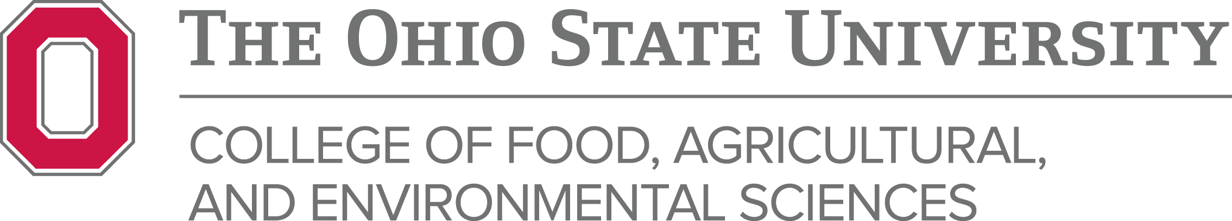

Tuesday

June 7, 2016

TIME 9::00-11:00 AM

# Location-Columbus Campus- 333 Kottman

# Wooster Campus-Fisher Classroom

# Cost: Free

Phone/Contact