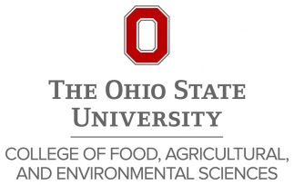
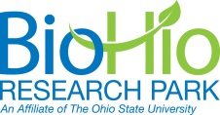
CFAES BioHio Innovation Seminar Series Kick-off
Innovation and Entrepreneurship in Higher Education
October 16, 2015 Seminar - 10 – 11am
CFAES Dean Bruce McPheron, OARDC Director Steve Slack, and BioHio President/CEO Shauna Brummet invite you to our BioHio Innovation Seminar Series kick-off. We plan bimonthly events focusing on Innovation and Entrepreneurship strategies, capabilities and successes with speakers drawn from successful schools and businesses and highlighting OSU events, capabilities and tools.
Please join us for our kick-off event with Judith Cone on Friday, October 16, 2015. The seminar will be held from 10 – 11 am in Wooster, Research Services Room 130 and video-linked to Columbus in Ag Admin Room 140G. There will be opportunities for faculty, students and staff to meet with Judith before and after the seminar. We plan a student lunch with Judith at Wooster – please contact Shauna Brummet (admin Betty Aylsworth, aylsworth.1) if interested in joining the lunch.
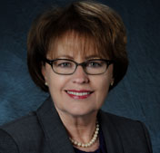
Judith Cone is the University of North Carolina at Chapel Hill’s special assistant to the chancellor for innovation and entrepreneurship, interim vice chancellor of commercialization and economic development, and interim director of the Frank Hawkins Kenan Institute of Private Enterprise. She leads the campus in strengthening a university-wide culture of innovation and entrepreneurship so that Carolina is a place where innovators thrive. The university is committed to making an impact on the lives of people in North Carolina and around the world.
Before coming to Carolina, Cone served as vice president of emerging strategies and entrepreneurship at the Ewing Marion Kauffman Foundation, capping a 15-year career with the Foundation. During her tenure, Cone led many of the foundation’s signature education and entrepreneurship initiatives and programs, including a business start-up training program that has been used worldwide by millions of entrepreneurs; an award-winning Web resource for entrepreneurs; and the Kauffman Campuses Initiative, which has transformed the culture on university campuses by making entrepreneurship education accessible to students and faculty across all fields of study. As global ambassador for the Kauffman Foundation, Cone worked with leaders around the world to help transform economies and was a sought-after speaker on the topic of entrepreneurship.
For the previous 12 years, Cone co-founded two management consulting firms serving Fortune 500 clients. Cone writes and lectures nationally and internationally on entrepreneurship and innovation.

