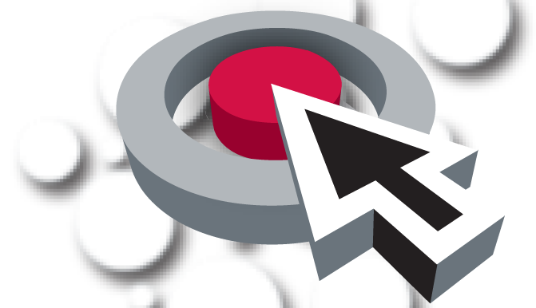
Clinical Laboratory Techniques
Standards Alignment Workshop
May 20, 2021

Agenda

3:00 Sign In

3:00 Large Group Welcome and Brief Introductions
Reimbursement Explanation
Orientation: Workshop Purpose, Procedures, and Logistics

3:30 Small Groups Review item bank, edit items, make notes
Discussion: approval/adjustments

5:00 Adjourn

