Weather Pt. 1
2nd Grade
Sources:
http://www.weatherwizkids.com/experiments-tornado-bottle.htm
http://www.icanteachmychild.com/2011/06/making-it-rain/
http://www.learnplayimagine.com/2013/08/making-convection-currents-weather-for.html

“I Can” Statements:
I can observe how air and water relate to weather and weather changes.
I can measure the relationships between air and water.
I can observe and ask questions about the natural environment.
I can communicate about observations, investigations, and explanations.
I can review and ask questions about the observations and explanations of others.

Objective: Students will learn about different types of weather and how they occur through demos and experiments. This lesson will be divided into four stations (tornadoes, thunderstorms, rain, and how thermometers work). Note: We are not doing an experiment on clouds because the next time we visit 2nd grade, we will be teaching them about clouds.

Procedure:
- Divide the class in half. You can decided whether it is easier for the students to rotate to each station, or leave the kids where they are and the volunteers will rotate themselves.
- Each station should take about 30 minutes.
- At each station, begin by introducing yourself and telling the students what type of scientist you are (chemist, physicist, etc).

Station 1: Thunderstorms and Rain(30 minutes)

Materials:
- Clear bucket
- Warm water
- Blue ice cubes
- Red food coloring
- Hot plate
- Beakers (one for rain demo and a few for measuring temperature with thermometers)
- Water
- Plate or tray
- Ice optional
- Thermometers
- Cloud in the Bottle Demo

- Rain Demo
  - Prepare the rain demonstration before the lesson begins.
  - Explain to the students how rain is formed: The hot water at the bottom is evaporating and turning into a gas or water vapor. That water vapor rises in the air and hits the cold pan. The cold from the pan turns the water vapor back into raindrops. The hot water represents water on the ground, and the cold water represents clouds.
- Show the students the cloud demonstration, and explain that the sky is clear with no clouds when there is high pressure. Clouds are formed when the air pressure is low.
  - Three things that are needed to make a cloud. Moisture or water vapor, dust/pollen, and change in temperature/pressure. The moisture in the air condenses (or turns into a liquid) when the pressure and temperature changes from high to low. The liquid collects onto the dust and pollen in the air, and that is why it looks cloudy. When there is high pressure, it is a nice and clear day outside. When there is low pressure, it is cloudy outside.
  - Fill the 2 Liter bottles with just enough rubbing alcohol to coat the entire inside of the bottle. The rubbing alcohol will evaporate in the bottle as its pressure quickly changes from high to low. The rubbing alcohol represents water in the air.
  - Use the bike pump to pump air into the bottle. If possible, a student can pump the bike pump while a volunteer holds it in the bottle. Pump the bike pump several times to create high pressure in the bottle.
  - The volunteer will quickly remove the pump, and a cloud will immediately form in the bottle. This quickly changes the pressure from high to low. Low-pressure days are cloudy/foggy days.

- Thunderstorms
  - Prepare large clear bins with warm water (fill bins about half way).
  - Give a basic explanation of thunderstorms. A thunderstorm is a storm with lightning and thunder. Thunderstorms are started when warm air quickly rises. Heat naturally rises, and when colder air comes through, the heat rises faster. Lightning is formed from lots of small pieces of ice hitting each other. This creates a charge. When enough ice pieces hit each other and there is enough electrical change, lighting occurs. Lighting hits the ground so fast that it pushes the air out of the way, which makes a sound called thunder. Thunder is what you hear during thunderstorms.
- Show students the blue ice cubes, and tell them that they represent cold air.
- Have a student place a few ice cubes in the water at one end of the bin, then have another student add a few drops of red food coloring at the other end of the bin. Explain to the students that the red food coloring represents warm air.
- After a few minutes, the red and blue will begin to mix. Have the students look and observe the colors mixing from the top, and the side. (a picture of experiment is below)
- Ask the students what they see. If no one mentions how the red color is on top of the blue, point it out and ask the students why they think this happened (heat rises).
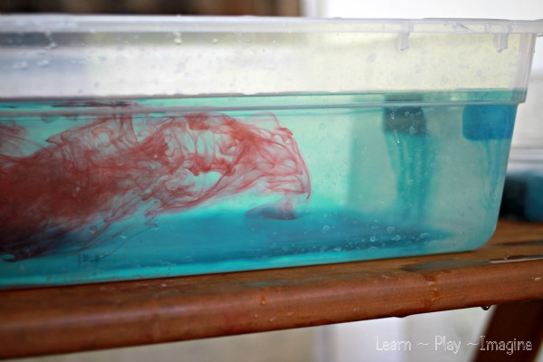
Picture by: Allison Sonnier; http://www.learnplayimagine.com/
7. If time allows, let the students use the thermometers to measure the temperatures of different beakers of water. Beakers should have varying temperatures.

Station 2: Making a thermometer (30 min)

Materials
- clear, plastic bottle (11oz. water bottle works)
- water
- rubbing alcohol
- clear plastic drinking straw
- modeling clay
- 1 gallon of cold water
- 2 water bottles of room temperature water
- 11 oz plastic water bottles
- liter bottles of hot water from sink
- food coloring
- Ice Cubes

- Start out with the room temperature bottle of water. Show the students that the water level in the straw is about the same as the water outside of it. Place in hot water from the sinks. (May need to change out a few times). The students will use cold water in their thermometers.
- Divide students into groups; each group will make one thermometer and each student should have a turn/job in constructing the thermometer.
- Pour cold, colored water from the jug in the 11 oz water bottles for each group.
- Mold clay around the top of the straw and place the straw in the bottle, but don't let it touch the bottom. Seal the neck of the bottle, so the straw stays in place. The kids will need help placing the straw in and making sure there is an air-tight seal. This can be checked by squeezing the bottle and listening for air to leak out.
- Place in foam cup with hot water from the sink.
Discussion: As water heats up, it expands and becomes less dense, rising to the surface. When it cools down, it contracts, becoming more dense and sinking down. This cycle is called convection. (Water is unique, however - when it gets cold enough to freeze, the molecules line up in an open crystalline structure that is actually less dense than the liquid form. This is why ice floats.) When the water in your bottle thermometer heated up, it expanded. But since the bottle was sealed, it had nowhere to go but up through the straw.

Real thermometers don't use water inside because it doesn't respond to temperature change very quickly. Our thermometers have 50% rubbing alcohol and 50% water. Does the liquid move up and down the straw faster with or without the rubbing alcohol? Why do you think this is?

With your homemade thermometer you aren't actually measuring temperature, just seeing temperature changes. If you have a real thermometer, you can use it to make a scale on your homemade thermometer: let your bottle get to room temperature and then mark the straw with what the actual room temperature is. Then set the bottle in the sun and do the same. Mark several different temperature levels and then watch your thermometer for a day and see how accurate it is.

Extension: Have the students mark where the water is, then leave it overnight and see where the water is then!

