Composition of Earth and Planets
5th Grade

“I can” statements:
I can make a scale model of the interiors of planets.
I can draw a circle using a compass and understand the radii/diameter of a circle.

Sources
https://www.msnucleus.org/membership/html/k-6/uc/solar_system/2/ucss2_1a.html

Materials for each group
Planetary Interior data table
Large piece of paper (at school)
Ruler
Compass or pencil on string
Cotton balls (atmosphere)
Saran wrap (ice/liquid)
Aluminum Foil (metal)
Sand paper (rock)

Introduction:
Planets are divided into two categories: the four inner planets closest to the sun that are small and rocky and the outer planets that are large and gaseous. Comparisons within the groups of four inner-terrestrial planets or four outer gas giants show strong similarities in composition and internal structure within each group and very strong contrasts with the other group. However, it is fascinating to note that the inner rocky cores of Jupiter and Saturn are near to the sizes of Earth and Venus. These differences are caused by variations in temperature and gravity during the formation of the planets.

Go through the difference of radius and diameter with the students and how to use/ make a compass with a pencil. Have the students try to draw a circle with a compass on their own on scrap paper.

Then, explain and draw on the board in general the interior of a planet and the four different parts: core, interior, surface, and the atmosphere.

Procedure
- Divide the students into small groups. Distribute the planet interiors page on the following chart. Tell the students to model two planets (Earth and Jupiter) on their poster. If they have time, they could also model Saturn.
- Using a scale of 1 cm to 1000 km, draw a circle on the poster with a radius the size of the planet. This represents the planet’s surface. Jupiter and Saturn are too big to fit on the poster so have the students draw ¼ Jupiter and ½ of Saturn.
- Draw an inner circle with a radius the size of the core and another circle for the interior.
- Draw and outer circle with a width the size of the atmosphere (0-2 cm).
- Fill in the circles with colors or glued art materials to represent the composition and state of the layers
- Conduct a discussion that compares the inner planets with the outer planets and reasons for variations in size and composition. Consider distance from the sun and likely temperature differences.

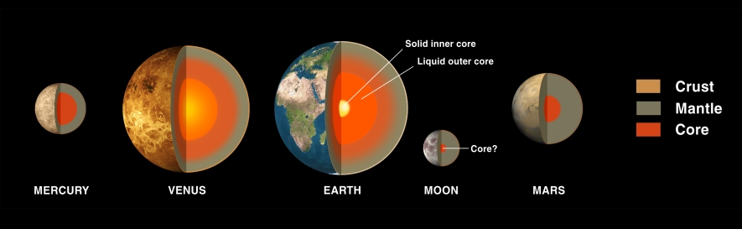
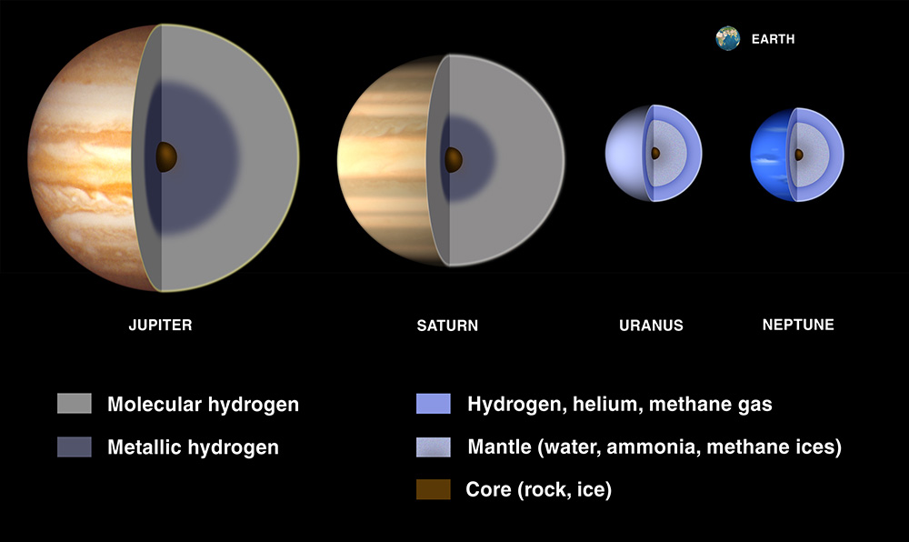

Additional Information:
The planets are a wonderful example of how scientists slowly accumulate new information and make new conclusions. With each new space probe, much is learned about the planets. The discovery of more satellites around a planet to changing atmosphere can be revised with new information. We really do not know all there is about the planets.

Mercury is the closest planet to the Sun. It orbits the Sun quickly, once every 88 days. It rotates slowly, however, only once every 59 days. Mercury is small, about 4850 kilometers (~3000 miles) in diameter. Because Mercury is so close to the Sun, the side of its surface that faces the Sun is very hot, ~800oK. The surface of Mercury is gray to orange in color, and is covered with craters. Mercury is named for a mythical god who ran very fast.

Venus, the second planet away from the Sun, is Earth’s closest neighbor. It is about the same size as the Earth, a little over 12,000 kilometers (7300 miles) in diameter. Venus has a very thick atmosphere, composed largely of sulphuric acid and CO2. We could not breathe on Venus, because the atmosphere would be very toxic to humans. This atmosphere gives Venus a brownish-yellow color. It also traps heat (the greenhouse effect) making the surface of Venus the hottest in the Solar System, about 900oK. Venus rotates very slowly, taking 243 days to complete one turn. It is named for the Roman goddess of love.

Earth is a little more than 12,000 kilometers in diameter. It differs from the other planets because it has liquid water on its surface, maintains life, and has active plate movement. It rotates on its axis every 24 hours (a day) and revolves around the Sun every 365 days (a year). The Earth has one moon.

Mars is a little more than half the size of the Earth, having a diameter of 6,790 kilometers. It takes Mars 687 days to revolve once around the Sun. It rotates at about the same speed as the Earth, taking 24.6 hours. Mars has a very thin atmosphere, which is composed largely of CO2. Its surface is very cold, and is covered with craters, volcanoes, and large canyons. Mars is reddish in color. Mars has two small moons. It is named for the Roman god of war.

Jupiter is the largest planet in the Solar System, with a diameter of 142,980 kilometers, more than 11 times wider than the Earth. Jupiter orbits the Sun once every 12 years. It rotates very fast, in 9 hours and 19 minutes.. Its surface is made up of gas (mostly hydrogen), so that if you landed on the surface you would sink into it. Jupiter probably has a core of metallic hydrogen and rock, although evidence for this is theoretical. The outer gaseous part of Jupiter is broken into bands of white, yellow, red, and brown clouds. Jupiter has 4 rings mainly composed of dust. Huge oval-shaped storms also occur on the surface. Jupiter has 67 known satellites (as of 2016) including the four large Galilean moons (Io, Europa, Callisto, and Ganymede) plus many more small ones some of which have not yet been named. Jupiter is named for the Roman supreme god of heaven.

Saturn is well known for its system of three rings. It is a large planet: at 120,536 kilometers it is only a little smaller than Jupiter. It revolves around the Sun in 12 years, and rotates a little more than 10 hours. Like Jupiter, Saturn is composed of mostly gas, and has a core composed of rock and metallic hydrogen. The surface of Saturn looks banded, and has a brown-yellow, butterscotch color. Saturn’s rings are probably composed of small particles of ice and rock. Saturn has 62 moons (as of 2016). It is named for the Roman god of agriculture.

Uranus is 51,118 kilometers in diameter, about 4.4 times the size of the Earth. It revolves around the Sun slowly, taking 84 years to complete one orbit. It rotates in about 17 hours. It is covered by a thick layer of gas, and has a fairly uniform blue-green color. Uranus has 27 moons (as of 2016) and is surrounded by a system of nine rings. It is named for another Roman god, the grandfather of Jupiter

Neptune is slightly smaller than Uranus, with a diameter of 49,500 kilometers. It circles the Sun once every 165 years, and rotates in 16 hours. Its atmosphere appears blue , and is marked by large dark blue storm systems. It is surrounded by a system of five rings and at least 14 moons. Neptune is named for the Roman god of the ocean.

Pluto in 2006 was renamed as a dwarf planet. It has an eccentric, oval-shaped orbit, which is tilted with respect to the rest of the Solar System. Pluto revolves around the Sun in 248 years, and rotates in a period of 6.4 days. Pluto is probably composed of rock. Its surface and color are unknown. It has one large moon that is almost like a twin with 2 smaller moons. Pluto is named for the Roman god of outer darkness.

