Standard Operating Procedure
Surface Analysis Laboratory
Department of Chemistry and Biochemistry
Reopening Stages II-III

- RSS Group Leader: Tanya Whitmer

- Research Laboratory Coordinator (RSS Managers): Yehia Khalifa

- Building and Rooms:
Office Laboratory
CBEC 085 CBEC 073

- SAL Personnel
Yehia Khalifa.17
GTA for Fall 2020: Melissa Marx (shared with SAL, Analytical Laboratory)

- Brief Summary of SAL Research in Stages II-III:
Stage II – SAL in Preparation to Reopen - May Open with Extremely Limited Service
During Stage II, some research activity may be restarted. However, these activities should be limited to those that are of highest priority and are low to medium risk with mitigation activities. The current expectation is that there will be no more than 10% density at any given time during this stage. This expectation applies both to building occupancy and to individual research space occupancy.
- SAL manager will be allowed to return to work for instrument maintenance and operating the instruments for a small number of users.
- SAL manager will continue to telework during Phase II for all activities that do not require an onsite presence. All data analysis and writing will be completed off-site.
- Any requests to access instrumentation will be scheduled on an individual basis with priorities based on Stage II university policies.
- Users of SAL will not yet be allowed to access the facility without explicit permission by SAL manager.
Stage III – SAL Open with Limited Service
Research activities may restart but must be performed in a manner that complies with all safety requirements for PPE, sanitizing, distancing, and density of people. There will be no more than 25% density at any given time during this stage.
- SAL manager will return to work as needed keeping physical distance from users. Activities that can be done from home or private office will continue to be done outside the facility.
- SAL manager will communicate via email and posted signage to users.
- SAL occupancy is restricted time during Stage III – no one may accompany the user to observe or aid in experiments.
- There are no new users accepted during stage III.
- Priority will be given to users doing Covid-19 research and groups in the Department of Chemistry & Biochemistry.
- Due to the 1) social distancing measures, 2) the lack of a designated teaching assistant and 3) the SAL facility manager splitting their time between two instruments it is necessary to restrict access to the Kratos and Near ambient pressure XPS (NAP-XPS) to three days and two days a week respectively. Mondays and Tuesdays are designated for NAP-XPS
experiments while Wednesdays through to Fridays are for UHV Kratos measurements. It is critical to remind ourselves that these are unprecedented times and so there will be room for flexibility in the schedule according to the demand of each instrument.
- Data transfer to the group will occur digitally.
- Anyone found to have entered or used the SAL without alerting Dr. Khalifa will be banned and have door access removed immediately.
- Relevant information for sample drop-off and location is located under the last section “Sample exchange protocols”.

- Instrument specific Guidelines

- For Kratos users: scheduling will be done through FOM by the manager with no more than 5 samples per session. Users are required to email the facility manager the day of the drop off (khalifa.17@osu.edu) no later than 3:00 PM. The email should contain clear information regarding what the materials being analyzed are, # of samples and any information regarding preferably analysis sports or sputtering.
- Users are required to follow the below labelling scheme. Clearly mark with one X the order of samples 1-5 with 5 always being followed with two X’s.

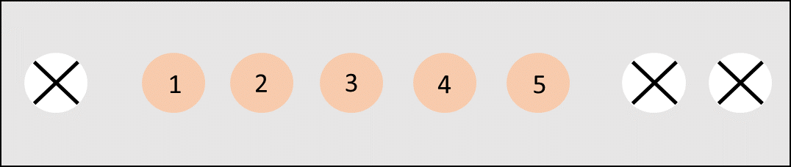

- For sessions involving 3 or more samples it is vital that each sample is less than 1 cm x 1 cm and not thicker than 1 cm due to limited space on sample bar.
- For NAP-XPS users: Due to the complexity of parameters involving these experiments, a summary sheet (.pdf) detailing isotherm or isobar parameters with relevant information that is approved by the advisor is required. Sample drop off is designated at the same table as the Kratos.
- For NAP-XPS, users will be expected to be remotely available during data collection and could be provided with Teamviewer credentials to see their data live.

- Summary of precautions and standard operating procedures that must be followed to safely conduct the above research activities in the spaces listed and with maintenance of social distancing
PPE Requirements and Cleaning Procedures:
- Anyone experiencing symptoms of Covid-19 and/or a respiratory illness should refrain from entering the facility. Symptoms include Cough, fever, shortness of breath, chills, aches, new loss in taste/smell
- Masks must be worn at all times during the sample drop off; both nose and mouth must remain covered.
Sample Exchange Protocols:
- Users will leave samples by the SAL designated table located in the basement of CBEC by the NMR cutout.
- Users are required to have their samples clearly labeled by name.#, group and a linear diagram depicting the labelling scheme on a taped piece of paper or post-it in the designated RSS drop-off location (CBEC basement) and vacate the area. Below is an example for Kratos samples. NAP-XPS experiments are naturally limited to one sample a day, only name and group information is required to be taped on the sample.
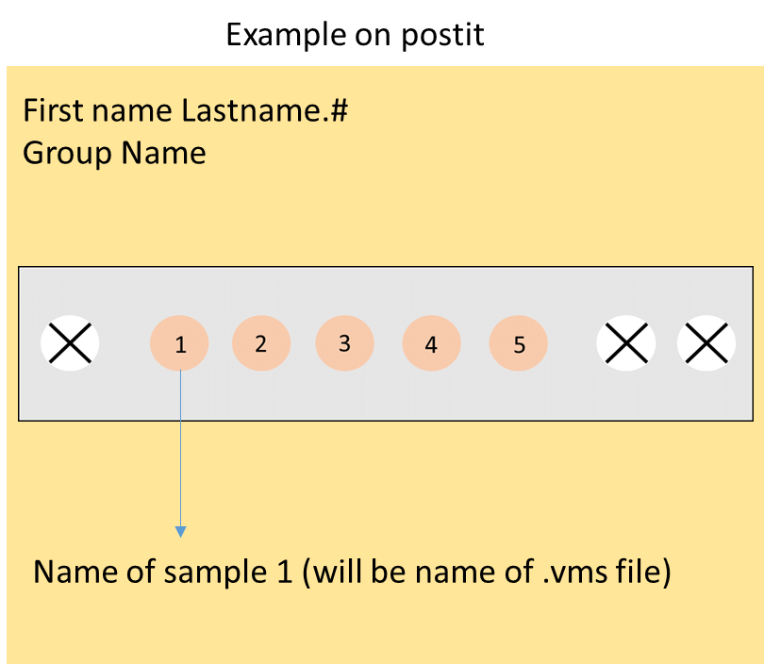

- Immediately after sample drop off users must email the facility manager detailing the sample drop off and its contents. Vital information here is reconfirming the naming system and additional details regarding sputtering if relevant. The SAL manager will then retrieve the samples, sanitize them, and run analyses the following day.
- Data will be sent digitally, either via email or using the Shared Drives set up for the facility.

