Me
My name is Cao Lin and I come from China. My English name is Ashley. In general, I am an outgoing person and have a lot of hobbies like singing, dancing, writing, and diving. When I have spare time, I prefer to hang out with my friends and sometimes we play instruments like the guitar together. Among all the hobbies that I have, my favorite one is traveling, because I can not only broaden my horizon but also experience different cultures. I believe traveling is like studying, where you get to study the different cultures, including obvious ones such as food, fashion and language, and not so obvious ones such as education, beliefs, and traditions.

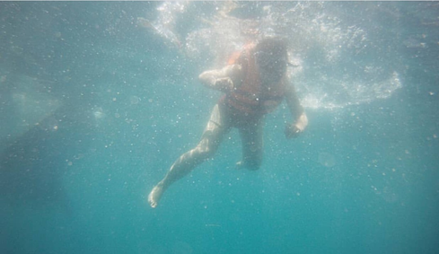

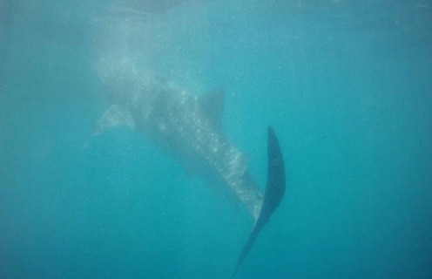

Let’s talk about my past, I studied at the Macau University of Science and Technology (MUST), where I majored in English, and minored in Spanish and Business. Coincidently, Macau was returned to mainland China on the day that I was born, so I think that I have a special relationship with the place Macau. The university that I attended to is located in Taipa, which is the most prosperous place in Macau. In the two years of studying at Macau, I went out for a walk almost every night to explore the city. The source of my daily happiness was that I got to see the Morpheus Hotel whenever I looked up. The Morpheus Hotel is very beautiful and allows me to see the wisdom of architects, scientists, and artists. The Morpheus Hotel is definitely my favorite architecture.
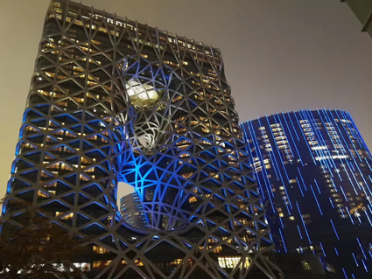
Picture resource: https://image.baidu.com/search/detail?ct=503316480&z=0&ipn=d&word=%E6%91%A9%E7%8F%80%E6%96%AF&step_word=&hs=0&pn=8&spn=0&di=770&pi=0&rn=1&tn=baiduimagedetail&is=0%2C0&istype

There are a couple of reasons why I chose to study at OSU. First, it is the most cost-effective choice because the ranking of OSU is middle to high, yet the tuition is not expensive. The second reason is that I didn’t want to begin my new college life in a big city where I may become stressed out. I just transferred 30 credits from MUST to OSU this past summer, and I want to continue my study career at OSU. From this point on, I will continue to study hard in every semester, including the summer semester, so I can graduate on time. I will choose financial mathematics as my major because I love mathematics and finance and I like analyzing data.

